Ben’s Brave Choice Suits Him
 | Ben loved his new iPhone.  He texted friends and played games.  It did everything for him, and so quickly!  He looked at the screen day and night, ignoring his family.
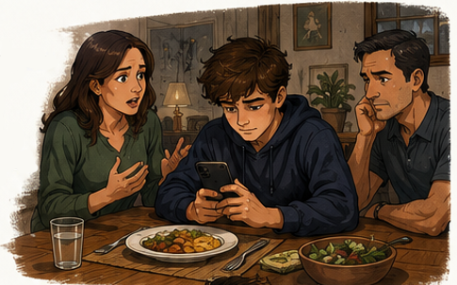 | At dinner, his food got cold as he scrolled.  His mother said, “Ben, this does not suit you. You don’t talk to us any more. Please put down the phone. We miss you.”  Ben felt guilty. She was right.
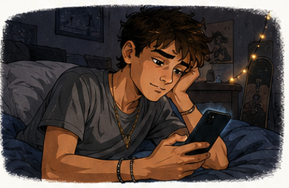 | Ben tried to quit but it was hard.  He knew he wanted to build a happier life, full of people and interests.
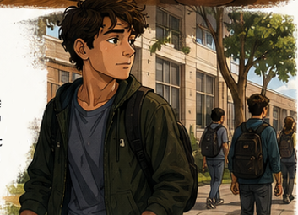 | Instead of staring at the screen, he walked outside the school building. He didn’t know what to do with himself, when he wasn’t on a screen.
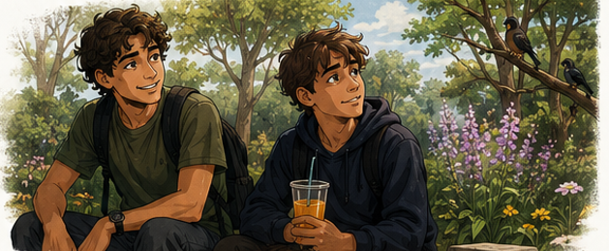 | A guy in Ben’s class who loved nature was passing and saw Ben looking sad. “Can I guide you on a nature walk?” Ben agreed.  It was a hot day, so they stopped and drank some fruit juice. The guy pointed out birds, flowers, and trees. Ben listened quietly and enjoyed every minute.
 | They passed a guard near the park gate.  A friendly guest at the park waved hello.
 | When Ben got home, he picked up his guitar instead of his phone.  He played a new song and smiled.
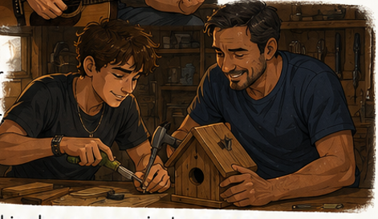 | That evening, Ben helped his father build a birdhouse.  They built it together.  Ben felt joyful.
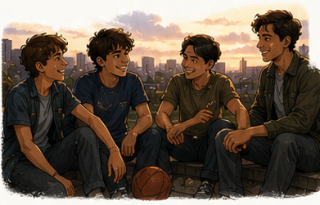 | He didn’t need his phone every minute anymore – it was misguiding him.  He chose a life that suited him better than endless scrolling.
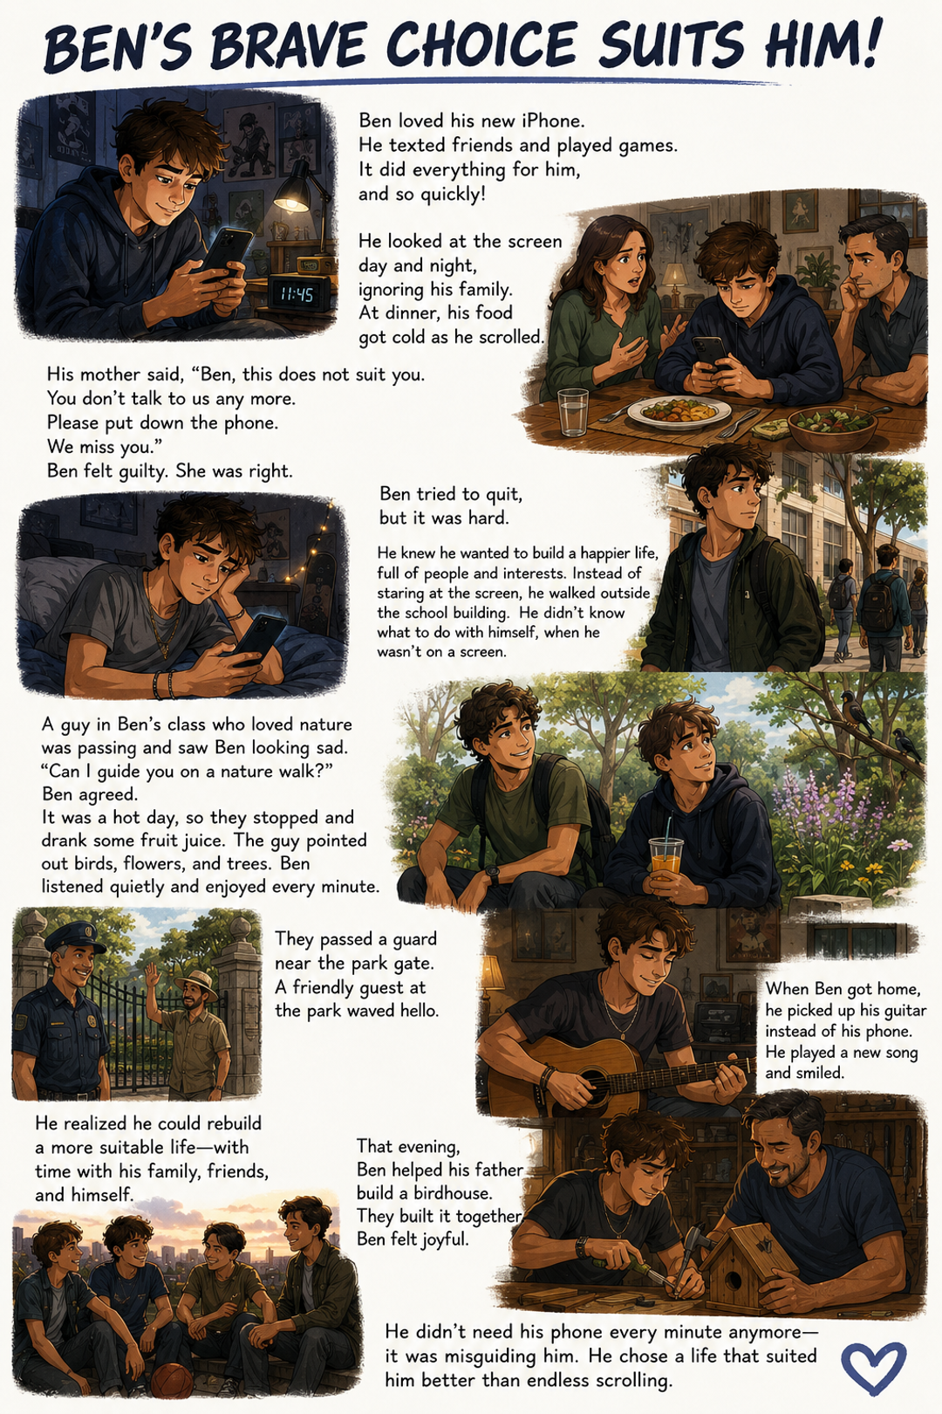
Word List
1 | 📱 | phone
2 | ✋ | quit
3 | 🧭 | guide
4 | 🙋 | guest
5 | 👮 | guard
6 | 🌳 | nature
7 | 👍👕 | suit
8 | 😔 | guilty
9 | 🙈📱 | ignore
10 | 🧱➡️🧱 | rebuild
11 | 😄 | joyful
12 | 🚫➡️ | misguide

Online game: https://wordwall.net/resource/116707927/ui-word-groups

UI Word Detective Sort
Objective
Sort each word into the correct UI family and explain why it belongs there.
Students earn a point only if they can explain the spelling pattern.
Preparation: Print (laminate) and cut out the cards on the next page.
How to Play
Shuffle all the cards.
Spread the four Family (Category) Cards on the table.
Players take turns.
- Draw one card.
- Read it aloud.
- Decide which family it belongs to.
- Place it under the correct heading.
- Explain why.
For example:
guide
"I put it under GU because the u is silent. It keeps the g hard."
If the explanation is correct, the player keeps the point.

Answer Key:
🟨 Family 1  ui says short i /ĭ/  The letters ui make the short i sound.  Examples  - build  - built  - building | 🟧 Family 2  ui says long u /ū/  The letters ui make the long u sound.  Examples  - fruit  - juice  - suit  - suits  - suited
🟦 Family 3  qu words  The u belongs to qu.  qu = /kw/  Then read the vowel after it.  Examples  - quit  - quickly  - quietly | 🟩 Family 4: gu words  The u is silent.  It keeps the g hard.  Examples  - guide  - guy  - guard  - guest  - guitar  - misguiding

🟨 Family 1  ui says short i /ĭ/  The letters ui make the short i sound. |  | 🟧 Family 2  ui says long u /ū/  The letters ui make the long u sound.
🟦 Family 3  qu words  The u belongs to qu.  qu = /kw/  Then read the vowel after it. |  | 🟩 Family 4  gu words  The u is silent.  It keeps the g hard.
build | suit |  | guide
built | suits |  | guiding
building | suited |  | misguide
quit | fruit |  | misguiding
quickly | juice |  | guest
quietly | guy |  | guard
 |  |  | guitar

