Kate’s Trip to Freda’s Home
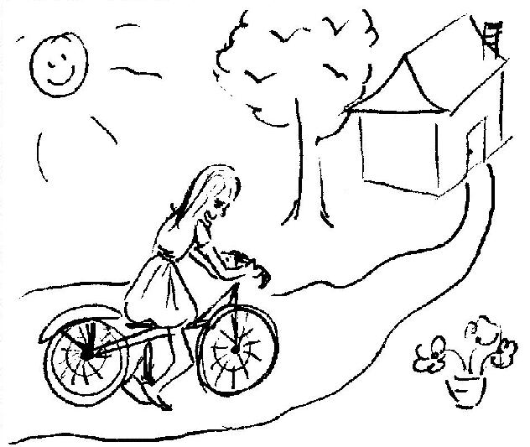  This is the tale of Kate’s trip to Freda’s home. Freda is Kate’s friend. | 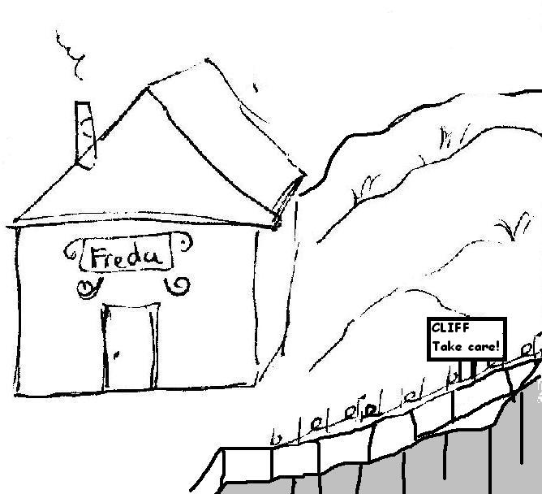  Freda’s home is big, it’s red and black, and it’s on a slope close to a cliff.
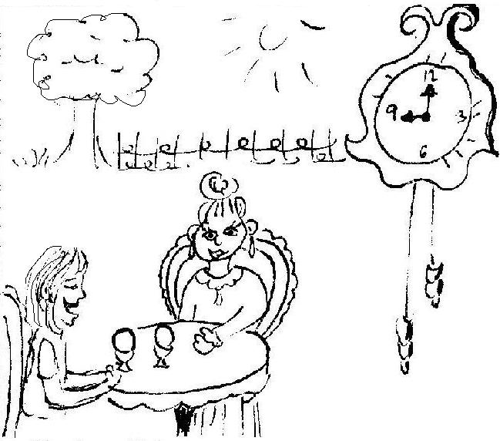  At nine, Kate and Freda ate eggs in the garden. | 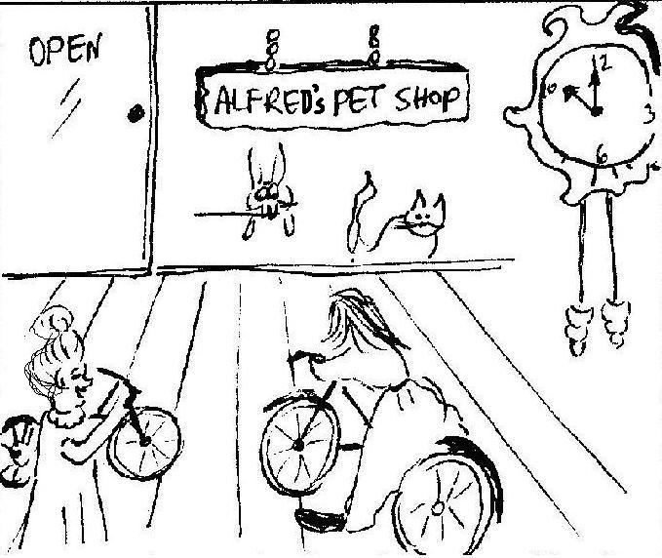  At ten, they rode their bikes to Alfred’s pet shop. Kate hopes it isn’t far.
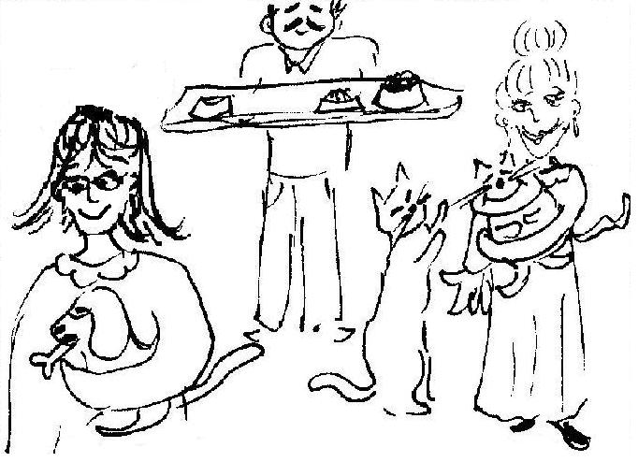  In the pet shop are dogs and their bones, and cats and their kittens.  Kate likes the dogs.  Freda likes the cats and kittens. | 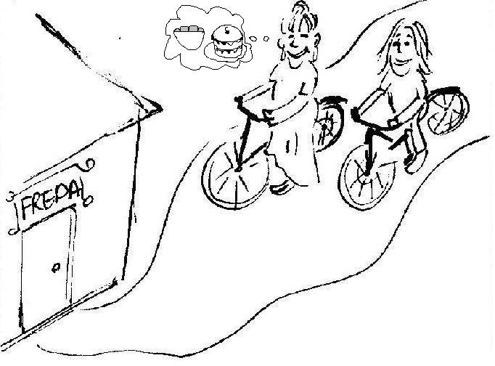  Then they rode back to Freda’s home. Freda hopes to prepare falafel and some cake.

Word List
1 | 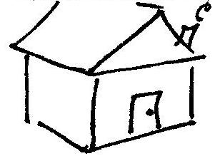 | home
2 | 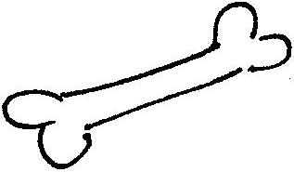 | bone
3 | 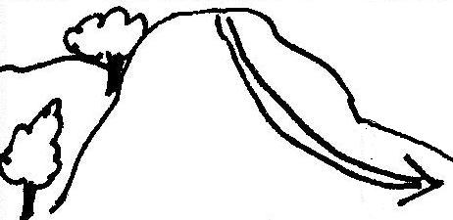 | slope
4 | 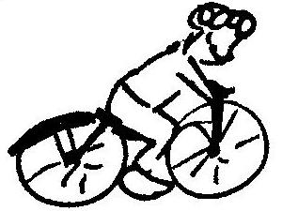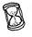 | rode
5 | 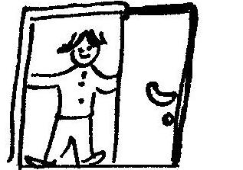 | come
6 | 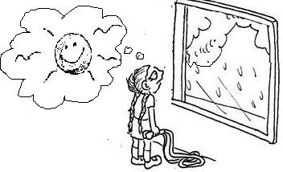 | hope
7 | 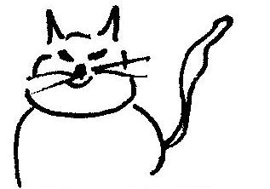 | cat
8 | 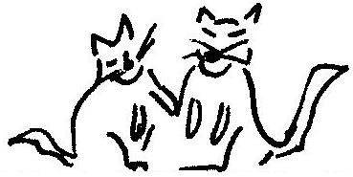 | kittens
9 | 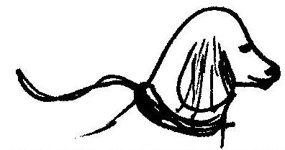 | dog
10 | 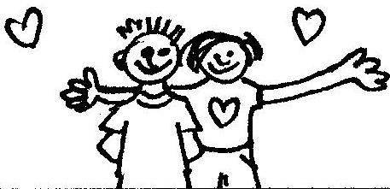 | friends
11 | 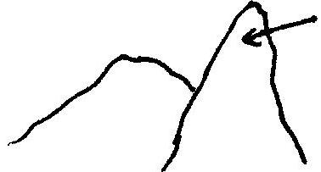 | cliff
12 | 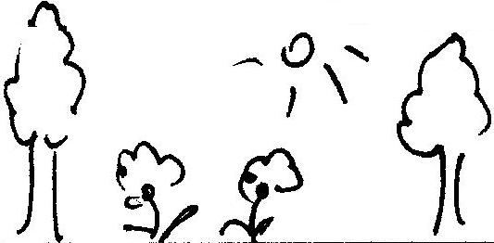 | garden

“Opposites and Categories” Matching Game
Goal of game: to match pairs of words that are either opposites, or two different examples of the same category (girls, boys, animals, languages, colors).
Cut out the squares on the dotted lines only (don’t cut out the triangles). Options: You can enlarge the puzzle and glue it onto colored paper or cardboard and laminate.
To play: match the words, placing them together (the edges of their squares touching). Assemble the puzzle into a 3X3 square so that every word only touches a matching word. There are lots of “right ways” to assemble the puzzle, since the words at the top and bottom of each column and both ends of each row also match.

small  didn’t don’t  doesn’t | come  do thin  Tom | happily  fat did  Mr.
does  none Freda  talk | Bob  Kate cat  sit | Mrs.  dog some  fill
listen  black Latin  big | stand  Arabic this  go | empty  that red  sadly

