Phil and Fred Visit Sophie
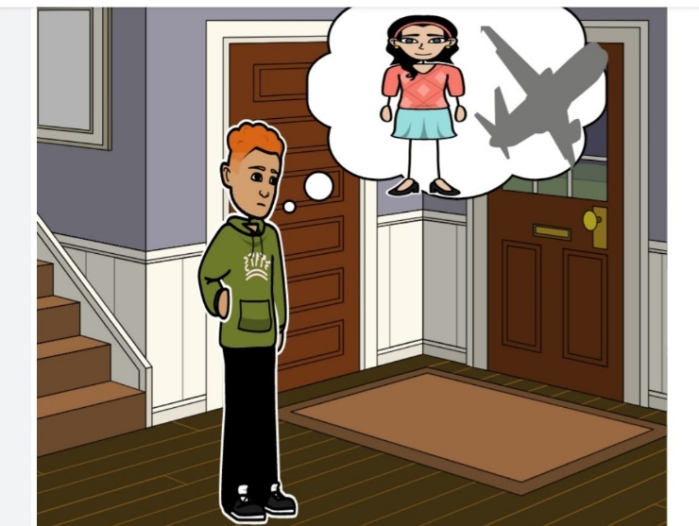  Phil wants to visit his friend Sophie. Sophie lives in France. However, Phil has a problem. He has a phobia of flying. | 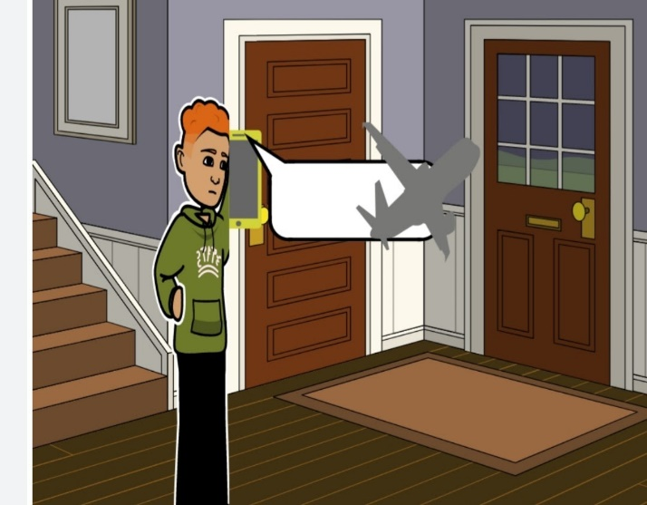  Phil phones Sophie. He tells Sophie how he feels. He tells her that he wants to visit her in France but that he has a phobia of flying.
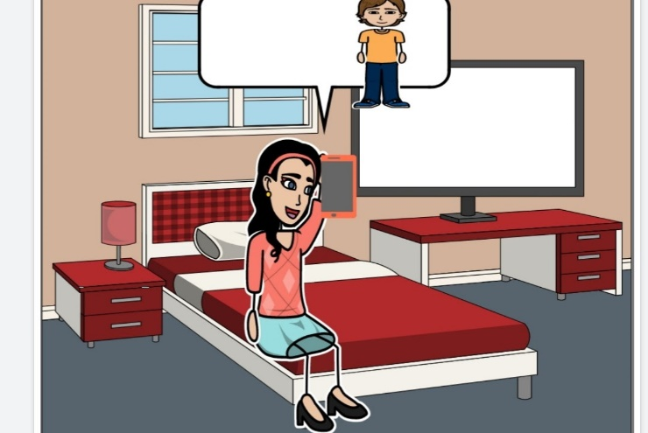  Sophie tells Phil to fly to France with his nephew Fred. | 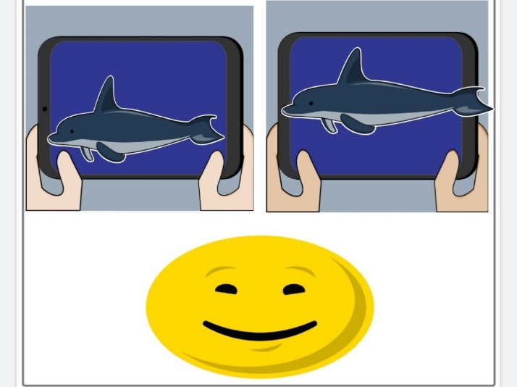  On the plane, Phil and Fred watch a film about dolphins. Phil forgets about his phobia of flying. Phil feels fine.
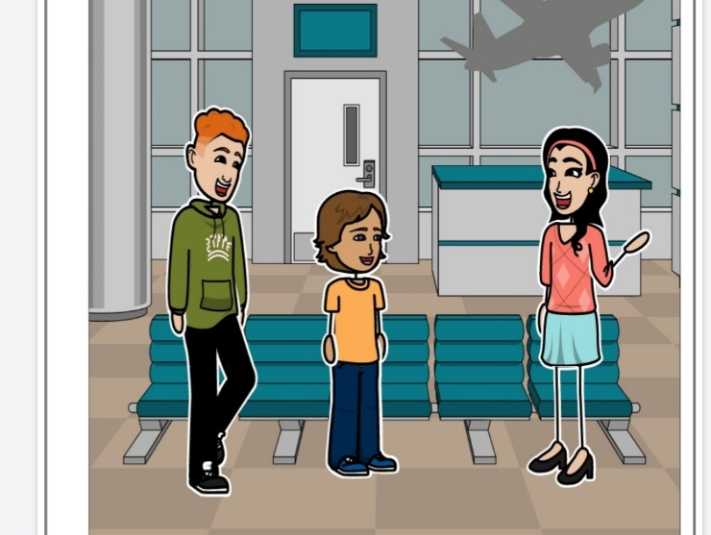  The plane lands in France. Sophie meets Phil and Fred after their flight. Sophie is pleased to see them. | 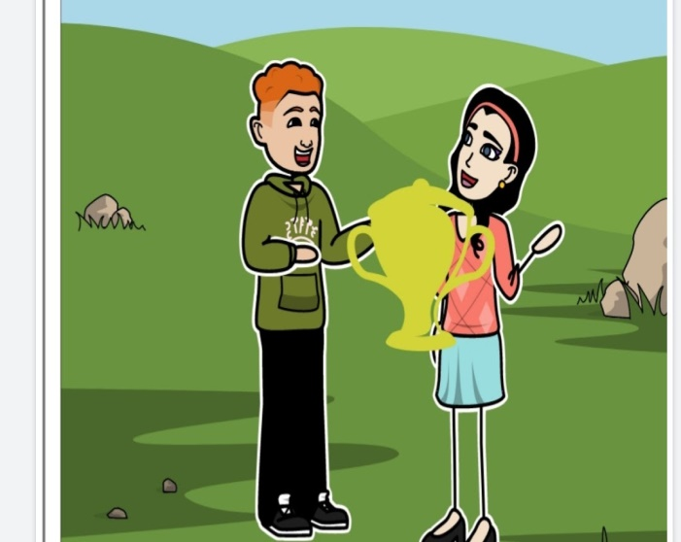  Finally, Sophie gives Phil a fancy trophy. Phil has defeated his phobia of flying. Phil feels fantastic.

Word List

1 | 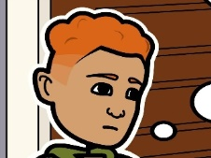 | Phil
2 |  | Sophie
3 |  | friend
4 | 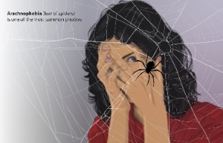 | phobia
5 |  | feels
6 | 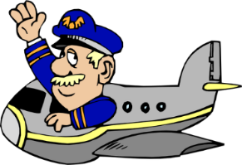 | to fly
7 | 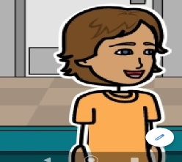 | nephew
8 |  | dolphins
9 |  | pleased
10 | 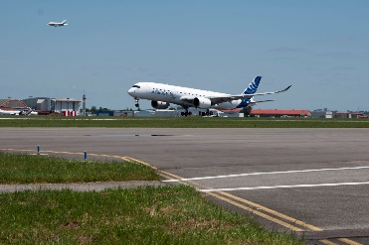 | flight
11 |  | trophy
12 |  | forgets

Game: Click on the following link to see a set of
Quizlet – flashcards from Word list
For a printed game, print the cards below. (Flashcards: fold word & picture back-to-back, laminate. Concentration: cut word and picture cards individually and match word to picture)
friend | 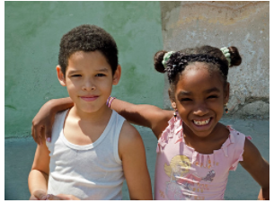
phobia
feels
to fly | 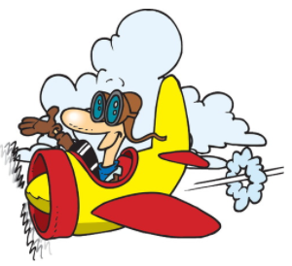
nephew | 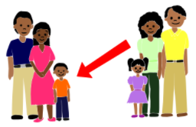
dolphin | 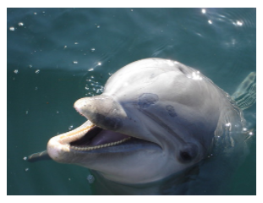
pleased
flight | 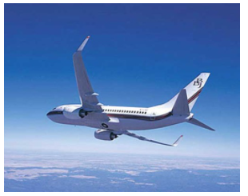
trophy
forgets

