The Best Dinner Ever
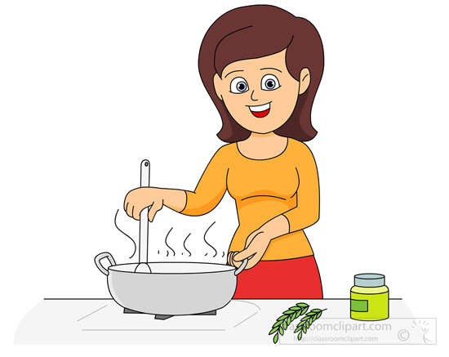  Tara’s mom was such a delight, but her sight was bad, so Tara made dinner every night. | 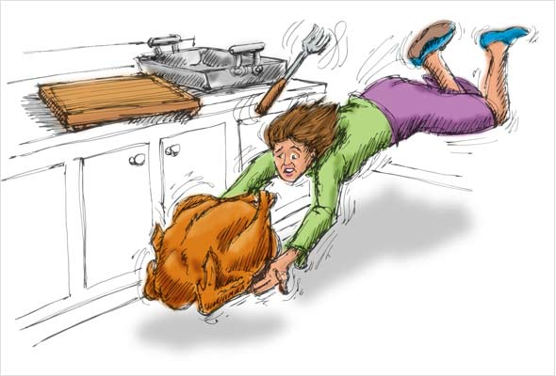  One Tuesday, the chicken thighs decided to put up a fight and did not fit in the oven.
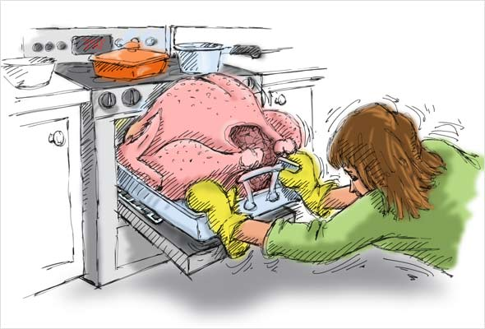  Tara let out a sigh, and with all her might pushed the chicken thighs into the oven. | Soon, Tara heard a boom, and noticed bright lights coming from the kitchen. The oven exploded, what a sight! The chicken thighs were high up all over the walls!
Tara’s mom came in and noticed the chicken thighs high up on the walls. Tara’s mom said, “It’s alright, Tara, let’s make another dinner without the oven.” | 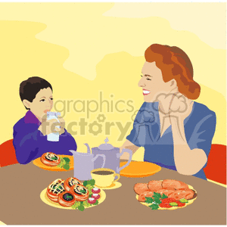  That night, Tara and her mom cooked what might have been the best dinner ever!

Word List
1 |  | delight
2 |  | sight
3 |  | night
4 |  | Tuesday
5 | 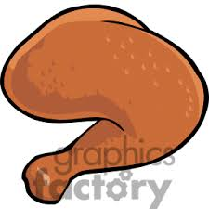 | thighs
6 |  | fight
7 |  | sigh
8 |  | might
9 |  | bright
10 | 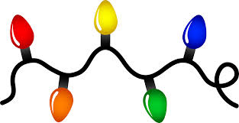 | lights
11 | 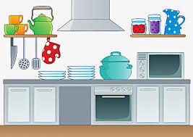 | kitchen
12 |  | alright
Concentration or Matching Game
Cut apart the squares. Match each word or sentence to the picture it describes.
Tara’s mom was such a delight.
Tara let out a sigh.
With all her might, Tara pushed the chicken thighs into the oven.
Tara noticed bright lights coming from the kitchen.
The oven exploded, what a sight!
It’s alright Tara, let’s make another dinner.
chicken thighs
lights
night
fight

