Iris's Cabin Picnic
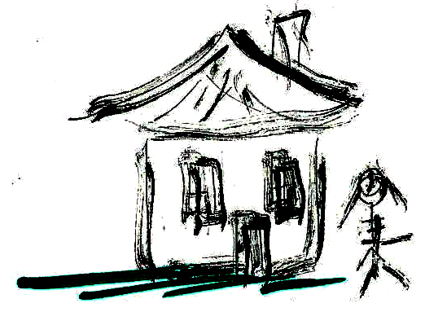  Iris is the tenant in the cabin.  It is a basic cabin.  It is a shack. | 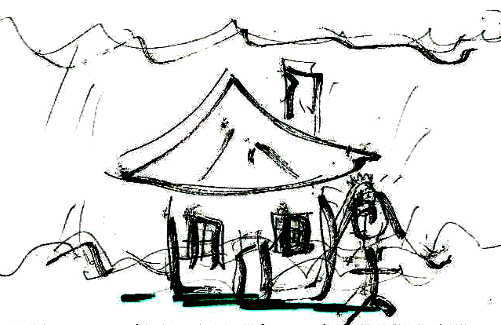  They predict mist. The cabin is in mist.  Iris's eyes are sad.  She is timid and in a panic.
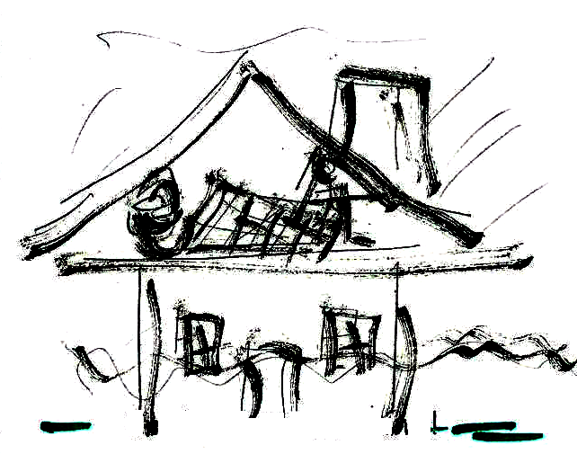  Iris's tactic is a picnic!  The best picnic is in the attic. | 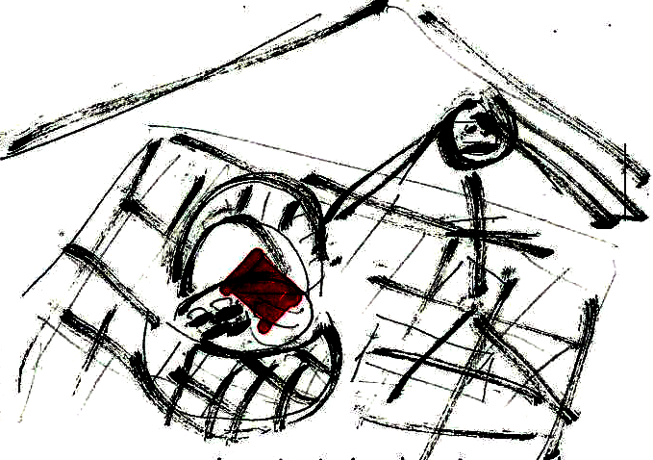  An item in the picnic basket is a red napkin. She has yams and mints in the picnic basket.
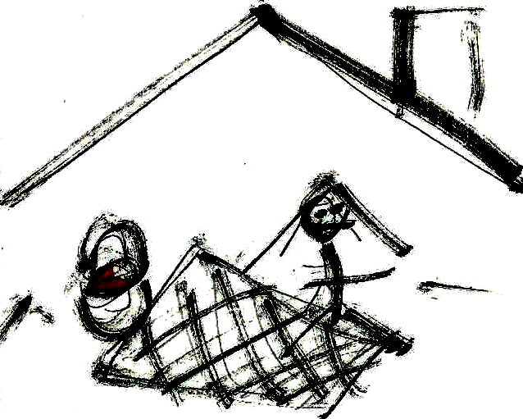  Iris pretends the attic is a tent.  She had a picnic in the cabin's attic! | 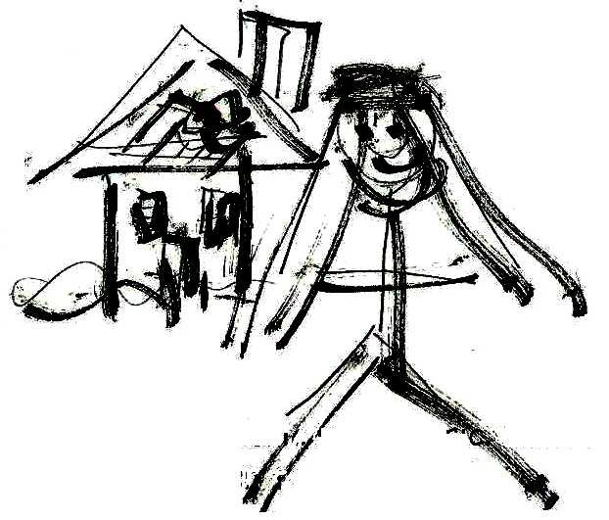  Tenant Iris's picnic in the basic cabin's attic isn't a bad tactic!  She isn't sad and timid, and isn't in a panic!

Word List
1 | 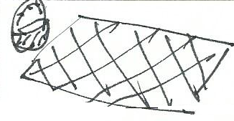 | picnic
2 | 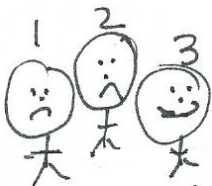 | tactic
3 | 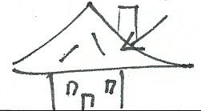 | attic
4 | 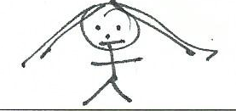 | Iris
5 | 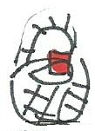 | item
6 | 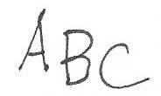 | basic
7 | 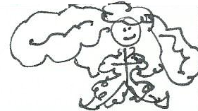 | pretend
8 | 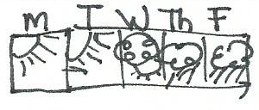 | predict
9 | 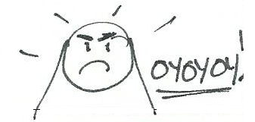 | panic
10 | 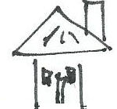 | cabin
11 | 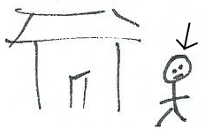 | tenant
12 | 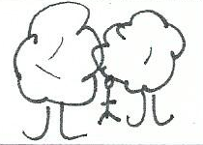 | timid
(Syllable division patterns: words 1-3 are vc/cv, words 4-8 are v/cv, words 9-12 are vc/v)
Word Sort Game
Preparation: Glue the following two sorting boards and word cards onto cardboard (lamination optional) and cut out the word cards. Play: Sort the words in two ways: first, by meaning; second, by syllable division pattern. In the "meaning" sort, there are multiple ways to sort the cards; discuss their choices with learners. Answer key for syllable division patterns sort is below.

Word Sort by Meaning: Who or what does this word describe?
Iris | Cabin | Picnic

Word cards: cut up

picnic | tenant | panic
timid | basic | attic
basket | napkin | tactic
item | pretend | predict
mints | Iris | cabin
sad | shack | yams
best | tent

Word Sort by syllable division pattern.
Put one-syllable words in a separate pile.
vc/cv | v/cv | vc/v
Answer key for syllable division patterns
vc/cv | v/cv | vc/v
picnic | item | timid
basket | Iris | tenant
tactic | pretend | panic
napkin | basic | cabin
attic | predict

1-syllable words:
sad, best, tent, shack, yams, mints

