The Party at Mark’s Bar
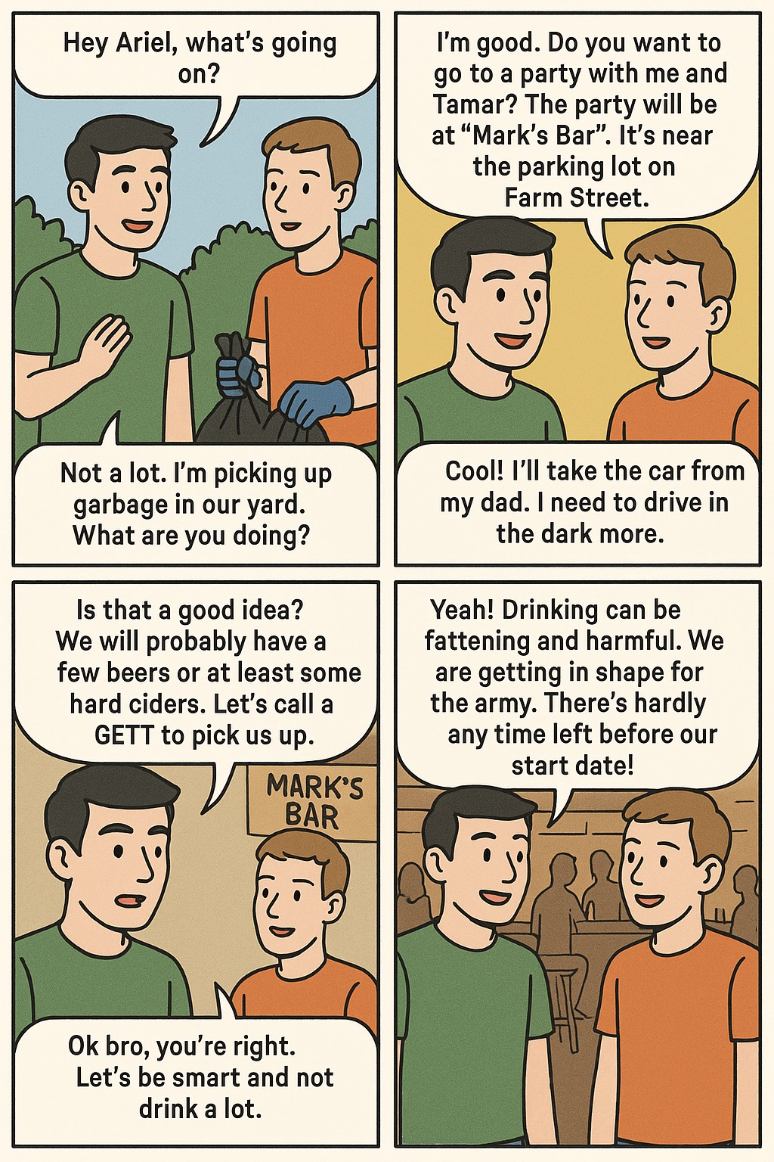
Word List
1 | 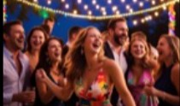 | party
2 |  | Mark’s Bar
3 | 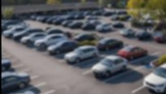 | parking lot
4 | 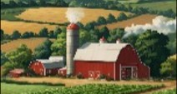 | Farm Street
5 | 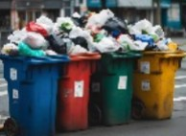 | garbage
6 | 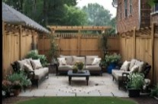 | yard
7 | 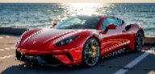 | car
8 | 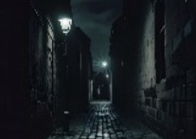 | dark
9 |  | harmful
10 | 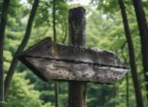 | start
11 | 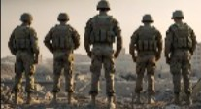 | army
12 |  | hardly

Word Search Puzzle
d | a | r | k | a | s | t | a | r | t | y | g
a | r | m | y | f | a | r | m | s | t | r | e
r | a | p | a | r | k | i | n | g | l | o | t
k | g | y | a | r | d | k | b | h | g | y | a
h | a | r | m | f | u | l | c | r | g | r | r
a | s | m | a | r | k | s | b | a | r | b | b
r | l | g | a | r | b | a | g | e | i | d | a
d | y | p | h | a | r | d | l | y | r | m | g
l | o | t | t | h | c | a | r | y | a | a | e
y | a | r | d | t | l | o | r | e | b | t | l

Words to Find

party | car | yard
Mark's Bar | dark | hardly
parking lot | harmful | garbage
Farm Street | start | army
Online game: https://wordwall.net/resource/94213042/%D7%90%D7%A0%D7%92%D7%9C%D7%99%D7%AA/hickey-lesson-49-by-f

