Storm’s Fall
We love our dog, Storm. We are sad because we just saw him fall on the lawn. | It’s awful! He can’t walk or run. He can only crawl. He is awkward.
We draw near and see that he has a thick thorn in his paw! We pick him up and take him to the vet. | The vet is kind and is able to take the thorn out of his paw. It hurt him an awful lot. His paw is raw and red.
The vet gives us pills for Storm. Mom puts them in a drawer at home to keep them safe. The pill makes Storm sleepy. He yawns. | The next morning at dawn, Storm is better. We are so happy because he can play ball with us. We crawl with him on the green lawn.
Note: “-all” also has the (aw) sound.
Word List
1 | 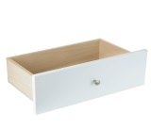 | drawer
2 | 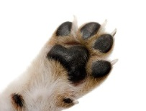 | paw
3 | 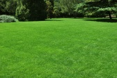 | lawn
4 | 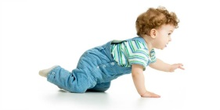 | crawl
5 | 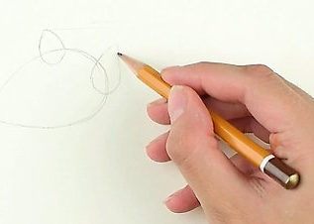 | draw
6 |  | vet
7 | 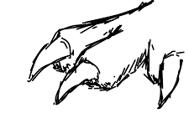 | claw
8 | 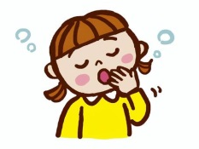 | yawn
9 | 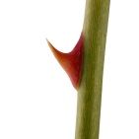 | thorn
10 |  | straw
11 |  | awkward
12 |  | saw

Game:

Snakes and Ladders: See attached PDF file. Assemble the four pages into one large board. You will need dice and a piece for each player.

Wordwall game- https://wordwall.net/resource/56345648

