Bob and Tom
Bob is a snob.    He doesn’t talk to Tom. |   They had a picnic  near the pond.
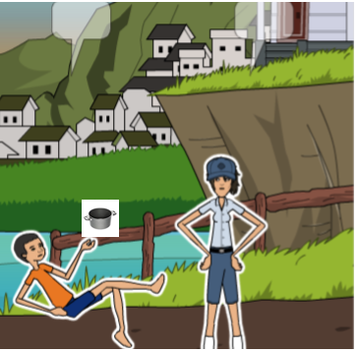  Sloppy Tom drops a hot pot on Bob  and spots his sock. It's so hot! | 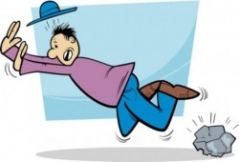  Stop! Tom is sorry.  He fell on a rock.
  Bob told Tom  that he is in the hospital. | Tom came to the hospital.  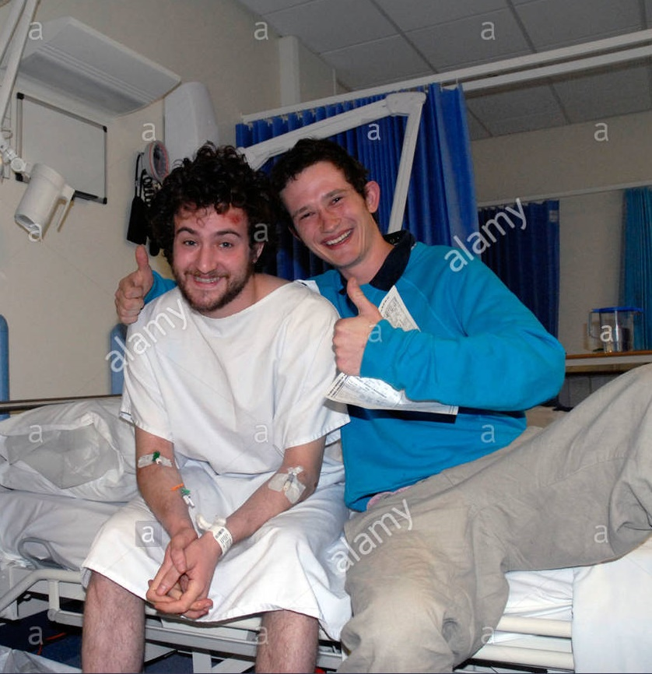  Bob and Tom finally are friends.

Word List
1 | 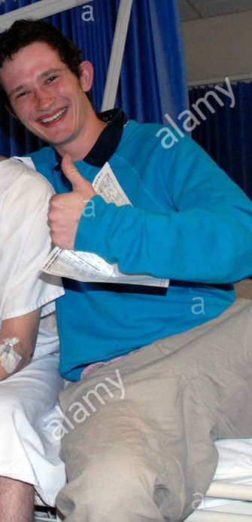 | Bob
2 |  | snob
3 | 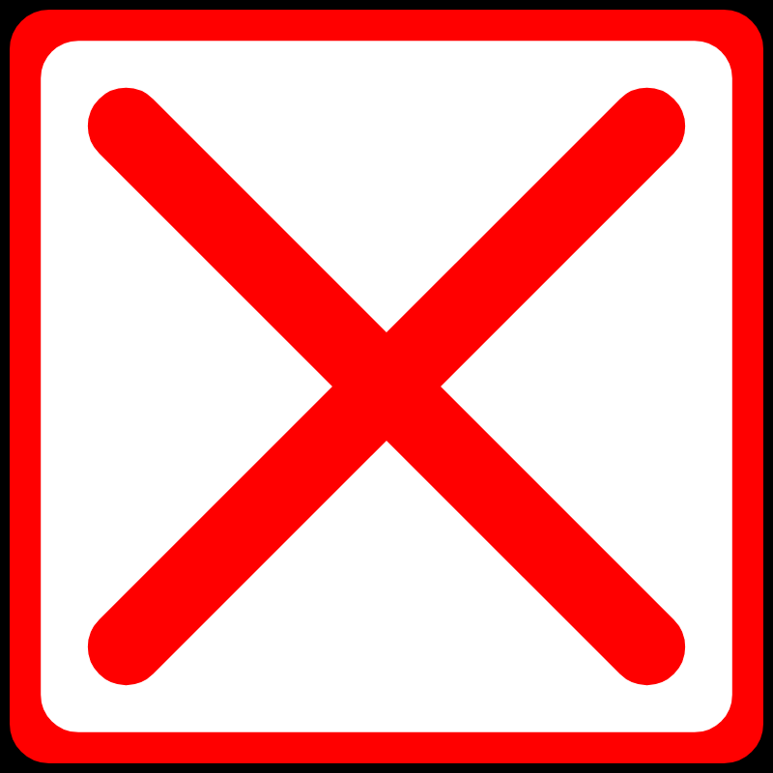 | doesn’t
4 | 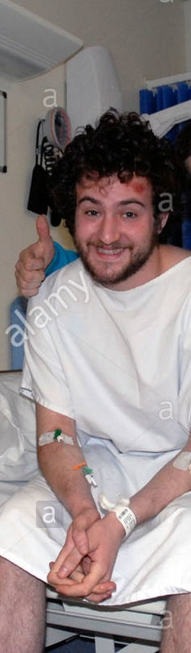 | Tom
5 | 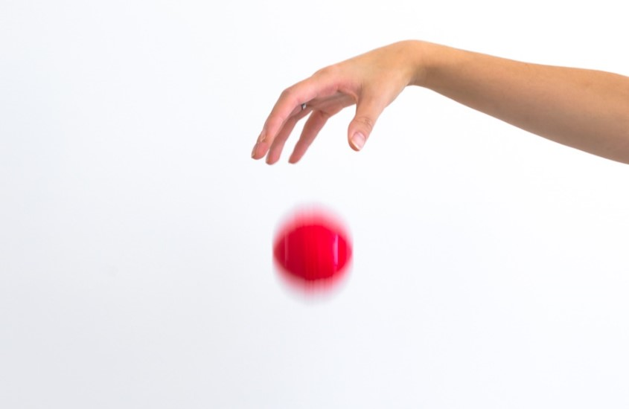 | drop
6 | 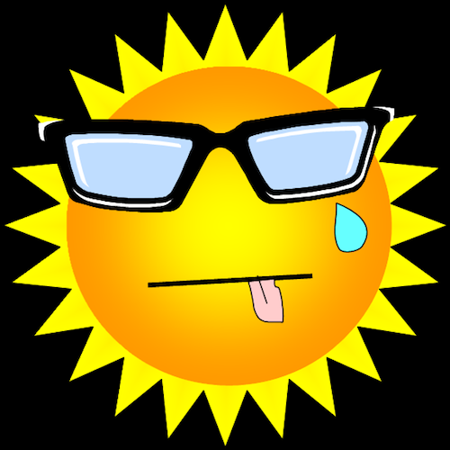 | hot
7 | 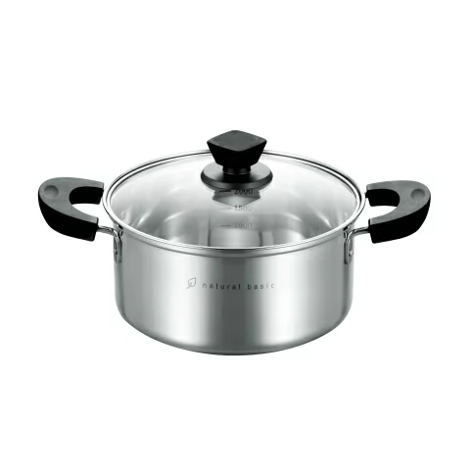 | pot
8 |  | spot
9 |  | sorry
10 | 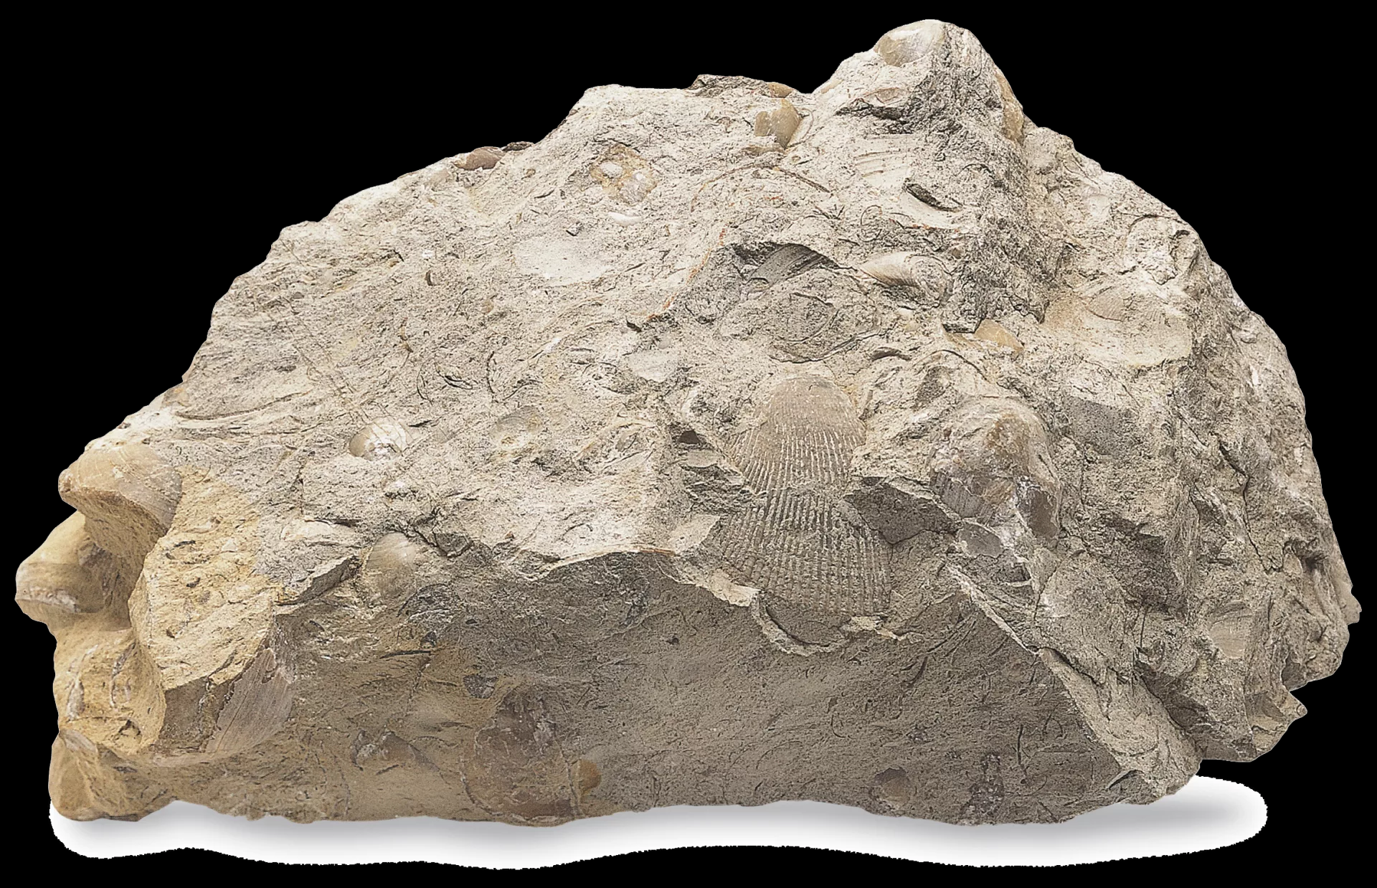 | rock
11 |  | hospital

Bingo
Cut up these words into cards, place in a bag, and have learner read words aloud. Players place a marker on each word on their boards that are called.

Tom | drop | hospital
Bob | pot | hot
rock | sorry | snob
spot | doesn’t | stop

Bingo Player 2

Tom | drop | hospital
Bob | pot | hot
rock | sorry | snob
spot | doesn’t | stop

Bingo Player 1

stop | hot | pot
spot | Tom | Bob
hospital | snob | doesn’t
rock | sorry | drop

Bob and Tom

S | V | E | S | P | G | J | U | Q | O | M | V | T | R | U
X | P | O | L | H | J | V | Y | B | V | M | C | I | Q | J
Z | Q | O | H | Q | N | E | M | G | K | H | W | H | V | O
R | T | M | T | N | S | E | O | D | A | F | O | J | F | L
O | W | J | F | R | J | M | J | V | F | S | G | M | Q | R
R | X | K | R | T | W | B | Z | X | P | K | M | K | L | E
A | F | I | O | Y | U | U | Z | I | B | C | E | V | Y | G
K | Y | M | F | S | I | C | T | K | O | O | I | Y | F | M
I | S | R | Y | L | C | A | T | A | B | R | D | P | P | S
J | E | L | R | T | L | X | X | I | W | B | F | A | A | C
T | E | O | P | O | Z | Y | J | Y | O | B | D | R | O | P
N | O | F | V | A | S | Y | L | N | V | J | I | L | X | B
P | T | P | V | Y | A | F | S | L | R | Q | J | G | Q | X
I | K | L | W | N | V | L | J | A | P | T | O | H | M | N
A | N | C | N | L | D | V | S | Y | U | T | S | C | A | F

SPOT | BOB | DOESNT
DROP | HOSPITAL | HOT
POT | ROCK | SNOB
SORRY | TOM

