Mr. Boten
by David Geliebter, Iris Marx, Shalhevet Solway

Mr. Boten and Boy Boten look like the letter B/b because they make the same sound as the first sound in בּוטן. Likewise, these characters look like peanuts.

Game board – Page 2 (Next page)
Instructions for the game appear on the game board. The board shows all the letters and letter combinations learned by lesson 8. B is the new letter, hence the emphasis on Mr. Boten. The letter combinations are in a separate area of the board to remind students of their unique sounds.

Piece – Page 3
The pieces page can be printed to assemble players’ pieces. Each page of this template can make pieces for 30 players, thus you may want to print one page like this and several of the playing boards, one board for each group of students. Pieces should be put together as shown in the photograph at the bottom of this page. Alternatively, students can use any identifiable small object. Each group of students playing the game also needs a die or another way to randomly select numbers up to six.

Cards – Pages 4-5
Cut these cards out and assemble them in a stack for students to draw. Each group of students can get a complete set or you can split the cards between different groups.

Empty Cards – Page 6
You can also make you own cards to add new words beyond lesson 8. For this reason, a blank template has been included. This template has been preset, but in case the formatting gets changed, you can make this template on your own by making a 2x12 grid with font size 45 Comic Sans. This is a good size grid for A4 paper.

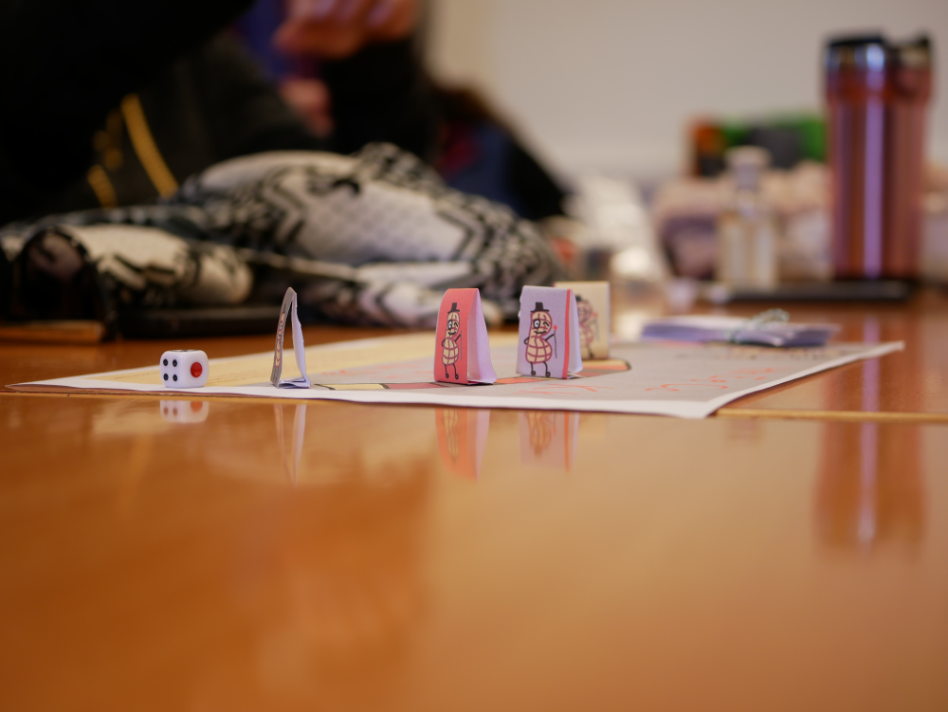
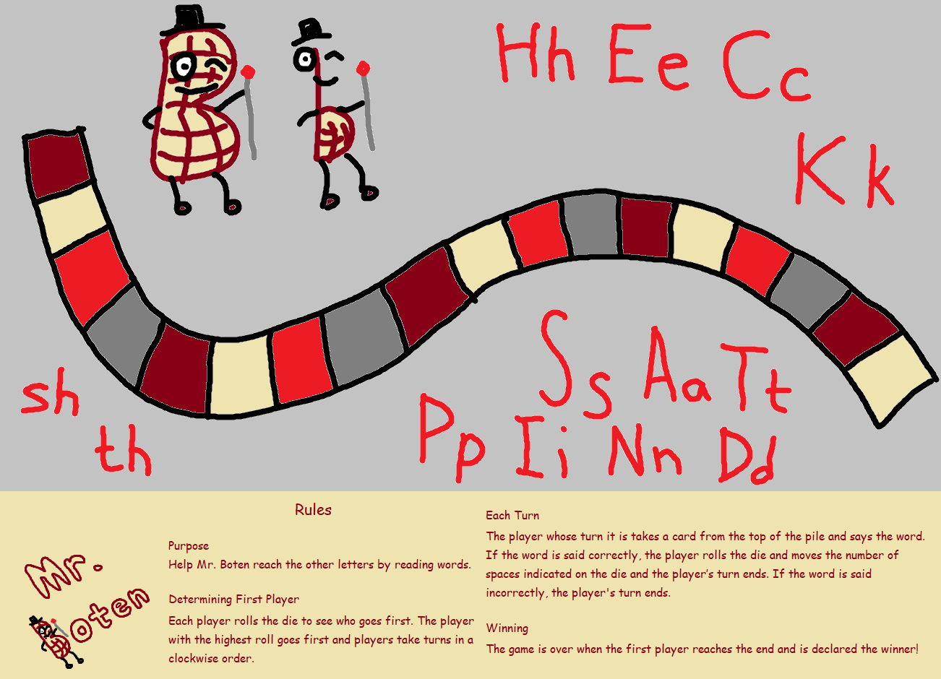
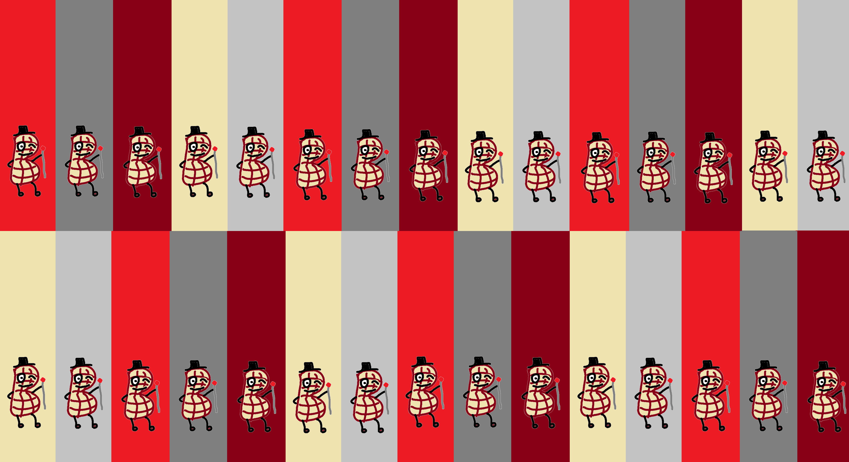
kit | Ben
bin | be
band | bat
cast | bib
pan | tab
bit | bind
cab | Kip
bent | Ken
bend | Kent
best | skip
bet | task
stab | act

end | tact
set | net
pen | pet
spent | spend
test | hen
hit | dip
pant | sand
spin | nip
hint | Dad
snip | Dan
Ann | Nan
snap | pant

