A Vist to Nick's Dad

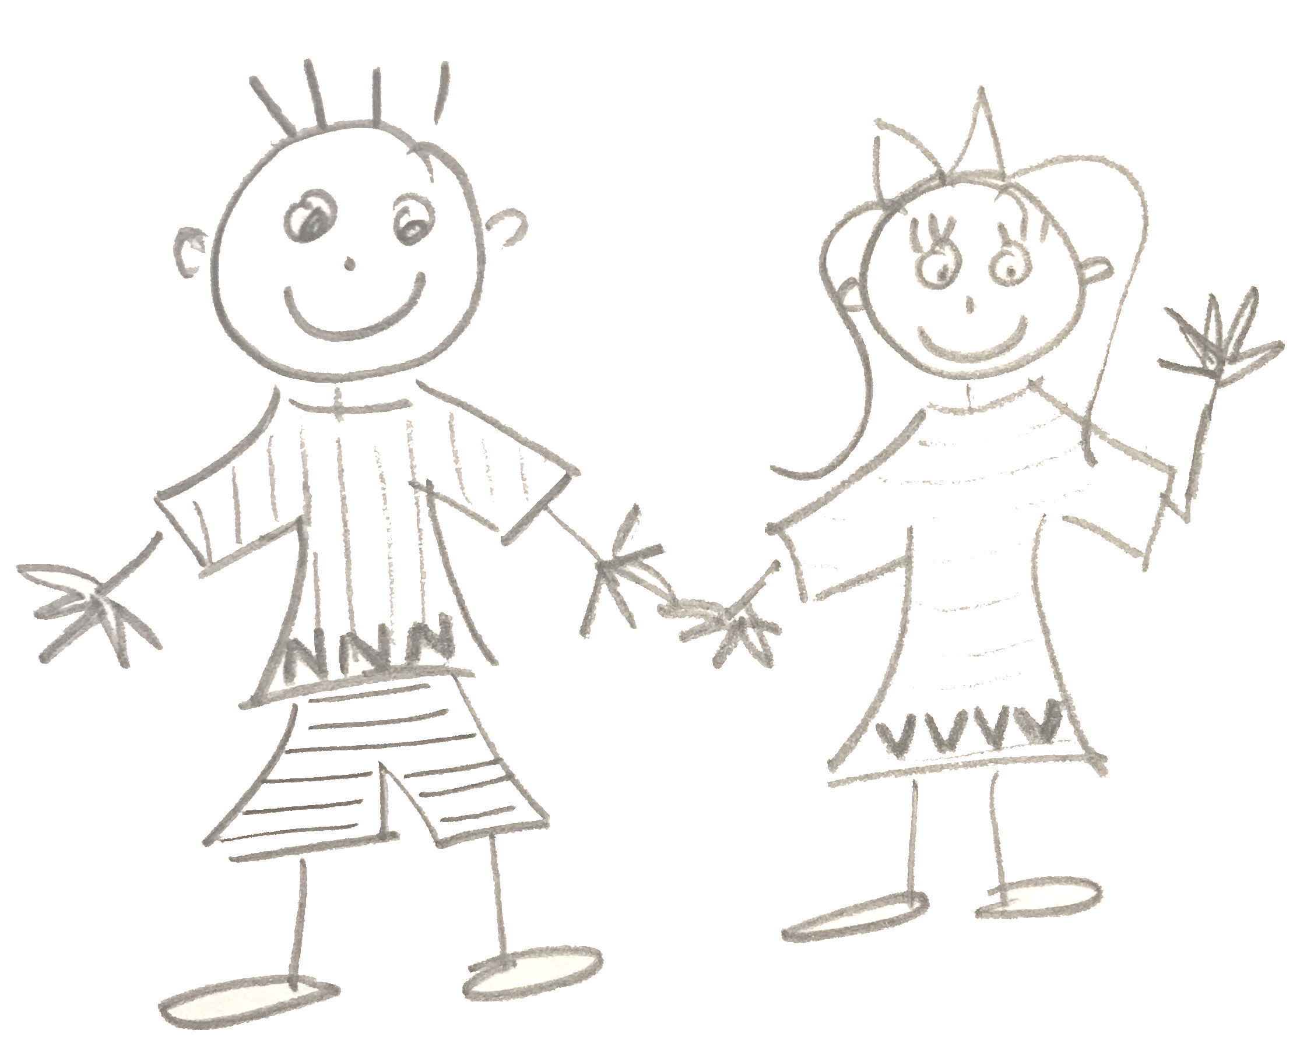 | 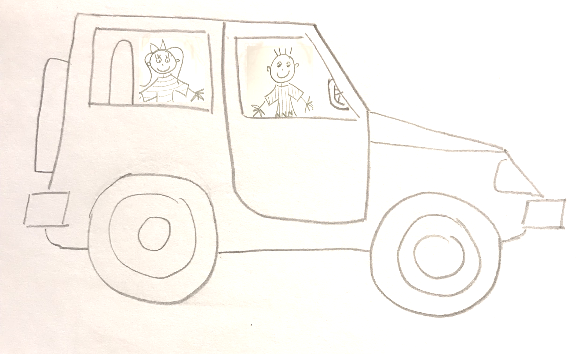
Nick and his friend Veronica went to visit Nick’s dad. “We must travel a very long time,” said Nick. Veronica gave him a wave and said, “We have time.” | Nick and Veronica drove until evening. Then they drove some more. It was late and Veronica felt tired. The car went on and on.
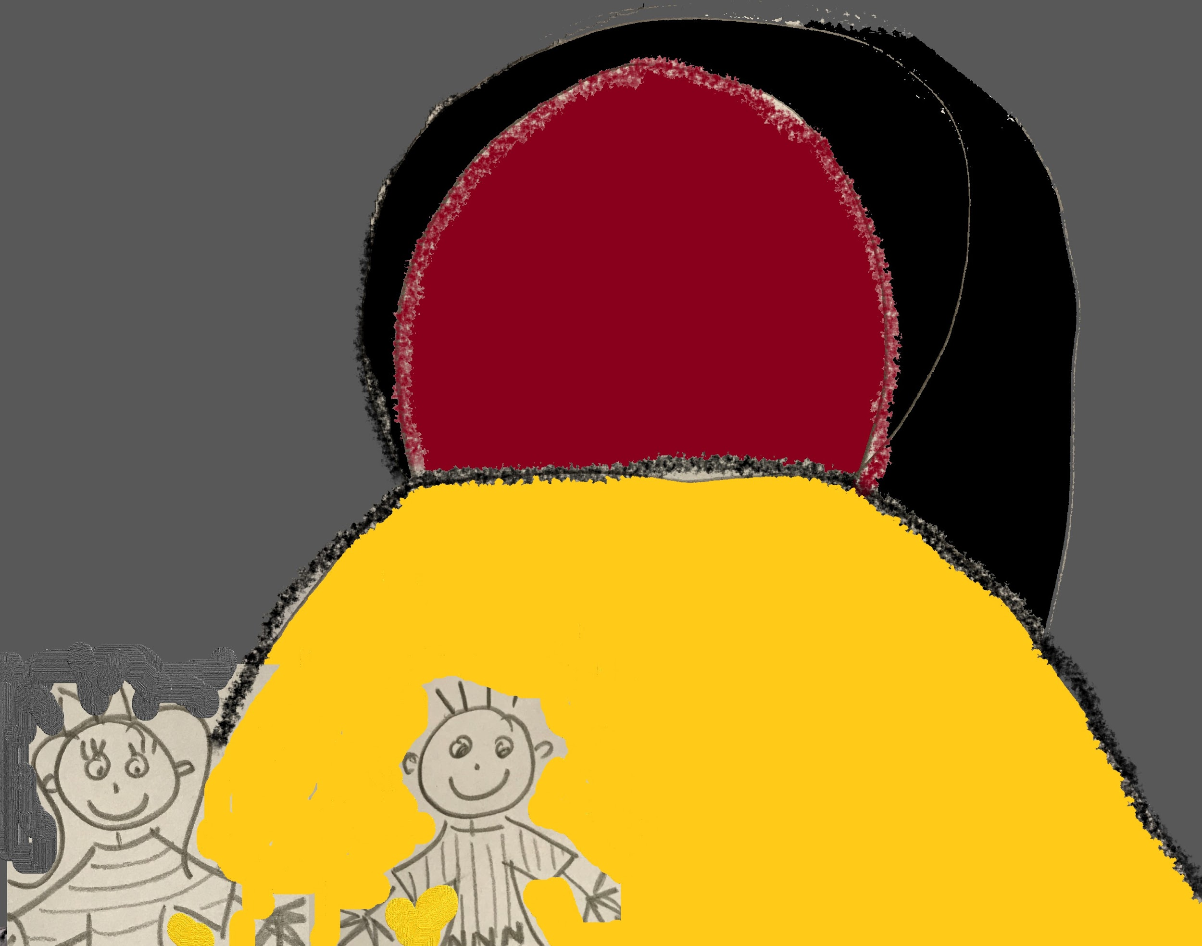 | 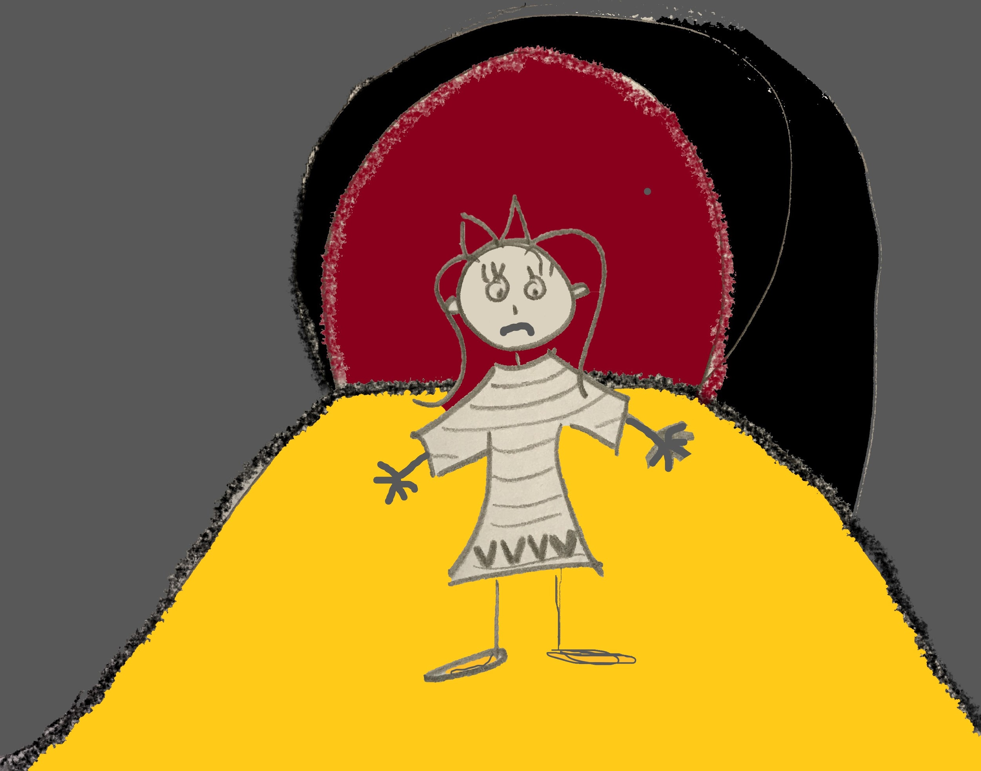
Finally, they came to a stop. It was nine o’clock! There was just sand, a tall hill, and a cave. “We will have a small adventure,” Nick said.  “We will visit this cave.” | It was very late and Veronica was tired. She felt angry. She didn’t want to have an adventure. “I didn’t come this far to visit a cave! I just want to visit your dad, Nick!”
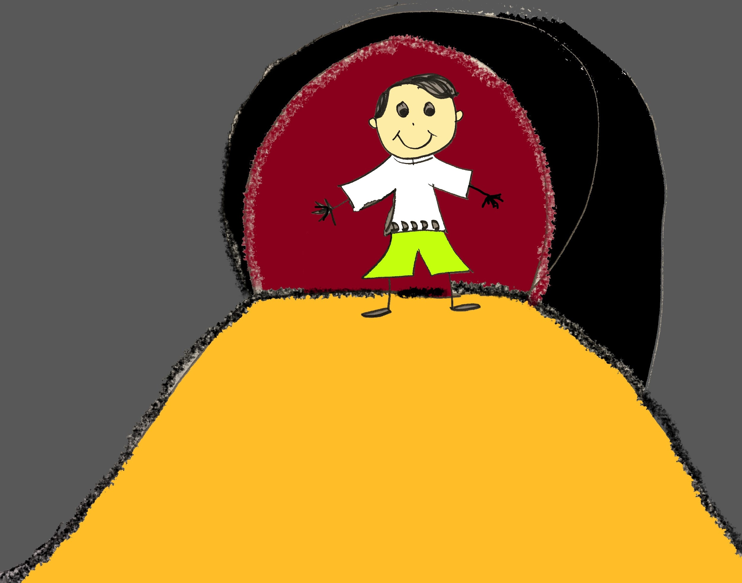 | 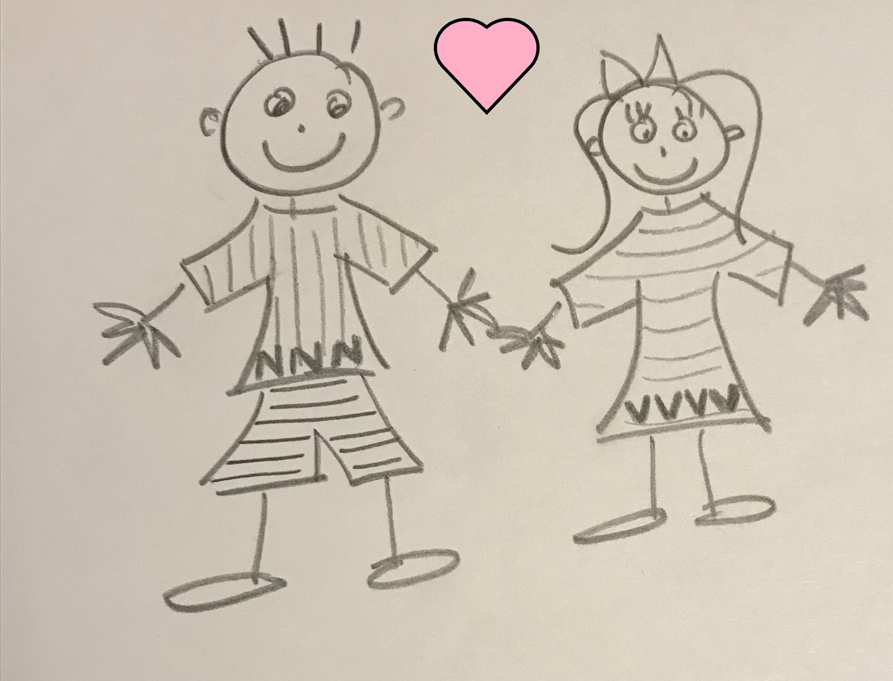
Suddenly, Nick began to grin. “Veronica,” he said, “this is my dad.” Nick’s dad was in the cave! “Thank you for visiting my home,” said Nick’s dad. “I live in this cave. I am so happy you came!” | Veronica was in shock but she felt badly for being angry. She gave Nick a sad stare. He gave her a kiss and said, “I don’t blame you! I didn’t warn you that Dad’s home is a cave!”
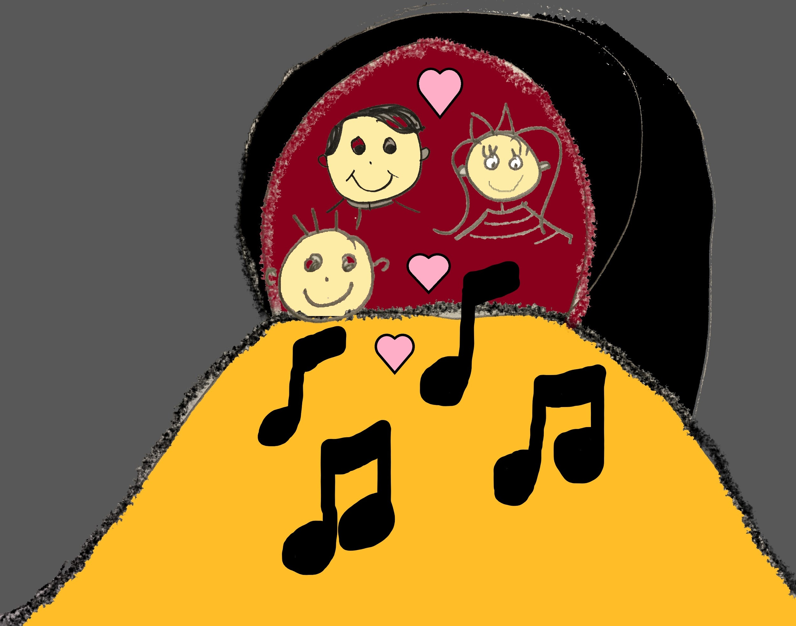 | 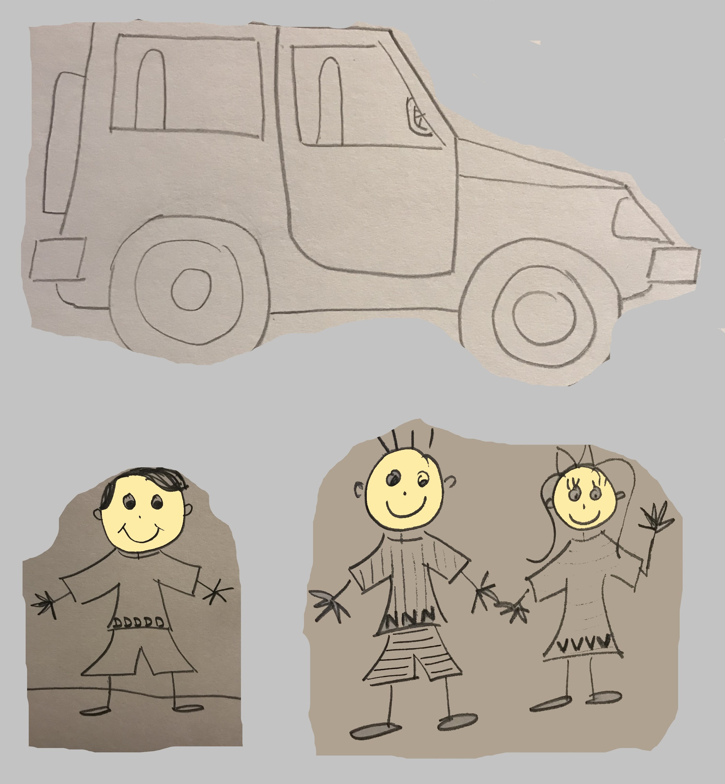
Veronica and Nick had fun visiting Nick’s dad in his cave home. They ate supper and sang songs until late. | Finally, Veronica told them, “I made a mistake! This adventure is wonderful. This cave is terrific. Thank you, Nick, for a grand evening!” To Nick’s dad, Veronica said, “Thank you for having me to visit in your fantastic cave home!”

Word List
1 |  | visit
2 | 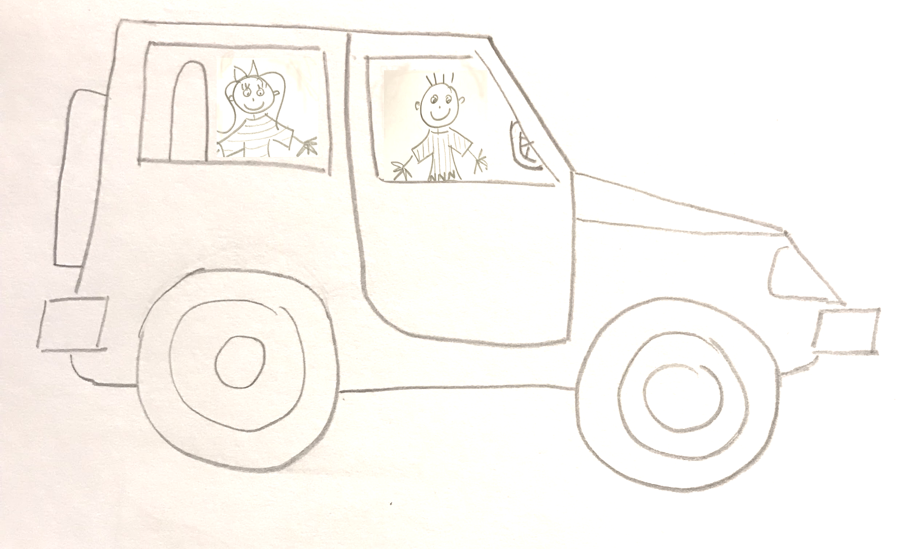 | travel
3 | !!! | very
4 | 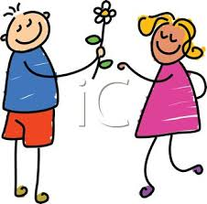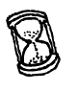 | gave
5 | 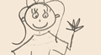 | wave
6 |  | have
7 | 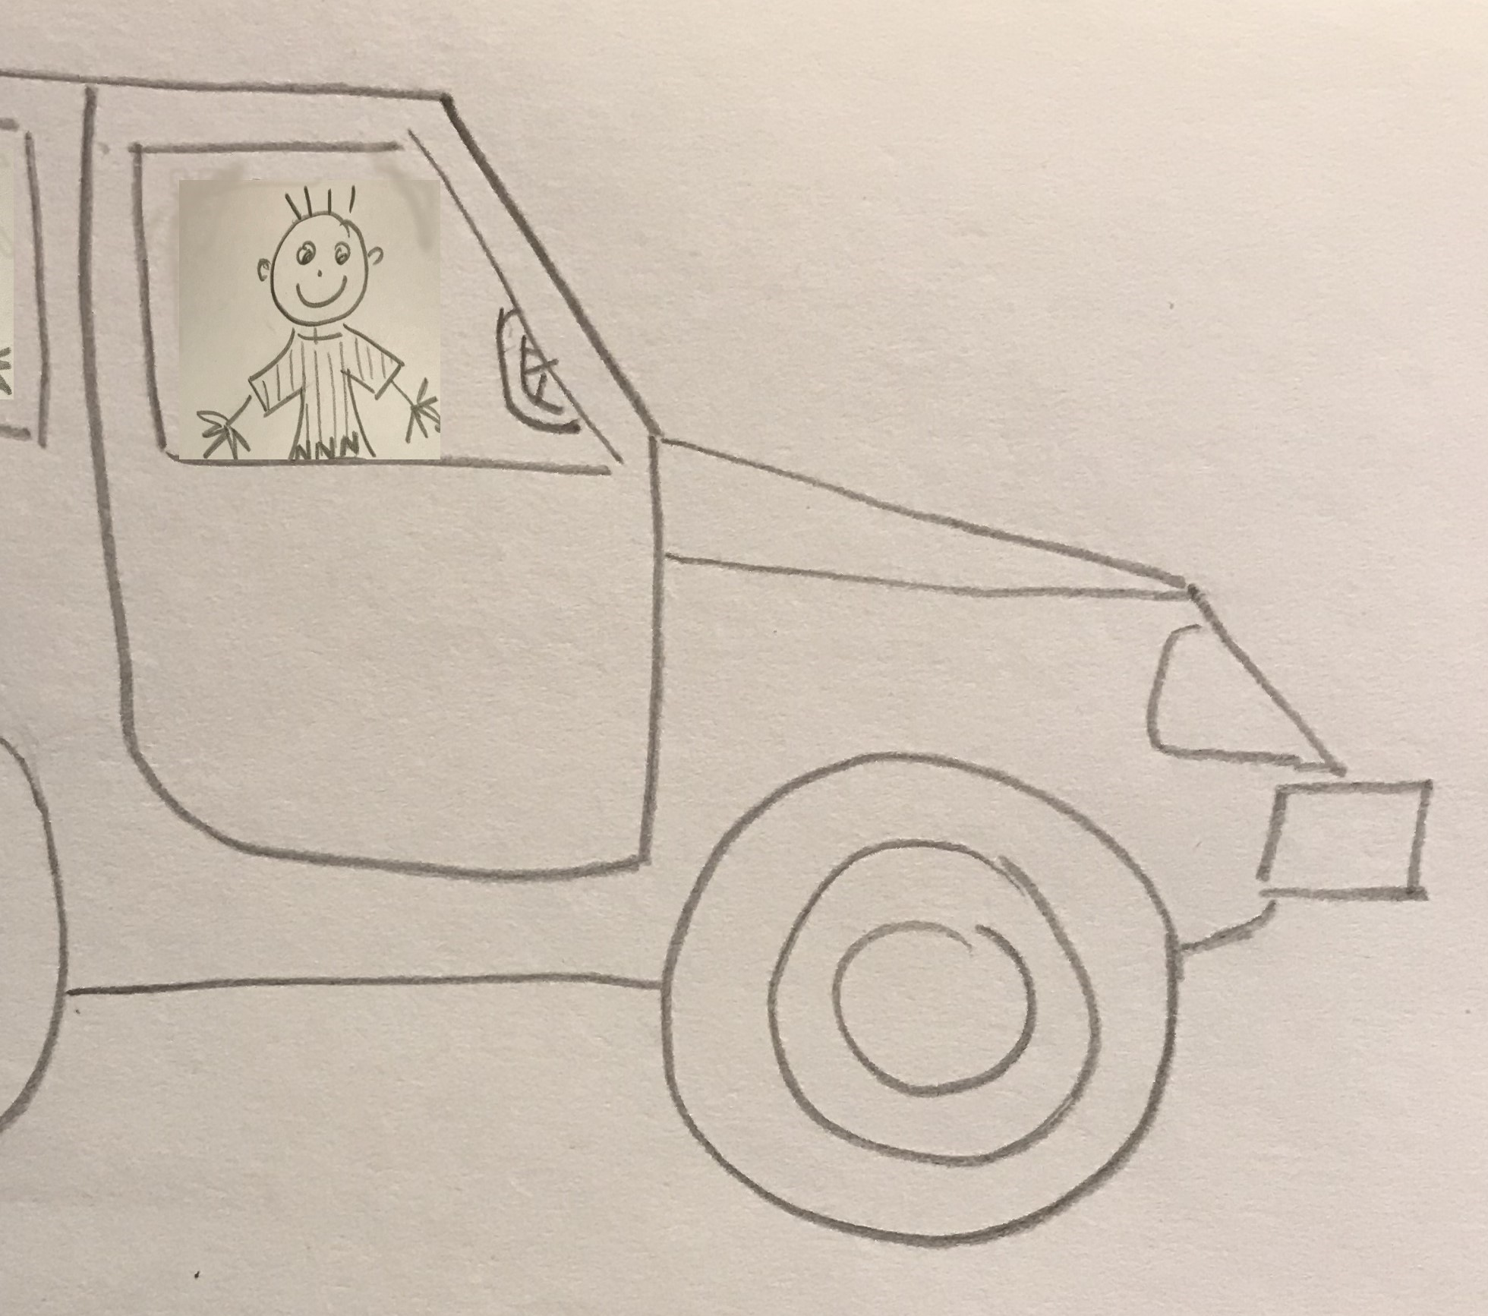 | drove
8 |  | evening
9 | 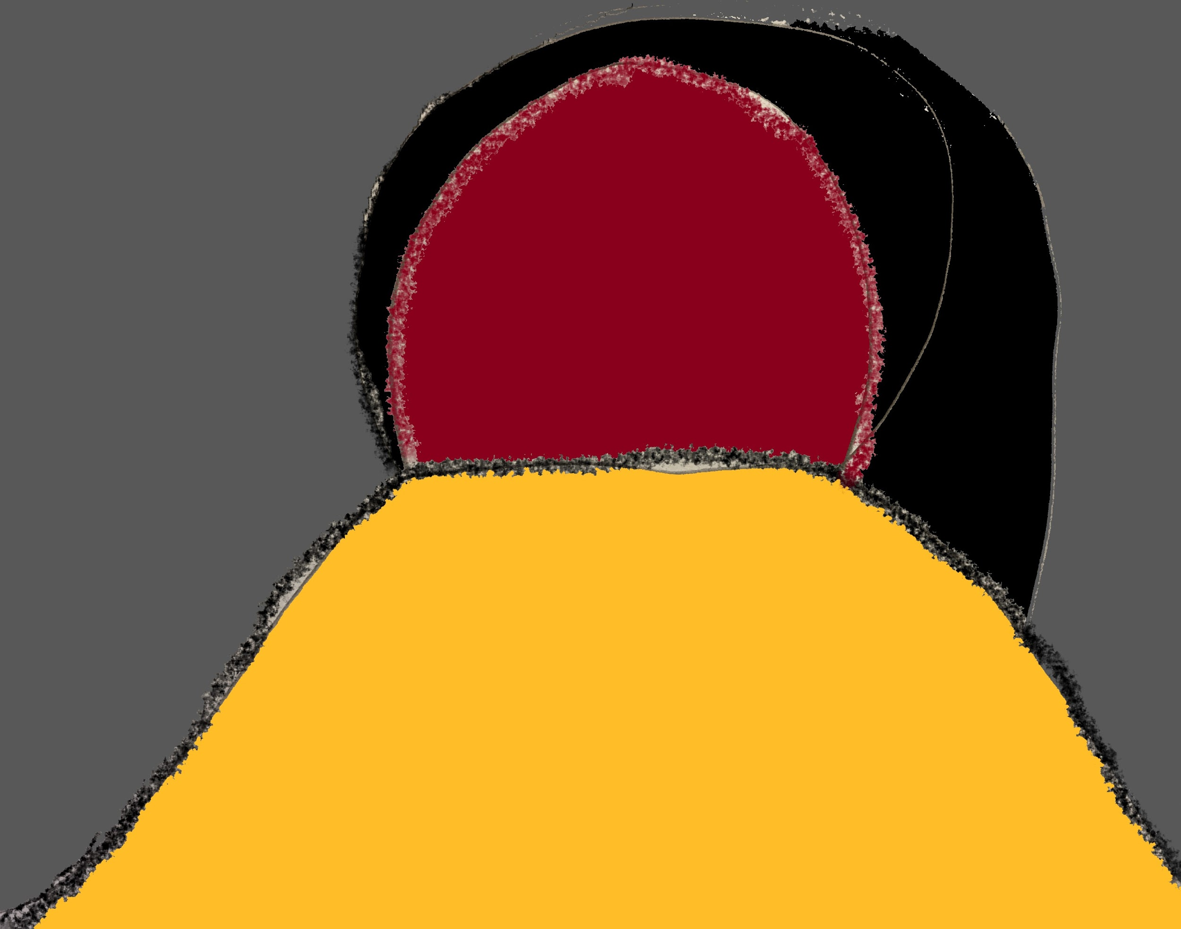 | cave
10 | 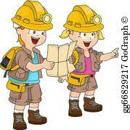 | adventure
11 | 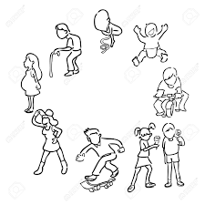 | live
12 | 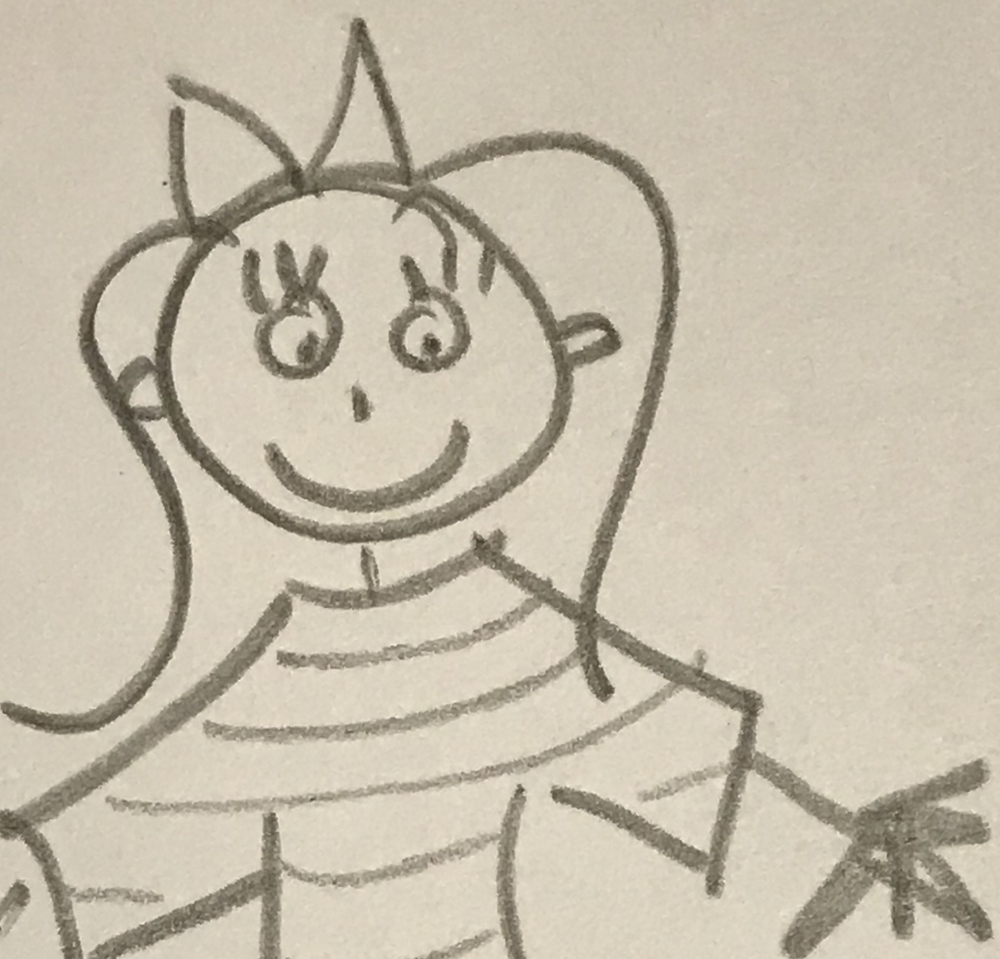 | Veronica
^{= past tense}
Board Game: Visit Nick’s Dad
Roll one dice. Move according to the number on the dice.
Start:  1  Nick and Veronica want to visit Dad. Dad lives in a cave. Have fun! | 2  Veronica spills milk in Nick’s car (move back one space) | 3 | 4  Nick hits a sand pit (move back one space) | 5  It’s women’s swim! Wave at the women!  (skip next turn)
10 | 9  Nick gave Veronica a kiss  (move ahead one space) | 8  Warning! Falling wall!  (roll dice again) | 7  They stop to swing in the evening.  (skip next turn) | 6  Nick and Veronica hurry!  (move ahead 4 spaces)
11 | 12  Veronica vomits!  (move back one space) | 13  Travel is fun!  (move ahead 5 spaces) | 14  Nick opens the window (roll dice again) | 15  Veronica closes the window (roll dice again)
20  Veronica smiles a wide smile (move ahead 4 spaces) | 19  A puppy in pajamas jumps in Nick’s car!  (roll dice again) | 18 | 17  Nick wants an adventure. Veronica wants to visit Dad! (skip next turn) | 16
21  Nick and Veronica have a puppy in the car  (skip next turn) | 22  Nick drives very well! (move ahead one space) | 23 | 24 | 25  Nick and Veronica drove to Dad’s cave!  ❤  End

