The Picnic in the Attic
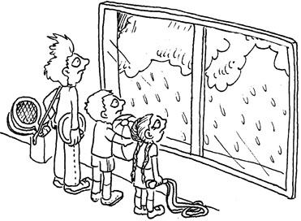  It is damp. The kids are sad.  They can’t picnic. | 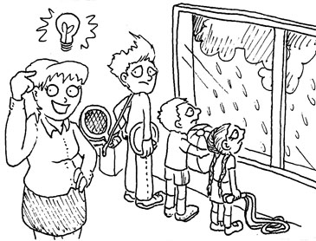  Nan didn’t panic.
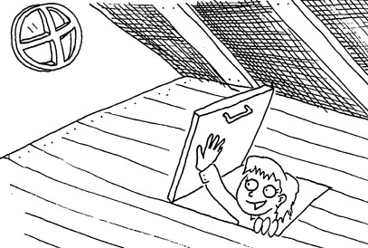  The attic isn’t damp! | 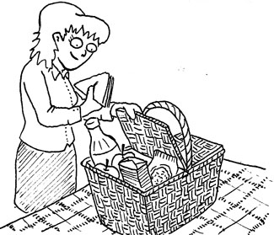  Nan packs a picnic basket.  She packs napkins and a snack.
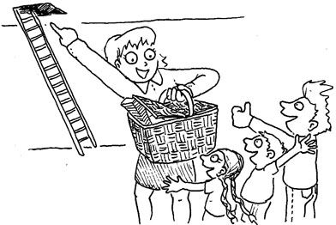  The kids aren’t sad. The picnic basket has a snack in it. | 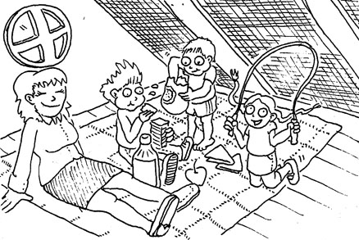  They had their picnic in the attic!

1 | 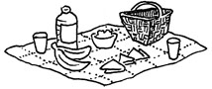 | picnic
2 | 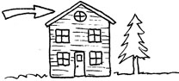 | attic
3 |  | panic
4 | 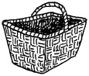 | basket
5 | 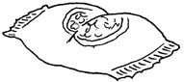 | snack
6 | 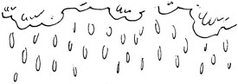 | damp
7 | 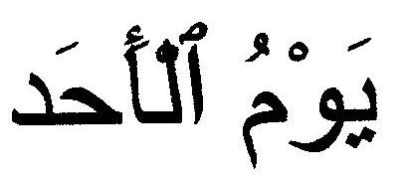 | Arabic
8 | 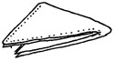 | napkin
9 | 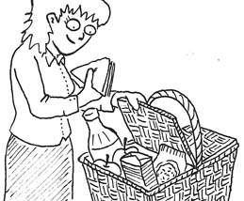 | pack
10 | 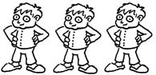 | kids
11 |  | sad
12 | 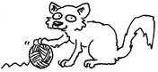 | kitten

Short Vowel Ladders
Preparation: Cut out and assemble the “dice” – each side has a short vowel sound. Copy the vowel ladder board, glue the two boards onto colored paper and cut out. You need 3 colored buttons or soldiers per player, one at the bottom of each ladder.
Play: Player rolls the dice and says the sound of the vowel that appears. Move the soldier one word up the ladder of that sound and read the word. (If the learner can give its meaning, she gets another turn.) BONUS: If the word contains –ck or –ic and she can explain the applicable rule, she gets a bonus turn. The first player to climb a ladder to the end wins.
Short Vowel Ladders
(ĭ) | (ă) | (ĕ)
panic | attic | them
napkin | yams | desk
picnic | backpack | best
stick | damp | red
rabbit | rabbit | yes
print | back | neck
kitten | ask | kitten
hid | stand | said
pick | sad | test
pin | crack | step

Short Vowel Dice:
Short Vowel Dice (vowels a, e, i): Cut out, fold on dotted lines, and glue outer side of flaps inside cube.
( ĭ ) ( ĕ ) ( ă )
( ĭ )

( ă )

( ĕ )

Think of other games to use this dice – example: roll it and say a word that contains that vowel sound.

