A Sleeping Bee
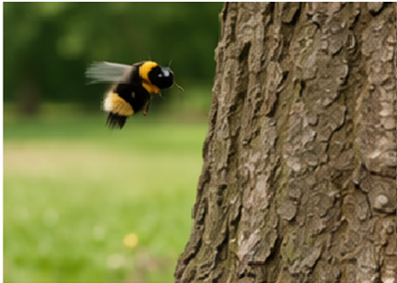  He sees a little bee.  “Buzz, buzz!” | 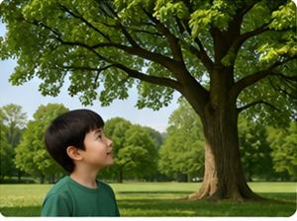  Lee is looking at a big,  green tree.
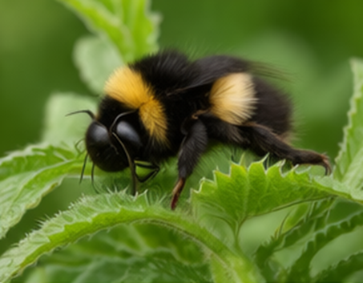  The bee needs to sleep.  It is a sleeping bee! | 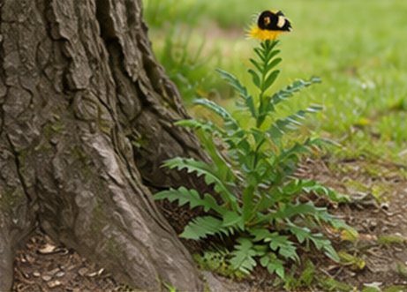  The bee lands on a  green weed. It is a  sweet weed.
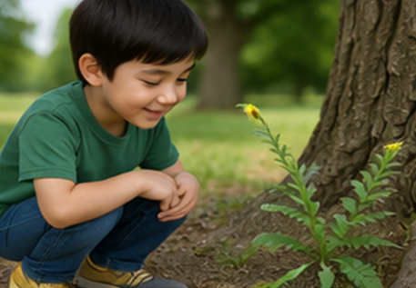  He is quiet. He lets the  bee sleep for the  rest of the week. | 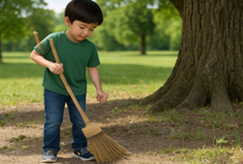  Lee starts to sweep. He keeps his feet back.

Word List
 | tree | 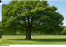 | 1
 | Lee |  | 2
 | week |  | 3
 | sweet |  | 4
 | sweep |  | 5
 | bee | 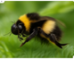 | 6
 | feet |  | 7
 | sleep |  | 8
 | green |  | 9
 | see |  | 10
 | keep |  | 11
 | weed |  | 12
Match each word to picture

Online game: https://wordwall.net/resource/111957445/hickey-lesson-35-ee

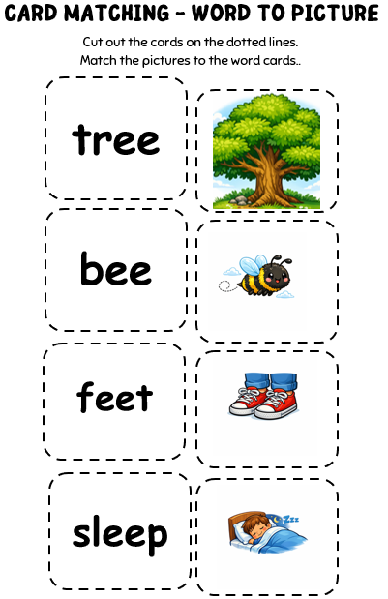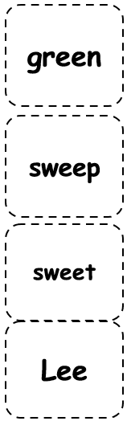
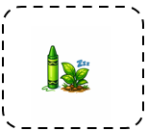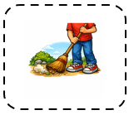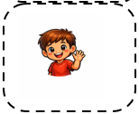

Made at https://canva.link/8qx1ues0l9sdf6a

