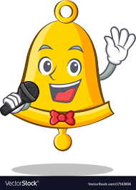
The Bell Tells
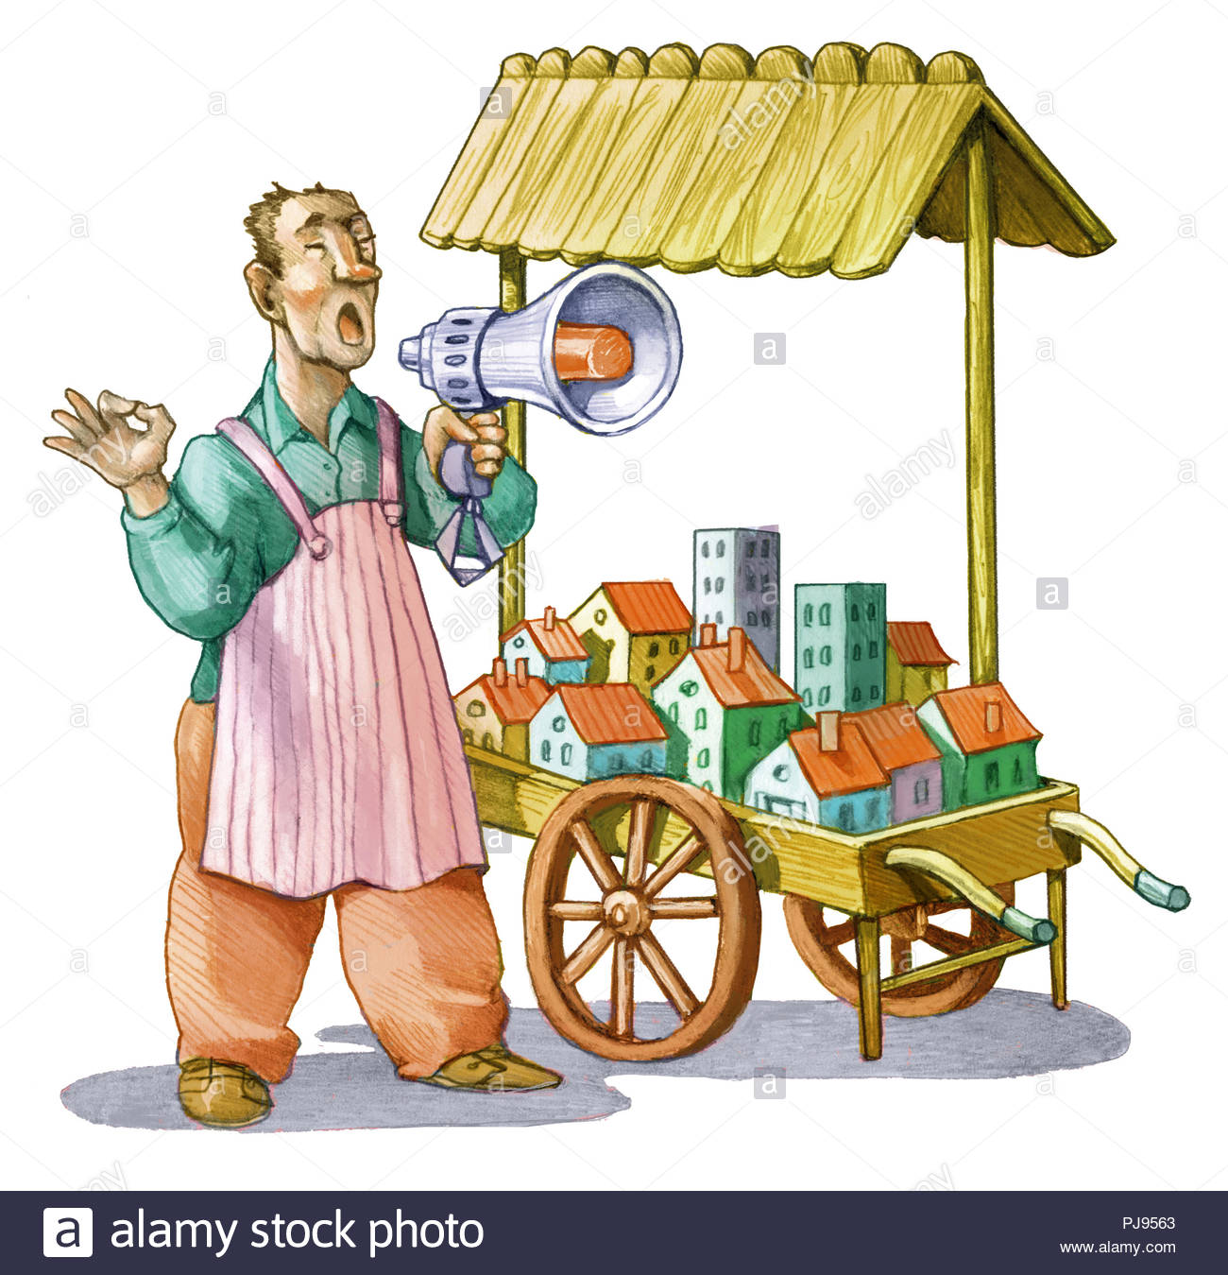  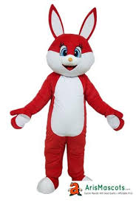  The bell tells, the bell tells all.  A tall man has a red rabbit.  Bell tells the man, “Sell it!” | 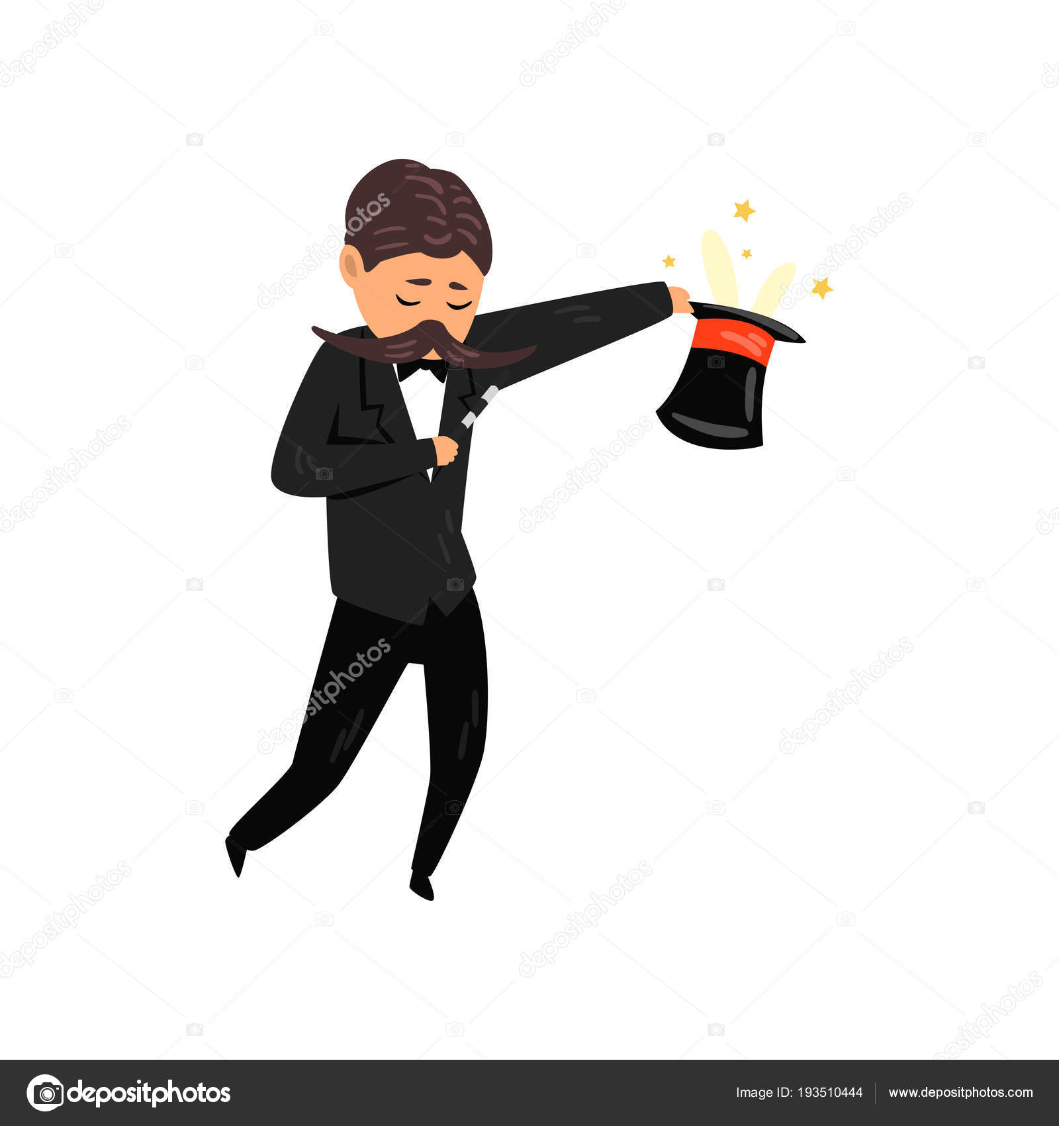    The man asks the bell, “Bell, this  man has a hat. Can I sell him the  red rabbit?” Bell said, ”This man’s  hat smells bad.”
Bell tells, Bell tells.  The tall man didn’t sell the rabbit. | 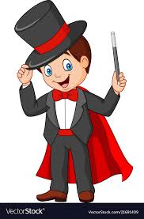  Bell tells, Bell tells.  The tall man asks, “Is this man’s  hat bad? Can I sell him the red  rabbit, Bell?”
  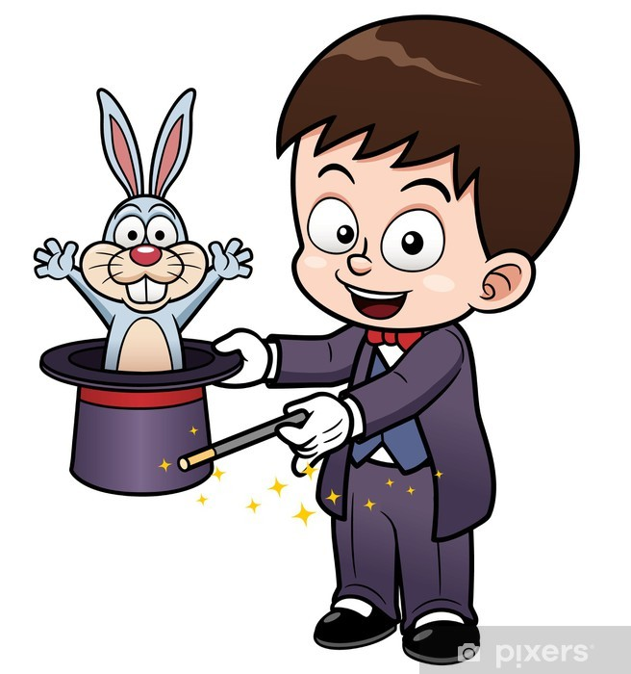  Yes, he isn’t ill,  and his hat isn’t small,  Bell said, ”I yell, sell!” | Bell tells, Bell tells. The red rabbit  has a hat and can rest in it.

Word List
1 | 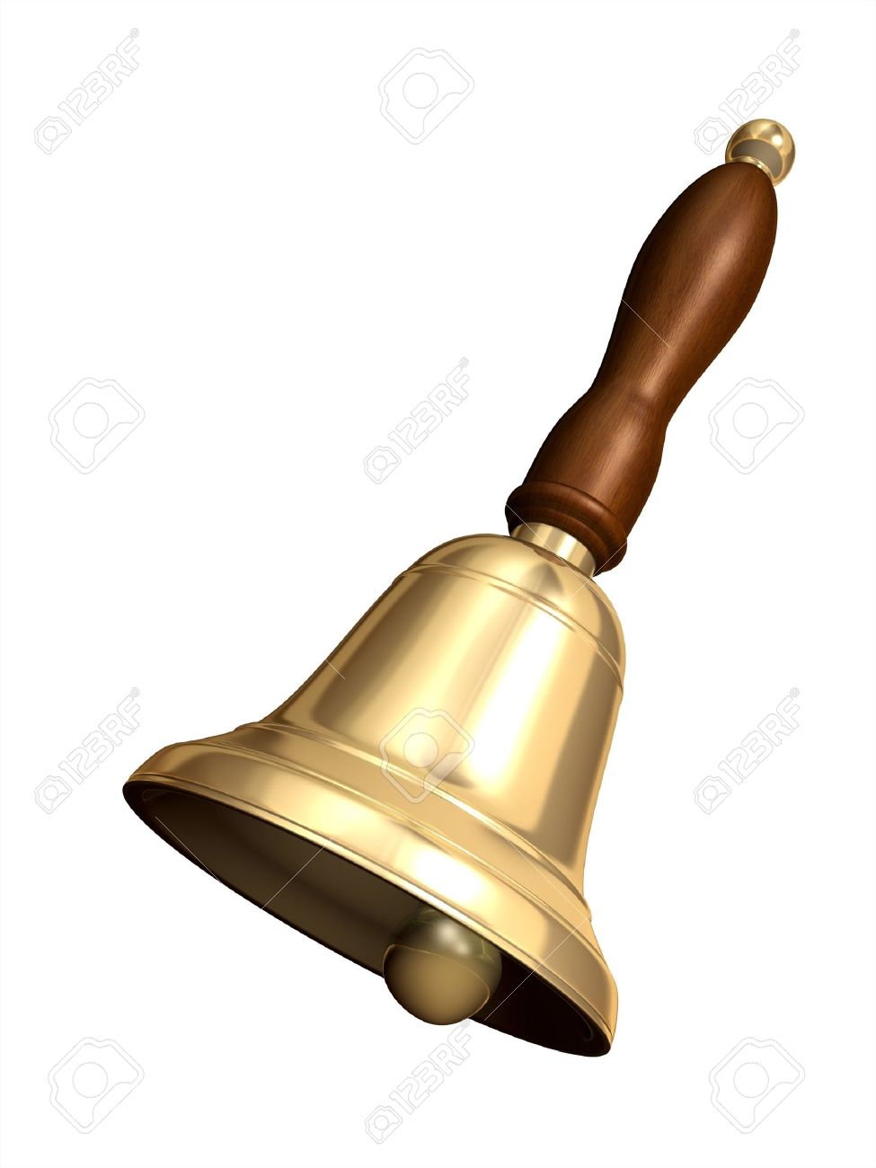 | Bell
2 |  | man
3 | 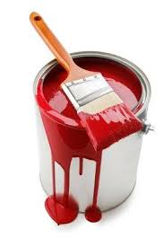 | red
4 |  | tell
5 |  | rabbit
6 |  | hat
7 |  | sell
8 |  | yell
9 | 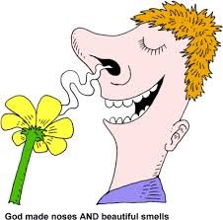 | smell
10 |  | little
11 |  | ill
12 | 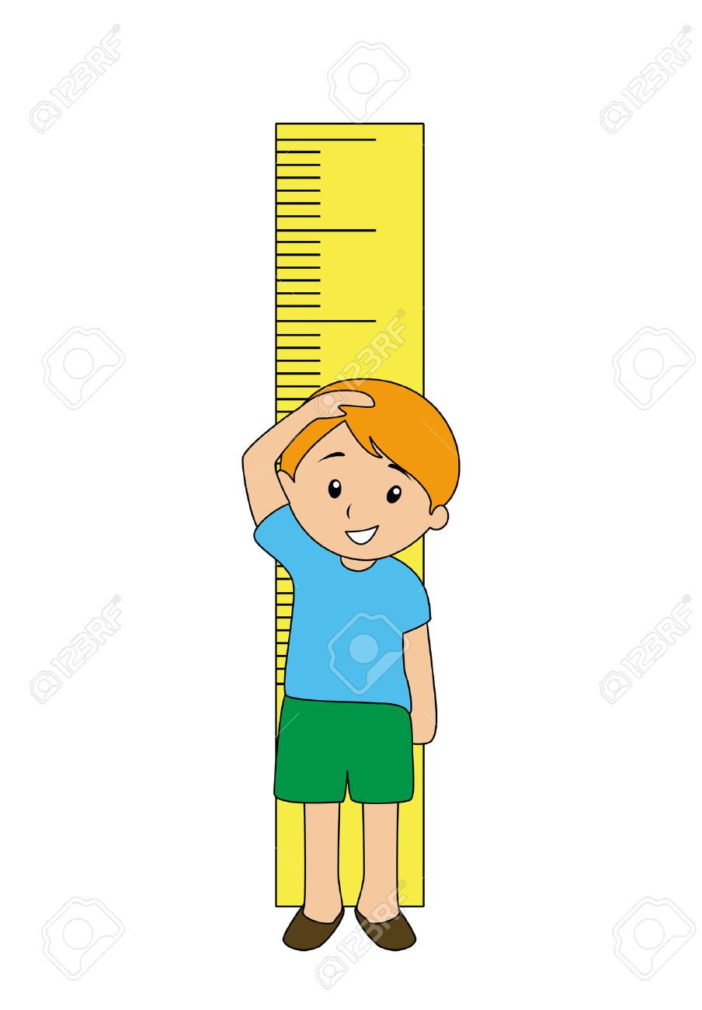 | tall

Game: Special Bingo game
Instructions- There is an empty blue space in the Bingo card, that can be filled by students drawing or by writing the missing word.

 | smell | man
 |  | yell
tell | hat | tall
sell |  | rabbit

smell |  | little
 | ill
tell
red | rabbit

