A Light in the Night
 | 
Dwight was awake very late at night,  He wondered why the light was so bright. | The light came from high, up in the sky.  He took a flashlight and went to see why.
 | 
"I might see something from the top of the hill, from the highest spot, oh what a thrill!" | "Look! There it is! Lights so bright in the night. A spaceship rocket, what a wonderful sight!"

He smiled at the bright lights, high in the sky. "What a perfect sight", he said with a sigh.
Word List
1 |  | Dwight
2 |  | night
3 |  | light
4 |  | bright
5 | 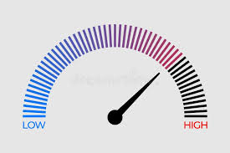 | high
6 | 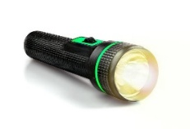 | flashlight
7 |  | might
8 |  | highest
9 |  | sight
10 |  | sigh
11 |  | awake
12 |  | smiled

Online games: https://wordwall.net/resource/111727668
https://wordwall.net/resource/112145471

Word Sort
Spellings of the sound ( ī ) we have learned

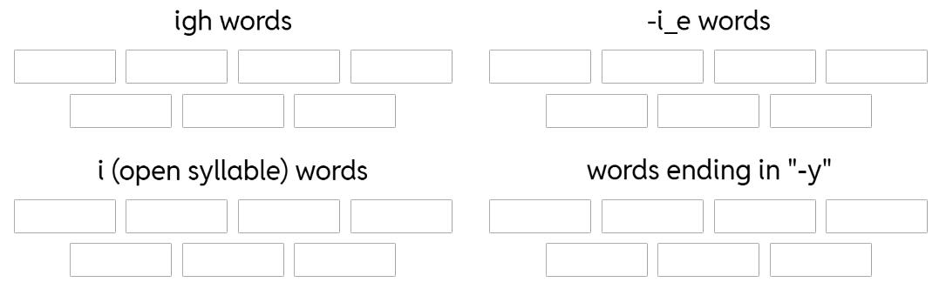
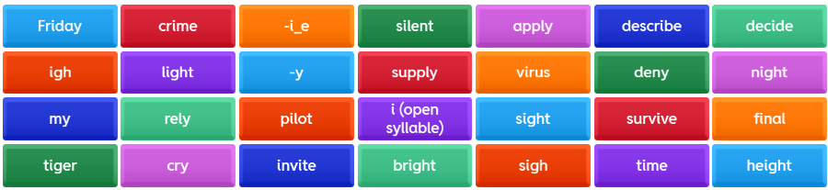

Cut up the words cards. Learner reads them aloud and places them in the right category (and discusses meaning).
Bonus question: Do you know another way to write the sound ( ī )?
Usually, -y makes the sound ( ī ) at the end of one-syllable words (by, cry, my, dry, spy etc.)
and the sound ( ē ) at the end of words with more than one syllable (happy, baby, pretty, candy, silly, etc.).
Here we have some exceptions to that pattern: rely, deny, supply, apply, deny.

