Tin-Tin
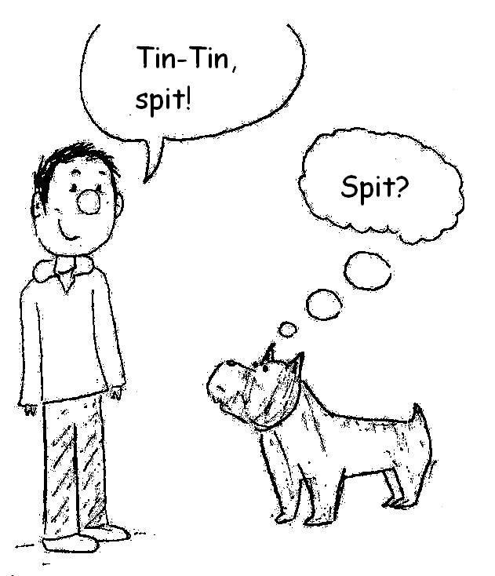 | 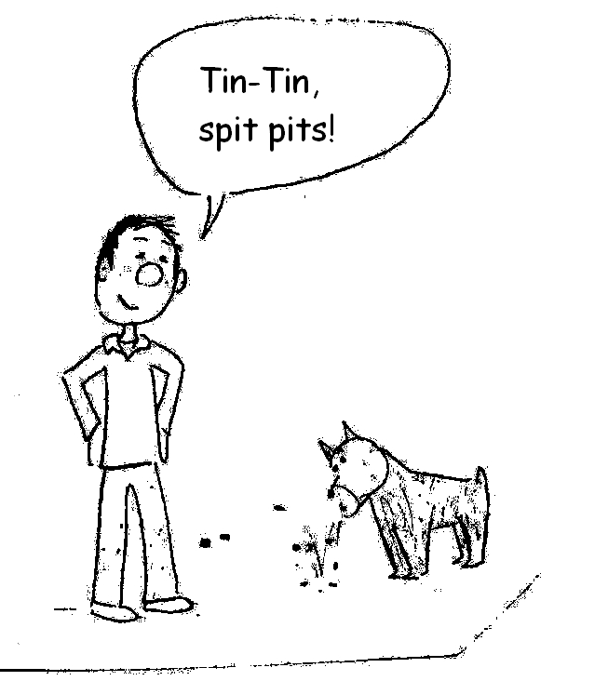  Tin-Tin spits pits.
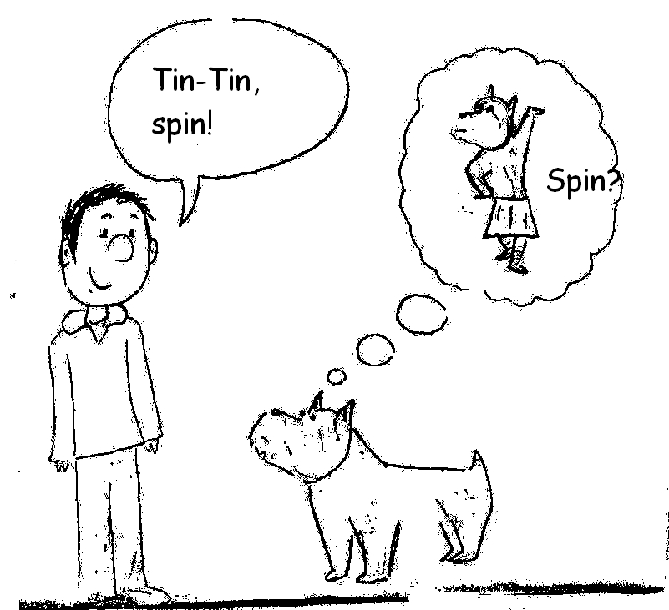 | 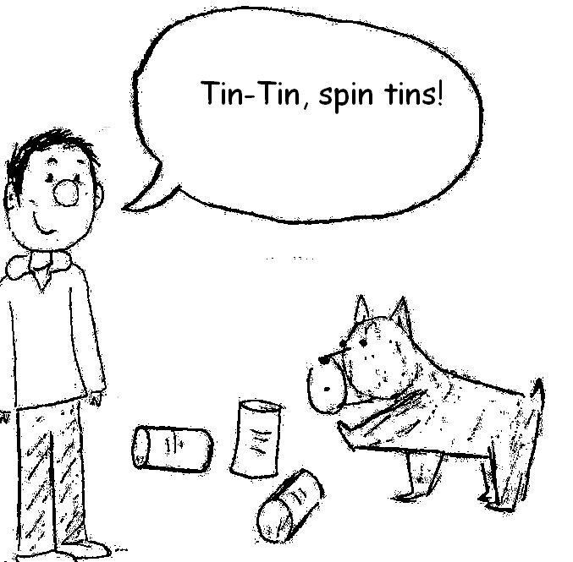  Tin-Tin spins tins.
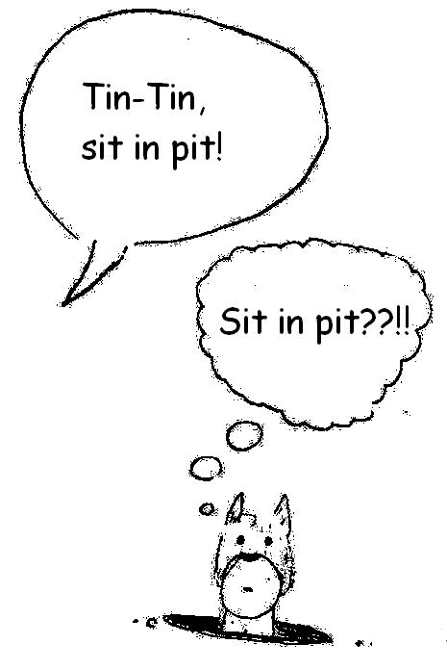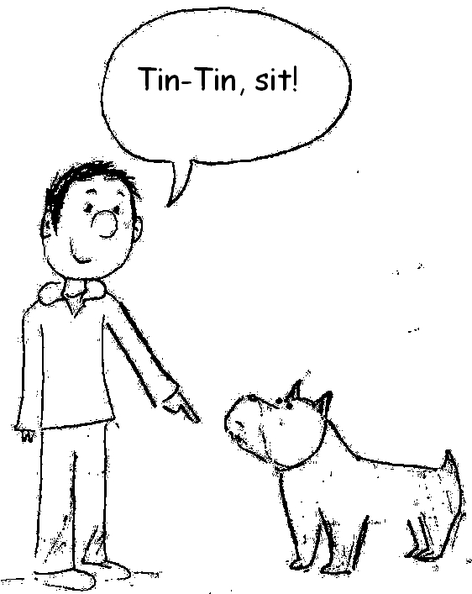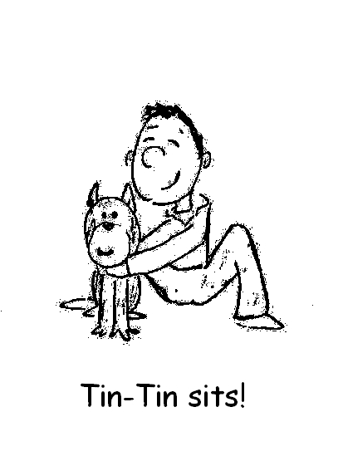

Word List
1 | 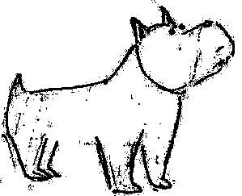 | Tin Tin
2 | 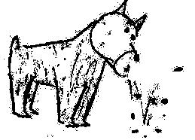 | spit
3 | 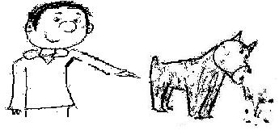 | spits
4 | 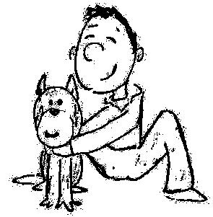 | sit
5 | 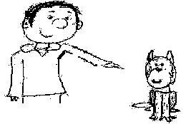 | sits
6 | 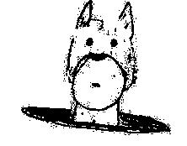 | in pit
7 |  | pit
8 |  | pits
9 | 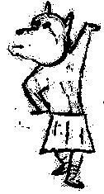 | spin
10 | 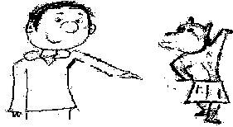 | spins
11 | 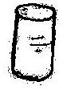 | tin
12 | 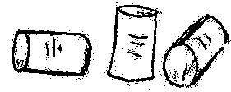 | tins

Build-the-Words Game

Goal: Collect all the letters of the words to receive a smiley card. Whoever receives the most smiley cards is the winner.

Instructions:

Equipment – pile of cards with single letters
10 T cards
10 P cards
10 I cards
10 S cards
10 N cards

1 game board per player
16 smiley cards

Each turn a player picks up a letter card and places the letter card on his game board to spell a word.

Any player who completes a word receives a smiley card.

The player with the most smiley cards is the winner.

Letter cards and smiley cards: laminate and cut out these cards and the ones on the page following the game board.

s | s | s | s | s | s | s
s | s | s

Print and laminate two copies of the game board on the next page, one for each player.
Build-the-Words Game Board

Tin-Tin in

pit spins

pits tins

sit spits

☺ | ☺ | ☺ | ☺ | ☺ | ☺ | ☺ | ☺
☺ | ☺ | ☺ | ☺ | ☺ | ☺ | ☺ | ☺
i | i | i | i | i | i | i | i
i | i | t | t | t | t | t | t
t | t | t | t | p | p | p | p
p | p | p | p | p | p | n | n
n | n | n | n | n | n | n | n

