Giraffes and a Gypsy at the Zoo
On Wednesday I went by van on a family trip to the zoo.  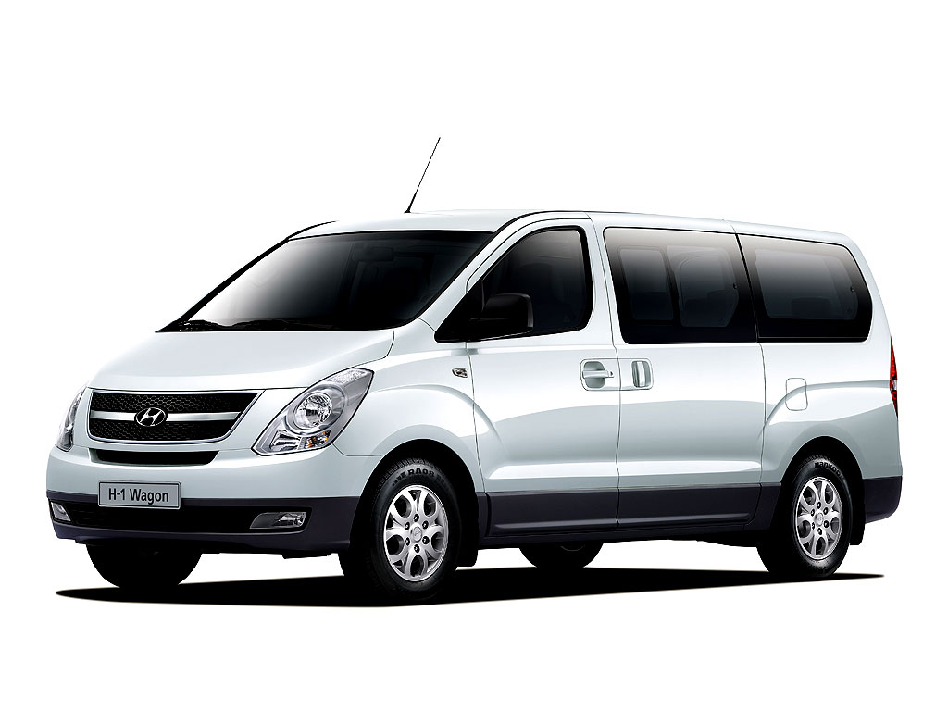 | It was a hot day. The gypsy selling tickets at the entrance had a hat.  
I looked at the zebra drinking water,  a giant lion in a cage  and the gentle gorillas.  One was in a tree.  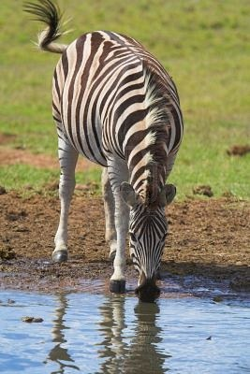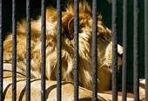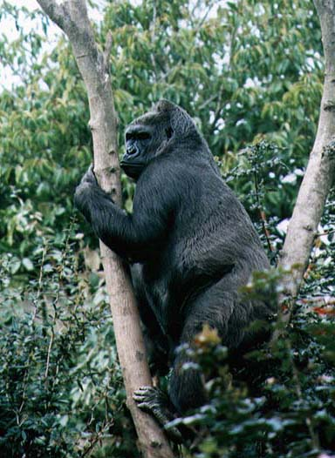 | We went on to see the giraffes. The giraffe is 18 feet tall with a long neck and horns. He stands when he sleeps.  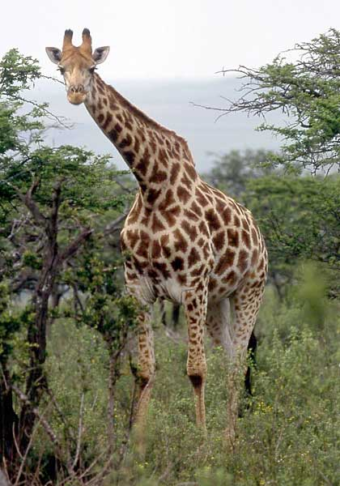
There was also a baby giraffe.  Baby giraffes are born 6 feet tall and are in their mothers for 15 months.  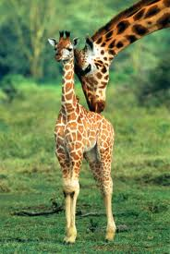 | We had a picnic. I had a falafel, pizza and an orange. We went home.  I had a good day!  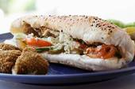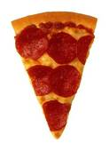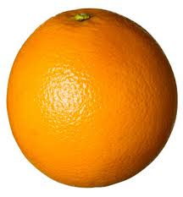
Word List
1 | 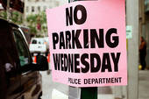 | Wednesday
2 | 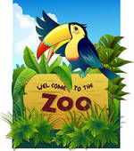 | zoo
4 |  | van
5 |  | zebra
6 | 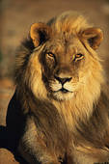 | lion
7 |  | giraffe
8 |  | cage
9 | 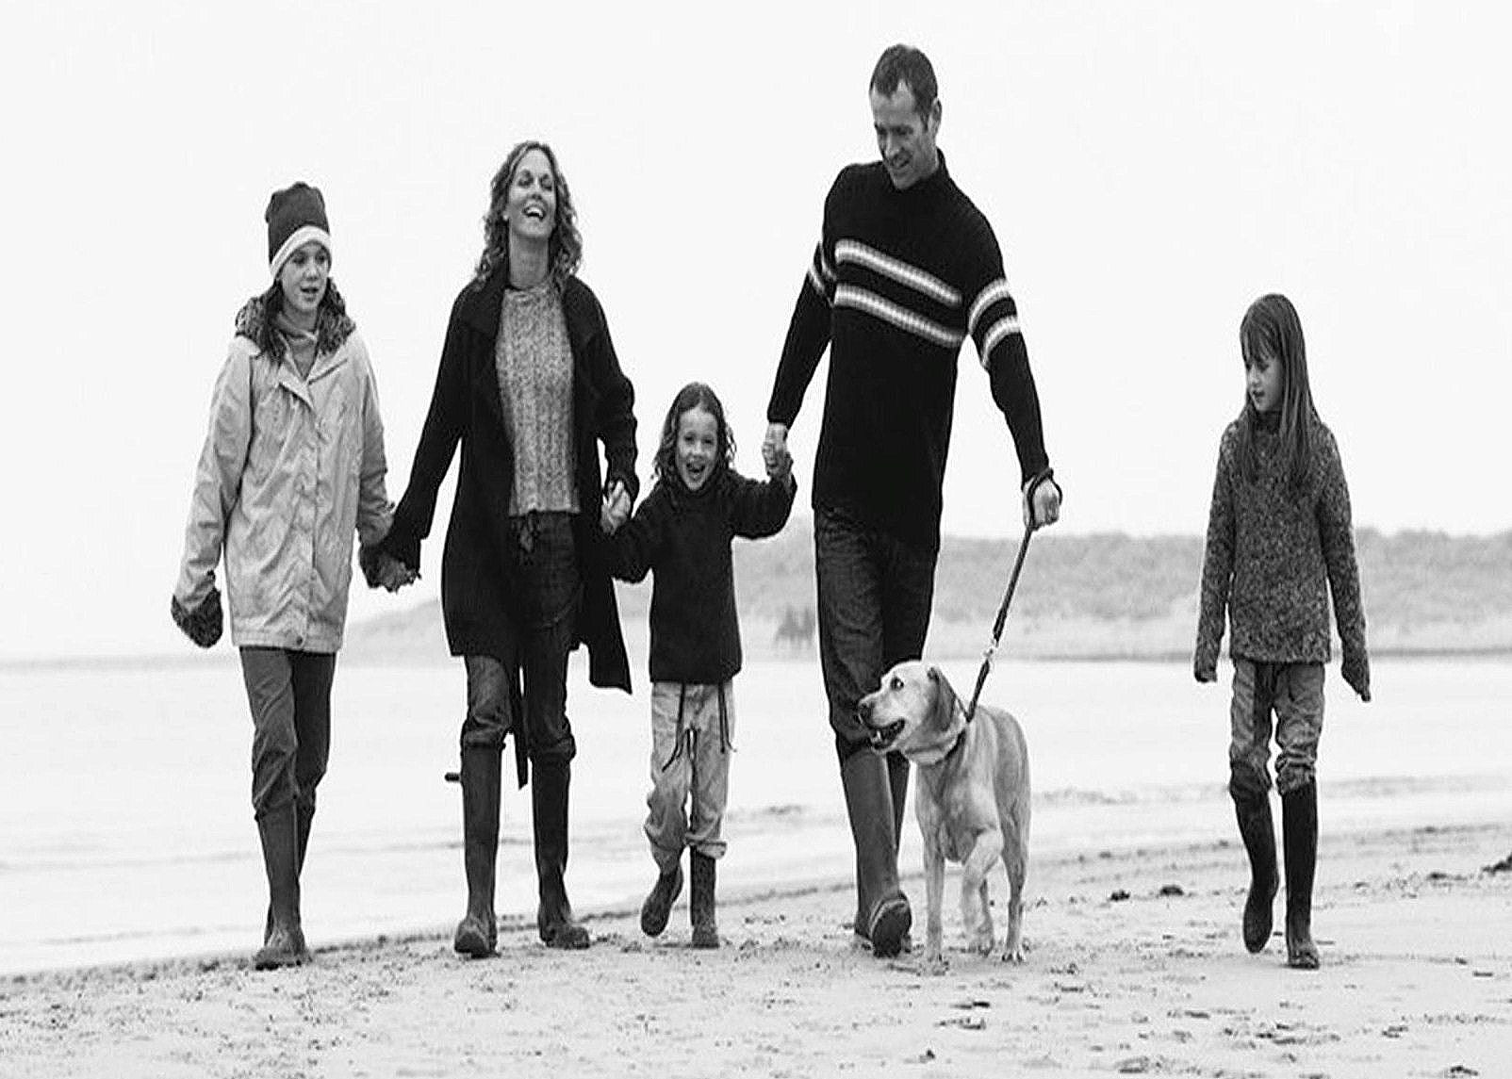 | family
10 |  | orange
11 |  | gypsy
12 |  | gorilla
FRUSTRATION GAME with Words and Categories
Preparation: Color in the four "home bases" on the game board. Laminate (optional) the game board and the Categories board and Word cards and cut out the individual word cards.
You need to have 4 "soldiers" of the same color per player. Each player's soldiers are a different color to match his home base. (If you have a limited amount of time use one soldier per player.)
Rules of Play
Place the soldier(s) on the home bases. The laminated word cards are placed face down or in a bag. The learner has to choose a word, read it and then spell it from memory. If the learner is successful, the learner moves his piece (around the board from home to home) the number on the card. If the student falls on a piece where the tutor is standing (or vice versa) the tutor gets sent home. The player who reaches his home first is the winner.
Optional additional component to reinforce the meaning of the words: Use the "categories" board to store the already-read word in the right category row after reading it (you might need to give hints).

PLAYER1 | HOME |  |  | PLAYER 2 | HOME
 | PLAYER 3 |  |  | PLAYER 4 | HOME
HOME

Laminate, cut out these word cards and keep them in a bag for players to choose from.
1  zebra | 2  deer | 3  dog | 4  gorilla | 5  lion | 6  giraffe
1  orange | 2  celery | 3  mango | 4  banana | 5  pizza | 6  falafel
1  car | 2  plane | 3  bike | 4  motorbike | 5  van | 6  bus
1  neck | 2  arm | 3  leg | 4  back | 5  horns | 6  finger
1  mother | 2  father | 3  brother | 4  sister | 5  grandmother | 6  grandfather
1  cage | 2  zoo | 3  gypsy | 4  tall | 5  long | 6  fat

Categories | Words in this Category
Animals
Fruits
Vehicles
Body
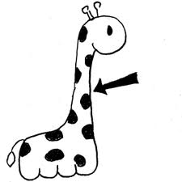
Family
Other

