New York Times: SCIENCE

What’s Lost as Handwriting Fades
By MARIA KONNIKOVA JUNE 2, 2014
Photo
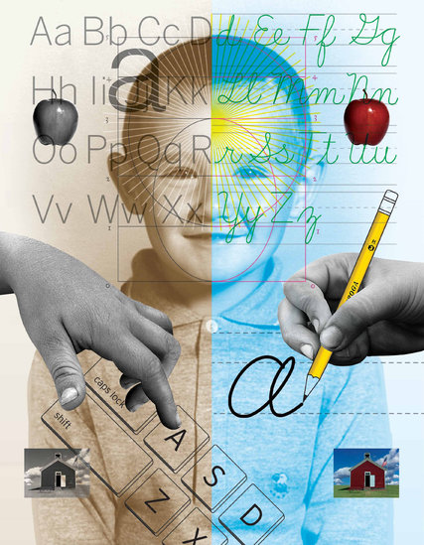
Credit Michael Mabry
Does handwriting matter?
Not very much, according to many educators. The Common Core standards, which have been adopted in most states, call for teaching legible writing, but only in kindergarten and first grade. After that, the emphasis quickly shifts to proficiency on the keyboard.
But psychologists and neuroscientists say it is far too soon to declare handwriting a relic of the past. New evidence suggests that the links between handwriting and broader educational development run deep.
Children not only learn to read more quickly when they first learn to write by hand, but they also remain better able to generate ideas and retain information. In other words, it’s not just what we write that matters — but how.
“When we write, a unique neural circuit is automatically activated,” saidStanislas Dehaene, a psychologist at the Collège de France in Paris. “There is a core recognition of the gesture in the written word, a sort of recognition by mental simulation in your brain.
“And it seems that this circuit is contributing in unique ways we didn’t realize,” he continued. “Learning is made easier.”
A 2012 study led by Karin James, a psychologist at Indiana University, lent support to that view. Children who had not yet learned to read and write were presented with a letter or a shape on an index card and asked to reproduce it in one of three ways: trace the image on a page with a dotted outline, draw it on a blank white sheet, or type it on a computer. They were then placed in a brain scanner and shown the image again.
The researchers found that the initial duplication process mattered a great deal. When children had drawn a letter freehand, they exhibited increased activity in three areas of the brain that are activated in adults when they read and write: the left fusiform gyrus, the inferior frontal gyrus and the posterior parietal cortex.
By contrast, children who typed or traced the letter or shape showed no such effect. The activation was significantly weaker.
Dr. James attributes the differences to the messiness inherent in free-form handwriting: Not only must we first plan and execute the action in a way that is not required when we have a traceable outline, but we are also likely to produce a result that is highly variable.
That variability may itself be a learning tool. “When a kid produces a messy letter,” Dr. James said, “that might help him learn it.”
“This is one of the first demonstrations of the brain being changed because of that practice,” Dr. James said.
In another study, Dr. James is comparing children who physically form letters with those who only watch others doing it. Her observations suggest that it is only the actual effort that engages the brain’s motor pathways and delivers the learning benefits of handwriting.
The effect goes well beyond letter recognition. In a study that followed children in grades two through five, Virginia Berninger, a psychologist at the University of Washington, demonstrated that printing, cursive writing, and typing on a keyboard are all associated with distinct and separate brain patterns — and each results in a distinct end product. When the children composed text by hand, they not only consistently produced more words more quickly than they did on a keyboard, but expressed more ideas. And brain imaging in the oldest subjects suggested that the connection between writing and idea generation went even further. When these children were asked to come up with ideas for a composition, the ones with better handwriting exhibited greater neural activation in areas associated with working memory — and increased overall activation in the reading and writing networks.
Photo
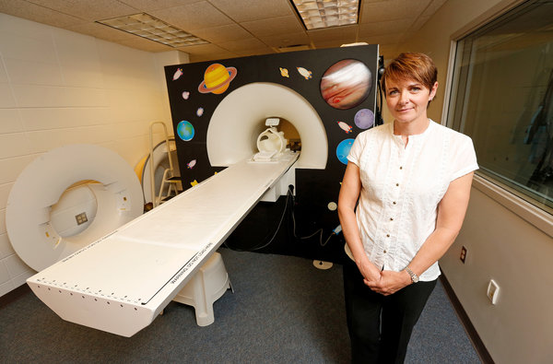
Karin James, a psychologist at Indiana University, used a scanner to see how handwriting affected activity in children’s brains. CreditA. J. Mast for The New York Times

It now appears that there may even be a difference between printing and cursive writing — a distinction of particular importance as the teaching of cursive disappears in curriculum after curriculum. In dysgraphia, a condition where the ability to write is impaired, sometimes after brain injury, the deficit can take on a curious form: In some people, cursive writing remains relatively unimpaired, while in others, printing does.
In alexia, or impaired reading ability, some individuals who are unable to process print can still read cursive, and vice versa — suggesting that the two writing modes activate separate brain networks and engage more cognitive resources than would be the case with a single approach.
Dr. Berninger goes so far as to suggest that cursive writing may train self-control ability in a way that other modes of writing do not, and some researchers argue that it may even be a path to treating dyslexia. A 2012 review suggests that cursive may be particularly effective for individuals with developmental dysgraphia — motor-control difficulties in forming letters — and that it may aid in preventing the reversal and inversion of letters.
Photo
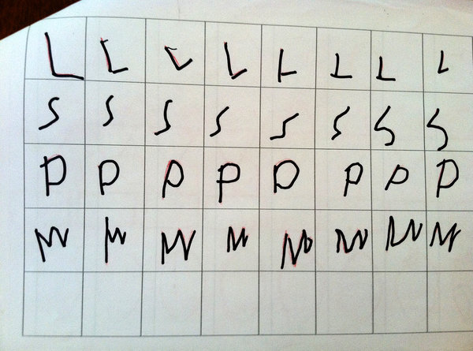
Samples of handwriting by young children. Dr. James found that when children drew a letter freehand, they exhibited increased activity in three significant areas of the brain, which didn’t happen when they traced or typed the letter. Credit Karin James

Cursive or not, the benefits of writing by hand extend beyond childhood. For adults, typing may be a fast and efficient alternative to longhand, but that very efficiency may diminish our ability to process new information. Not only do we learn letters better when we commit them to memory through writing, memory and learning ability in general may benefit.
Two psychologists, Pam A. Mueller of Princeton and Daniel M. Oppenheimer of the University of California, Los Angeles, have reportedthat in both laboratory settings and real-world classrooms, students learn better when they take notes by hand than when they type on a keyboard. Contrary to earlier studies attributing the difference to the distracting effects of computers, the new research suggests that writing by hand allows the student to process a lecture’s contents and reframe it — a process of reflection and manipulation that can lead to better understanding and memory encoding.
Not every expert is persuaded that the long-term benefits of handwriting are as significant as all that. Still, one such skeptic, the Yale psychologistPaul Bloom, says the new research is, at the very least, thought-provoking.
“With handwriting, the very act of putting it down forces you to focus on what’s important,” he said. He added, after pausing to consider, “Maybe it helps you think better.”
Maria Konnikova is a contributing writer for The New Yorker online and the author of “Mastermind: How to Think Like Sherlock Holmes.”
A version of this article appears in print on June 3, 2014, on page D1 of the New York edition with the headline: What’s Lost as Handwriting Fades.

RELATED IN OPINION

Room for Debate: Is Cursive Dead? APRIL 30, 2013

Our brain must understand that each possible iteration of, say, an “a” is the same, no matter how we see it written. Being able to decipher the messiness of each “a” may be more helpful in establishing that eventual representation than seeing the same result repeatedly.
Audio

Podcast: Your Brain on Cursive, Google Glass Operation, Tattoos for Healing 24:43
Play
Handwriting is being dropped in public schools — that could be bad for young minds. Google’s new hands-free computer is finding its way into operating rooms. Breast cancer survivors find the start of their new lives in a tattoo artist’s work.
Subscribe to the Podcast » David Corcoran, Kassie Bracken and Jeffery DelViscio

