Lesson 34, Target letter Qu by: C. Rivera and K. Bergman. Illustrated by Z. Bergman
The King Wants Quiet
The king wants a quiet, tranquil place to swim. He went to a pond.  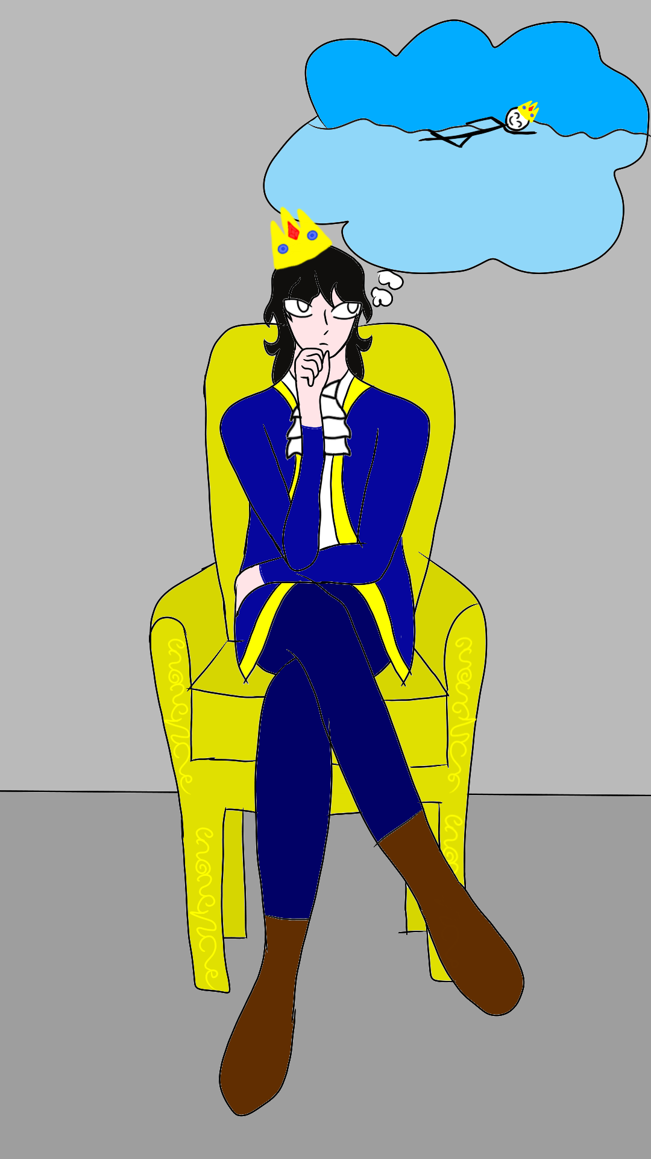 | A flock of ducks were singing and splashing. They toss rings and hit balls with square rackets.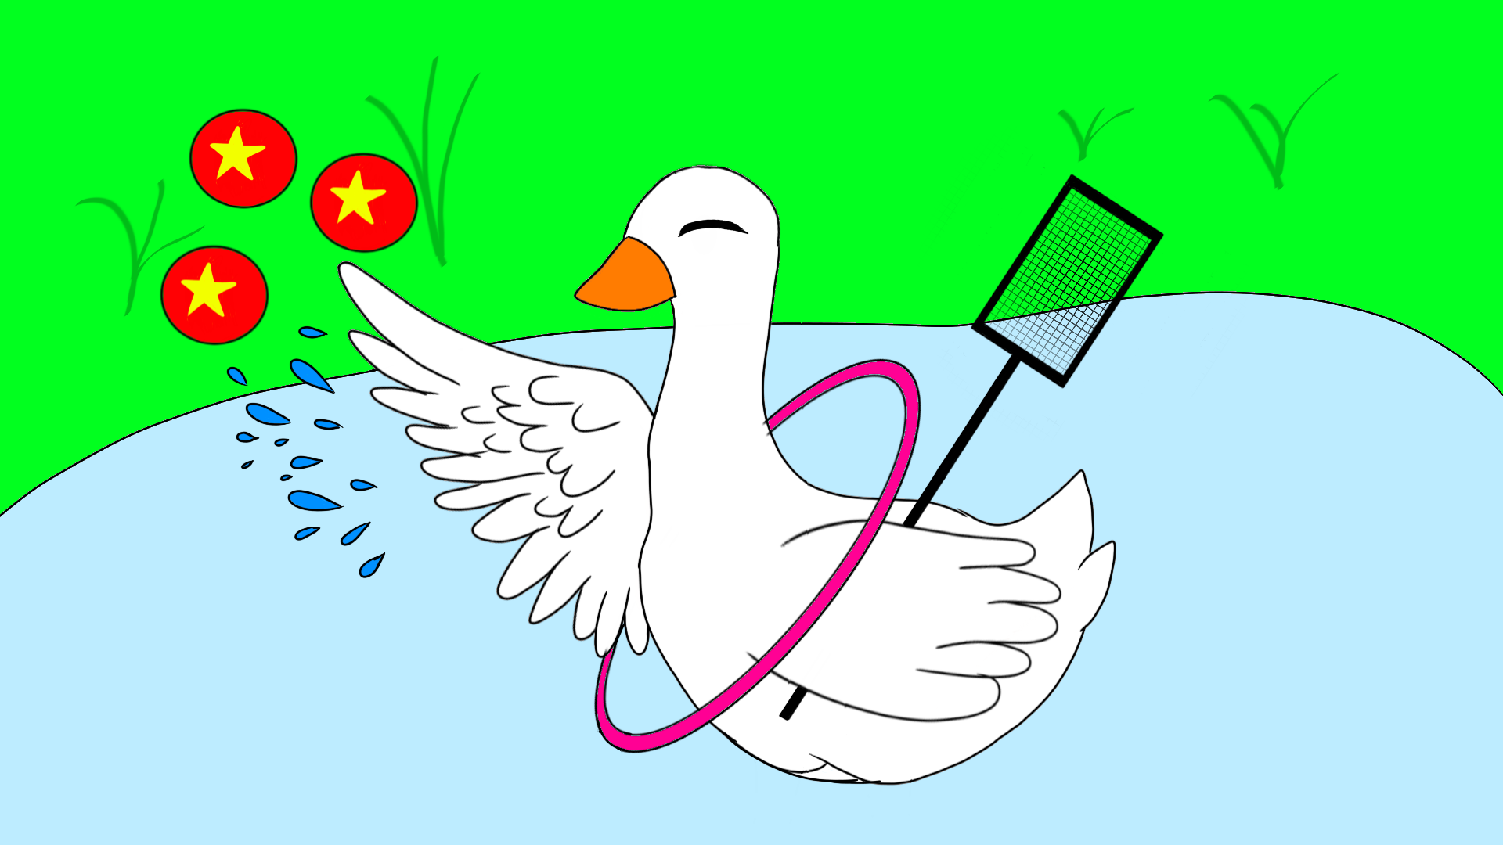
“Quack, quack, quack” they sing. They are quite happy.  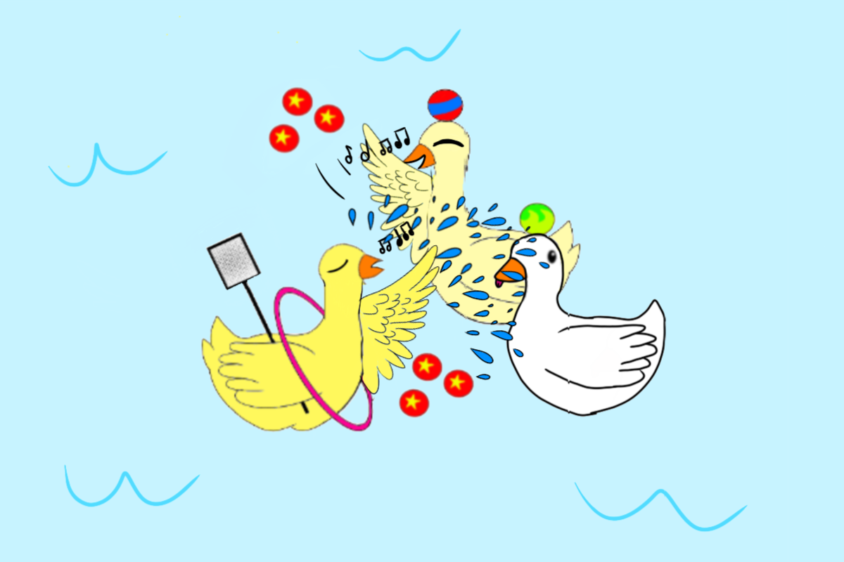 | But the king tells them to quit. “I require quiet quality time,” he commands.  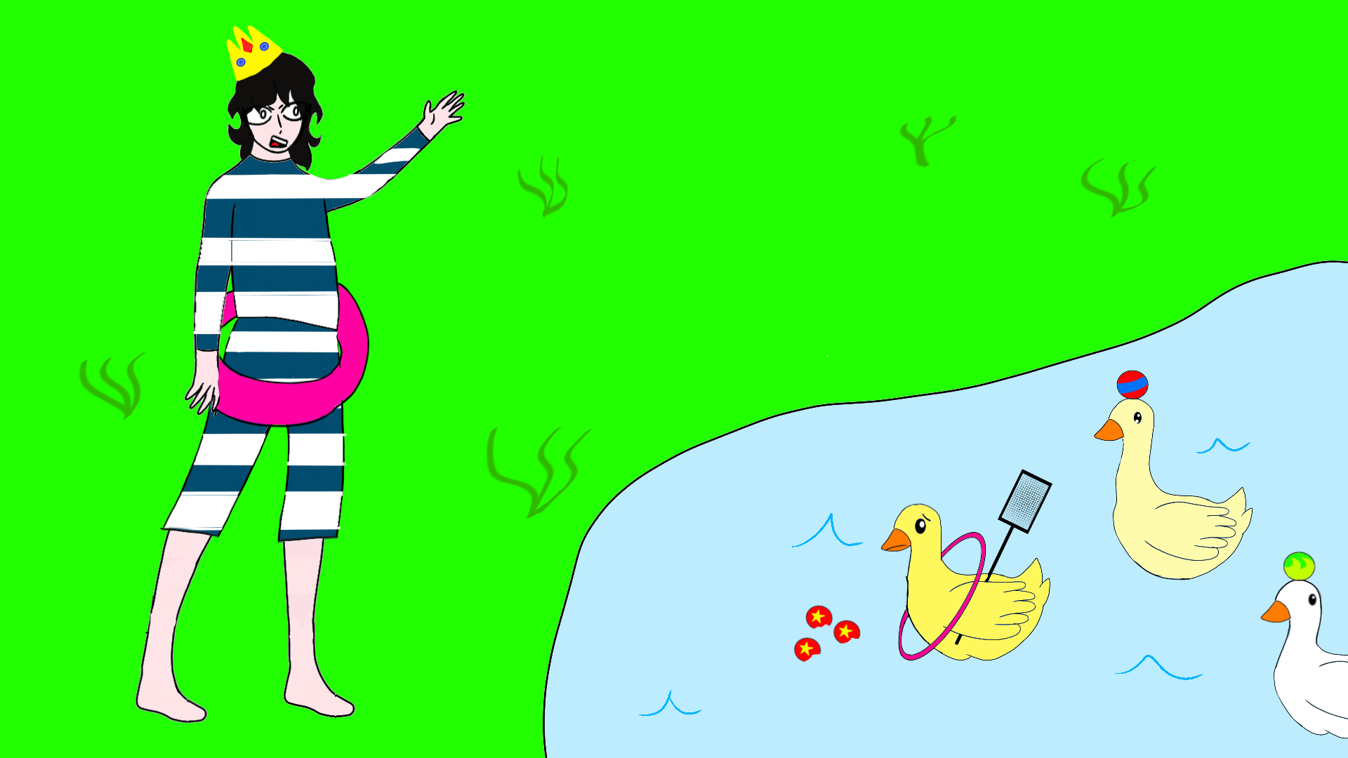
Quickly the ducks listen to his request.  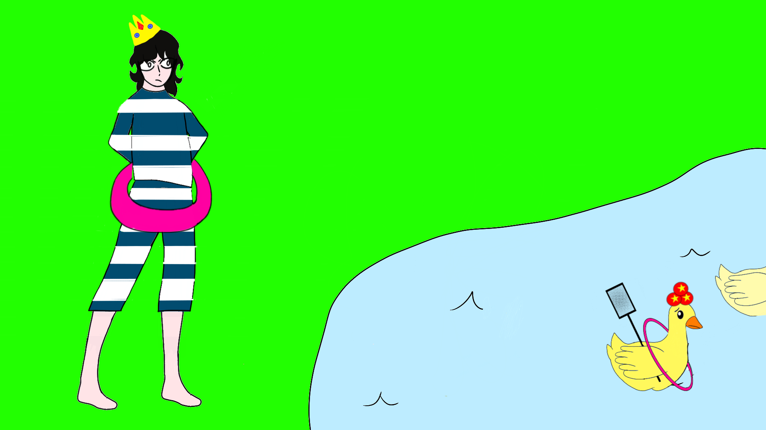 | The flock of ducks pack up their big quantity of equipment–all the rings and balls and rackets. They fly quickly up into the sky.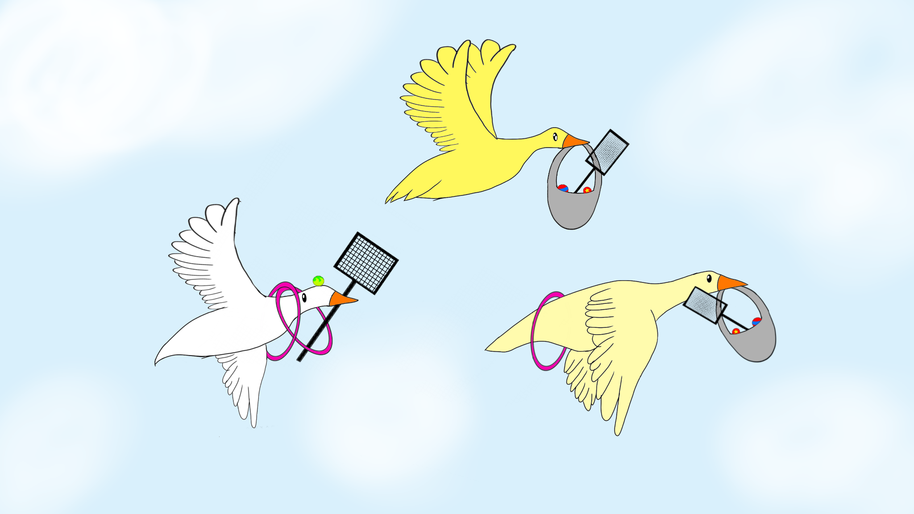
Lesson 34, Target letter qu by: C. Rivera and K. Bergman
Word List
1 | 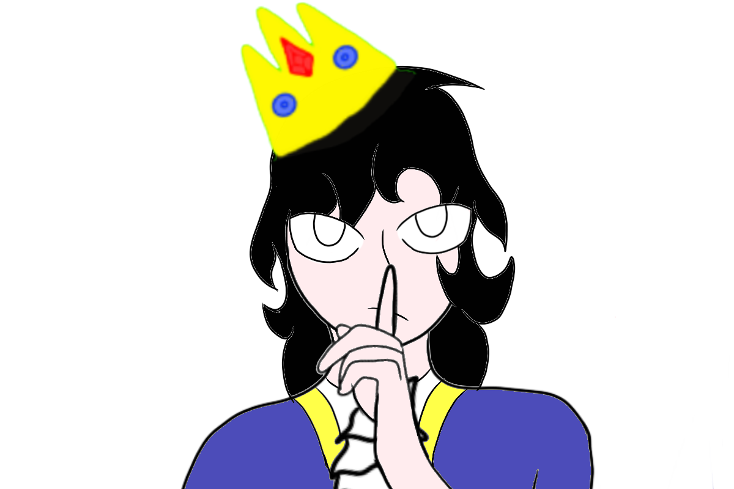 | quiet
2 | 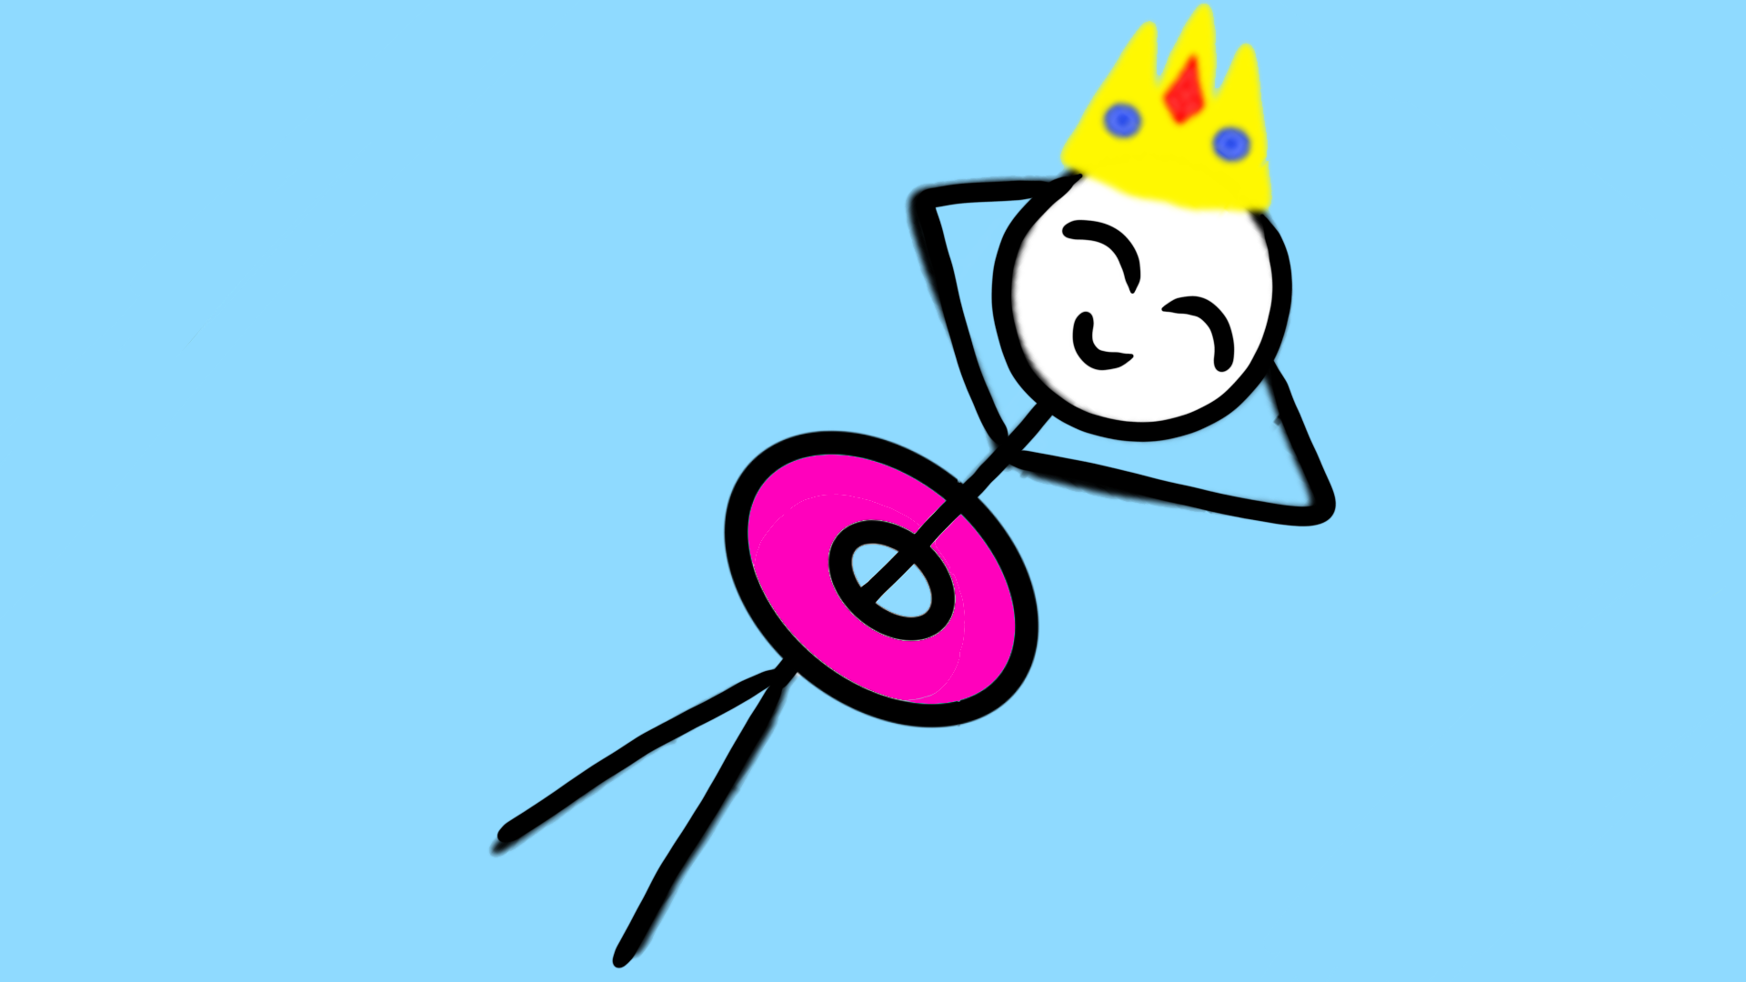 | tranquil
3 | 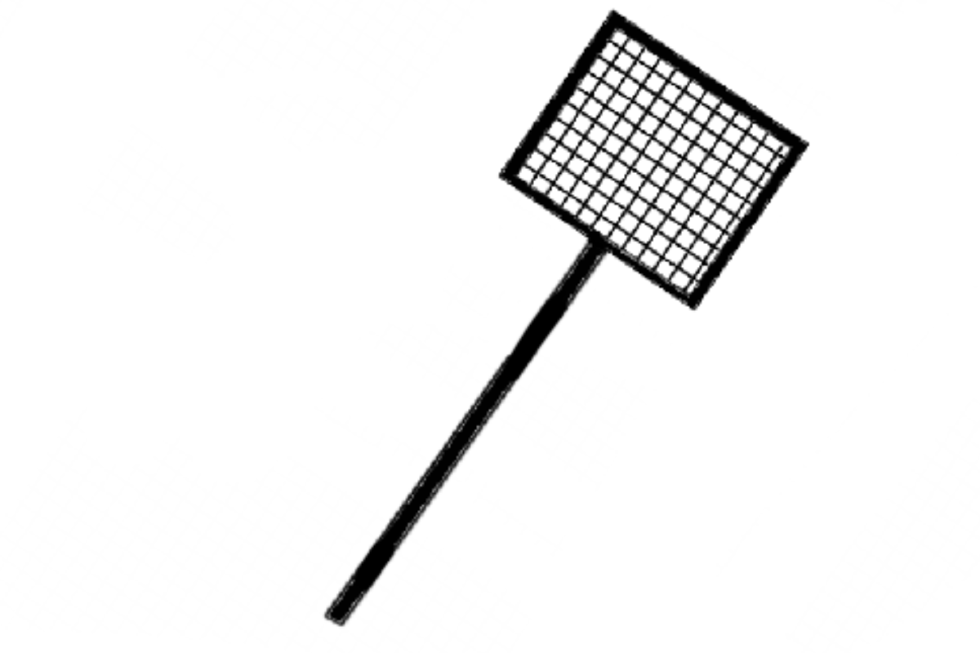 | square
4 |  | quack
5 | די | quite
6 | 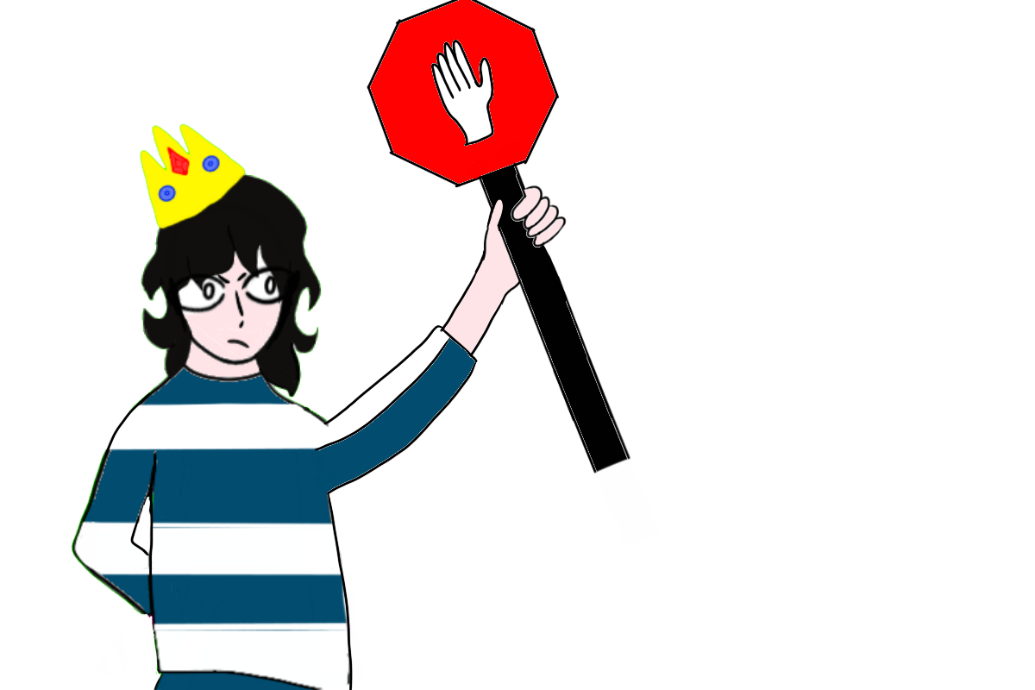 | quit
7 | 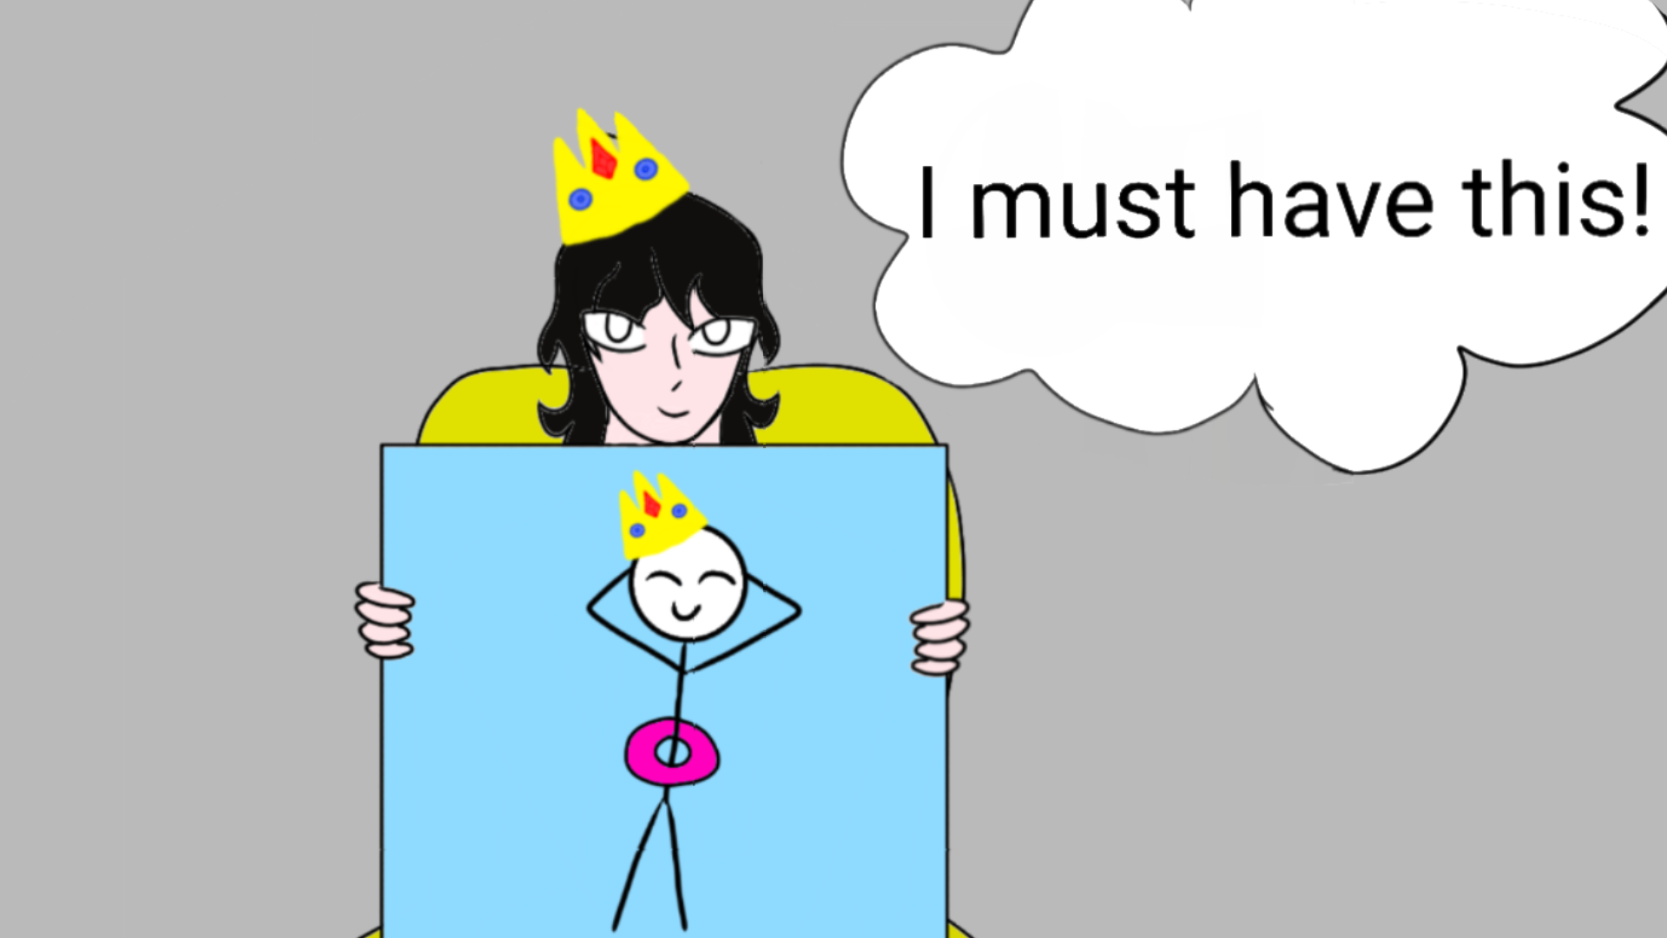 | require
8 | 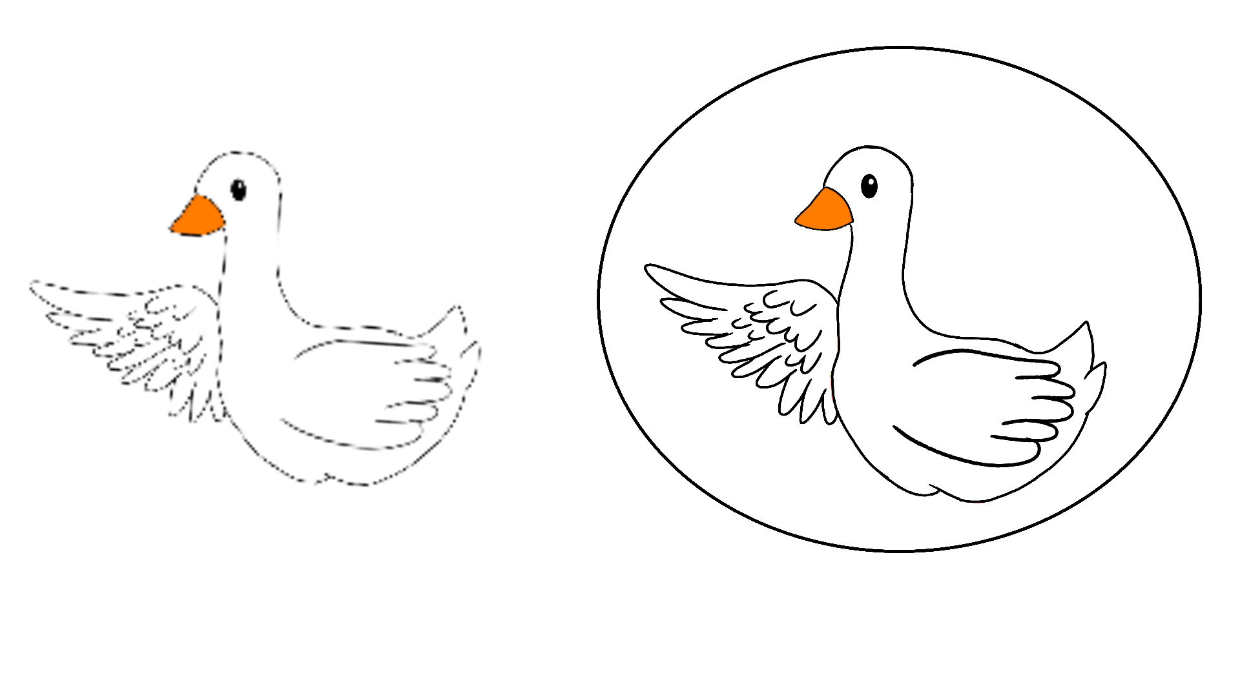 | quality
9 | 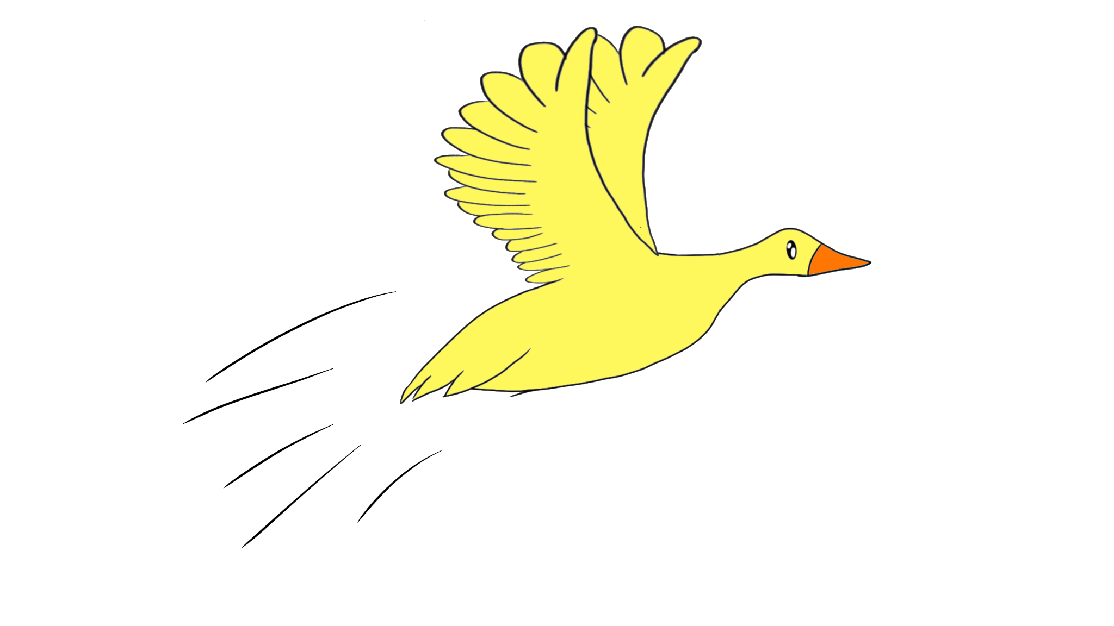 | quickly
10 | 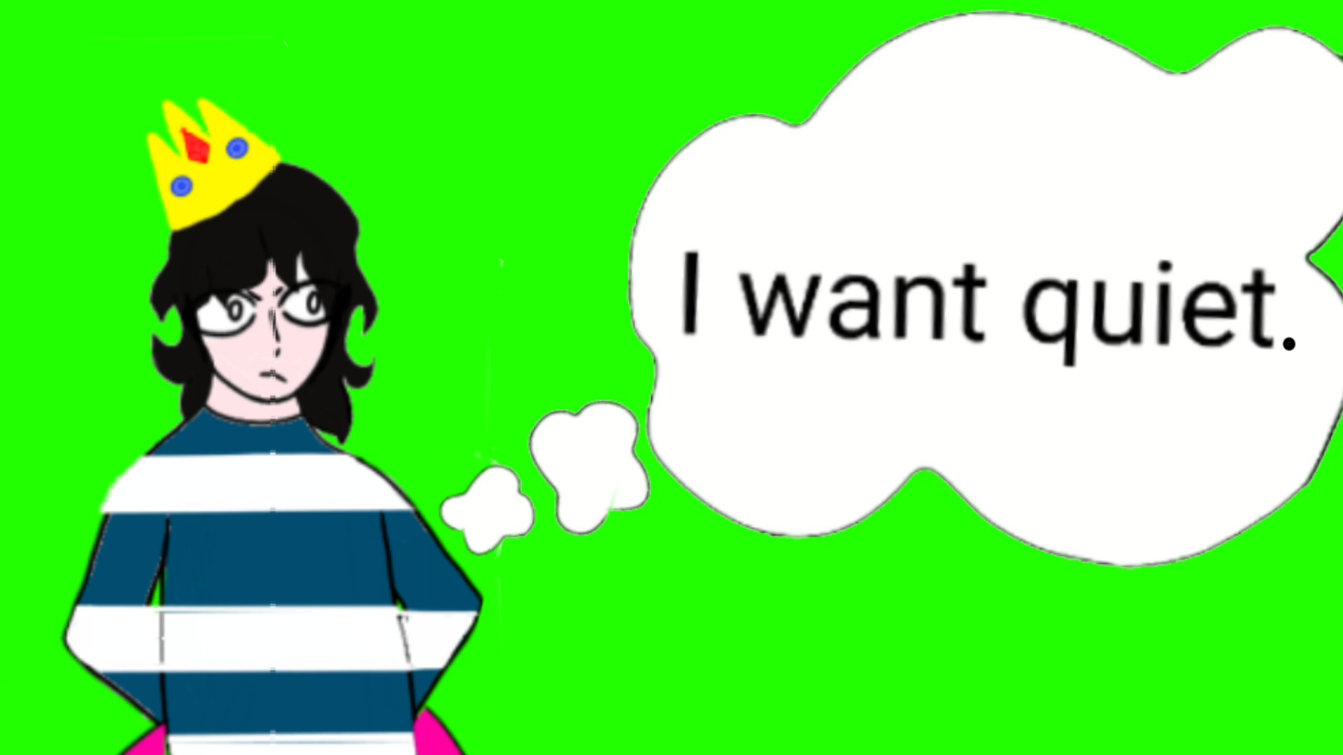 | request
11 | 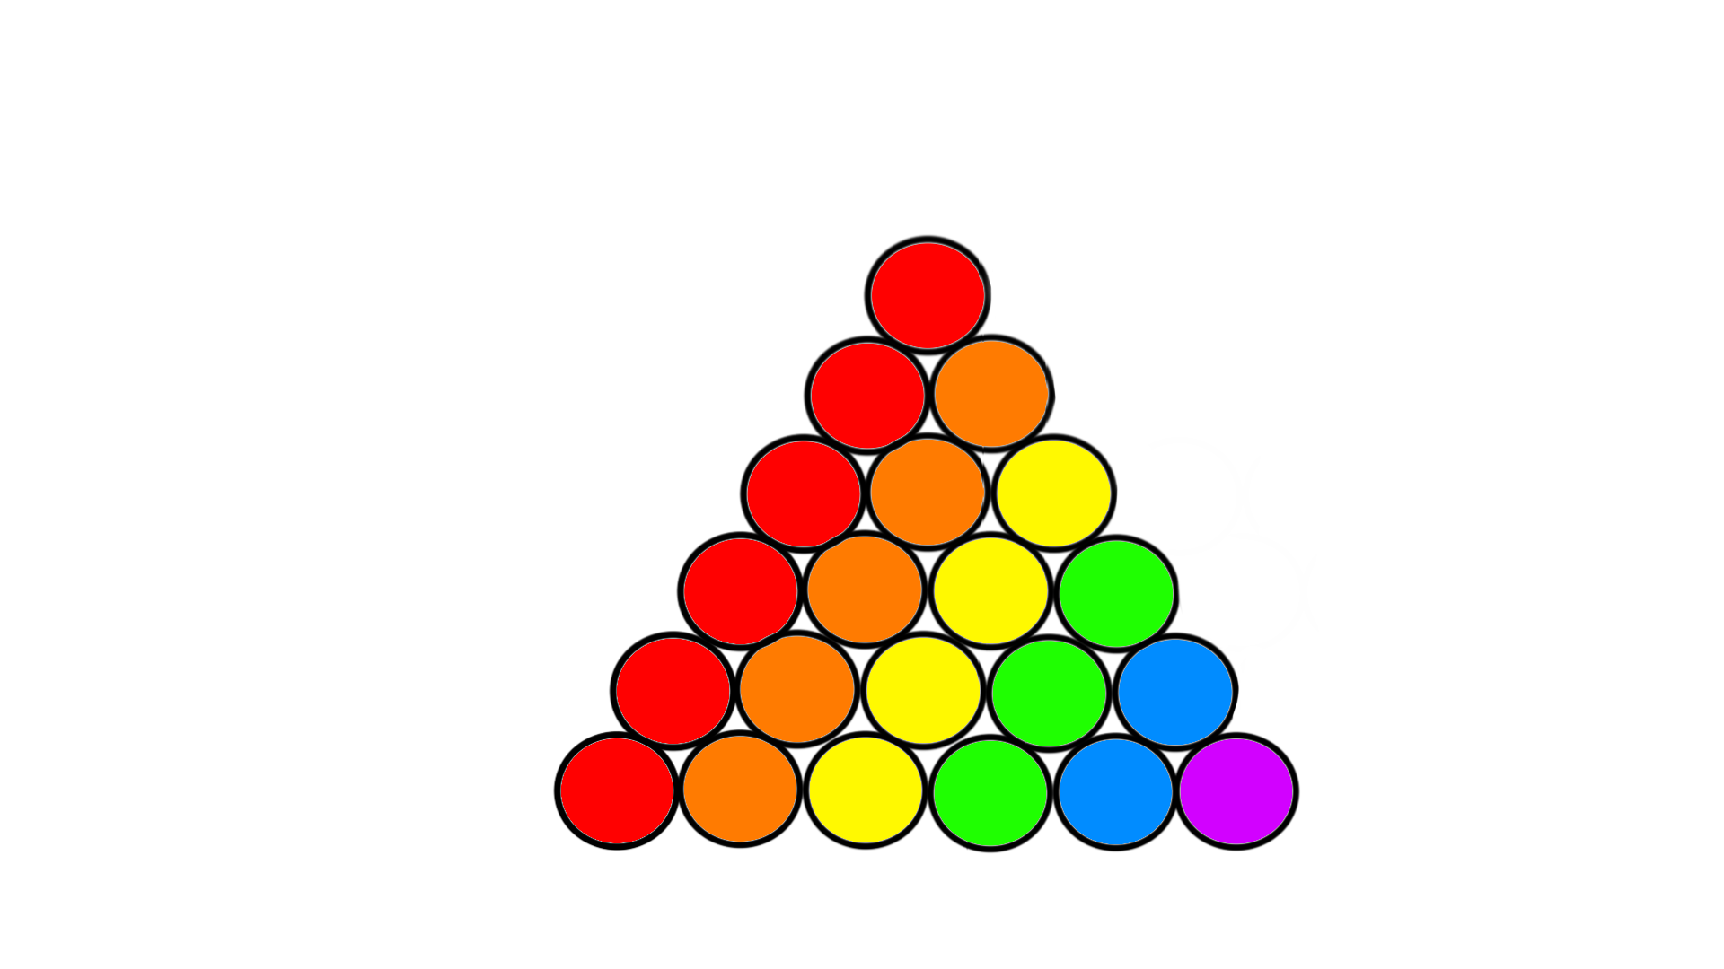 | quantity
12 | 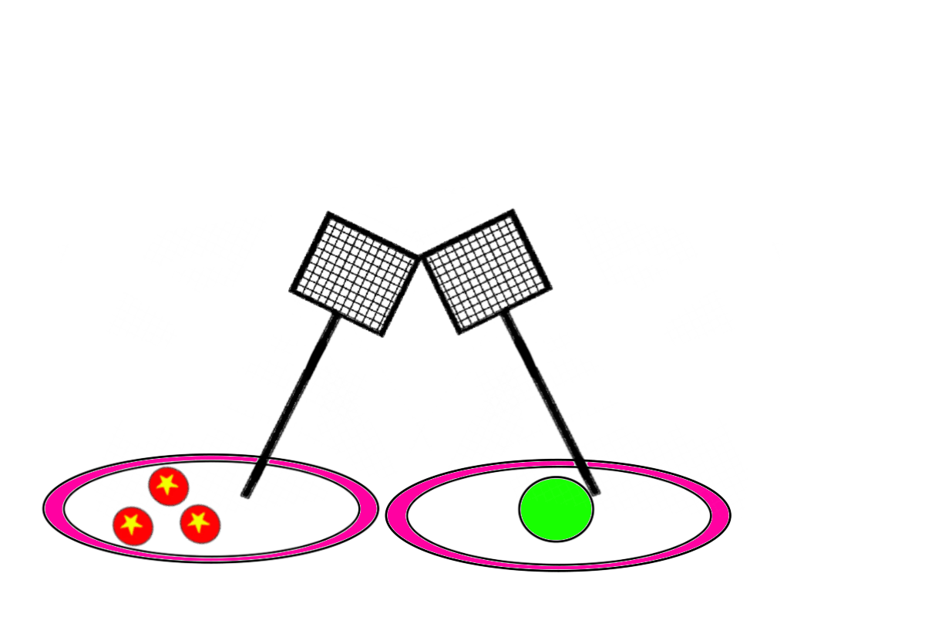 | equipment
Lesson 34, Target letter qu by: C. Rivera and K. Bergman
QU Card Flip
Supplies:
- qu card
- Question Cards (to be read by Tutor)
- Cards with “Word Parts”

qu words: quite, tranquil, quack, quit, require, request, quickly, equipment, quality, quantity, square

This game can be modified for learners who may have difficulties with working memory.
- The learner gets a “qu card” turned up.
- The other remaining “word parts” cards are shuffled and put face up.
- The learner gets to look at the cards for 30 seconds and then they are turned over. The “qu card” always remains turned up. If the learner has working memory issues, some or all of the cards can remain turned up.
- The tutor will read with the student a question card. If the learner needs more help to remember the word, then the tutor and student can read the sentence from the story. The tutor can also give additional clues if necessary. We have provided some clues with each question card.
- After the learner answers the question, she/he tries to remember where the cards are that make up the word. The learner flips over the cards, matches them with the “qu card” to spell the word they need to answer the question.
Example “qu+ick+ly” answers the last question card.
- These cards can be set aside or added back in, depending on the ability of the student.
- The game ends when all the questions have been answered.

Online game can be accessed at https://wordwall.net/resource/30284699

Card Templates Follow:

The king wants a _____, tranquil place to swim. He went to a pond.  Clue: This word means | The king wants a quiet, _______ place to swim. He went to a pond.  Clue: This word means that the pond is calm.
A flock of ducks were singing and splashing. They toss rings and hit balls with _______ rackets.  Clue: What shape are the rackets? | “_____, ______, ______, ” they sing.  Clue: What sound do the ducks make?

They are ______ happy.  Clue: This word has a long i sound and a magic e.  די | But the king tells them to ____.  Clue: The king tells them to stop.
“I _______ quiet, quality time,” the king commands.  Clue: This word means “to need.” The king needs his quiet, quality time. | “I require quiet, _______ time,” the king commands.  Clue: This word means that the king wants to have a very good time. The second picture is higher ______ because it is clearer.

Quickly, the ducks listen to his _______.  Clue: This word has a long e and a short e.  The word means something the king is asking them to do. | The flock of ducks pack up their big ________ of equipment.  Clue: This word means the “amount of” their equipment.
The flock of ducks pack up their big quantity of ________.  Clue: The ducks pack up their balls, rackets, and rings. This word means all of these balls, rackets and rings together. | They fly ______ up into the sky.  Clue: This word means to do something very fast.

ment | tran | it | est
ant | ity | re | are

ick | ly | al | ity
e | il | ite | ire

ick | ly | al | ity
ip | i | re | s

ack | et

qu

