Root for Dan
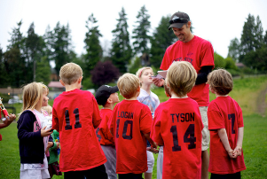  Dan the cool man meets the kids at noon. Dan is the man with the ball. | 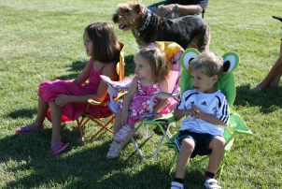  The kids look at Dan.  Dan runs with the ball.
  The kids root for Dan.  Dan the man kicks the ball.  He kicks the ball so far. Boom! | 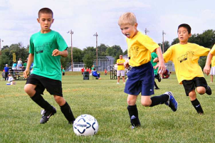  Dan the cool man wants them  to do their best.  He tells them they are good  athletes.
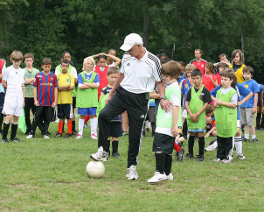  Dan the cool man scoops up the ball with his foot! Soon the kids are doing it too. |   Dan the cool man roots for them too.  He yells, "Yahoo!"

Word List
1 |  | root
2 |  | cool
3 | 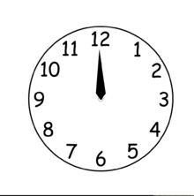 | noon
4 | 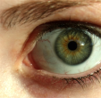 | look
5 |  | boom
6 |  | good
7 | 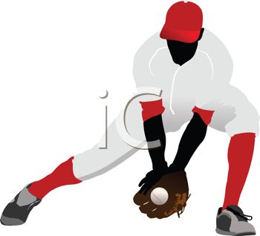 | scoop
8 | 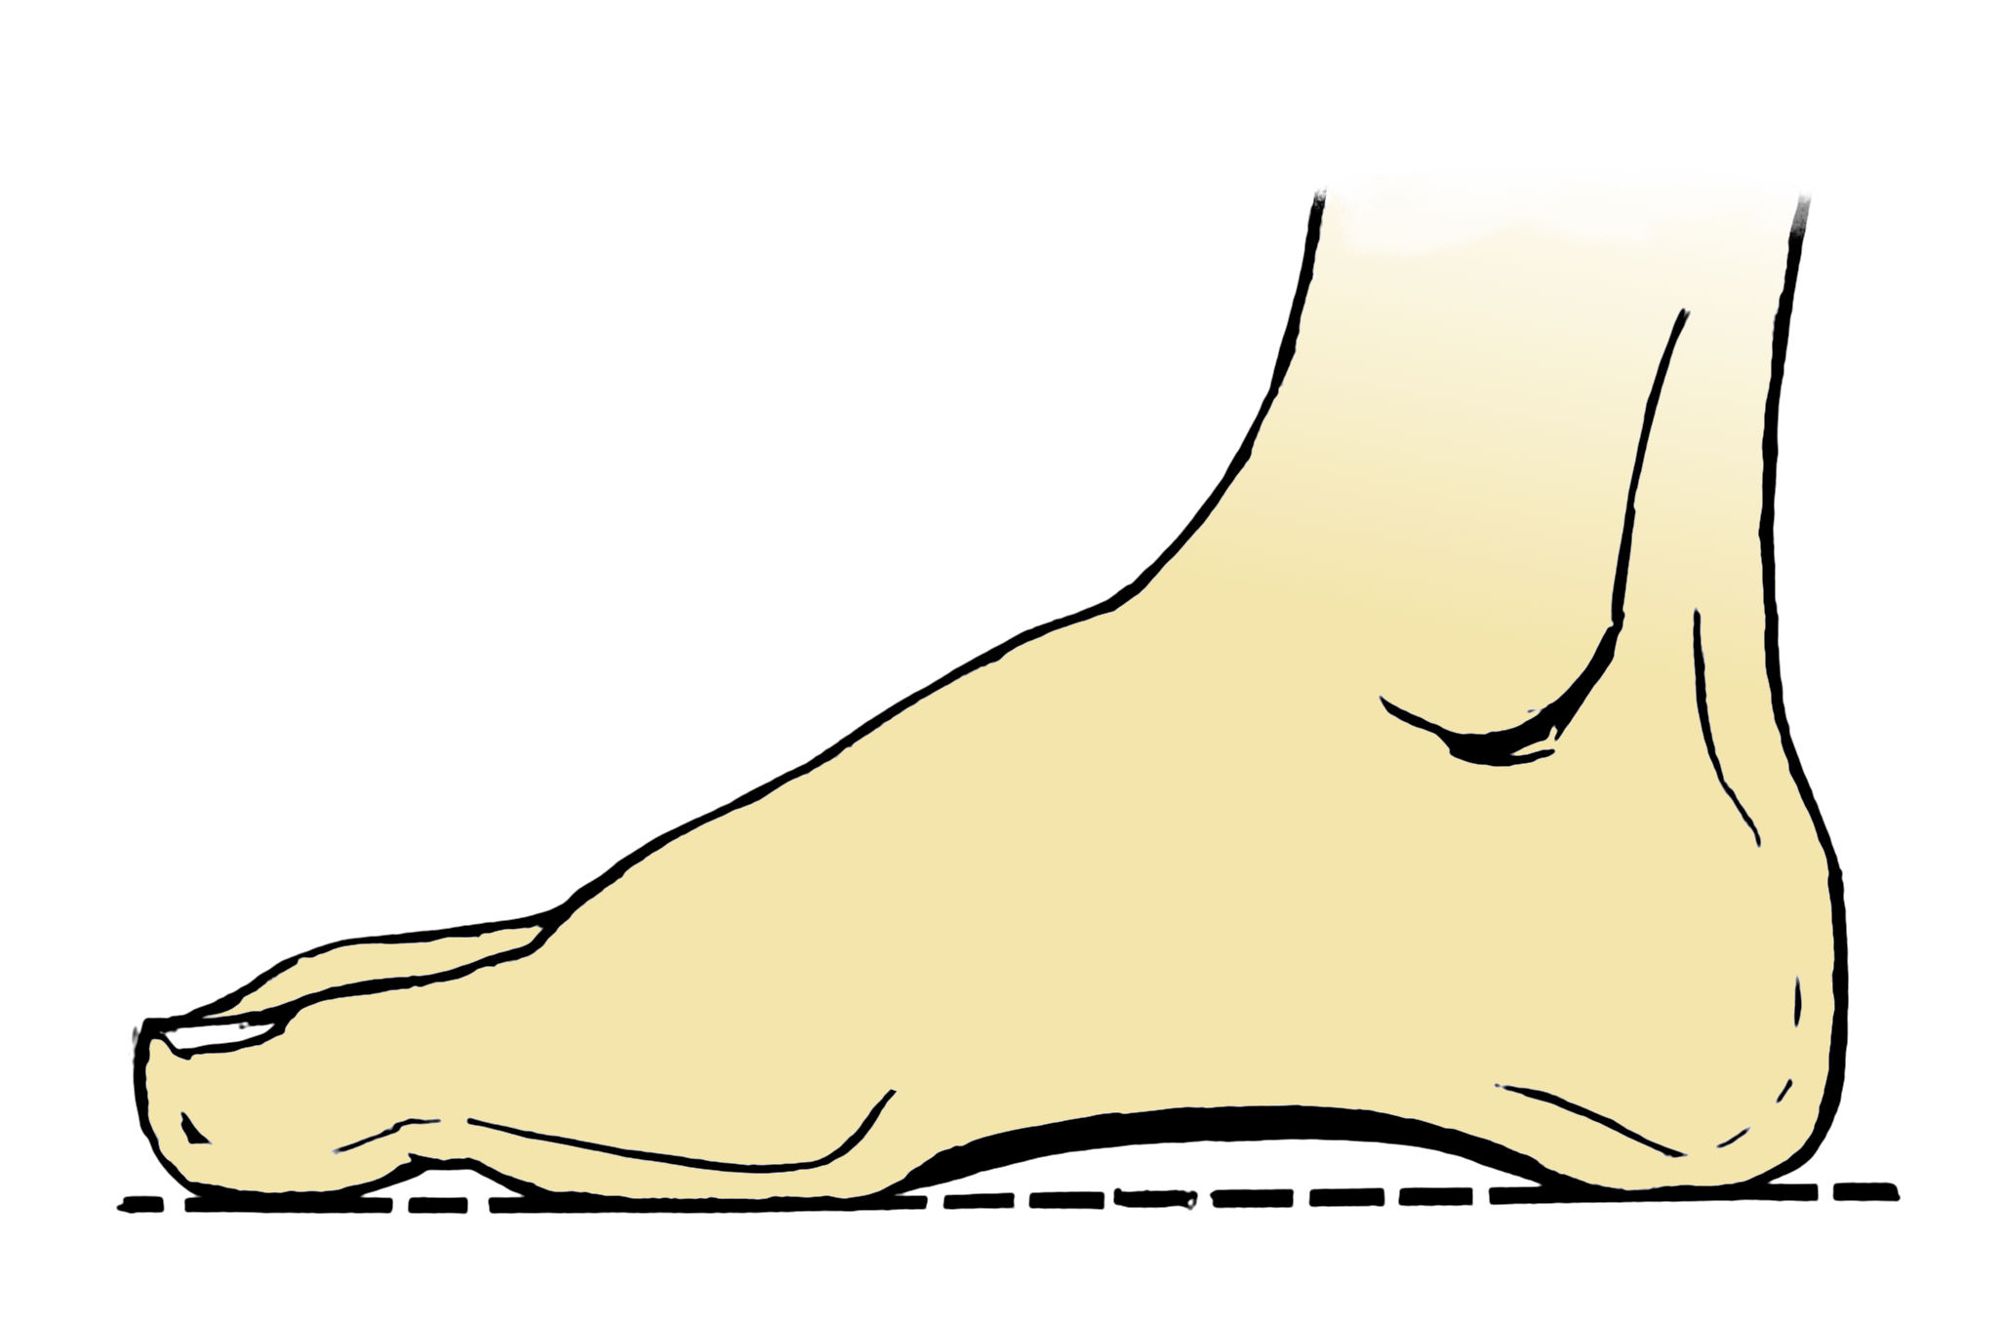 | foot
9 |  | soon
10 |  | too
11 |  | yahoo
12 |  | book

Two-Part Puzzles
This type of puzzle allows the learner to match the word to its picture with a built-in self-check.
Preparation: Glue onto colored paper (lamination optional) and cut out halves. Play: Match halves!
root  | book 
cool  | yahoo 
noon | too also
look  | soon
boom  | foot 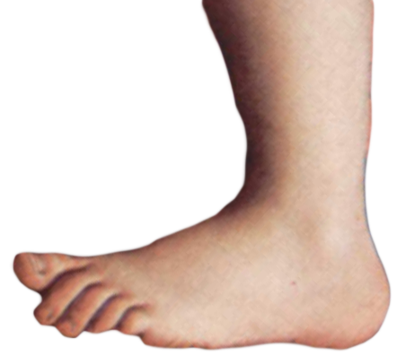
good  | scoop

