Catch and Fetch
They went to the park with Champ.  Champ barked and wagged his tail. Chandler took off his chain leash and tossed the Frisbee. Champ ran and fetched the flying disc.  “Good dog, Champ,” said Chandler and patted Champ, but he didn’t have a treat for him.  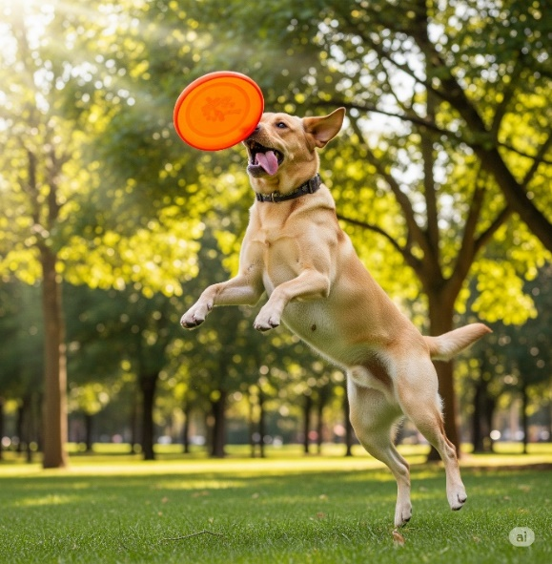 | The next morning, Chandler wanted to teach his beloved dog Champ a trick.  After patching things up with his once again best friend Chad, Chandler suggested that they take the dog out.  “Chad, let’s take Champ to the park and watch him play. I want him to catch and fetch this Frisbee,” Chandler said.  Chad stretched in his chair.  “Let’s go!”  
Just then Chelsea, their charming classmate, walked by.  “Hey” she said, her cheeks flushed. “What’s up?”  “We’re teaching Champ to fetch the Frisbee,” Chandler said.  “But we don’t have a treat for him!” Chad added.  “I have some Cheddar cheese for Champ,” Chelsea offered.   | As she was about to give Champ the cheese, a cat ran by and snatched the cheese from her hand. Champ wanted to chase the cheeky cat.  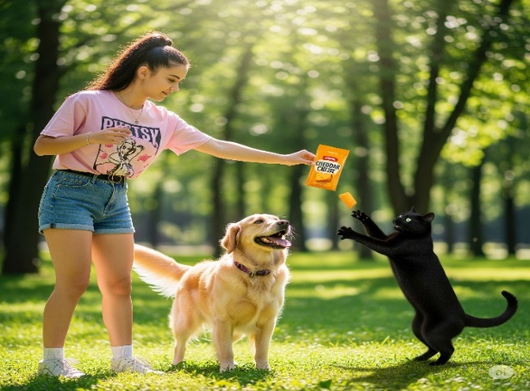  “No chasing cats, Champ! But no worries, I will switch your reward to a hot dog with ketchup. Leftovers from my kitchen,” Chelsea told him.  

Champ ate it happily. “He’s such a charmer,” Chelsea said. “He will win any match. One day he will make you very rich.”   | "You are a fantastic dog coach!” said Chandler.  Chelsea smiled at him cheerfully.  “Thank you very much, so are you!"  Chandler smiled, blushing and feeling touched.  They looked at each other. Now what?  "I feel itchy all of a sudden," Chelsea said shyly.  It was time to go home.  

1 |  | patch things up
2 |  | watch
3 |  | catch
4 | 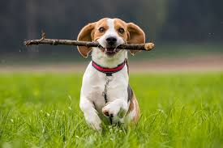 | fetch
5 |  | snatch
6 |  | switch
7 |  | kitchen
8 |  | match
9 |  | rich
10 | 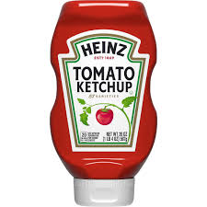 | ketchup
11 |  | stretch
12 |  | much
Word List

Sentences:
1 point for each sentence, bonus points if you use two words in one sentence!
1.__________________________________________________________
2,__________________________________________________________
3. __________________________________________________________
4. __________________________________________________________
5. __________________________________________________________

Online game: Ch and tch memory. Find matching pairs
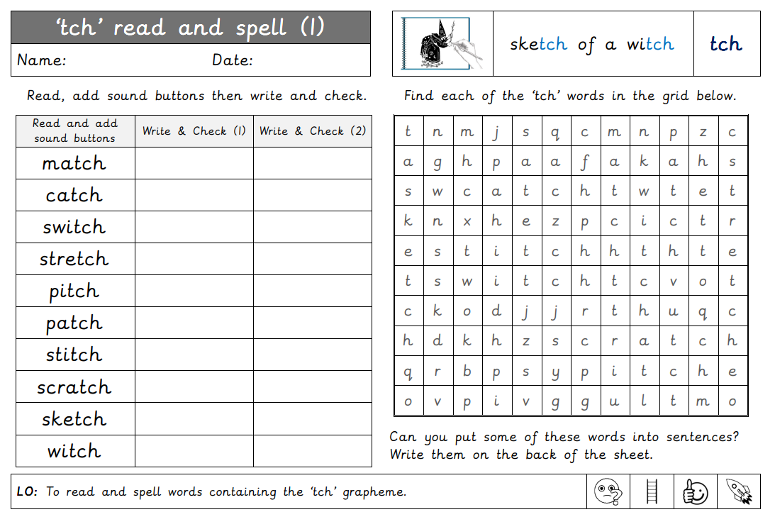
https://wordwall.net/resource/4406694/ch-and-tch-memory

