A Question in the Library
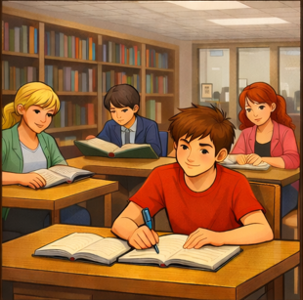  The class is in the library.  The library is quiet. | 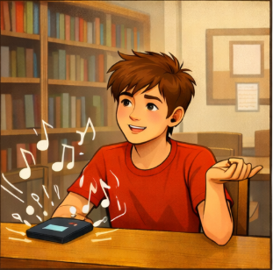  Dan sits at a desk and listens to music.  The music is not quiet.
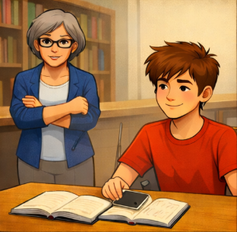  The librarian comes to Dan.  Dan asks her a question.  “Can I listen to music here?”  “Not like that!” she said. | 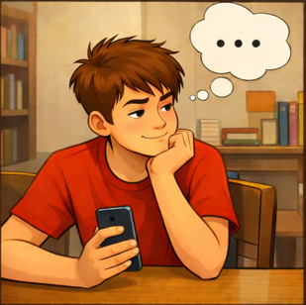  “Dan thinks quickly.  He wants to be in the library.
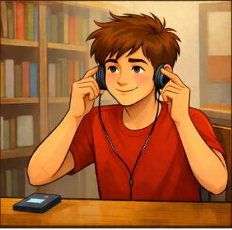  “I don’t have to quit listening,  I can do this!” he thinks. |   Dan smiles.  The library is quiet again.

Word List
1 | 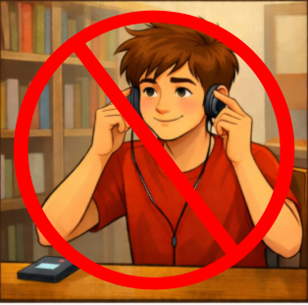 | quit
2 | 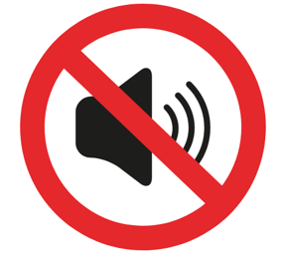 | quiet
3 |  | quickly
4 |  | question
5 |  | librarian
6 | 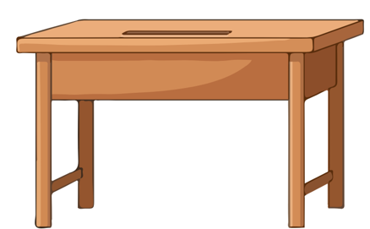 | desk
7 |  | library
8 | 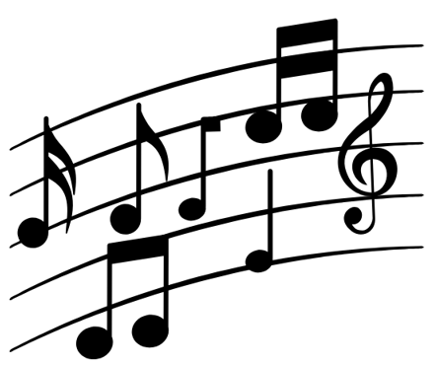 | music
9 | 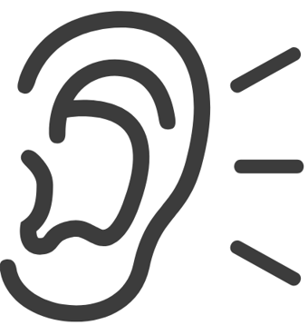 | listen
10 | 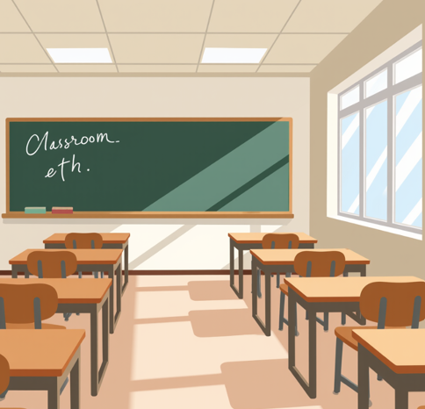 | class
11 |  | ask
12 |  | smile

Online game: https://wordwall.net/resource/109804784

Matching Game
Cut apart the squares. Match each word to the picture it describes.

quit
quiet
quickly
question
librarian
desk
library
music
listen
class
ask
smile

