Joe's Dancing Shoes
Closing his eyes, he imagines pianos playing, haloes hanging in the air, and himself dancing on his tiptoes. But something is missing…  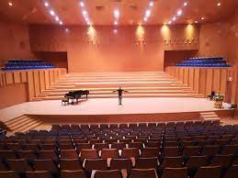 | Next week is the school Talent Show and Joe doesn't know what to do!  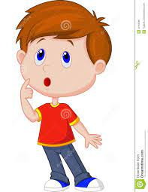
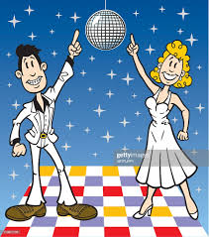  He wants to go completely retro, just like all the weirdos with cool hairdos he saw in photos. | SHOES! He doesn’t have dancing shoes!  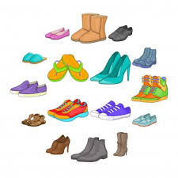  How will he dance without the right shoes?
He cannot have people laugh or throw tomatoes at him!  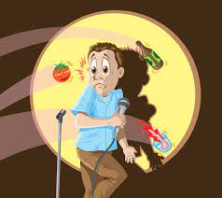 | 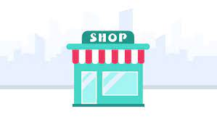  It doesn't even matter what he has tomorrow, he MUST make sure he goes to buy shoes, or his dance won't be perfect!
Until… At last, he found a vintage store.  So many shoes he didn't know what to choose! He tried on pair after pair, until he saw the perfect disco shoes!!!  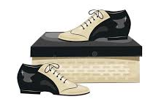 | And so, he went, and he looked. He saw tap shoes, and ballet shoes. All new and shiny. But nothing felt right.  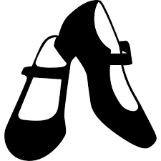  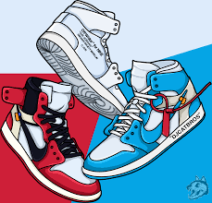  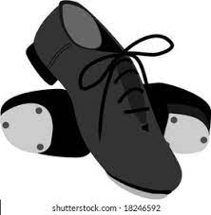
* Watch out for words that end with 'o' and don't get 'es' when plural:
hairdos, pianos, photos, weirdos.
Word list
1 |  | Joe
2 | 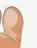 | toe
3 | 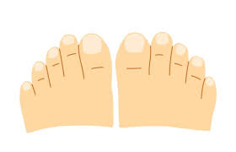 | toes
4 | 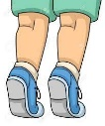 | tiptoes
5 |  | goes
6 | does not | doesn’t
7 |  | shoes
8 |  | haloes
9 | 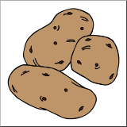 | potatoes
10 | 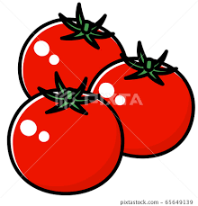 | tomatoes
11 | 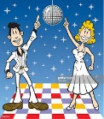 | weirdos

Game #1 – Bingo
Ask a family member to help you. Have them read out the translation of the words and try to find them in the following bingo board.
Let's see how fast you can find all of them!
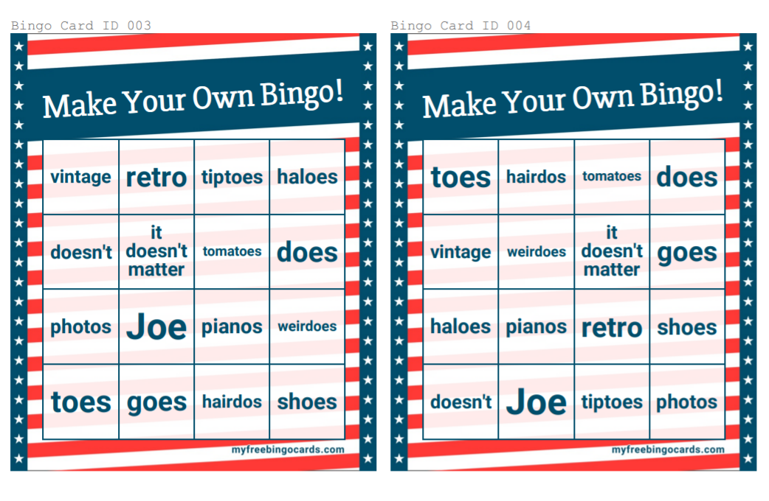
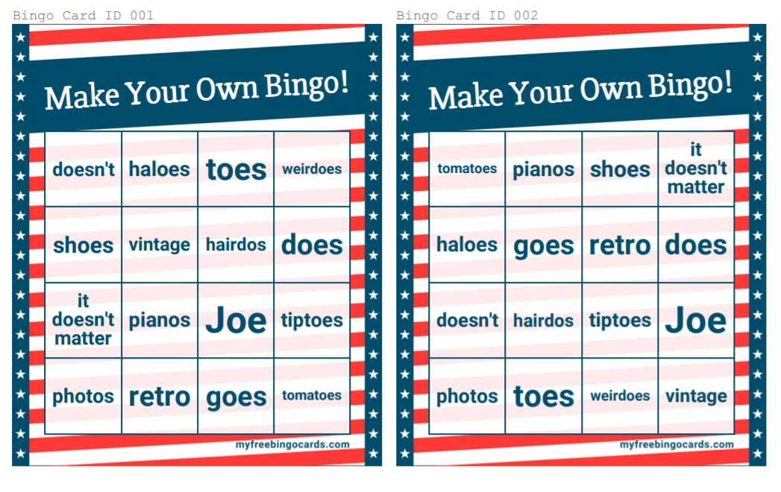
If you like competition play with a friend to see who has a bingo first!

Game #2 – Gap fill
Fill in the correct word in the sentences below:
(Use the words in the box for help)

- We wear ___________ on our feet to protect our _____________.
- When your parents are sleeping it is better to walk on your ______________.
- _____________ wanted to dance in the talent show
- Shira does a lot of sports but she ____________ play an instrument.
- When we think of angels we think of wings and ________________.
- I go to the mall. She ______________ to the mall.
- The best salads have cucumbers and _________________ in them.
- His father had three very old _______________ cars.
- Make a cool _____________ film with those old pictures!
- We make chips out of ______________________.
doesn't, tiptoes, tomatoes, shoes, Joe, vintage,

haloes, goes, retro, toes, does, potatoes

