The King's Missing Ring
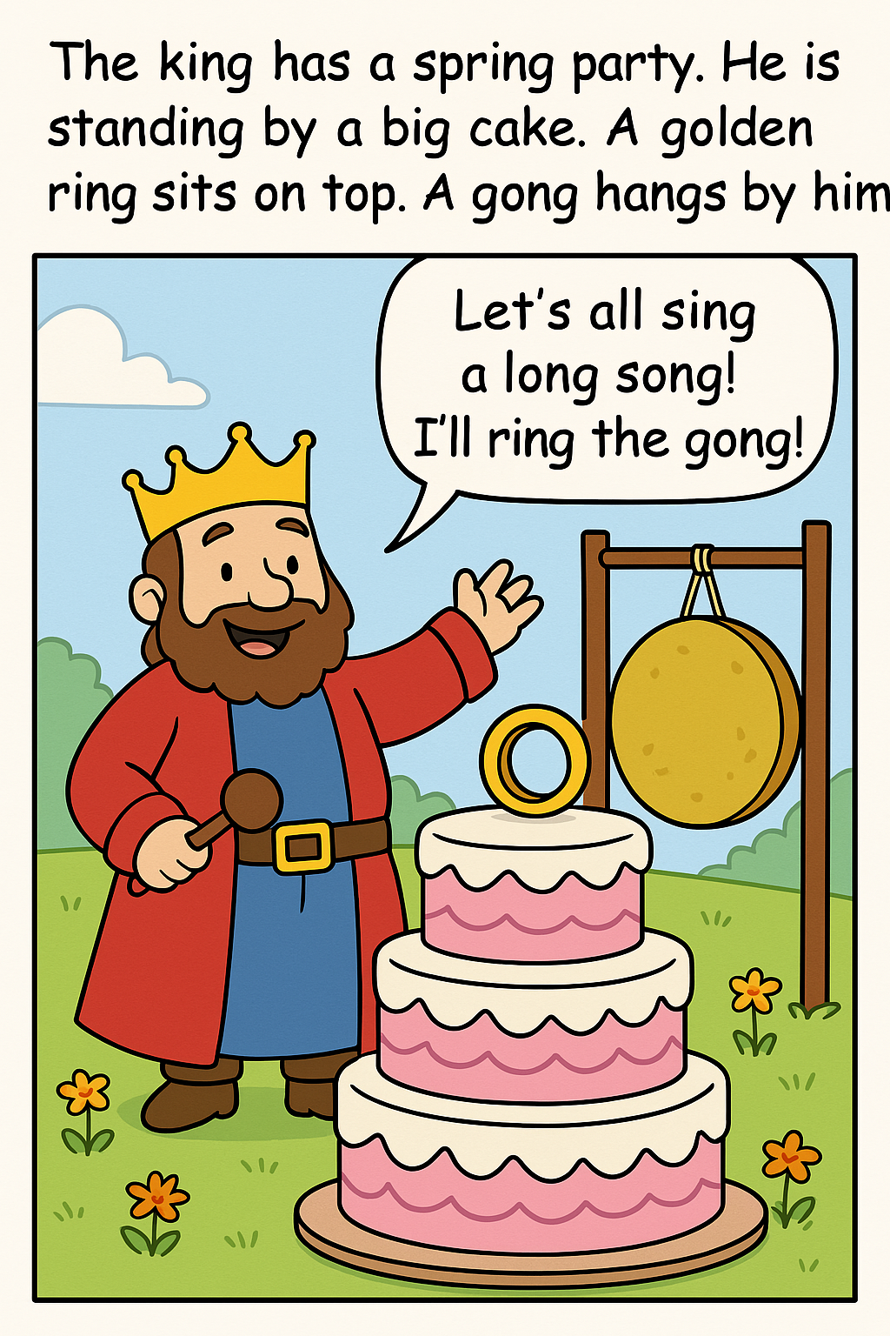 | 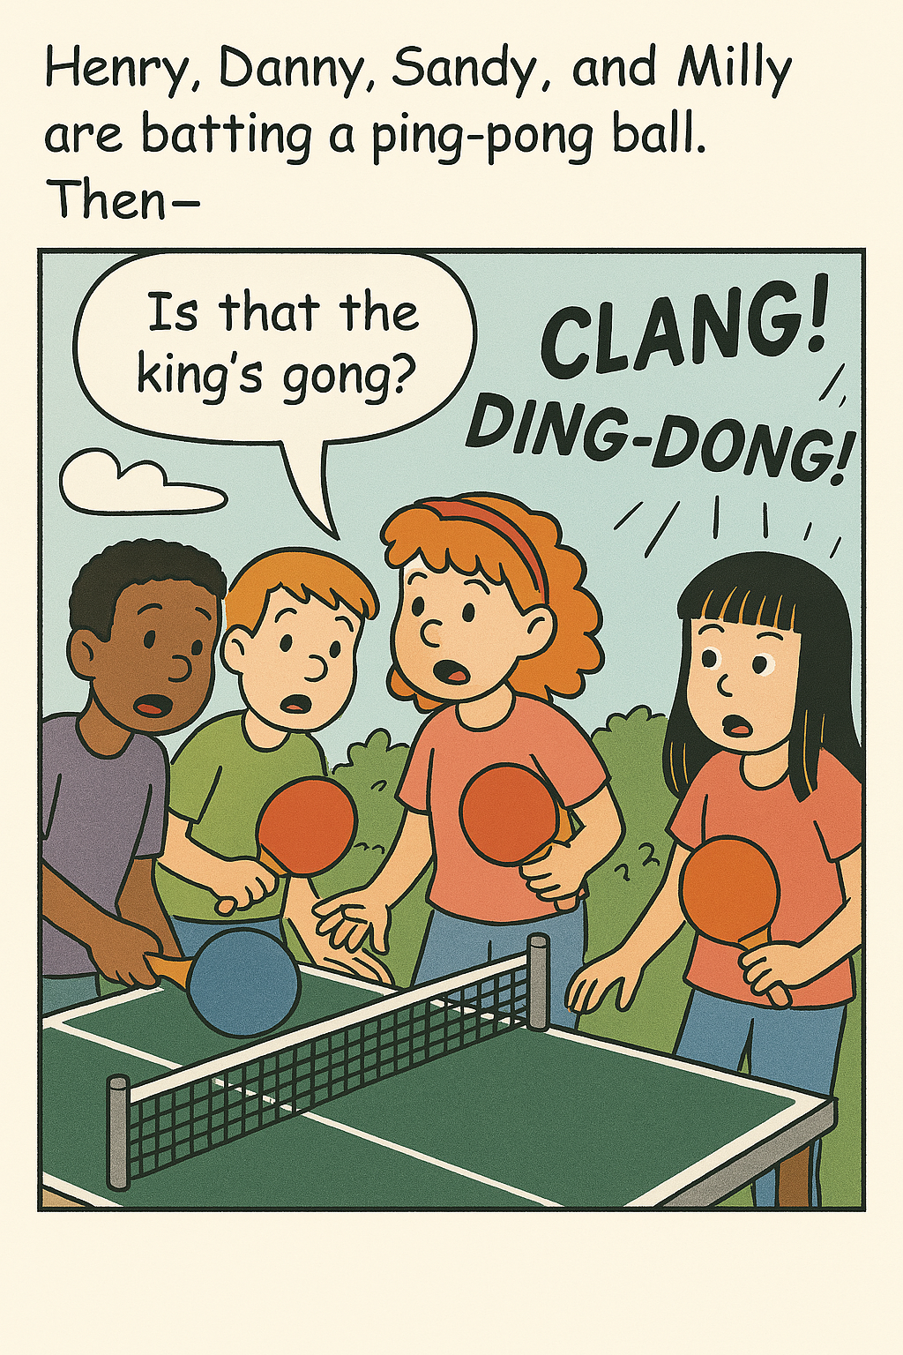
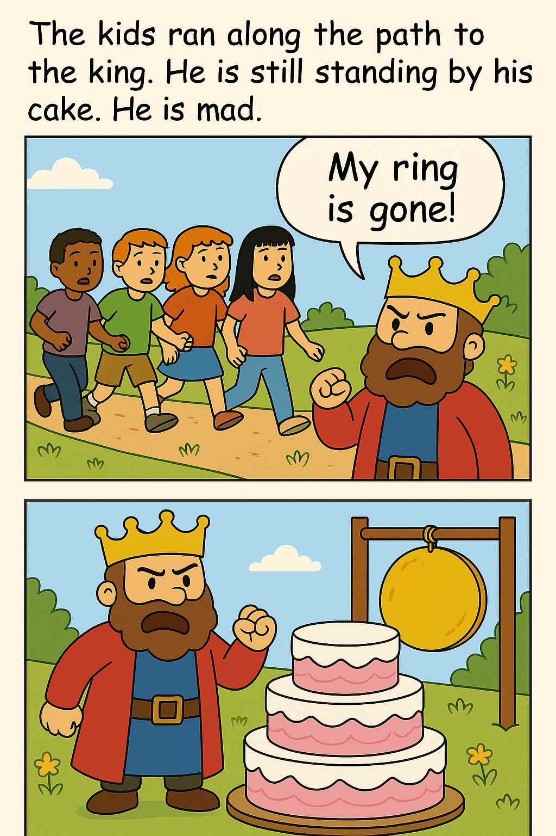 | 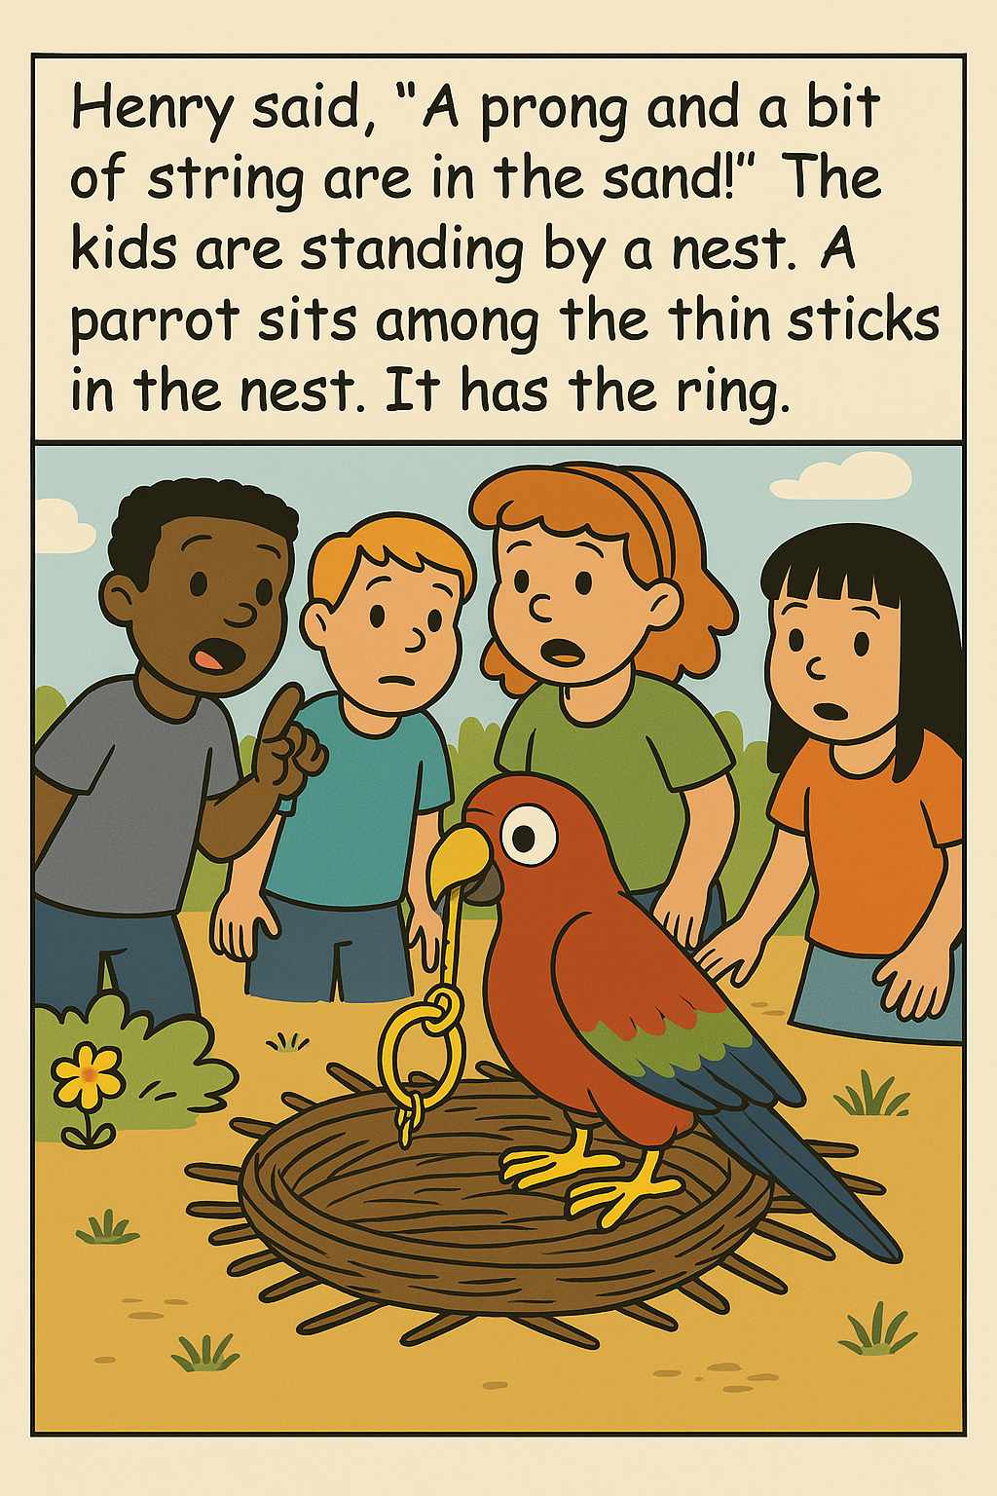
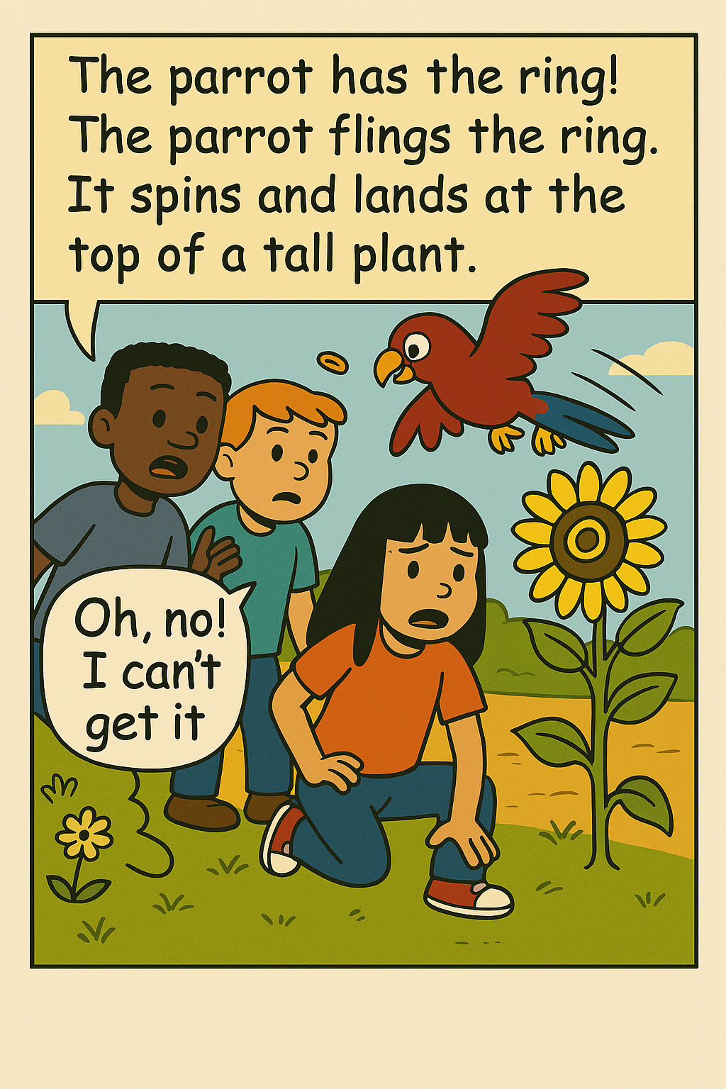 | 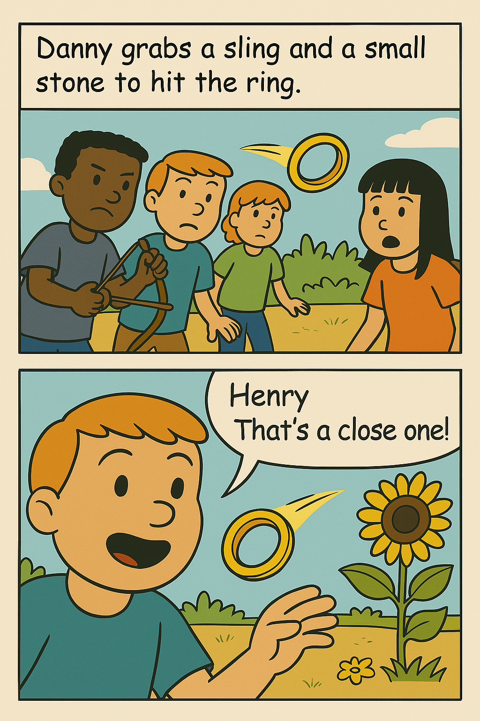
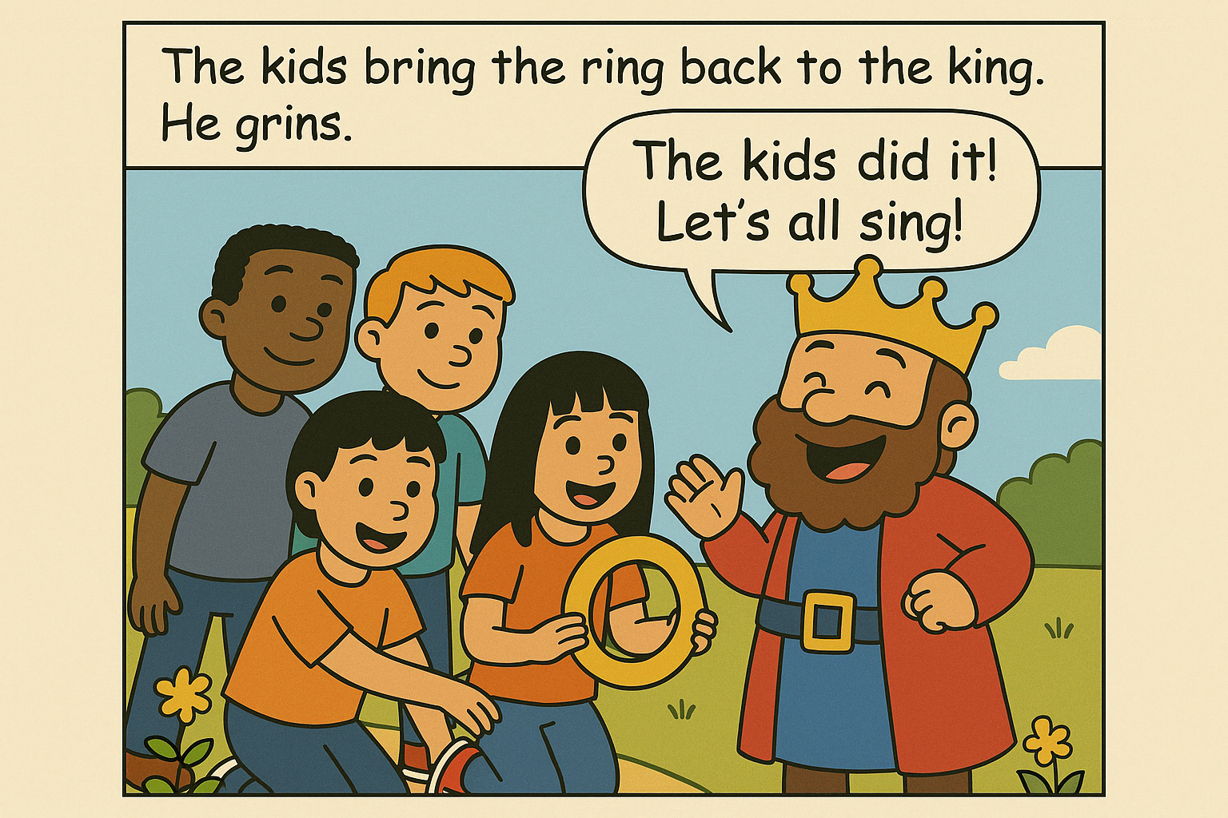 | 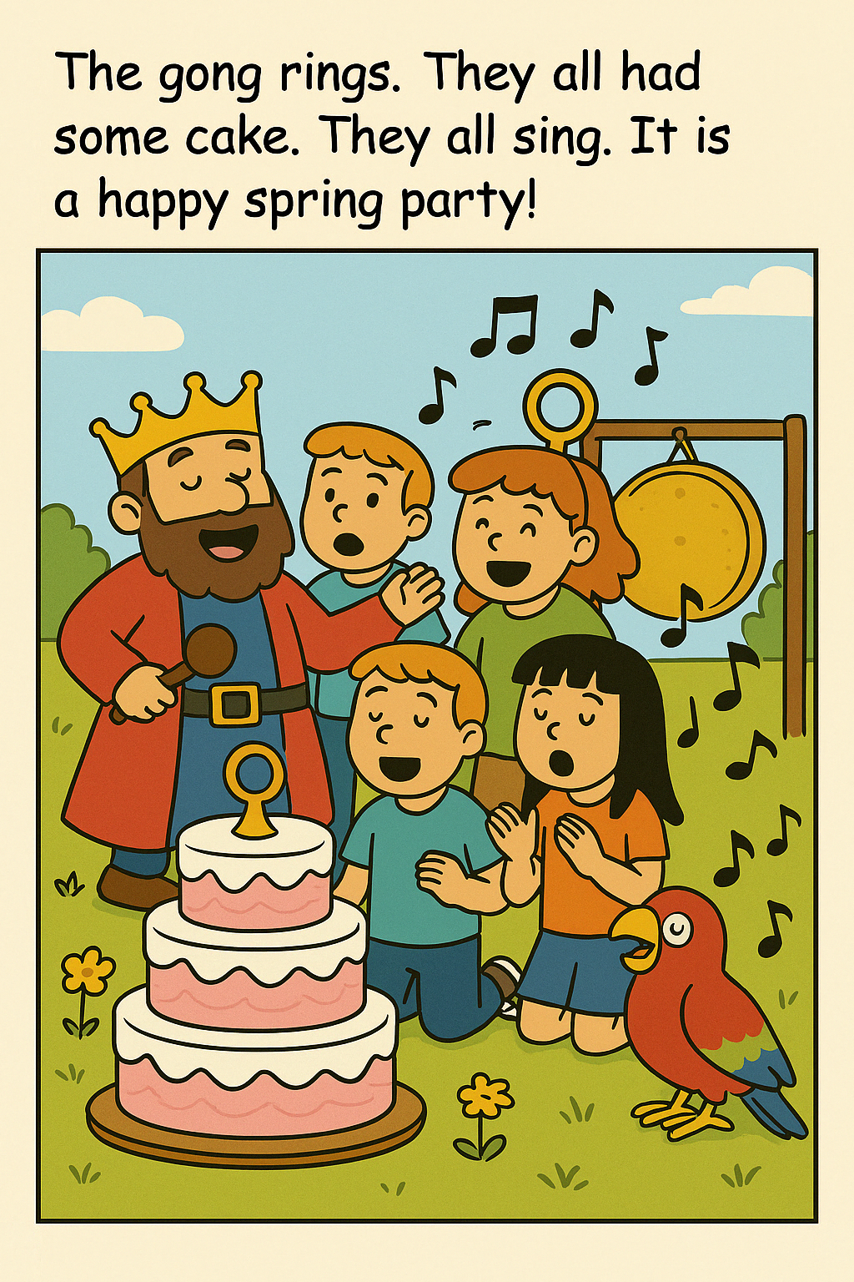

Online game: https://www.educaplay.com/learning-resources/23414692-the_king_s_missing_ring.html

Word List
1 |  | king
2 | 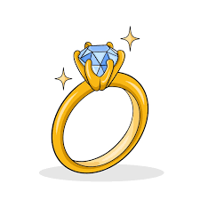 | ring
3 | 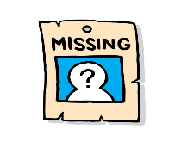 | missing
4 |  | spring
5 | 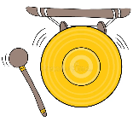 | gong
6 | 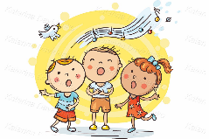 | sing
7 |  | string
8 | 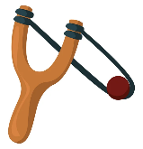 | sling
9 | 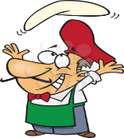 | fling
10 | 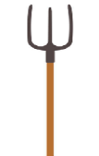 | prong
11 | 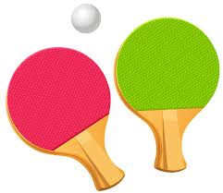 | ping-pong
12 | 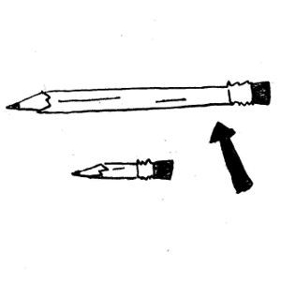 | long

Game:

Tic-Tac-Toe Word Game - Instructions
These Tic-Tac-Toe boards can be used in many fun and educational ways to enhance reading, vocabulary, and critical thinking. Below are several ways to play using the same board.
1. Read & Mark
Goal: Practice word recognition
How to Play:
- Players take turns.
- Before placing a mark (X or O), a player must read the word aloud.
- If the word is read correctly, they mark the square. If not, they lose the turn.
- The first to get 3 in a row wins.
2. Use It in a Sentence
Goal: Vocabulary comprehension
How to Play:
- Players choose a square and use the word in a sentence.
- If the sentence is correct, they can mark the square.
- Continue until someone gets 3 in a row.
3. Act It Out (Charades Style)
Goal: Improve comprehension through movement
How to Play:
- A player chooses a word and acts it out silently.
- If the partner guesses correctly, they mark that square.
- First to 3 in a row wins.
4. Draw It
Goal: Connect word to visual meaning
How to Play:
- A player picks a word and draws a quick sketch of it.
- If their partner guesses the word, they mark the square.
- Win by getting 3 in a row.
5. Definition Match
Goal: Reinforce meanings
How to Play:
- The teacher reads a definition aloud.
- Students must find and mark the matching word on the board.
- If correct, they can place their mark.
6. Rhyming Challenge
Goal: Phonemic awareness
How to Play:
- The player reads the word aloud and gives a rhyming word(ex: ring-king)
- If it's a real word and correct, they place their mark.

Tic-Tac-Toe Word Game
Board 1 | Board 2
  long | spring | sing
  fling | ping-pong | gong
  missing | king | prong
  gong | ping-pong | sling
  missing | ring | string
  king | long | sing

Board 3 | Board 4
  sling | ring | long
  ping-pong | string | spring
  gong | prong | missing
  spring | string | missing
  ping-pong | long | sing
  prong | king | sling

Board 5 | Board 6
  sing | string | ping-pong
  spring | prong | sling
  fling | ring | missing
  missing | sing | prong
  sling | string | spring
  gong | fling | ping-pong

