The Fawn that Draws a Strawberry
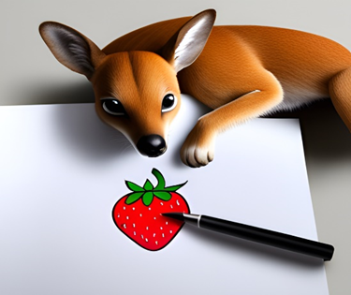  All night, the fawn draws a strawberry with pencils. He paints it with paints.  He draws until late. He doesn’t sleep. He is very tired, but he draws a great drawing. | 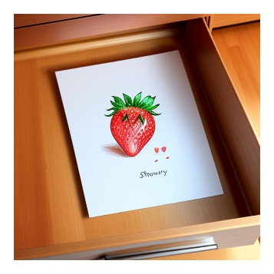  At dawn, he puts his drawing into a drawer in his desk.
The fawn yawns and crawls into bed. | Later in the day, when the fawn awoke, he saw his paints and pencils but he didn’t see his drawing.  “That’s awkward,” said the fawn. “I forgot where I put my drawing.”
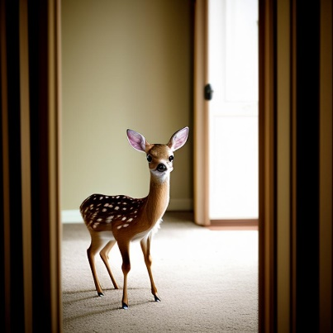  He looks all around his room. No drawing! | 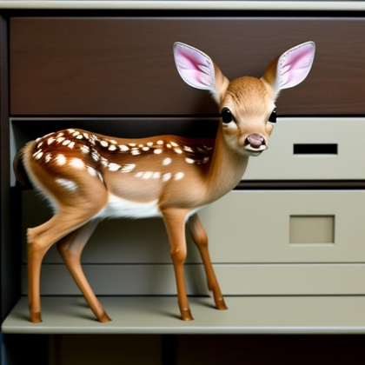  Suddenly he remembers. “Oh, that’s right, I put my strawberry drawing in my desk drawer.”
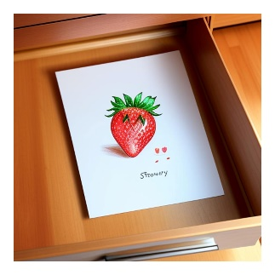  He opens the drawer. There is the drawing! | 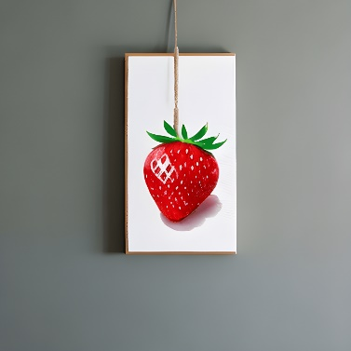  The fawn decides, “This drawing is so good, I will frame it and hang it on the wall.” And so he did!

Word List
1 | 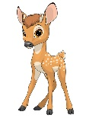 | fawn
2 | 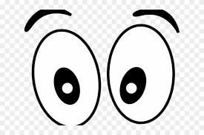 | saw
3 | 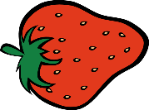 | strawberry
4 | 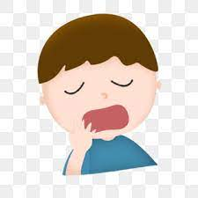 | yawn
5 | 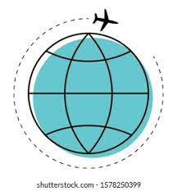 | around
6 | 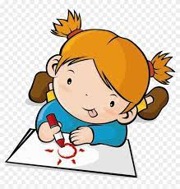 | draw
7 | 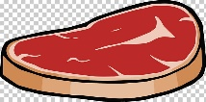 | raw
8 | 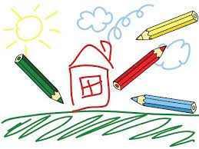 | drawing
9 | 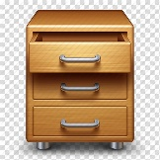 | drawer
10 | 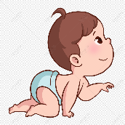 | crawl
11 |  | dawn
12 |  | awkward

Two-Part Puzzles
This type of puzzle allows the learner to match the word to its picture with a built-in self-check.
Play: Match halves!
fawn | awkward
saw | dawn
strawberry | crawl
yawn | 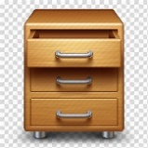 drawer
draw | drawing
around | raw
Online game: memory game
https://wordwall.net/resource/58497860

Hebrew definitions
fawn | עופר (אייל)
saw | ראה
strawberry | תות
yawn | לפהק
around | מסביב
draw | לצייר
raw | נא
drawing | ציור
drawer | מגירה
crawl | לזחול
dawn | שחר
awkward | מביך , לא נוח, לא חנני

