Shimon at the Shop
Shimon has ten dollars. | Shimon is at the shop
Oh, no! Shimon has a problem. | He lost all his dollars!
They fell from his hand. | Shimon is sad.  It’s O.K. – Mr. and Mrs. Cohen find them.

Word List
1 |  | Shimon
2 | 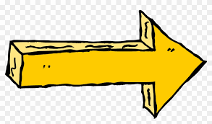 | to
3 |  | lose
4 |  | lost
5 |  | problem
6 |  | shop
7 |  | dollars
9 |  | Mr. and Mrs. Cohen
10 |  | OK
11 |  | fell
12 | 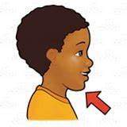 | from
Four in a Row
Play four in a row with a partner. Each chooses a different color marker.
Take turns, read a word and if you read it correctly, you can color it in.
The winner is the person to get four in a row first.
A row can be made ←↑

