Ms. Lake and Pale Kale
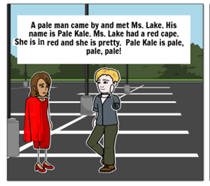 | 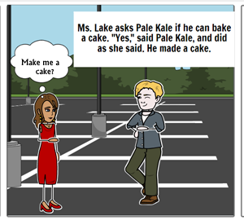
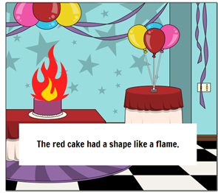 | 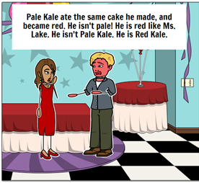
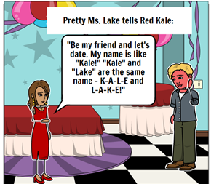 | 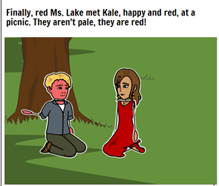

Word List
1 |  | pale
2 |  | Kale
3 |  | Ms. Lake
4 |  | came
5 | 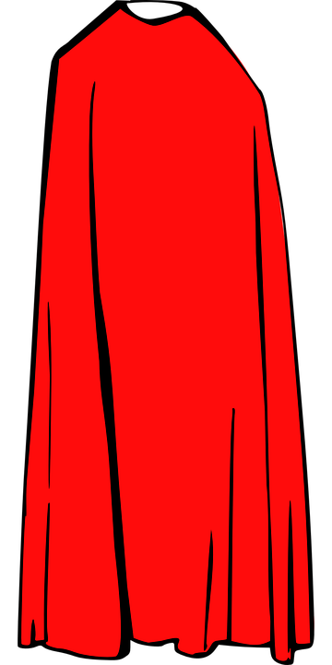 | cape
6 | 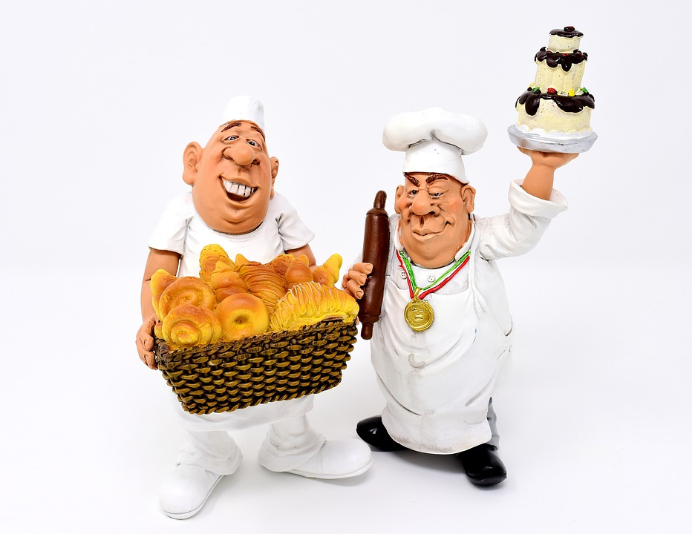 | bake
7 |  | cake
8 |  | flame
9 | 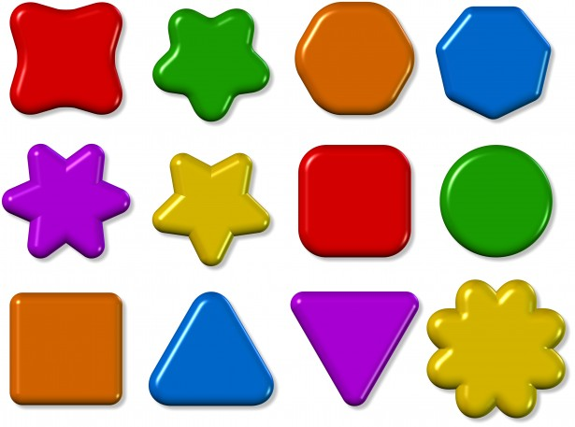 | shape
10 | 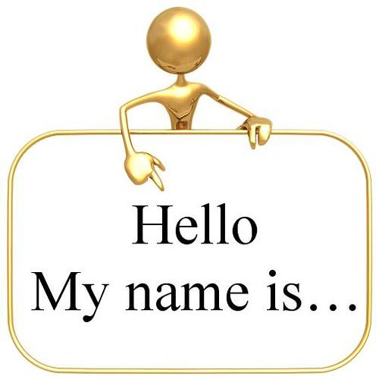 | name
11 |  | same
12 | 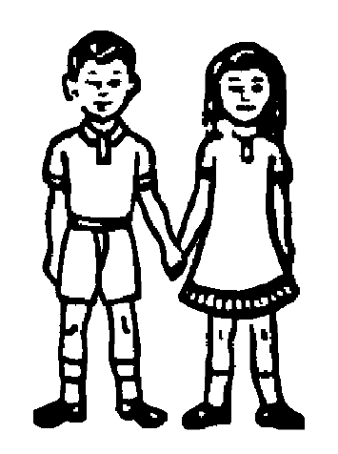 | date
Game:

Rewrite the letters in the right order.

plea ___ ___ ___ ___

leak ___ ___ ___ ___

kela ___ ___ ___ ___

cmae ___ ___ ___ ___

pace ___ ___ ___ ___

beak ___ ___ ___ ___

ckea ___ ___ ___ ___

shepa ___ ___ ___ ___ ___

lamef ___ ___ ___ ___ ___

mane ___ ___ ___ ___

seam ___ ___ ___ ___

deat ___ ___ ___ __

