Panic at the Picnic
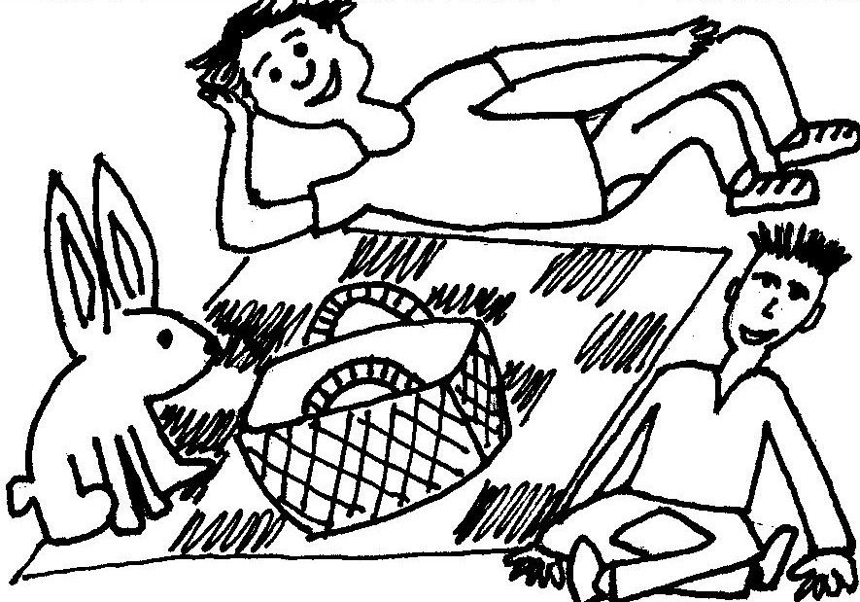  Eric and Mick are at a picnic.  A rabbit sits at the picnic. | 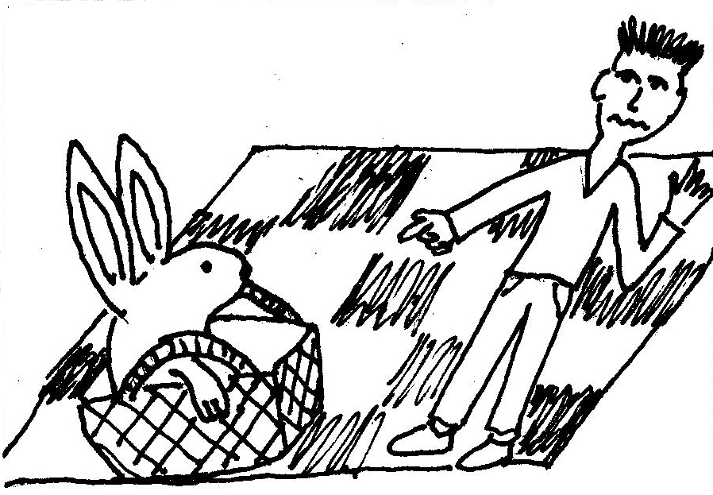  “Panic! Panic!” said Eric. “A rabbit sits at the picnic! It's in the basket.”
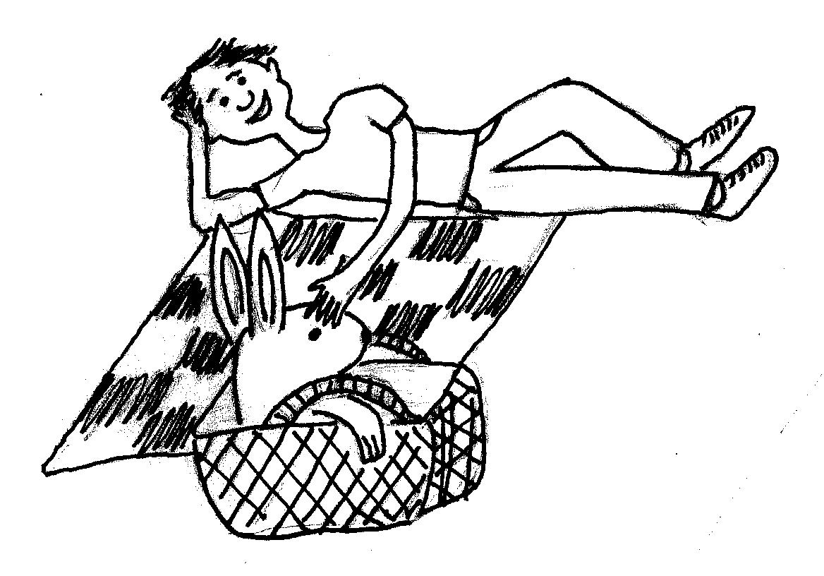  Mick didn’t panic.  “It is a rabbit,” said Mick. “It's timid.” | 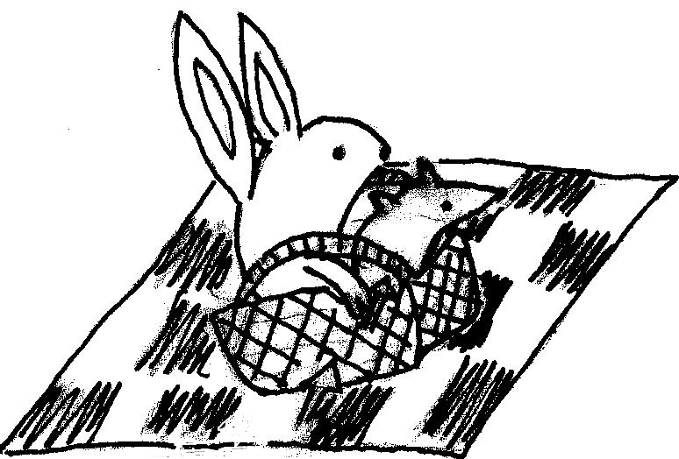  Then a rat sat at the picnic. The rat sat in the basket.
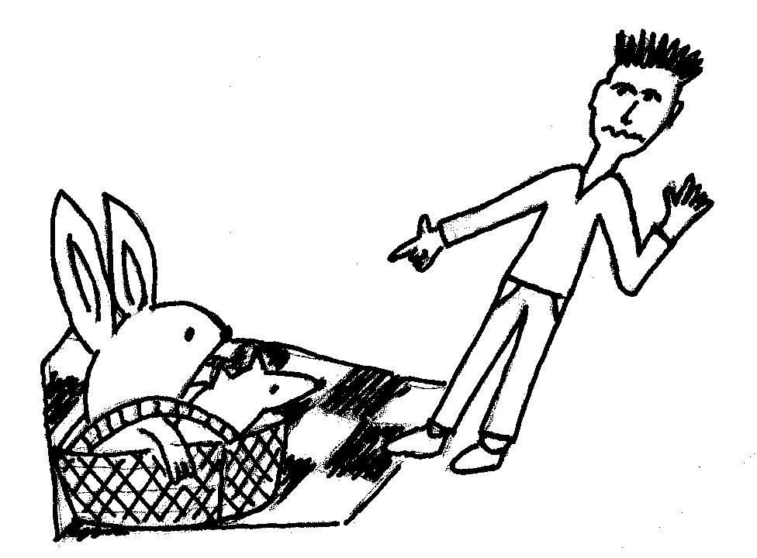  “Panic! Panic!” said Eric.  “There is a rat at the picnic! | 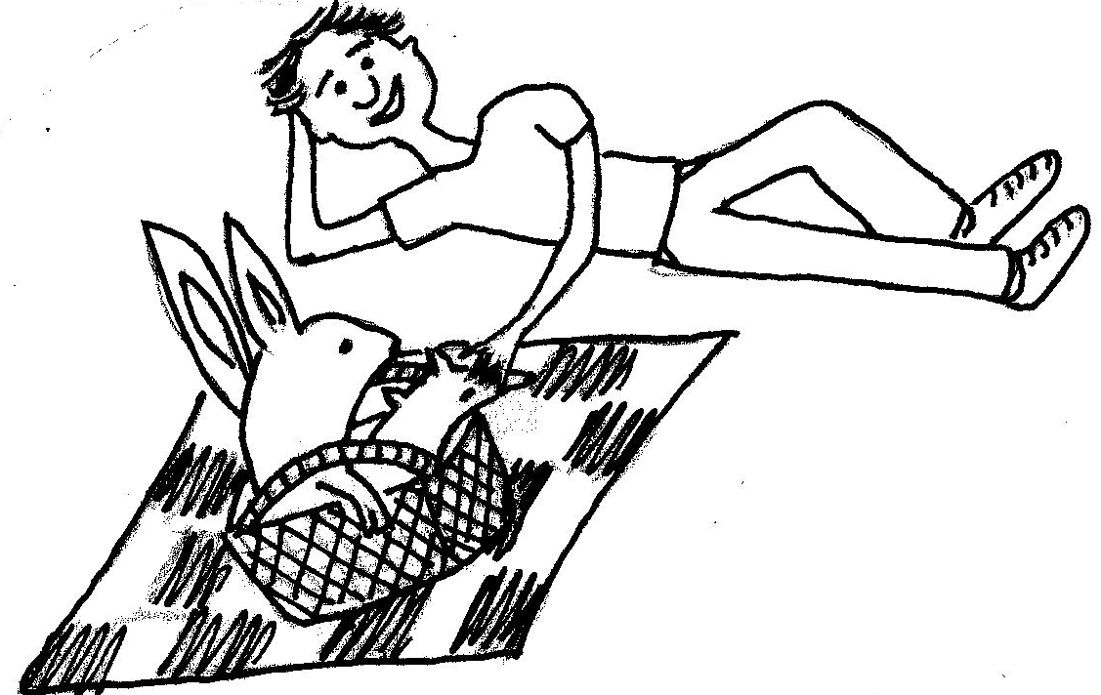  Mick didn’t panic.  “It is a timid rat,” said Mick.  The rabbit kicks the rat. The rat kicks the rabbit.

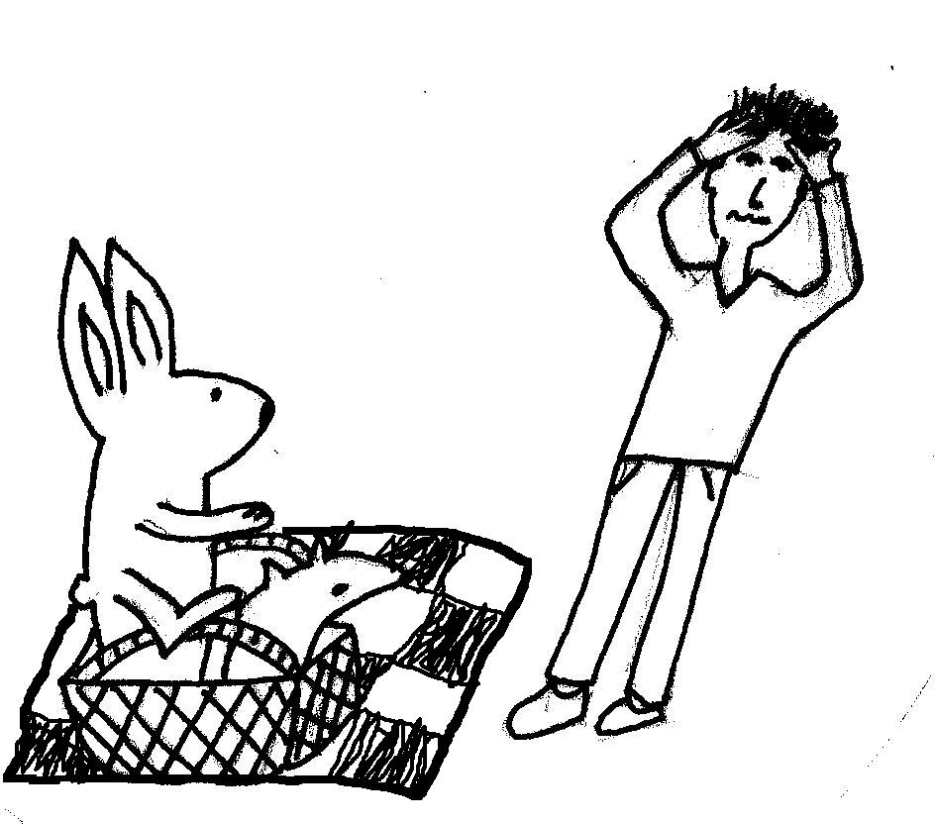  “It is hectic at this picnic,” said Eric.  “A rabbit and a rat sit and kick in the basket.” | 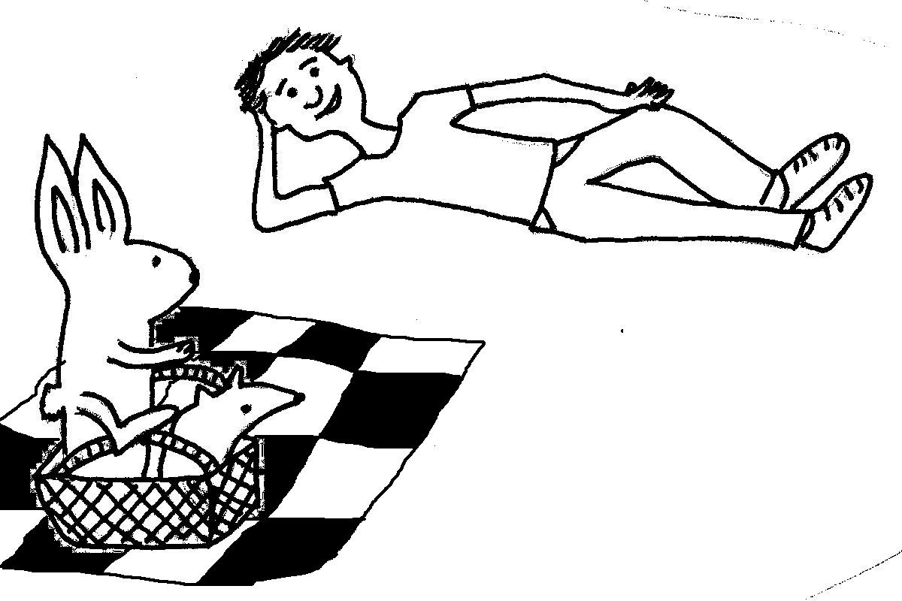  “It isn’t hectic,” said Mick.
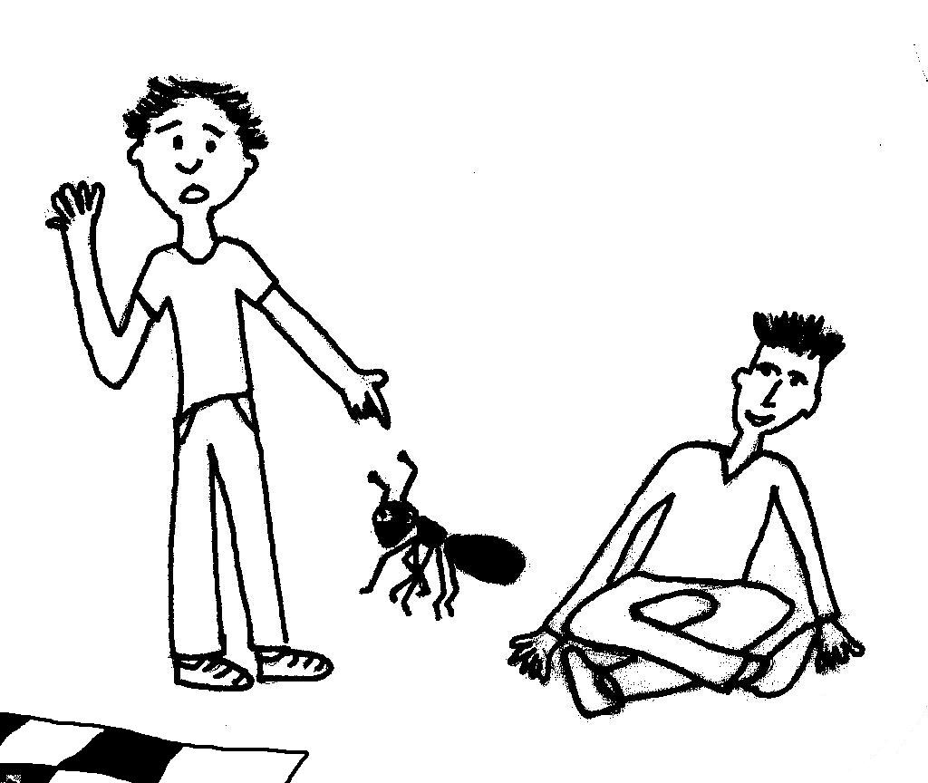  Then an ant sat at the picnic.  “Panic! Panic!” said Mick. | 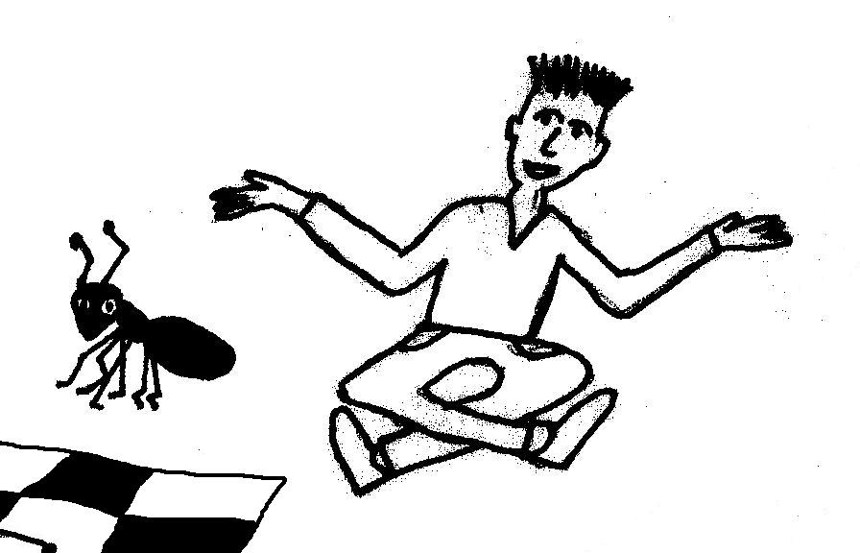  Eric didn’t panic.  “It is a timid ant,” said Eric.

Word List
1 | 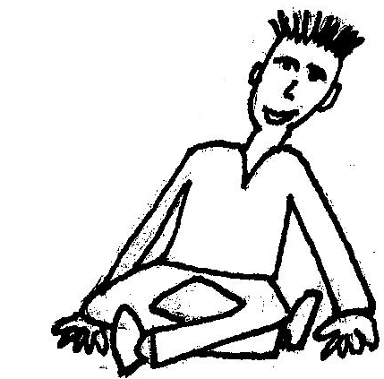 | Eric
2 | 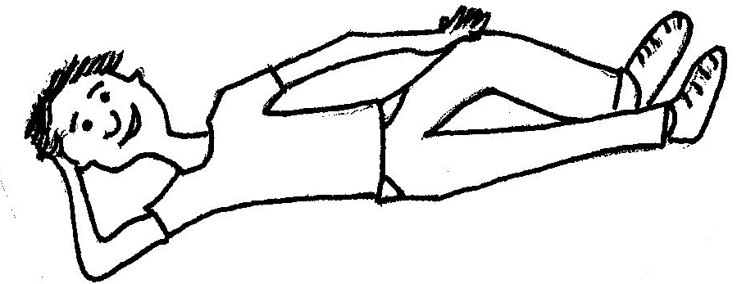 | Mick
3 | 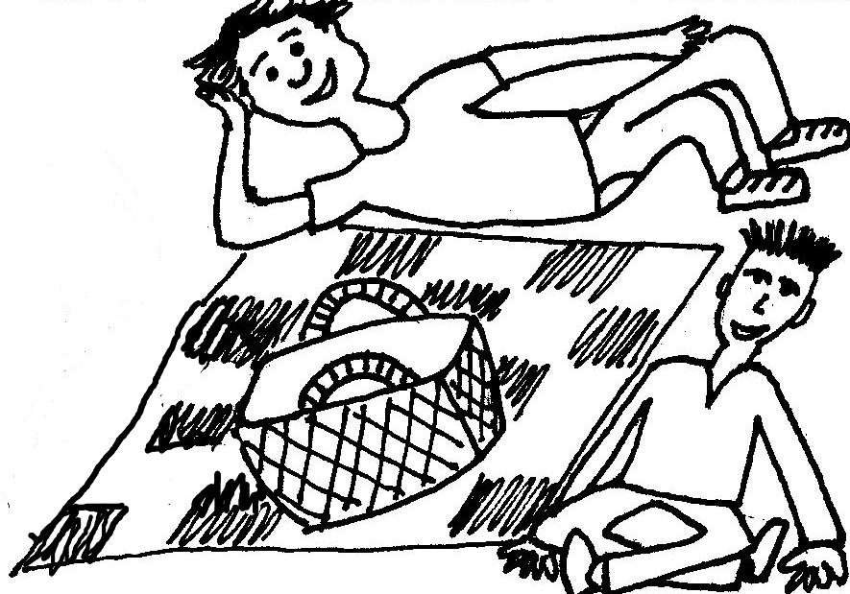 | picnic
4 | 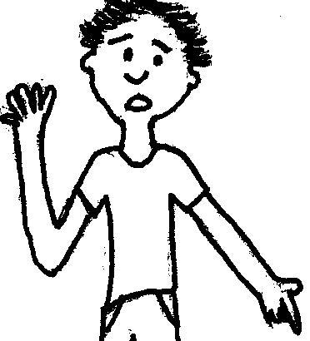 | panic
5 | 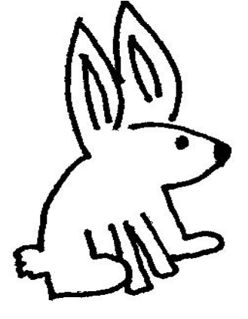 | rabbit
6 | 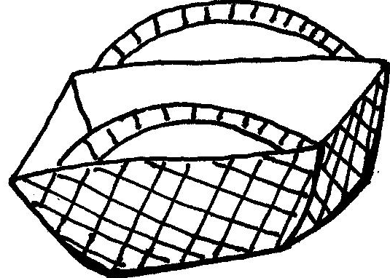 | basket
7 | 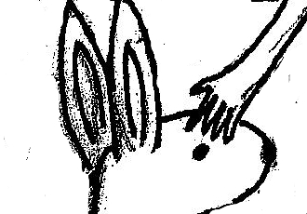 | timid
8 | 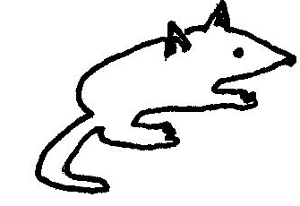 | rat
9 | 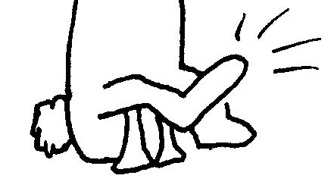 | kick
10 | 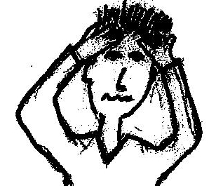 | hectic
11 | 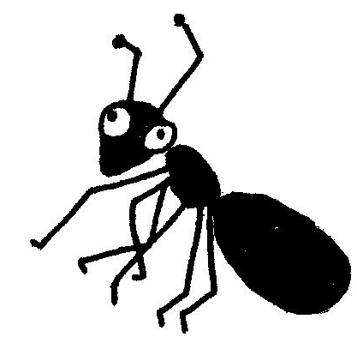 | ant
12 | 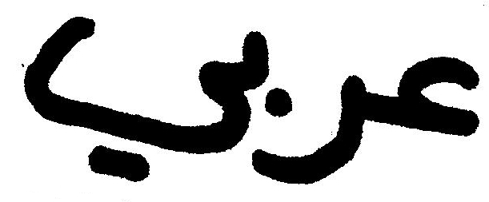 | Arabic
Symbol Board Game
Preparation: If you have not yet printed it, print the game board (page 1) from the Games section on the Documents for Download page of the David Yellin Hickey website: Symbols Game Board (created by Mandy Harpaz). This is a generic path game with question marks and colorful heart, triangle, and smiley symbols along the way. Laminate the board. Fold the table containing cards, below, on the middle dotted lines so that the picture or word is on the front and the symbol is on the back of each card. Glue the two blank inside sides together. Cut into cards. Laminate or cover with contact paper for long-lasting results.

Play: Player rolls the die & moves to a square. Each square has a specific symbol. Player has to choose a card from the pile with the matching symbol and do one of the following things.

HERE ARE THE CARD CATEGORIES:
 Read the word aloud.
 Say the English word for the picture.
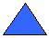 Act out the word
? : Ask a question using the word

Eric |  |  | 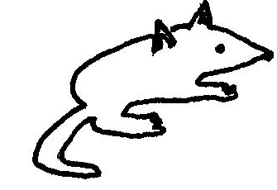
picnic
hectic
panic |  |  | Mick | ?
rabbit |  |  | basket  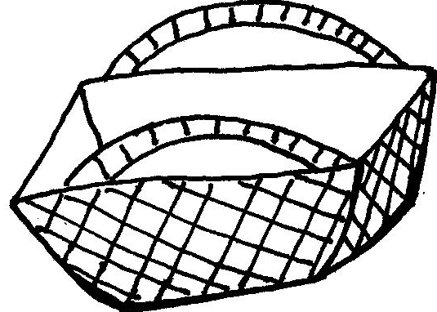 | ?
kick |  |  | timid | ?

