Ant in a Pan
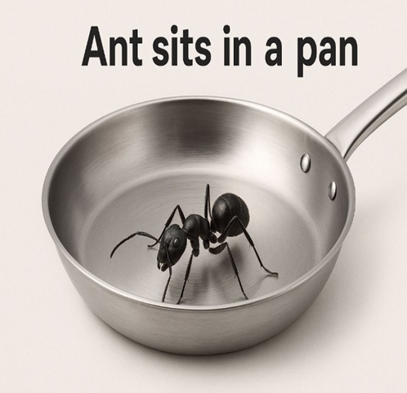 | 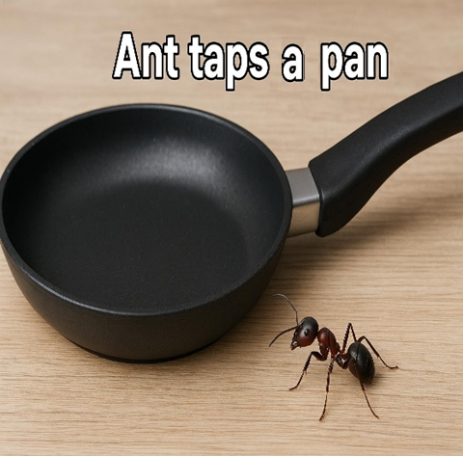
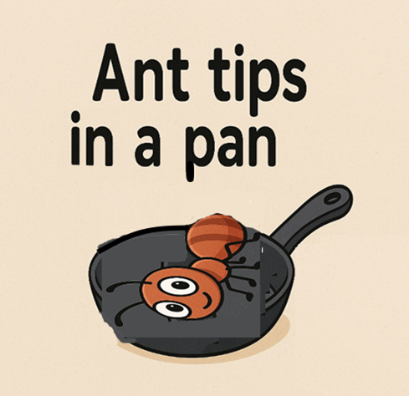 | 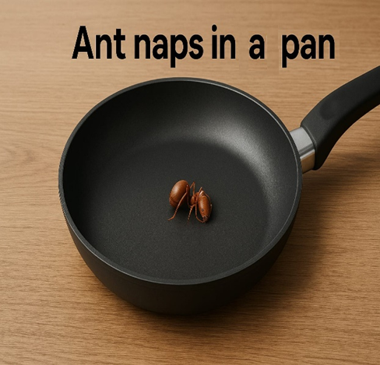
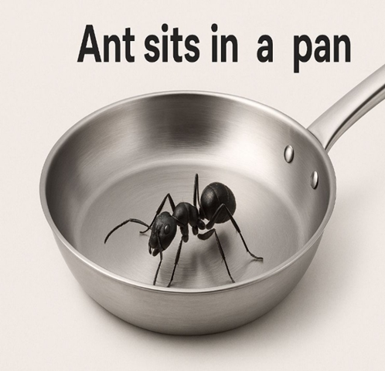 | 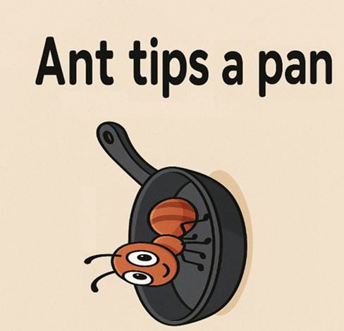

Word List
1 | 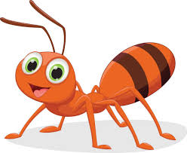 | ant
2 | 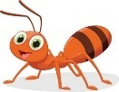 | ants
3 | 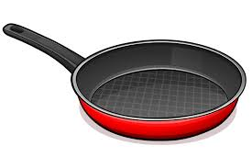 | pan
4 |  | pans
5 | 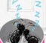 | nap
6 | 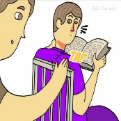 | tap
7 |  | spin
8 |  | tip
9 | 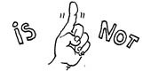 | isn't
10 | 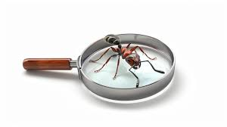 | in
11 |  | tin
12 |  | tins

Word to Picture Matching Game:

How to Play:
- Print the word cards and picture cards.
- Cut out the cards.
- Match each word to the correct picture.
- Read the word out loud when you make a match.
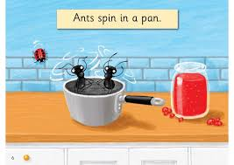 | spin | 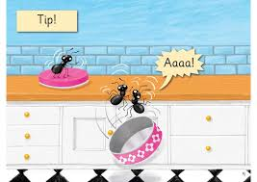 | tip
 | in |  | pan
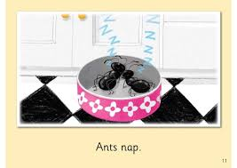 | nap |  | ant
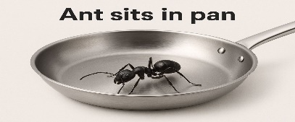 | sit | 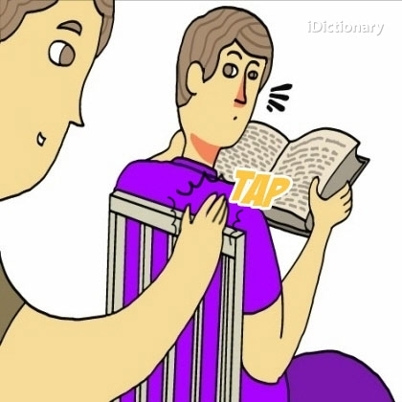 | tap

https://wordwall.net/resource/96751931/matching

How to Play the Word wall Game.
- Click Start to begin the activity.
- You’ll see a board with face-down tiles.
- Click one tile to reveal what’s underneath (a word or picture).
- Click another tile to find its matching partner:
  - Match a word (e.g. “ant”) with its picture

