Rex and the Chocolate Cake
Joy and Jonathon helped Dad bake a big chocolate cake for Mom's birthday.  Dad and the children went out to play in the garden.  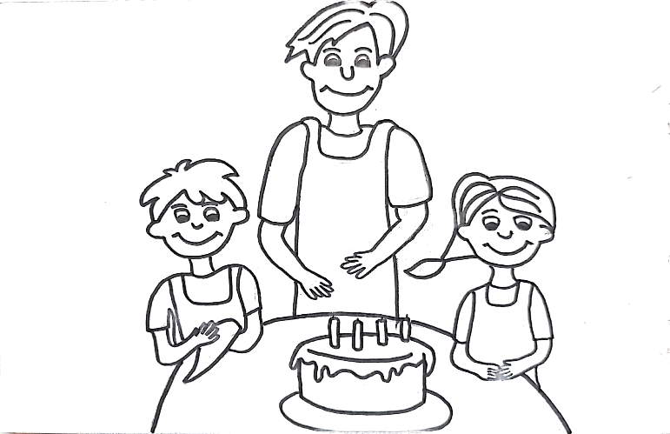 | The family dog, Rex, jumped on the table and ate the cake.  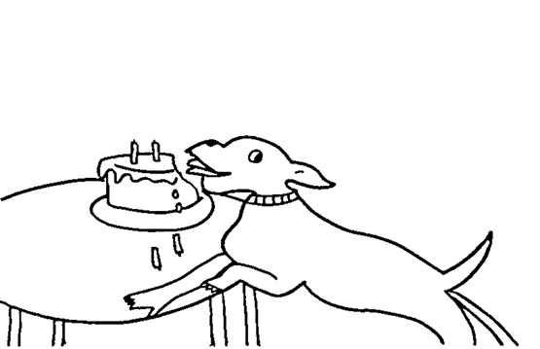
Joy and Jonathon found Rex on the floor. "What happened to Rex?" said Joy, "He looks terrible." "Look, he ate the chocolate cake!" said Jonathon.  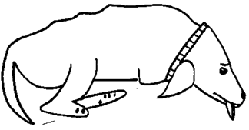  "Let's take him to the animal hospital." "That's a great idea" said Dad. "Let's go!" | The family got lost on the way to the vet, so they stopped and asked a policeman: "Where is the animal hospital?"  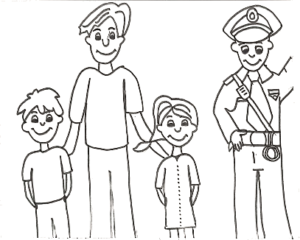  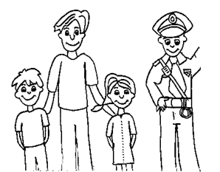  The policeman said:  "It is opposite the supermarket.
The vet looked at Rex and said: "Your dog looks terrible. Do you know the reason why?"  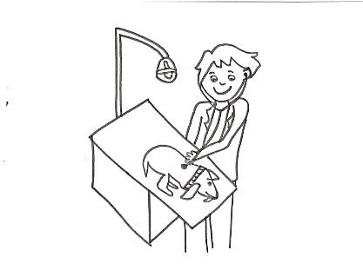  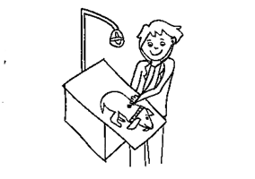  “Yes" said the children, "He ate a whole chocolate cake."  "Oh, no." said the vet, "Chocolate is terrible for animals. You need to go to the pharmacy to buy medicine for Rex." | 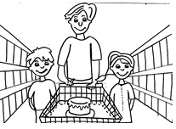  The family went to the pharmacy to buy Rex's medicine. Then the children said: "We have an idea! Let's go to the supermarket and buy a chocolate cake for Mom's birthday." Dad agreed: "That's a great idea!"
Word List
1 | 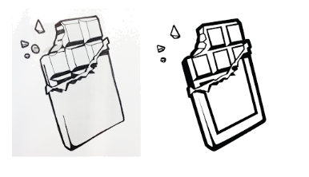 | chocolate
2 | 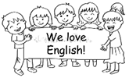 | children
3 | 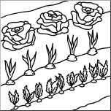 | garden
4 | 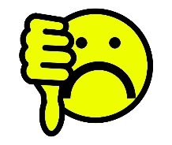 | terrible
5 | 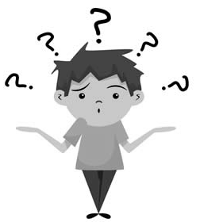 | reason
6 |  | idea
7 |  | hospital
8 |  | police
9 | 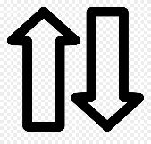 | opposite
10 | 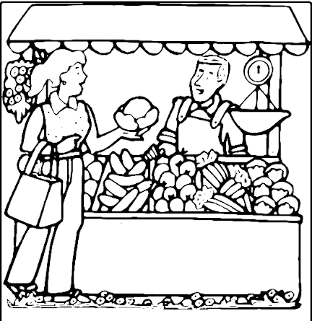 | market
11 | 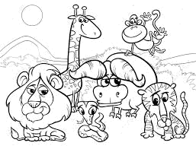 | animals
12 | 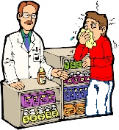 | pharmacy

Games

To print versions of board games using pictures, words, or both, see the accompanying PPT file.

Links to Online Games in Quizlet, (for phone or computer), no registration required:
Quizlet Match game https://quizlet.com/565625743/match Drag the word onto its picture or vice versa to make pairs disappear.

Quizlet Spelling game (with audio) The student sees picture and can hear the pronunciation of the word before spelling
https://quizlet.com/565625743/spell

Quizlet Gravity game https://quizlet.com/565625743/gravity Type the word for the picture before the asteroid falls to destroy your planet!

Quizlet Fill-in, Multiple choice, T/F quiz https://quizlet.com/565625743/test
Full review of the words and their meanings using various question types.

