Pope and the Stone Dome
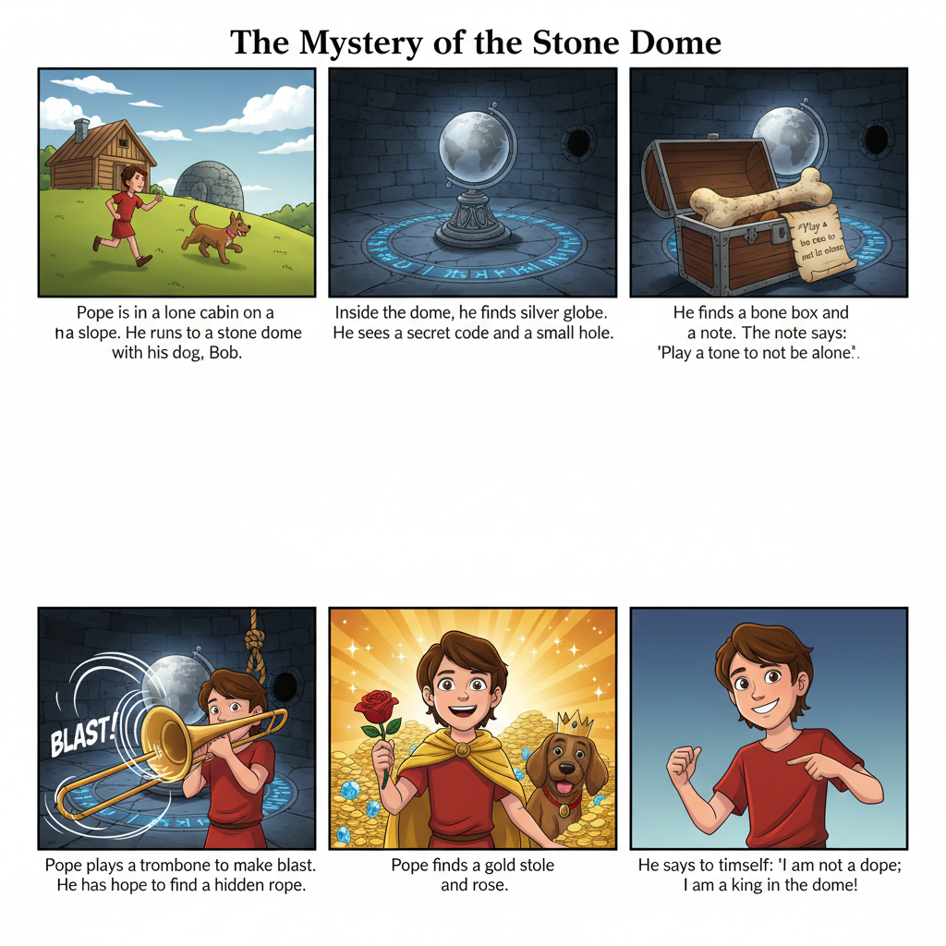  Pope is alone in a cabin on a slope. He finds a stone dome with his dog, Bob. | In the dome, there is a globe, beside it a secret code and a small hole.
He finds a note and a bone in the small hole. The note says: "Play a tone to not be alone" | Pope makes a note on a trombone.  He has hope to find hidden gold.
Pope finds a gold stole and a rose. | He says: "I am not a dope; I am a boss in the dome!
Word List
1 | 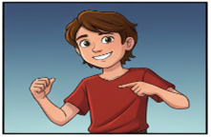 | Pope
2 |  | slope
3 | 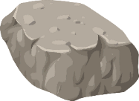 | stone
4 | 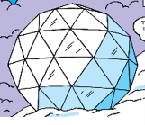 | dome
5 |  | globe
6 |  | code
7 | 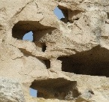 | hole
8 |  | hope
9 |  | note
10 | 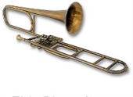 | trombone
11 |  | rose
12 |  | dope

A.Online activity
https://quizlet.com/il/1150630284/pope-and-the-stone-dome-flash-cards/?i=2y7si2&x=1jqt

- Lotto: Match the word to the picture
1. To play you need two boards (below), words =cut up and put in a bag, colored markers.
2. Each player chooses one board.
3. A player picks one card and reads the word aloud.
4. If the word matches a picture on the board, cover it with a marker.
5. The first player to cover all pictures wins.

Cut up these words and put them in a bag (for both Lotto and Bingo):

Pope | hope | hole
slope | note | tone
stone | trombone | code
dome | rose | alone
globe | dope | bone
stole

- Lotto Game Boards:
Player 1

Lesson 24 Lotto, Player 1:
Pope and the Stone Dome
 |  |  | 
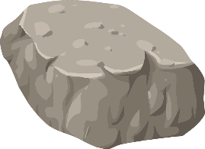 | 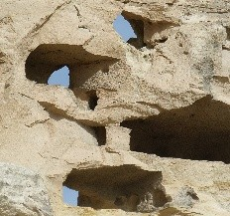 |  | 

Lesson 24 Lotto, Player 2:
Pope and the Stone Dome
  This Photo by Unknown Author is licensed under CC BY-SA |  | 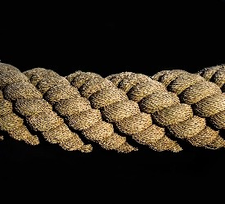 | 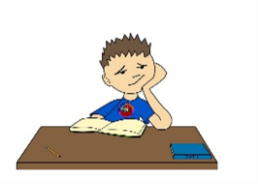
 | 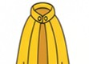 |  | 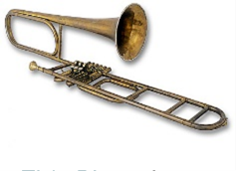
Player 2

C. Bingo Game
Same instructions as Lotto but the first person to get four in a row in any direction wins.
