Sometimes it Hurts
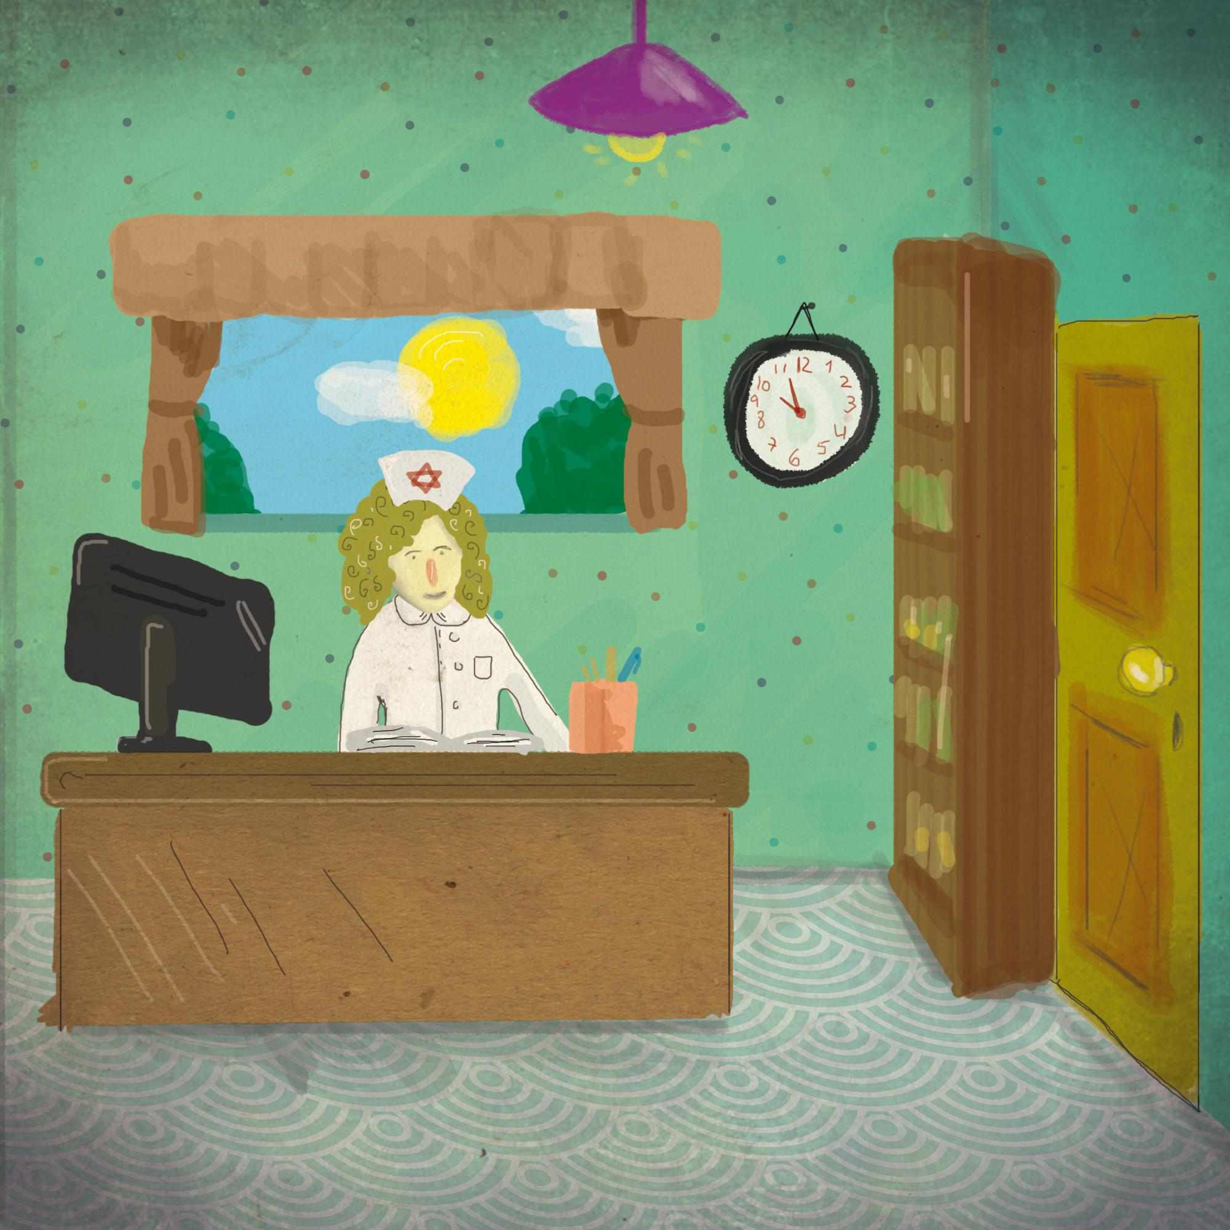  One sunny Thursday, a nurse with curly hair was sitting at her desk in the medical clinic. It was her turn to handle emergencies. | 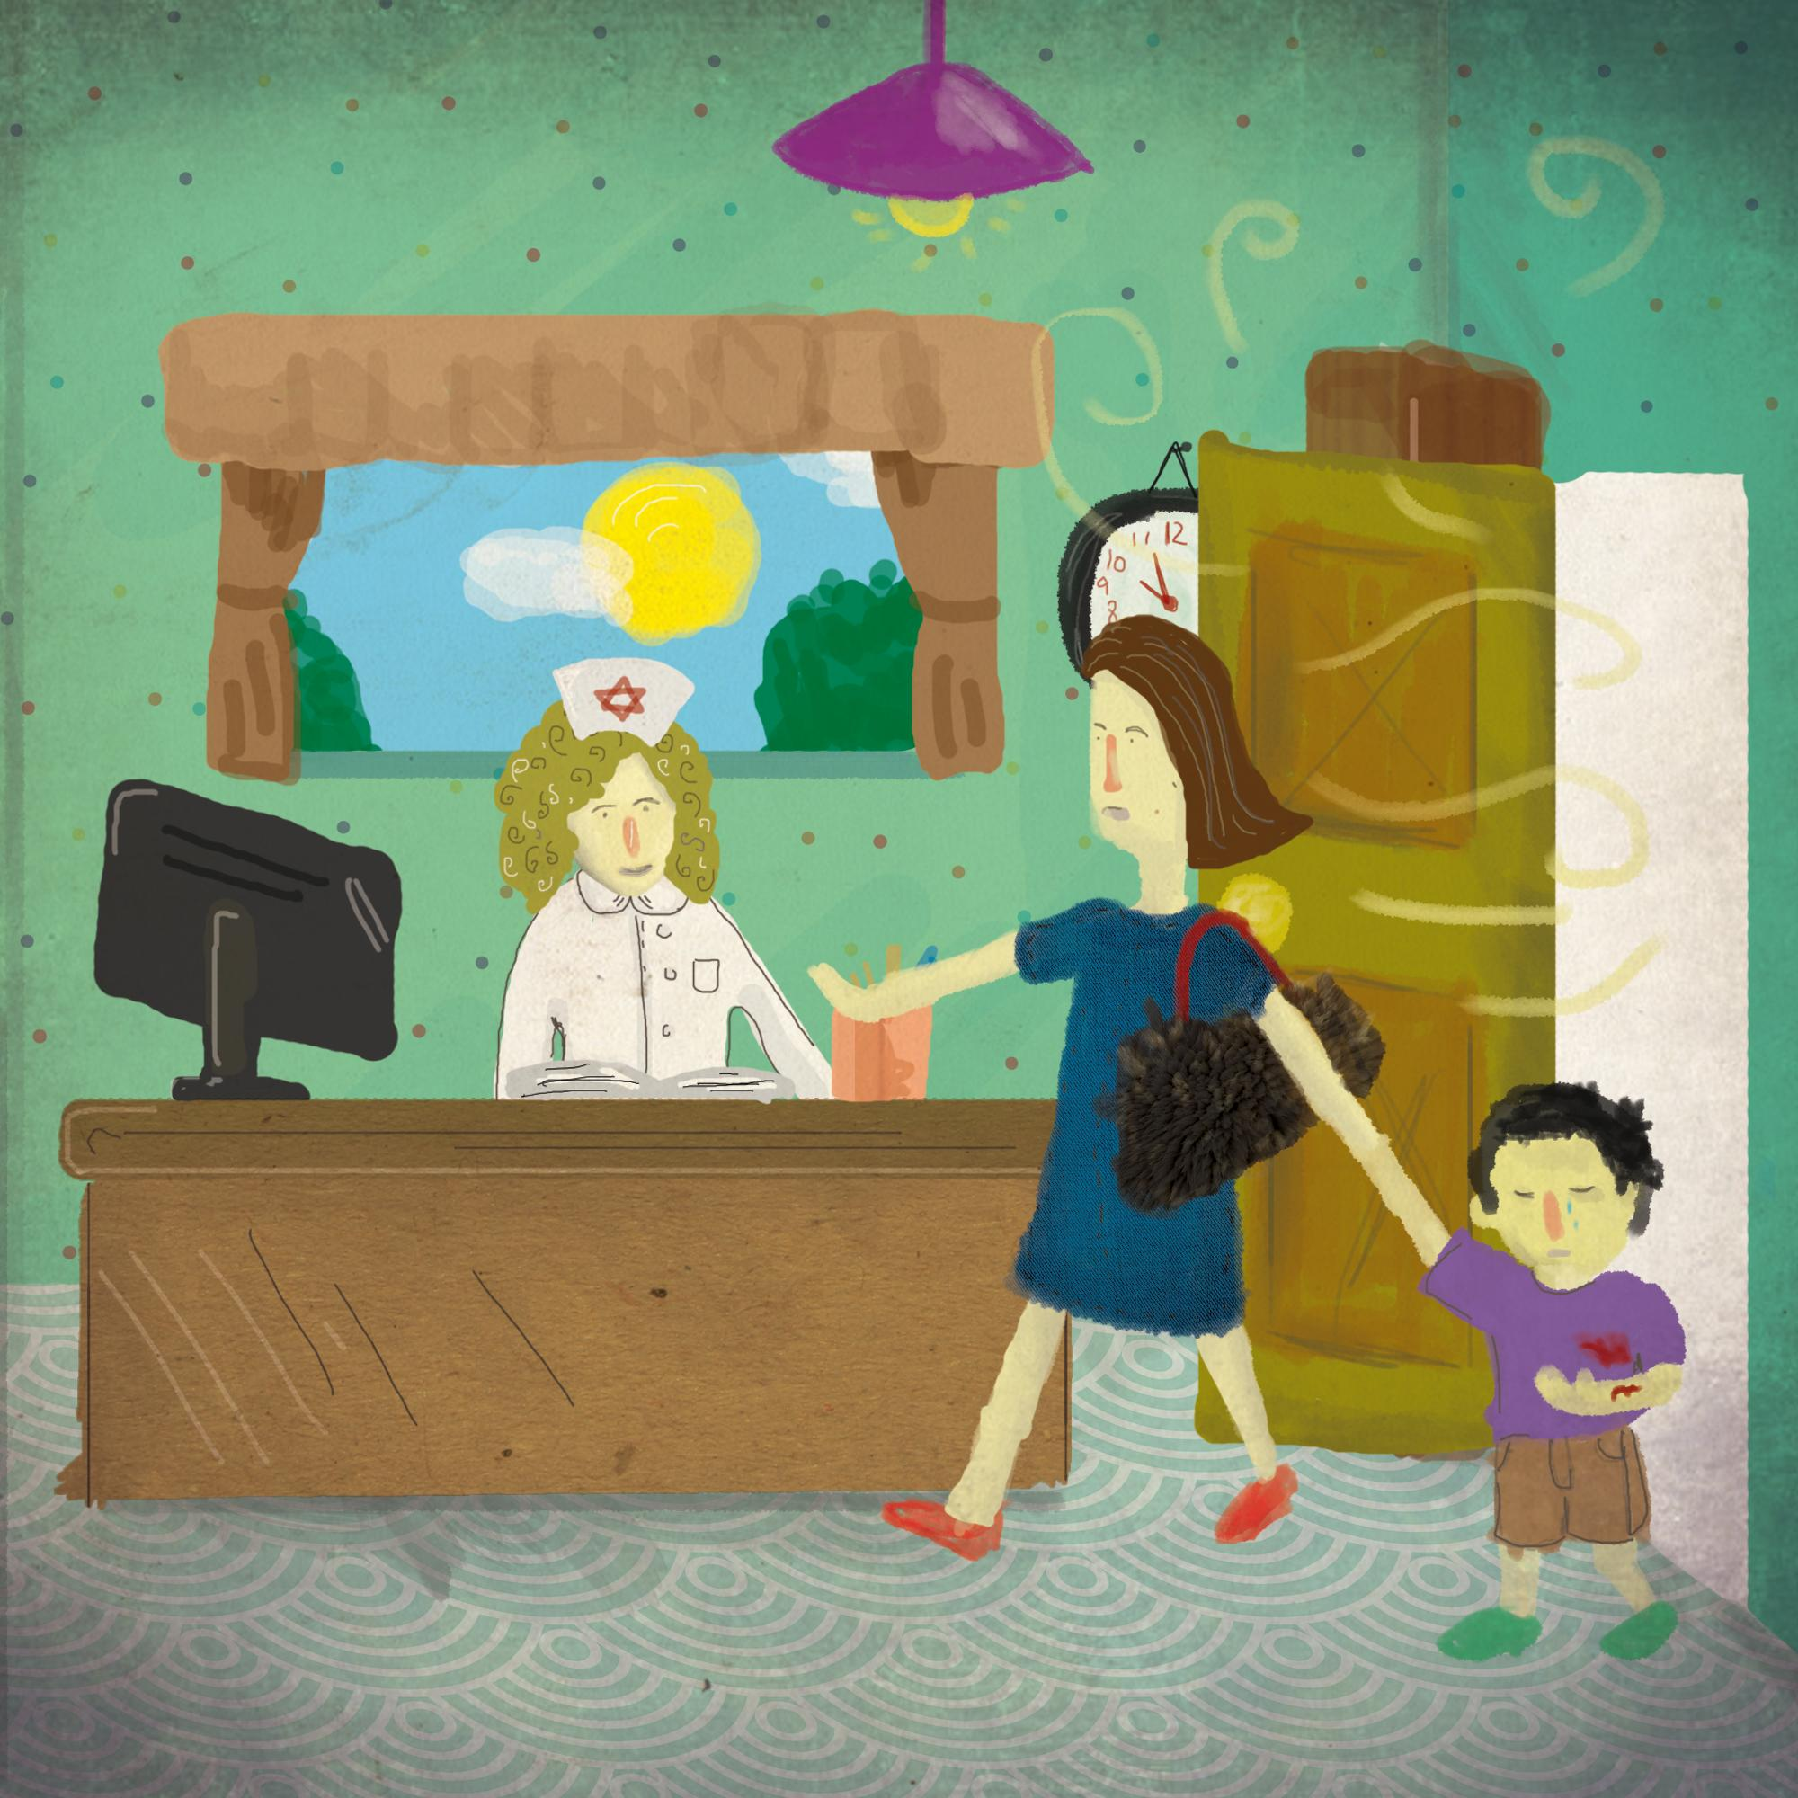  Suddenly, at about 10:00 o’clock, she was surprised by a woman with a furry purse who ran in with a young boy. He had blood on his purple shirt.
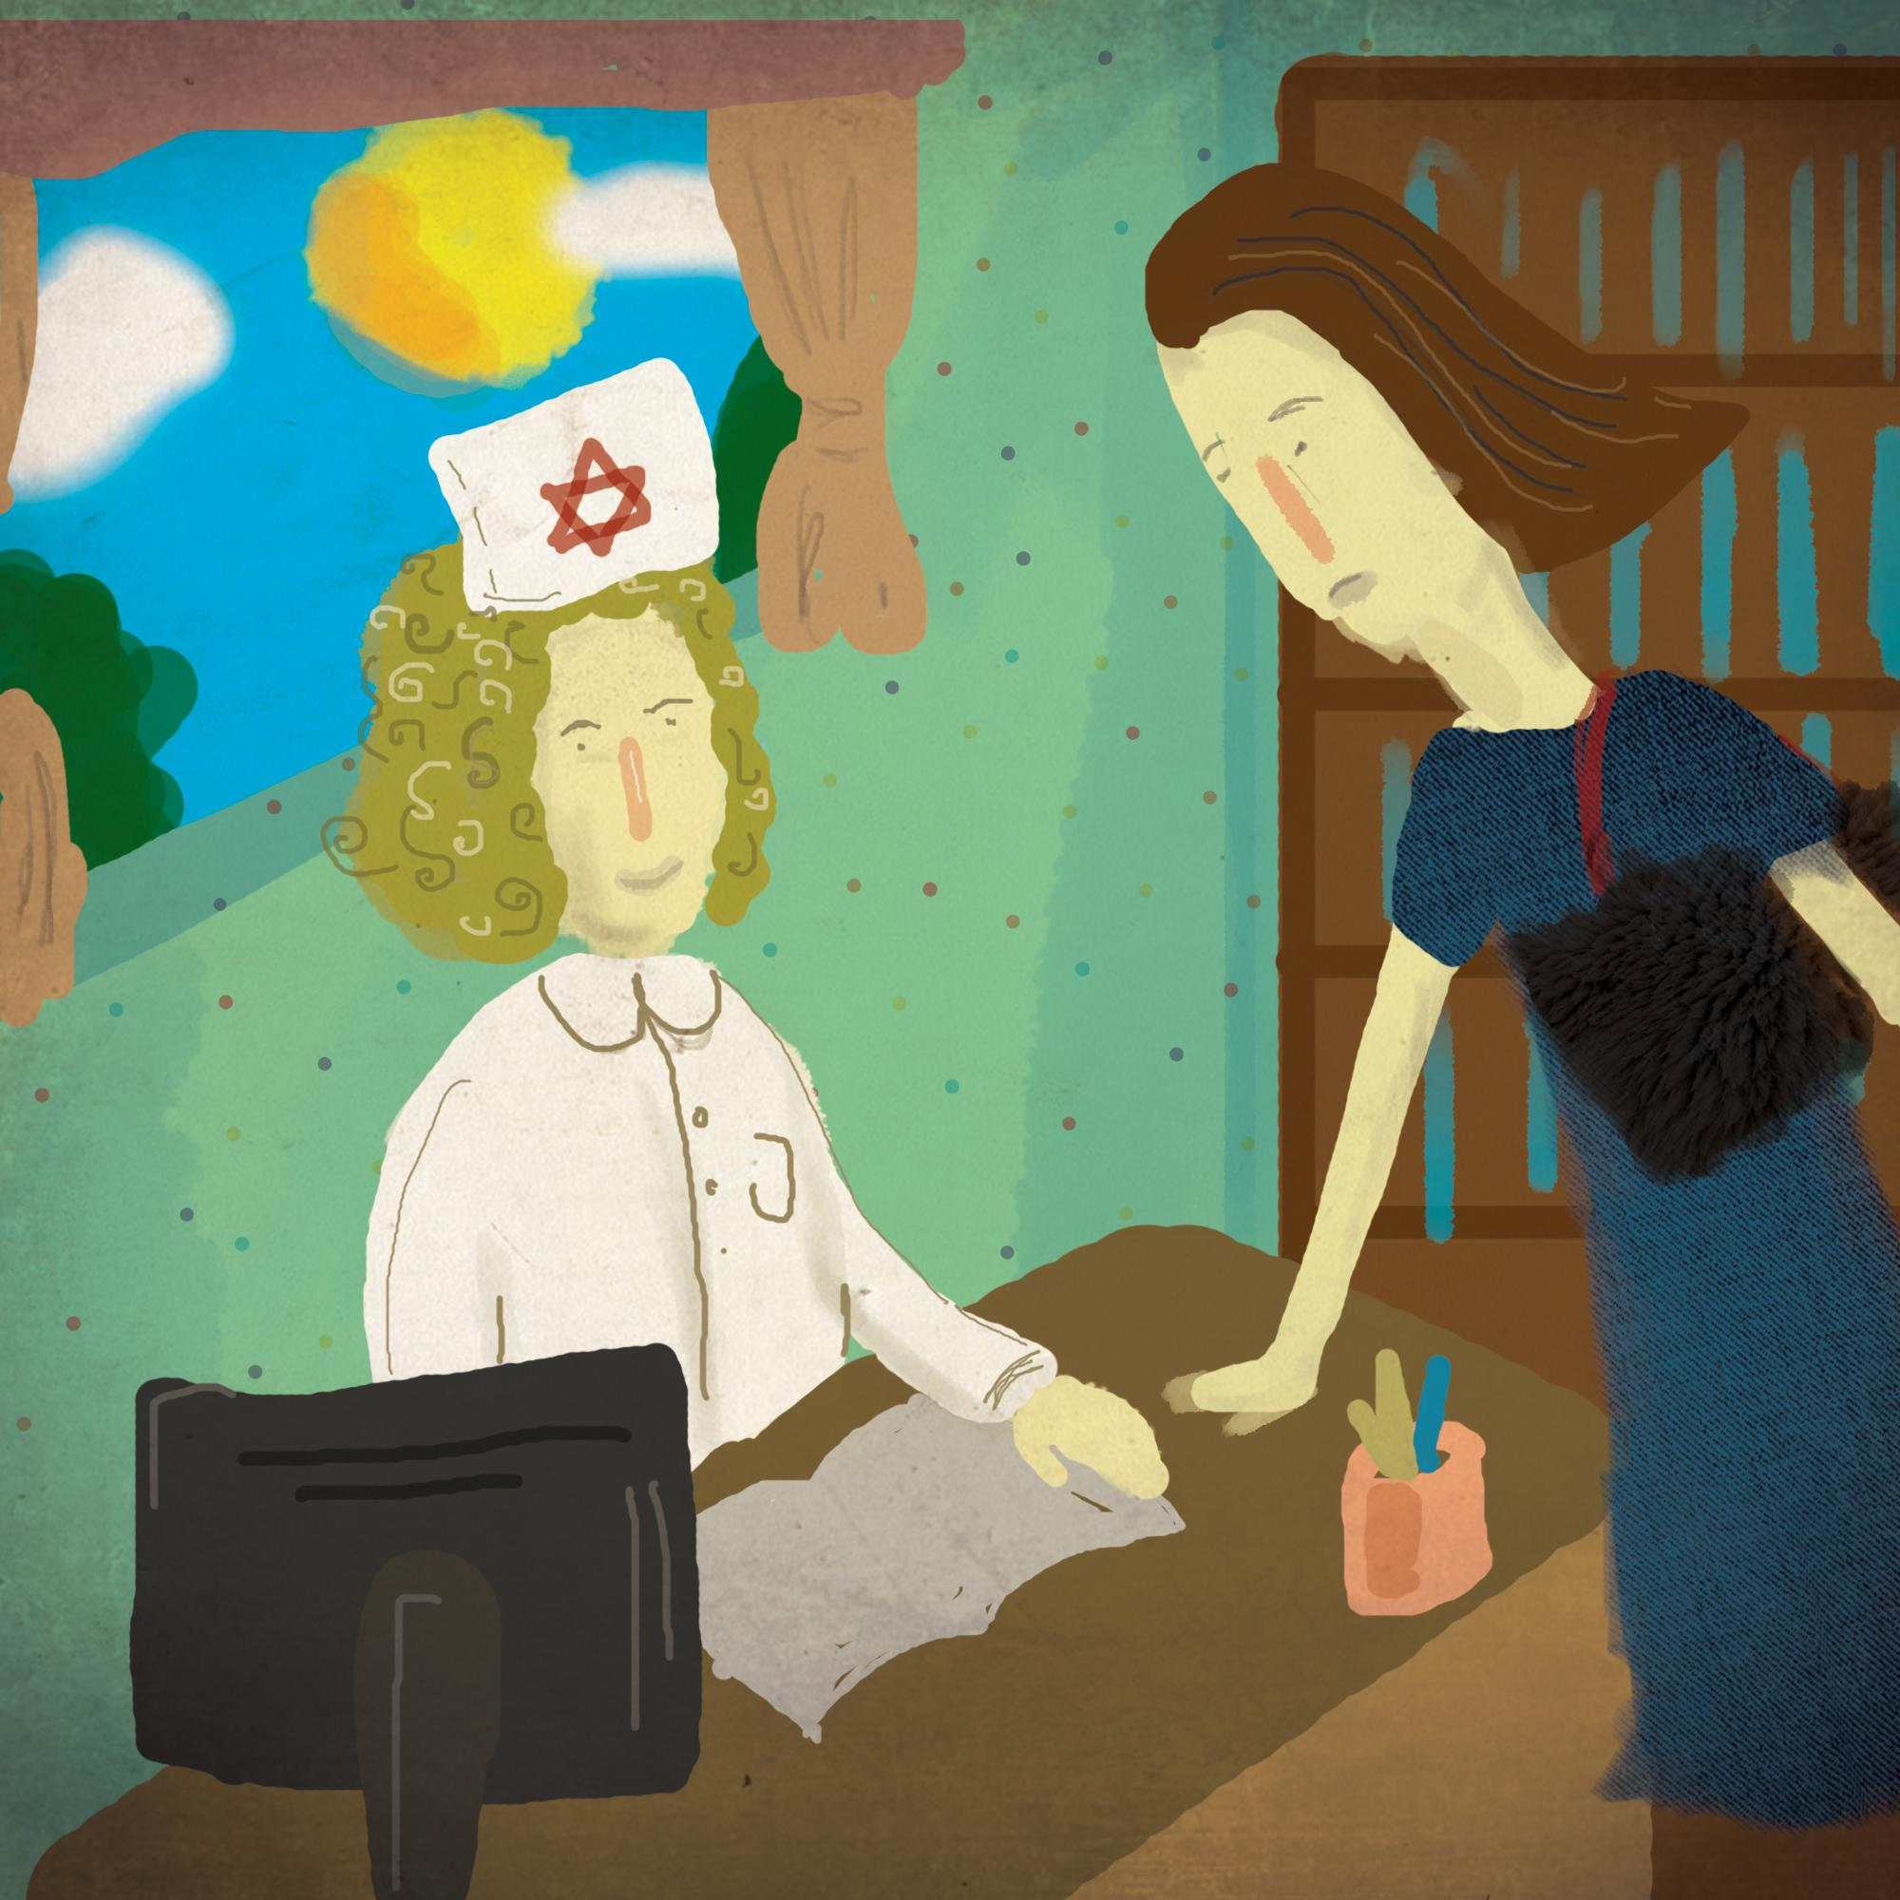  “This is urgent,” the woman said. “Please hurry and help this boy who is my student. His arm is bleeding a lot.” | 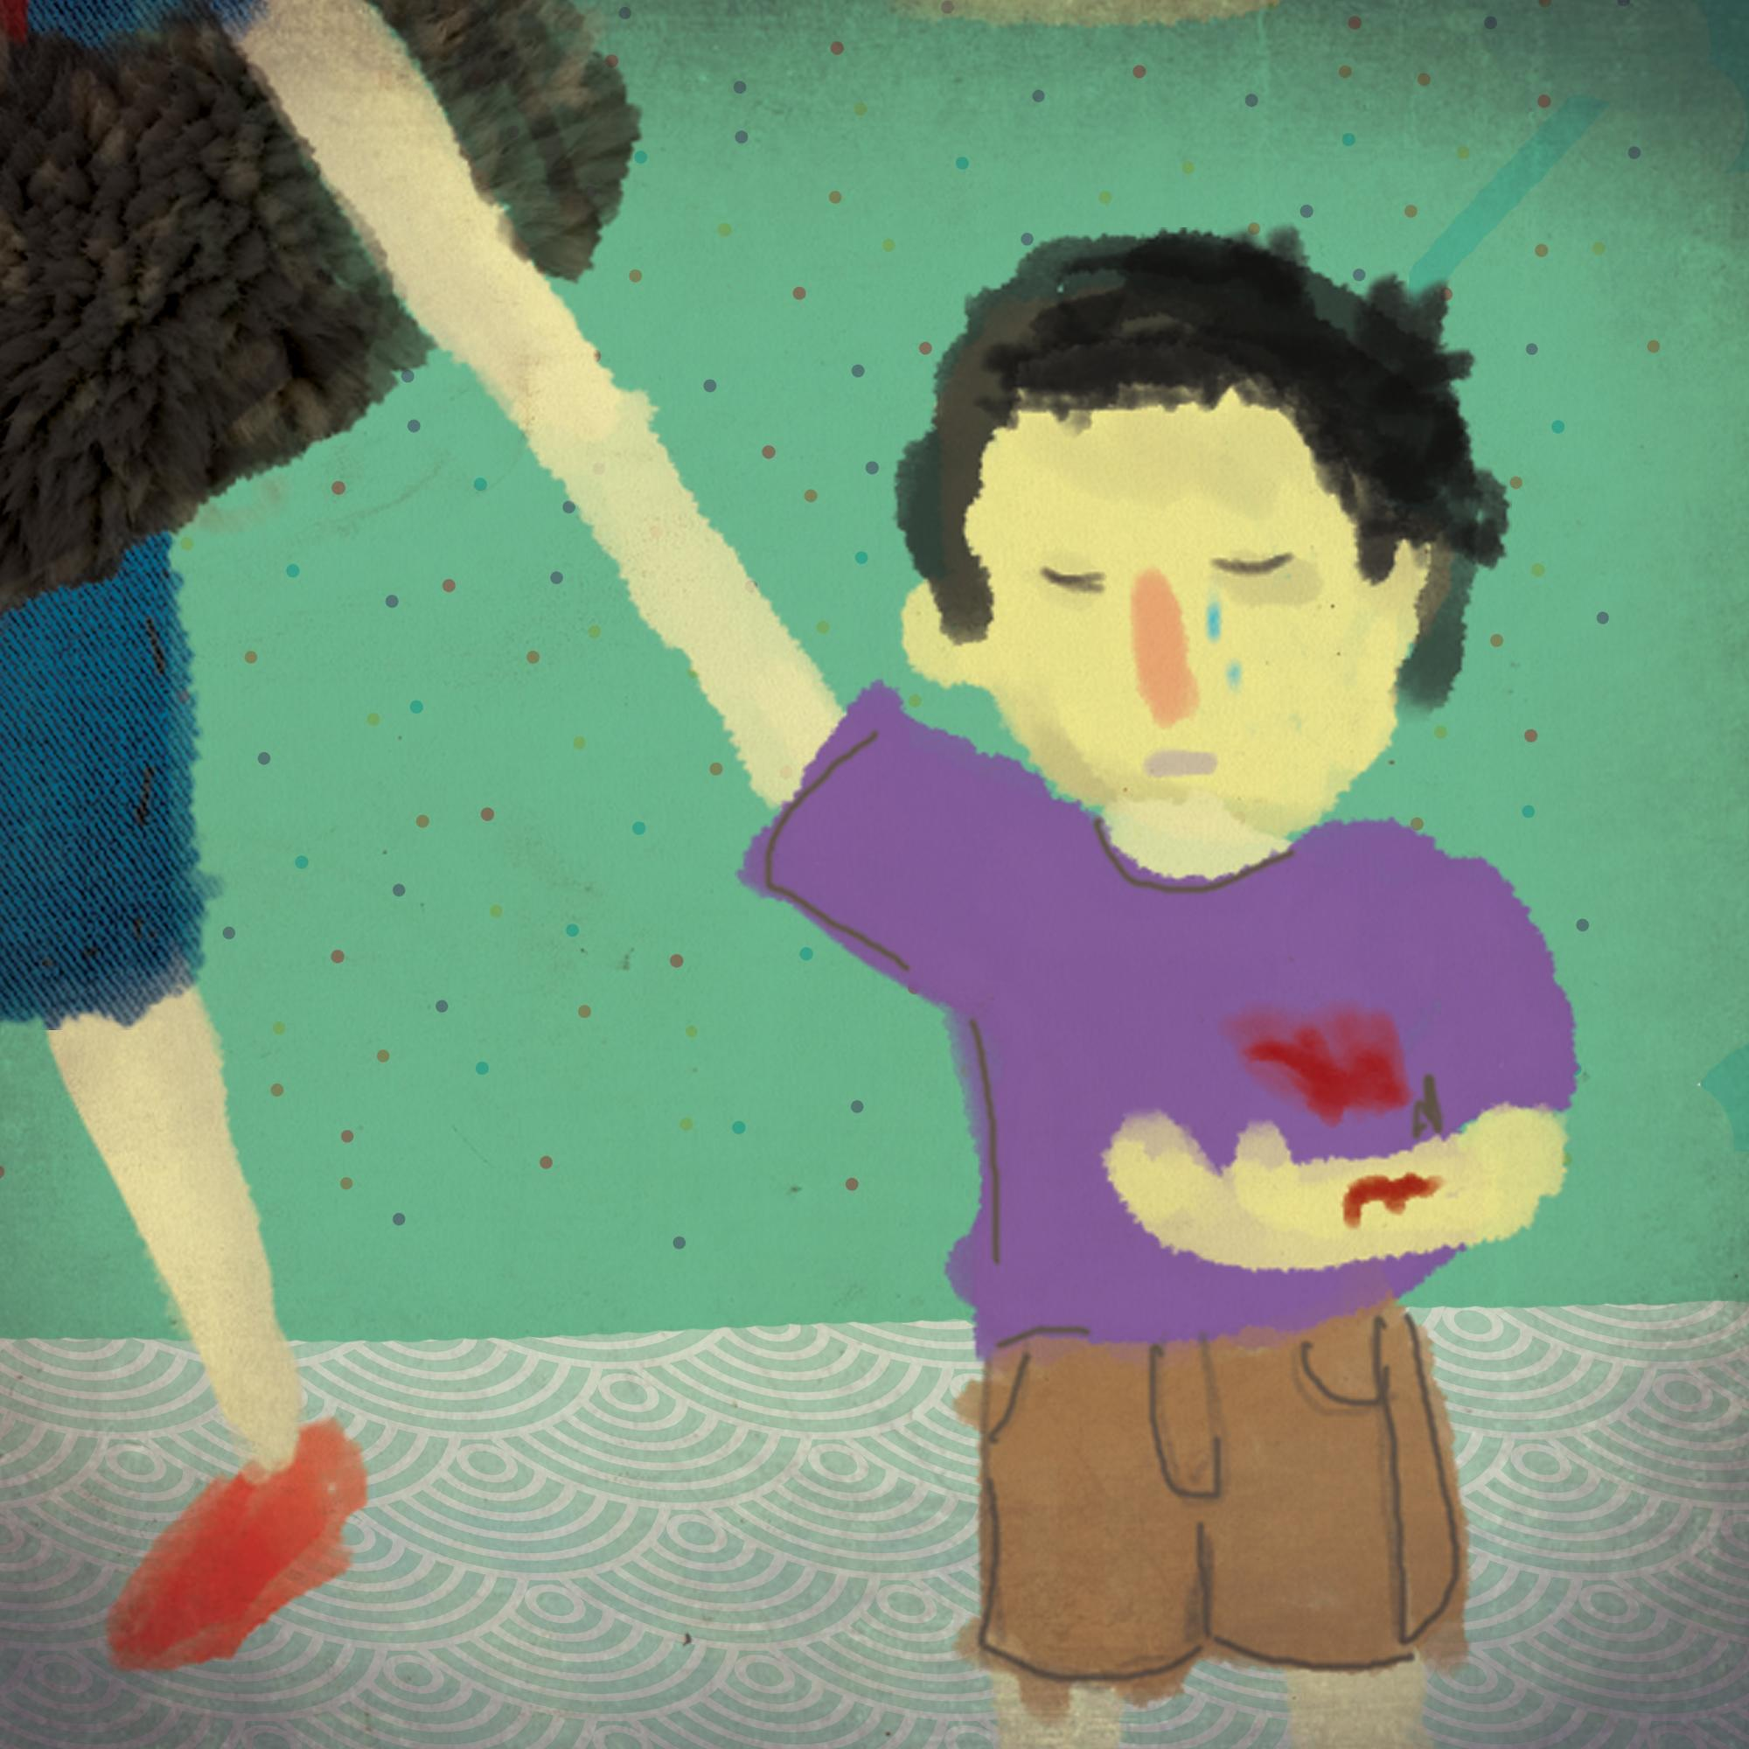  The boy was trying very hard not to cry. “I was running the fastest in a race but I tripped over Uri’s foot,” he said. “I know he didn’t do it on purpose but my arm REALLY HURTS!!”
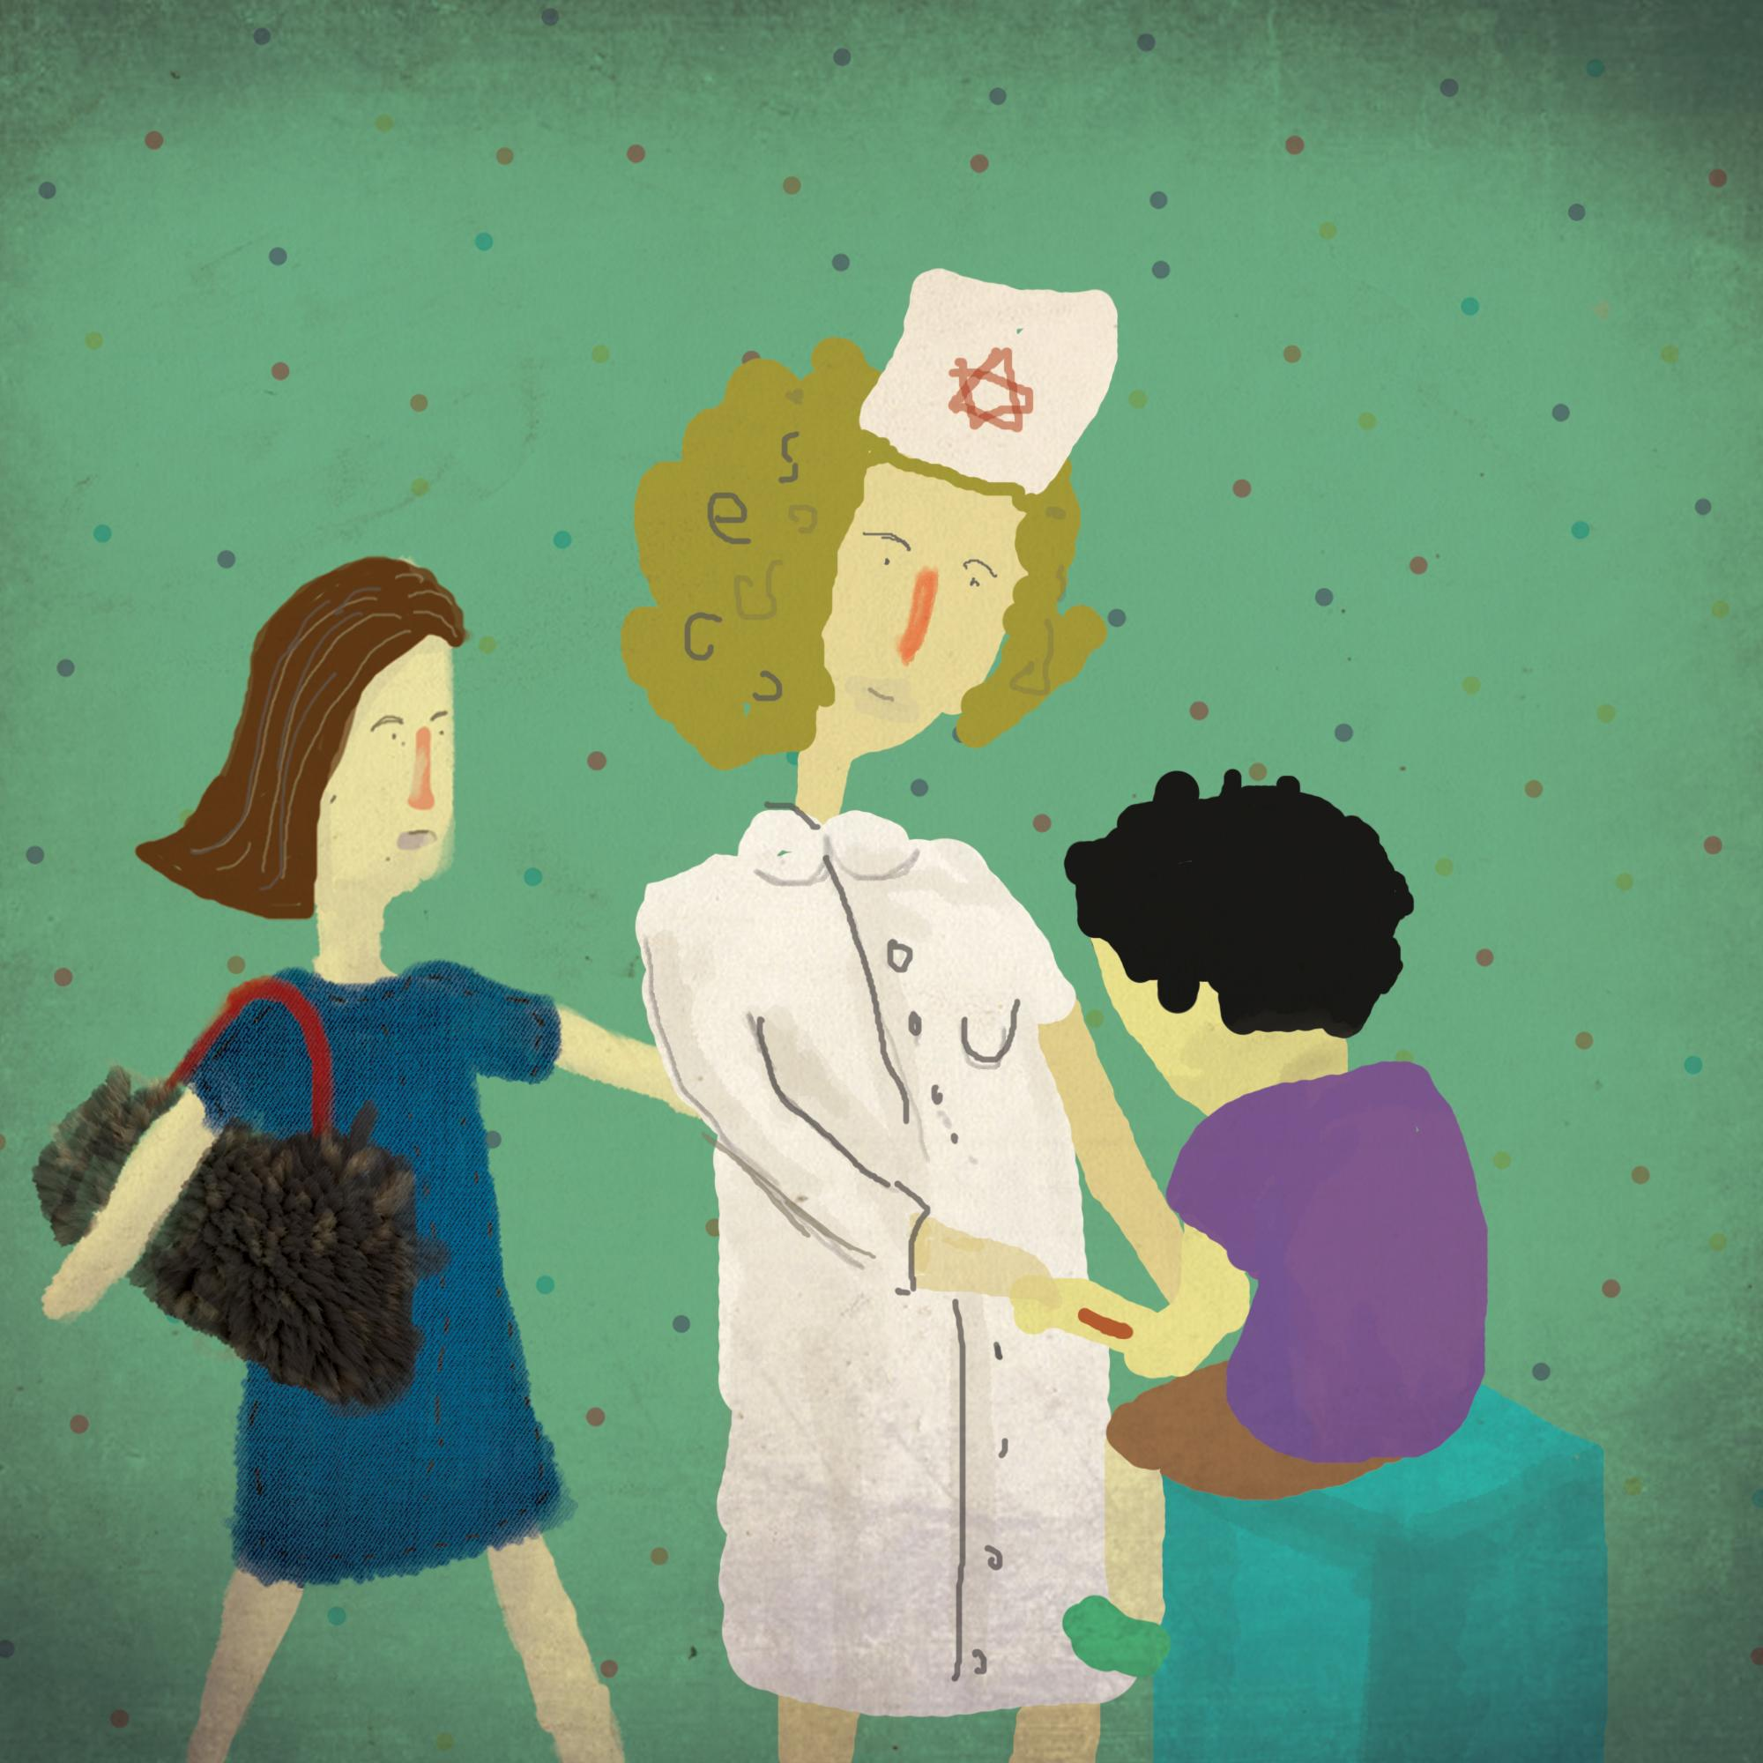  The nurse checked the cut on the boy’s arm. She also checked further to see that nothing was broken. “You will be perfect,” she said with a smile. “ I will put some cream and a bandage on it. It may burn a little but don’t worry.” | 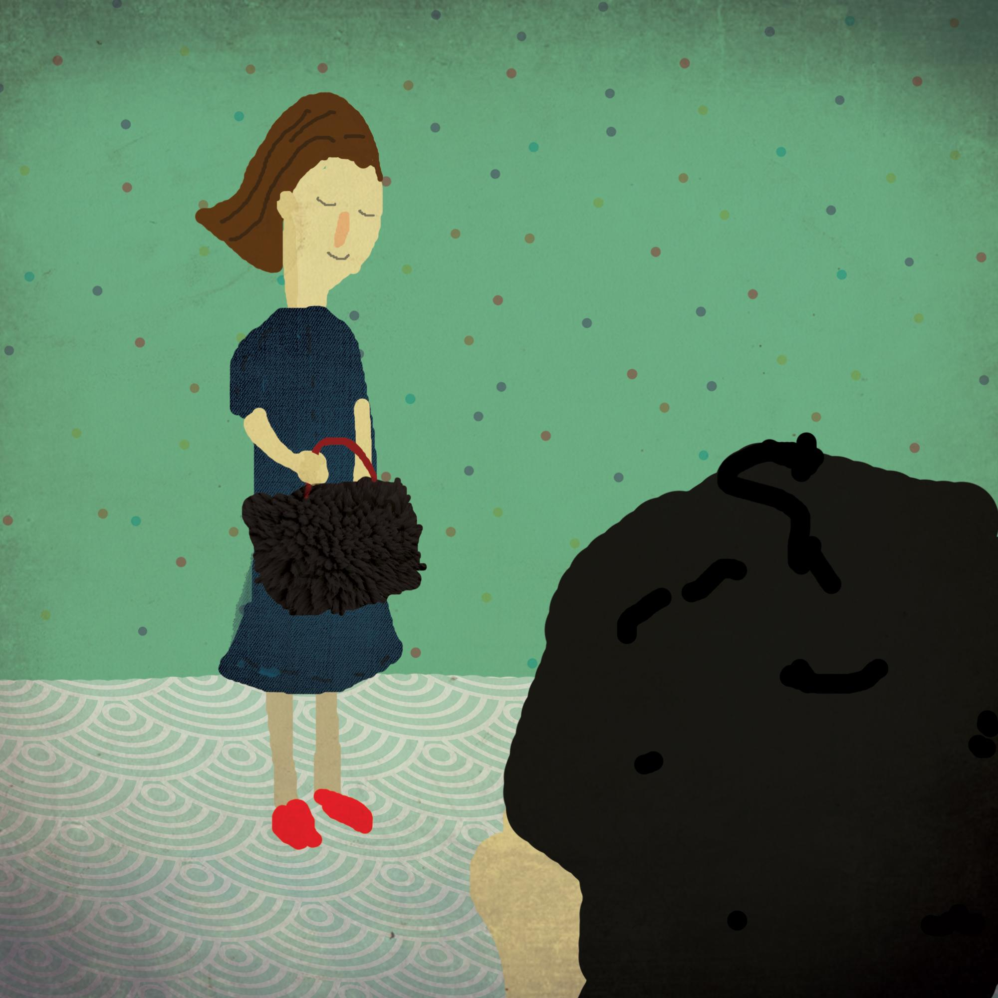  “I have something that will make you happy,” said the teacher. She took out of her furry purse the biggest lollypop that the boy had ever seen and gave it to him. “This is almost worth the fall!!” he said with a big smile.

Word List
1 |  | nurse
2 | 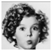 | curly
3 |  | turn
4 | 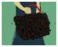 | purse
5 |  | surprised
6 |  | purple
7 | 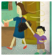 | urgent
8 |  | hurry
9 |  | purpose
10 | 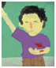 | hurts
11 |  | furry
12 |  | Thursday

Crossword Puzzle
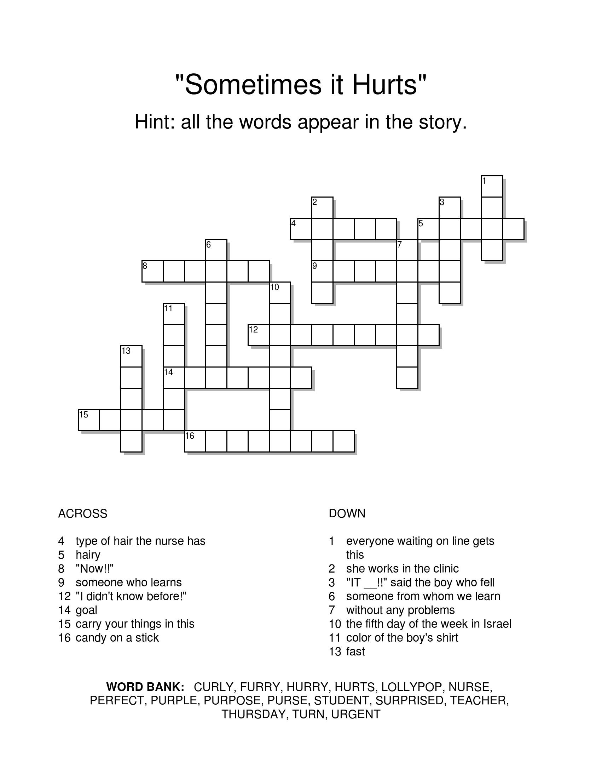

Crossword Puzzle - Answer Key:

