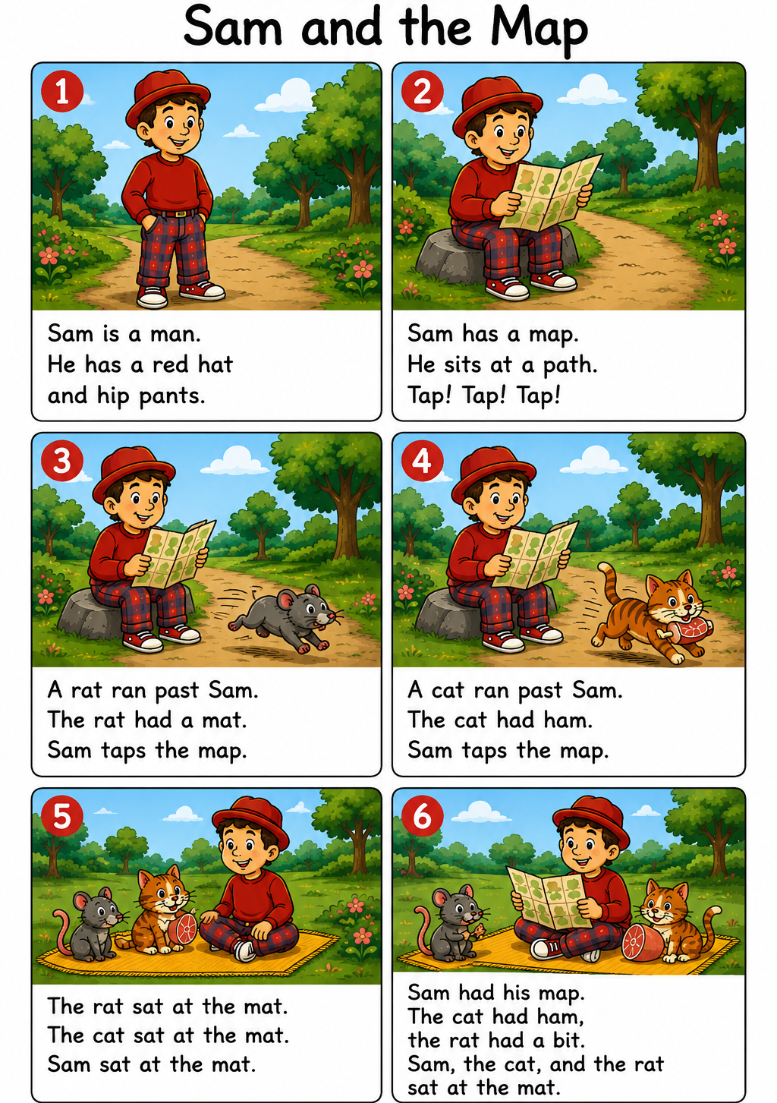
Word List
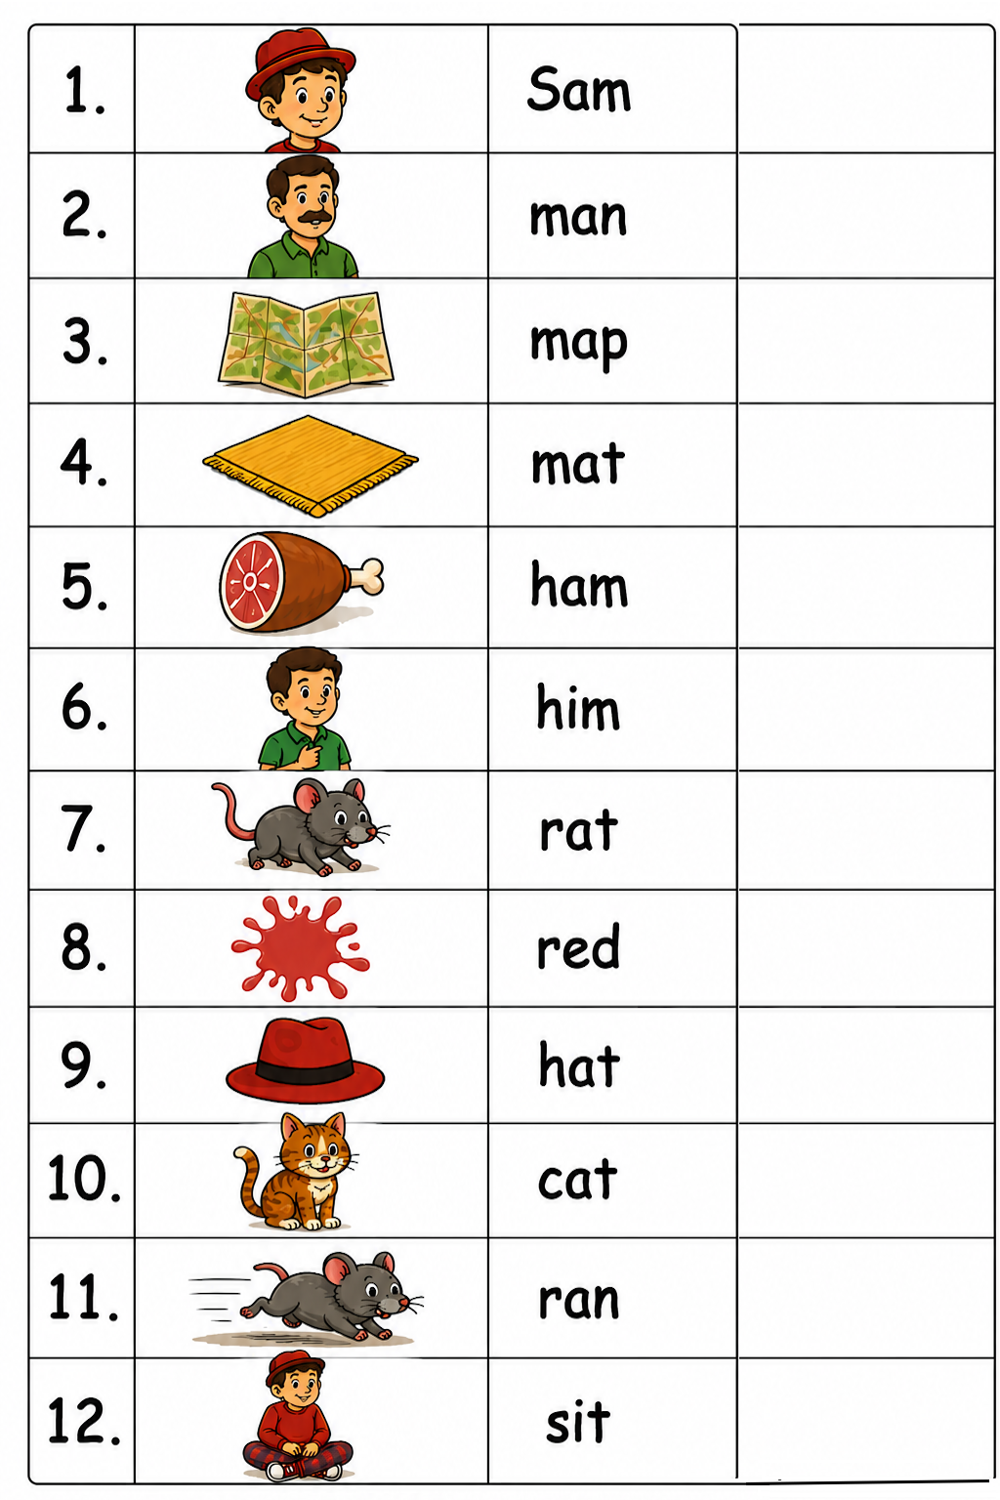

https://wordwall.net/resource/116624823/lesson-10-m

Online game: https://wordwall.net/resource/116624823/lesson-10-m
Game: Concentration: Cut out the words and pictures and match (first face up, then face down).
