Pam Met Kim

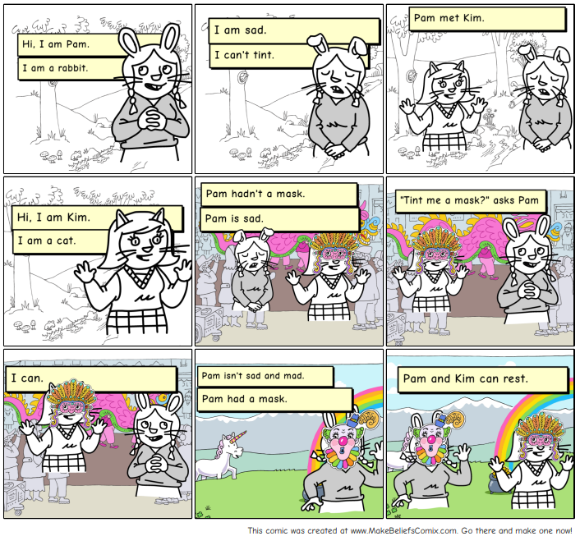
Word List
1 |  | Kim
2 |  | Pam
3 |  | ask
4 |  | I am
5 |  | mad
6 |  | mask
7 | 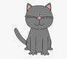 | cat
8 |  | and
9 | 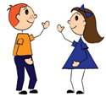 | met
10 | 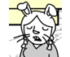 | sad
11 | 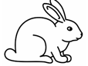 | rabbit
12 |  | rest

Bingo: match the word to the picture (cut up words, draw from bag and read aloud)

ask | Pam | Kim
mad | I am | mask
met | and | cat
rest | rabbit | sad

◊◊◊◊◊ B I N G O ◊◊◊◊◊
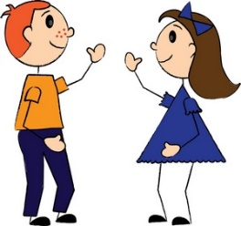 |  | 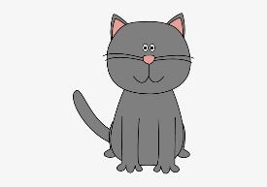
 | 