I Spoiled the Royal Oil
When I was a boy, I loved to play with toys. What joy!  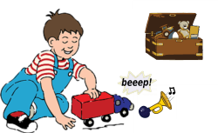  My favorite toy was a truck that made cool noises. | But one day it started making pointless noises.  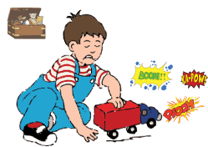
There was a small jar of oil hidden in the cupboard.  On it was written "Royal Oil."  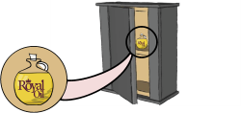  Father said he was saving this oil for something really important. | I thought to myself,  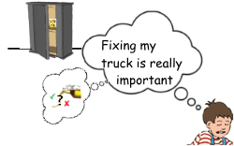  So now I had a choice…
I decided to take the oil from the cupboard and pour it on my toy truck.  It worked!  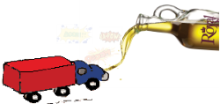  It stopped making  pointless noises. | 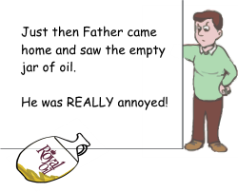
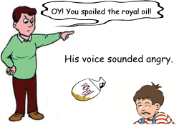 | And that is why the royal throne is void today!  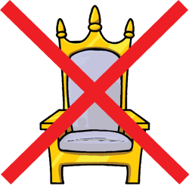
Word List
1 | 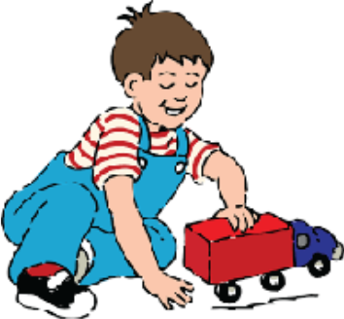 | boy
2 | 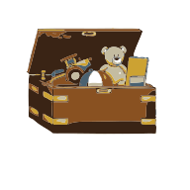 | toys
3 |  | joy
4 | 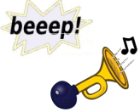 | noises
5 | 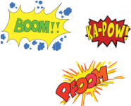 | pointless (noises)
6 | 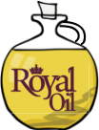 | oil
7 | 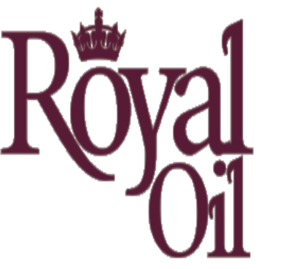 | royal
8 |  | choice
9 | 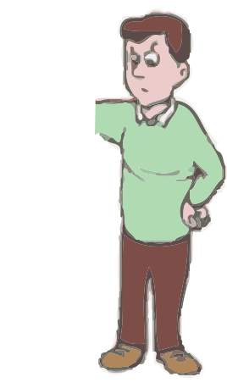 | annoyed
10 |  | spoiled
11 |  | voice
12 | 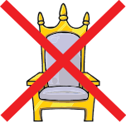 | void

Game:

 |  |  |  |  |  |  |  |  |  | 1
 |  |  |  |  |  |  |  |  |  |  |  |  | 2
 |  |  |  |  |  | 3 |  |  | 4
 | 5 |  |  | 6
7 |  |  |  | 8 |  |  |  | 9
 | 10
 |  | 11
 | 12

Across  4. what a king is  7. happiness  8. useless  10. this or that  12. empty | Down  1. bothered  2. used to fix squeaky wheels  3. things you hear  5. people speak in a loud _______  6. ruined  9. things kids play with  11. a male kid

