The Treasure in the Picture
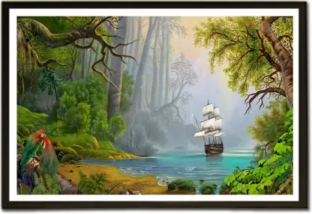  Aron favors culture and arts in particular.  One day, Aron saw a nature picture for sale. | 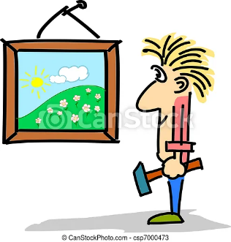  He paid for the picture and hung it on a wall with great pleasure.
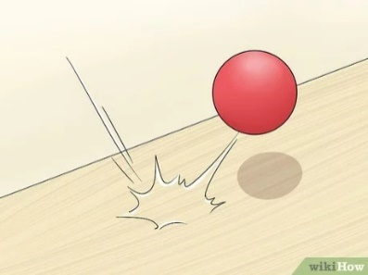  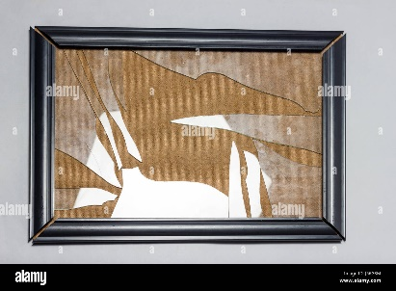  After a few days, his five-year-old boy kicked his ball and it hit the picture. The picture fell on the floor and broke. | 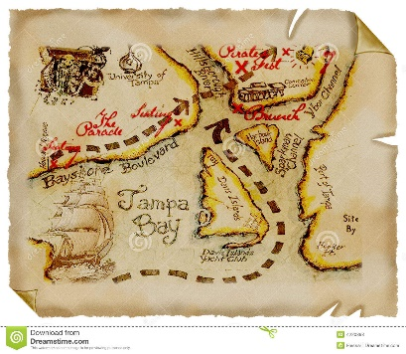  Aron was very upset. Suddenly, he saw an old paper hiding behind the broken frame. He opened the paper and to his great surprise he saw an old treasure map!
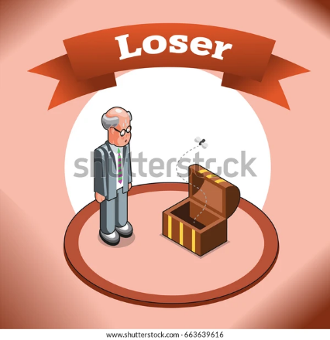  Aron said to himself: "Last time my search for a treasure was a failure. | 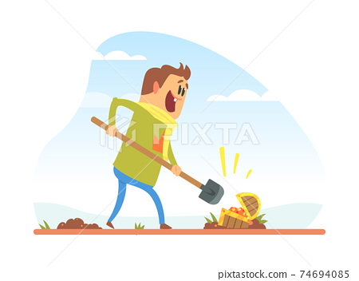  This time however, I am sure it is going to work well!
And he went out for a new adventure!
Word List
1 |  | culture
2 |  | particular
3 | 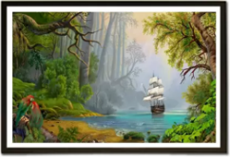 | picture
4 | 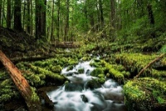 | nature
5 |  | pleasure
6 | 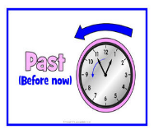 | paid
7 |  | suddenly
8 | 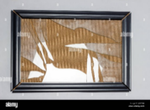 | broken
9 | 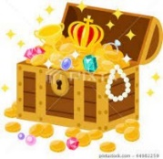 | treasure
10 |  | failure
11 |  | sure
12 | 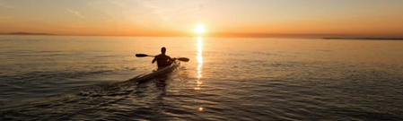 | adventure

An Online Game – Treasure Hunting
Instructions:
Download the game to your computer from this link: https://tinyurl.com/3c8p6hda
Type the 4-digit password 6395 when it is required.
Go to "presentation mode".
Find the hidden golden treasure using the treasure map provided. You will travel the world with many challenges by following the numbers. So, do your best and strive hard for the gold.
Let the treasure hunting begin!

Hint: All answers are words found in the Word List, above.
You can also print the questions for offline use (see next page):

NOTES ON THE ONLINE TREASURE HUNT: YOU CAN ADAPT IT TO ANY TEACHING CONTENT!
There is a clip on Youtube created by the extremely talented Teacher Zin. In this clip he shows the whole presentation. He allows everyone who watches his clip from beginning to end to download the presentation and even edit it with no restrictions at all. This is the link to the clip: https://youtu.be/5VZ7JVGhJxs
I took his presentation, kept the general style, items, structure and text, and changed the text in the challenges to fit the word list, added music at the beginning and made some small changes in the flow of the presentation. The great thing in his extraordinary presentation is that you can adapt it to any content and level. It's really a treasure for teachers.
I made some editing changes to the English in his presentation, since English is not his native language.
I expressed my gratitude by adding a link to his clip in my Treasure Hunt.

Challenges from the Treasure Hunt:
- Make up a sentence containing the word “pleasure”.

- What is not part of “culture?”
- Language
- Values
- Climate
- History
- Tradition

- Why do you think nature is important? Explain your answer.

- “All of a sudden” in one word is “__________________.”

- What is worth thousand words? Explain why.

- Fill in the gap: Looking for dinosaurs might be a great ___________ !

- The opposite of success is _________ .

- Before you answer the question, you have to be confident, that is, you have to be _______.

- When something is not working, it is ________. When something is made into pieces from a whole, it is also _________.

- If you were to find a treasure chest (box) full of characters, who would you like to find there for yourself?

- The Titanic was a ship that sank in the Atlantic Ocean, about 400 miles south of Newfoundland, Canada.

  - Make up a sentence with the word “Titanic”.

  - Let’s pretend that you are a passenger on the Titanic. If you found out that the ship were sinking, who would you save first from the ship and why?

- If you are working for someone, you want to get _______. If you bought something, you ________ for it as well.

- Make up a sentence containing the word and phrase “Nile River” and “great adventure”.

- There are many big volcanoes around the world. But, Mauna Loa is especially big, that is, it is big in __________.

- Arrange the jumbled letters first to form a correct word. Then, use it in a sentence.

DVNREATUE _____________________

ELTUCRU _____________________

LDSUDENY _____________________

