June's Music
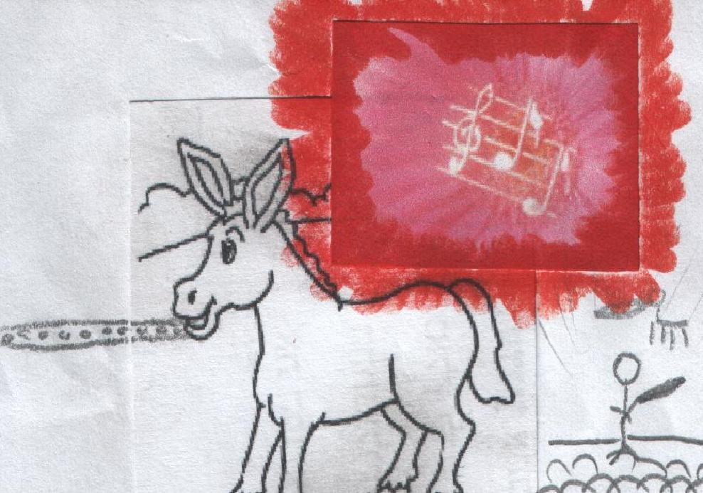  June is a cute mule.  June just adores music!  June the cute mule has a flute  to make music in a band. | 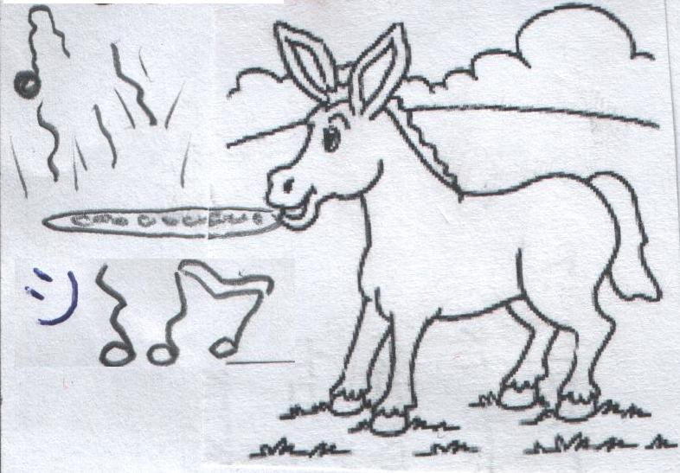  Happy tunes come from June's flute! But, June's flute isn't in tune.  The rule in the band is:  flutes must be in tune!
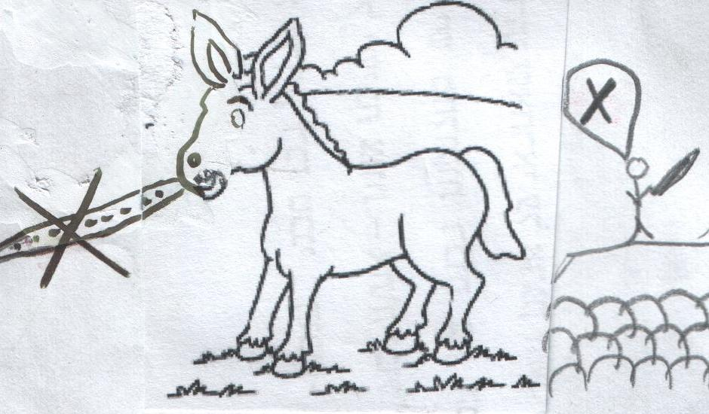  June must mute her flute if it isn't in tune.  The band refuses to let her make music. | 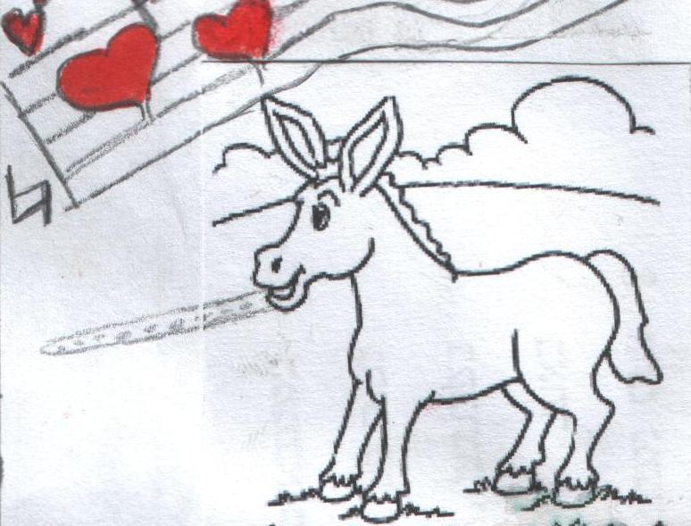  June tunes her flute.  The flute is in tune!
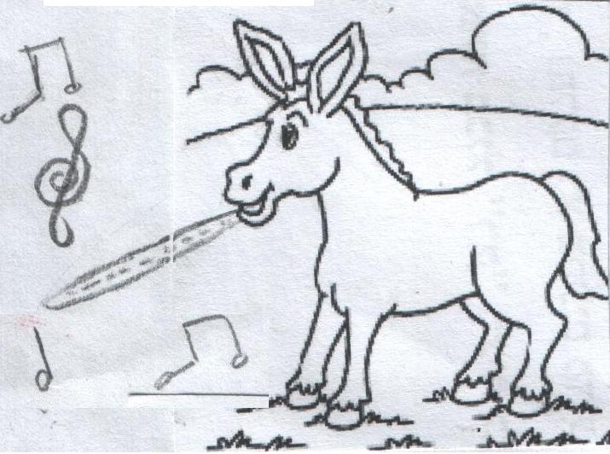  June can make music on the flute.  It's not mute anymore! | 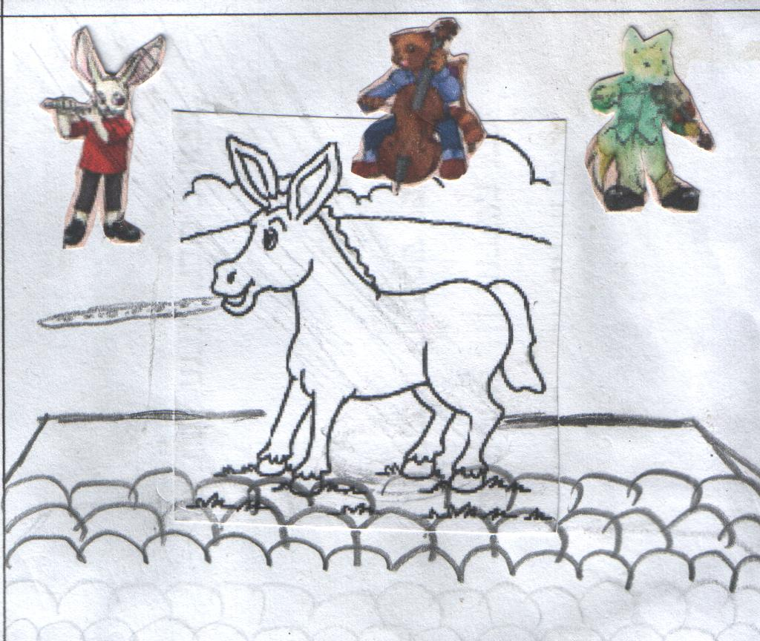  The band's rule is that in-tune flutes can come back.  They can't refuse the music of the cute mule June and her in-tune flute!

Word List
1 | 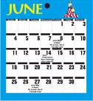 | June
2 |  | cute
3 |  | mule
4 |  | music
5 | 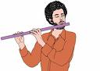 | flute
6 | 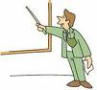 | rule
7 |  | tunes
8 |  | in tune
9 |  | refuse
10 |  | mute
11 |  | adore
12 | 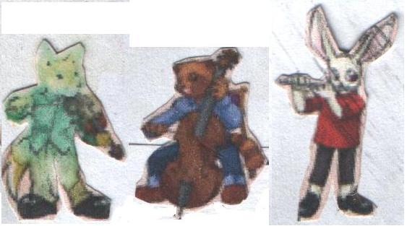 | band

Snakes and Ladders
Preparation: Glue board on stiff back and cut out (lamination optional).
Play: Roll one or two dice and move your “soldier” forward. When you land on a square, you read the word aloud. If you land on a ladder you climb up. If you land on a snake you slide down. If you know the definition of the word, you can choose to have another turn (or if you landed on a snake you can choose not to slide down.) The first person to reach 100 wins. (Or make up your own rules.)
11
12
13
14
15
16
17
18
19
20
10
9
8
7
6
5
4
3
2
1
51
52
53
54
55
56
57
58
59
60
50
49
48
47
46
45
44
43
42
41
31
32
33
34
35
36
37
38
39
40
30
29
28
27
26
25
24
23
22
21
70
69
68
67
66
65
64
63
62
61
71
72
73
74
75
76
77
78
79
80
90
89
88
87
86
85
84ז
83
82
81
91
92
93
94
95
96
97
98
99
100
84
fume fuse duke dune cube yule cute band June tune

hat met tune use elude refuse cat site met rise
flute at mute music back stick cute red June as a rise
kite duke bat tune stripe ride at cat music rule
picnic at June music site use man met flute hen
bat bad June salute cat flute cute tunes music rule
stripe elude kite bite red tune mute band ride use
panic its it’s prune truce bit bite mite site include
cute dune salute accuse rule truce elude band June fluke
muse truce amuse huge dupe dude tube use ruse rude

