A Mad Man Met a Kind Man
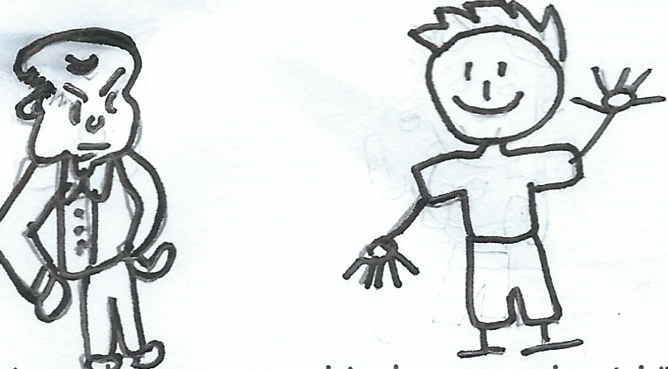  A mad man met a kind man and said,  “Kind men are bad." | 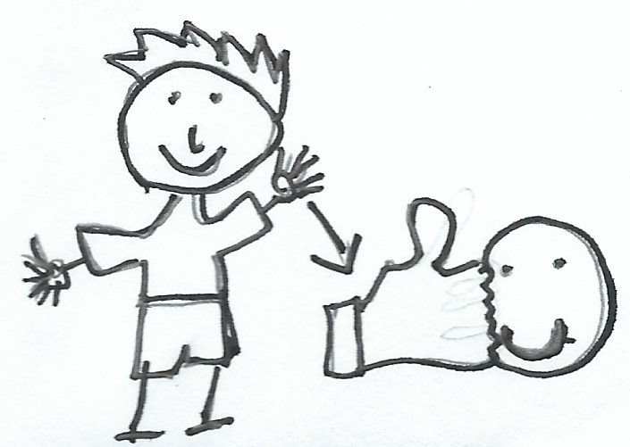  The kind man said,  “Kind men aren't bad.  A kind man has tact.”
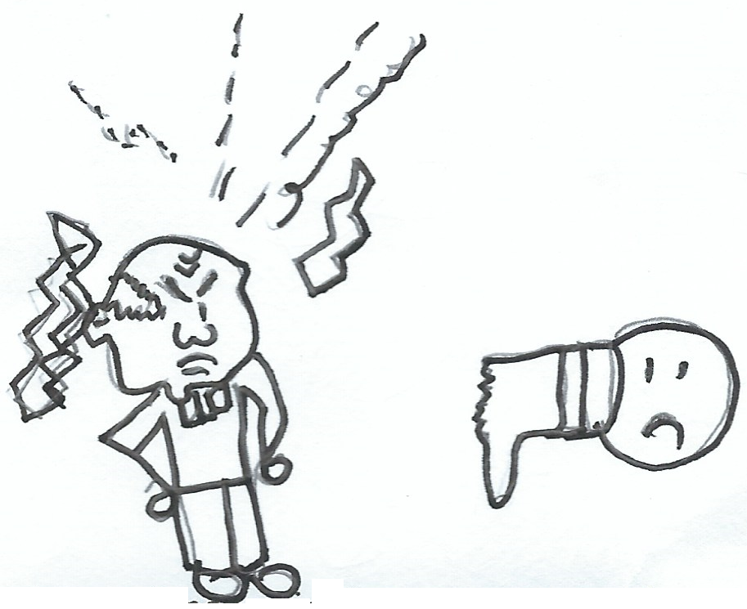  The mad man said,  ”I can stamp and rant.  Tact is bad.” | 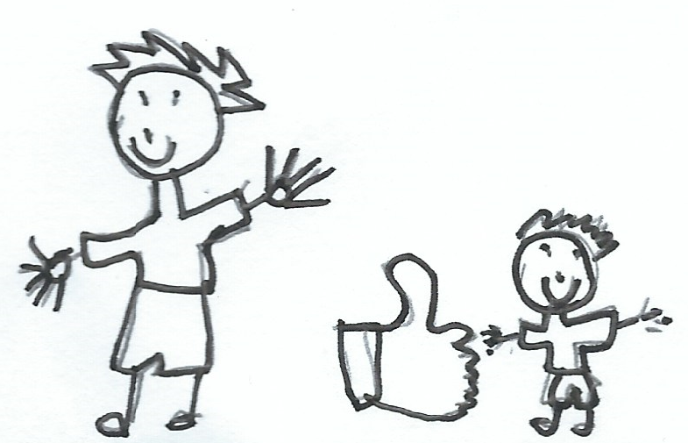  The kind man said,”  Tact isn't bad.  Kind men are the best.”
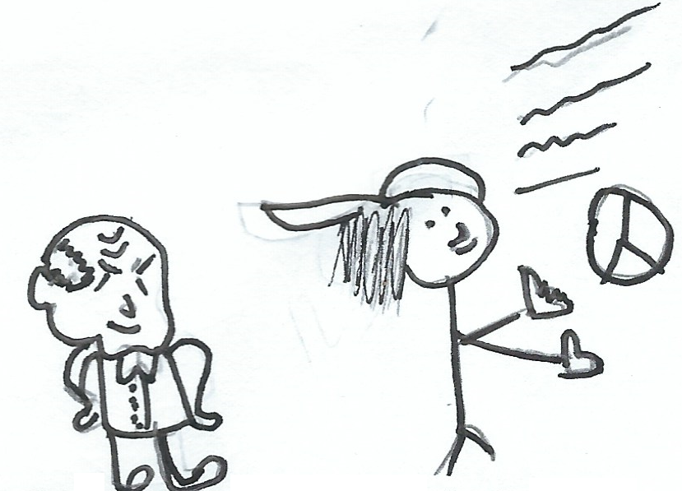  The mad man said, “Kind men and mad men can be hip.” | 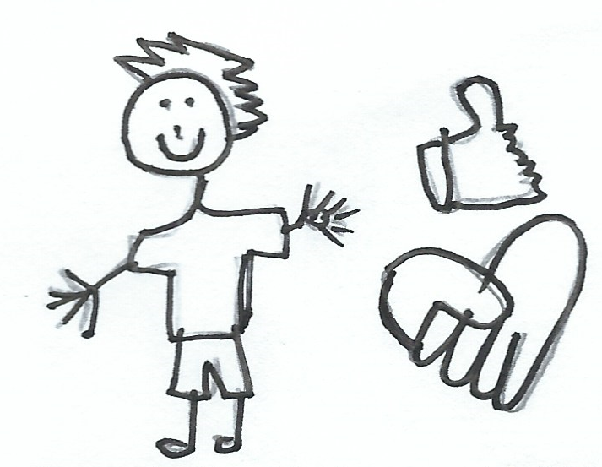  In the end, the kind man said,  "It is hip to be kind."

Word List
1 | 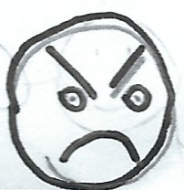 | mad
2 | 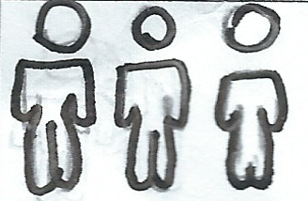 | men
3 | 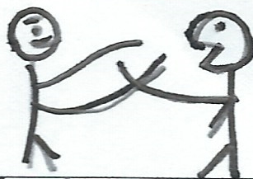 | met
4 | 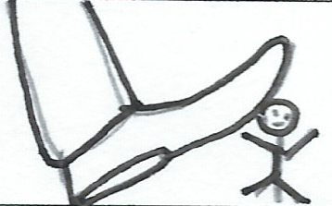 | stamp
5 | 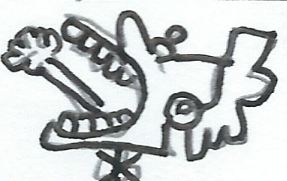 | rant
6 | 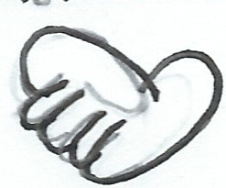 | kind
7 | 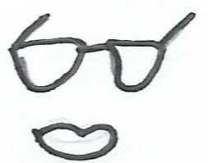 | hip
8 | 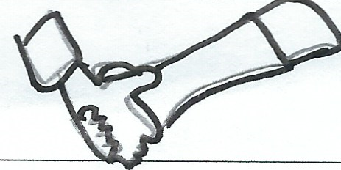 | tact
9 | 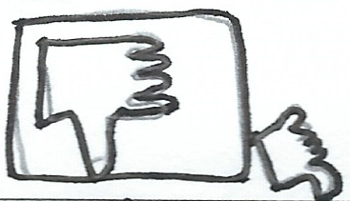 | bad
10 | 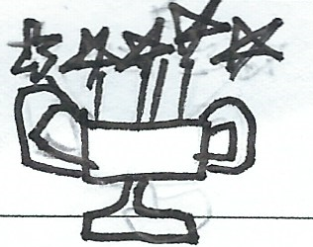 | best
11 | 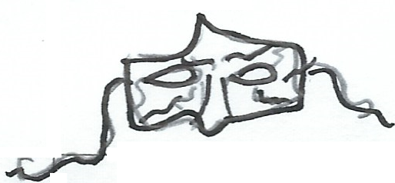 | mask
12 | 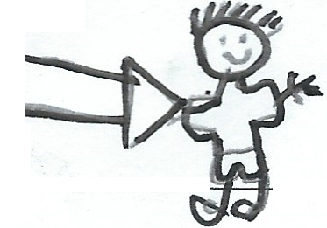 | him

Snakes and Ladders

Preparation: Cut out the following 12 word cards , lamination of board and cards optional. The board is reusable, so you can make new cards for other lessons.
To play: Place the word cards in a pile face down

The player(s) begin by placing their game pieces on the START square. The first player rolls the die and moves forward that number of spaces. If you and on a space that says “WORD CARD” take the top card from the pile and read the word aloud. Player keeps the cards they read correctly.
If a player rolls a number that lands them at the bottom of a ladder and they get the word correct, they may “climb” to the square at the top of the ladder. If a player rolls a number that lands them on the head of a snake, then they “slide” down to the square at the snake’s tail. The game finishes when all the players get to the FINISH square, with the first player to the end being declared the winner. You do not have to roll an exact number to finish the game.
mad | men | met | best
bad | kind | tact | hip
stamp | rant | him | mask


