The Garden Project
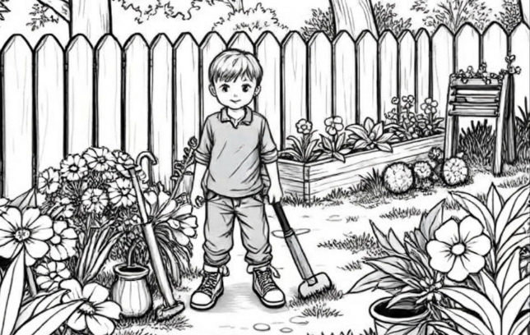  At the beginning of a beautiful day, Ben stands in the garden. He will start a grand project today. | 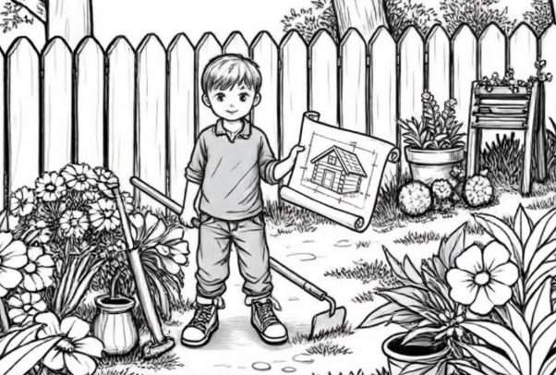  Ben is creating a small cabin for his pet. The plan for the cabin is predictable.
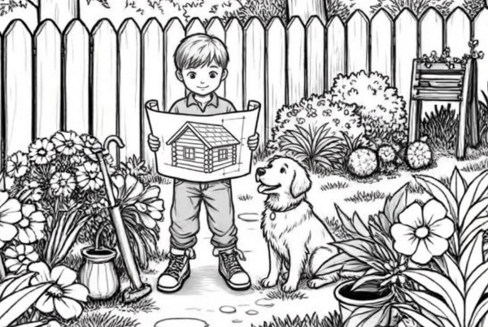  Sam is a dog. He is sitting on the garden mat, watching Ben. | 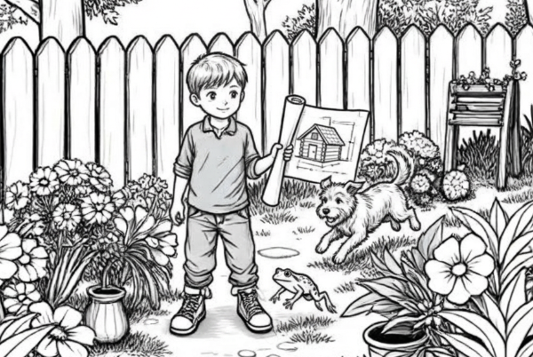  He sees a frog hopping by the pond. Sam is running after the frog!  His happiness is clear to see.
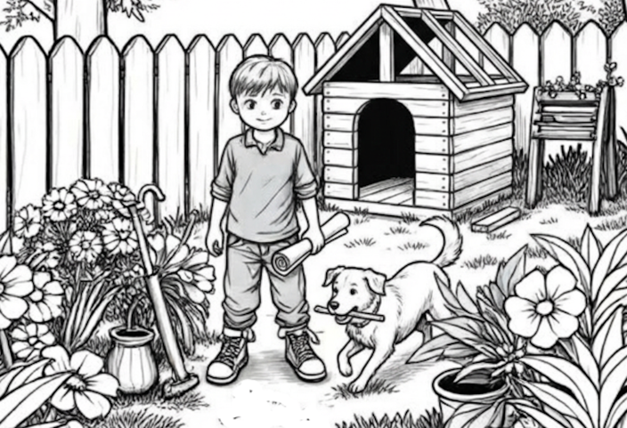  Ben needs a tool. Sam is a playful pet. He is very helpful to Ben. He brings a stick to the cabin. | 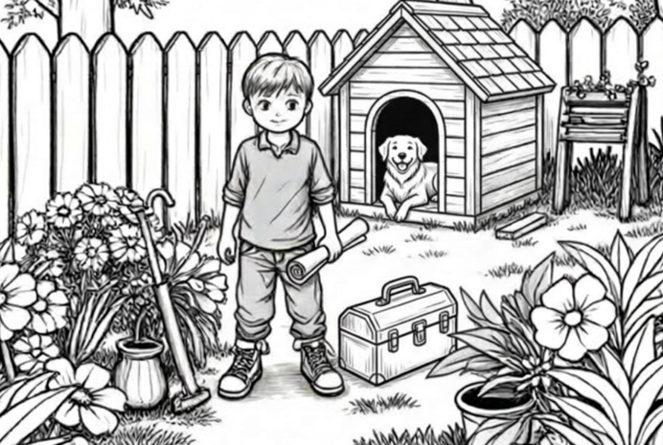  Ben is shutting his wooden box. The project is finished. It is an amusement to see his pet playing.
Wordlist
1. |  | beginning
2. |  | beautiful
3. | 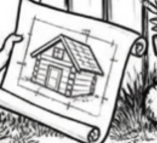 | creating
4. |  | predictable
5. |  | sitting
6. |  | watching
7. | 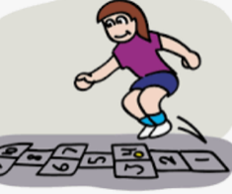 | hopping
8. |  | running
9. |  | happiness
10. |  | playful
11. |  | helpful
12. |  | amusement
Four-in-A-Row Reading Game for 2 players
You will need: Attached board, preferably laminated; one die; Coloured counters for each player, approximately 20
How to Play:
- Roll the die.
- Read a word with the same number as the die.
- Place one coloured counter on the word if read (and translated?) correctly.
- The winner is the first one to have 4 in a row either vertically, horizontally or diagonally.
Categories
1) Word ends in consonant + -y, suffix starts with a consonant: Change the y to i, then add the suffix.
2) One-syllable words ending in cvc, suffix starts with a vowel: Double the last consonant, then add the suffix.
3) Two-syllable words ending in cvc with the accent on the final syllable, if suffix starts with a vowel: Slso double the last consonant then add the suffix.
4) Words (some end in vowel+y) + suffix -ful: Just add -ful.
5) Words that end with magic e: If the suffix starts with a vowel, drop the magic e, then add the suffix.
6) Words that end with magic e: If the suffix starts with a consonant, just add the suffix.
Online games
- Double-trouble
https://sites.google.com/view/suffix-game/double-trouble
- Keep -e or drop -e
https://sites.google.com/view/suffix-game/keep-e-or-drop-e
- -y to -I rule
https://sites.google.com/view/suffix-game/y-to-i-rule
- Complex game
https://sites.google.com/view/suffix-game/complex-game

Four-in-a-Row Reading Game
1. Word ends in consonant+ -y, suffix starts with a consonant: Change the y to i, then add the suffix. | 2. One-syllable words ending in cvc, suffix starts with a vowel: Double the last consonant, then add the suffix. | 3. Two-syllable words ending in cvc with the accent on the final syllable, if suffix starts with a vowel: Also double the last consonant then add the suffix. | 4. Words + suffix  -ful: Just add -ful. | 5. Words that end with magic e: If the suffix starts with a vowel, drop the magic e, then add the suffix. | 6. Words that end with magic e: If the suffix starts with a consonant, just add the suffix.
1  beautiful | 2  sitting | 3  beginning | 4  joyful | 5  creating | 6  amusement
1  happiness | 2  hopped | 3  admitting | 4  playful | 5  noticing | 6  excitement
1  angrily | 2  running | 3  upsetting | 4  helpful | 5  locating | 6  settlement
1  plentiful | 2  shutting | 3  forgetting | 4  thankful | 5  deciding | 6  placement
1  dutiful | 2  putting | 3  regretting | 4  wishful | 5  inviting | 6  statement
1  crunchiness | 2  skipped | 3  submitting | 4  mouthful | 5  amazing | 6  movement

