Sasha Makes Shapes
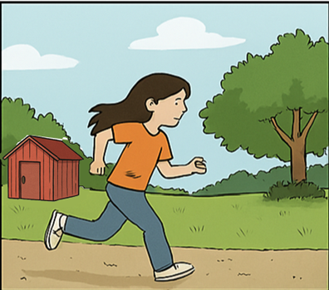  Sasha runs past the red shed.  Behind it is a small shack.  It’s quiet there. A good spot for Sasha. | 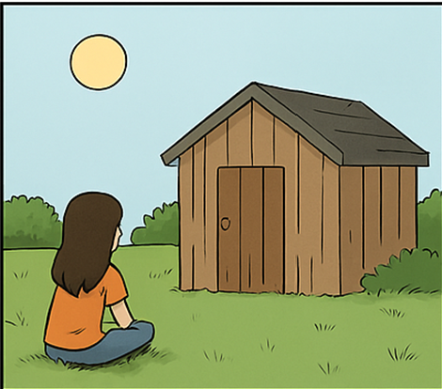  She sits by the shack.  The sun is up and still.  Sasha thinks,  “It’s a good time to make shapes.”
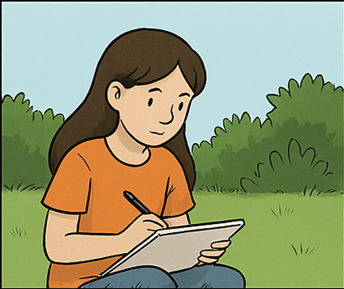  Sasha keeps her pad and a black pen in the shed. She gets them.  She wishes to make a shape of a ship with her pen. | 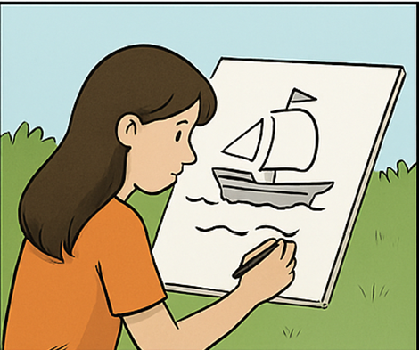  She makes shapes: a thin line, a shell and a flag. It’s a ship!
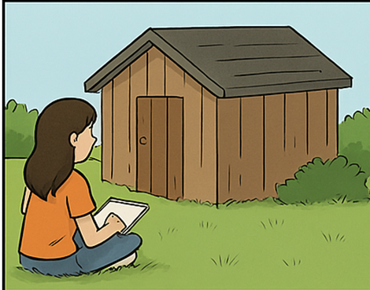  A hush comes from the shack.  Sasha keeps making shapes. | 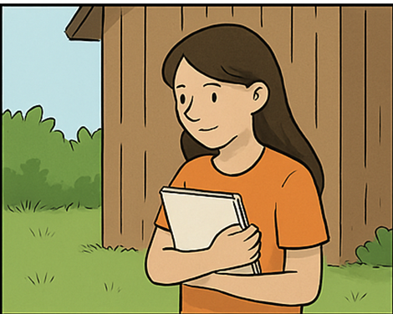  She holds her pad.  “This is the best spot for making shapes,” she said.

Word List
1 | 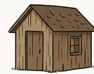 | shack
2 | 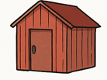 | shed
3 |  | Sasha
4 |  | pad
5 |  | ship
6 | 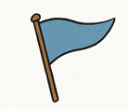 | flag
7 | 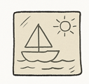 | shape
8 | 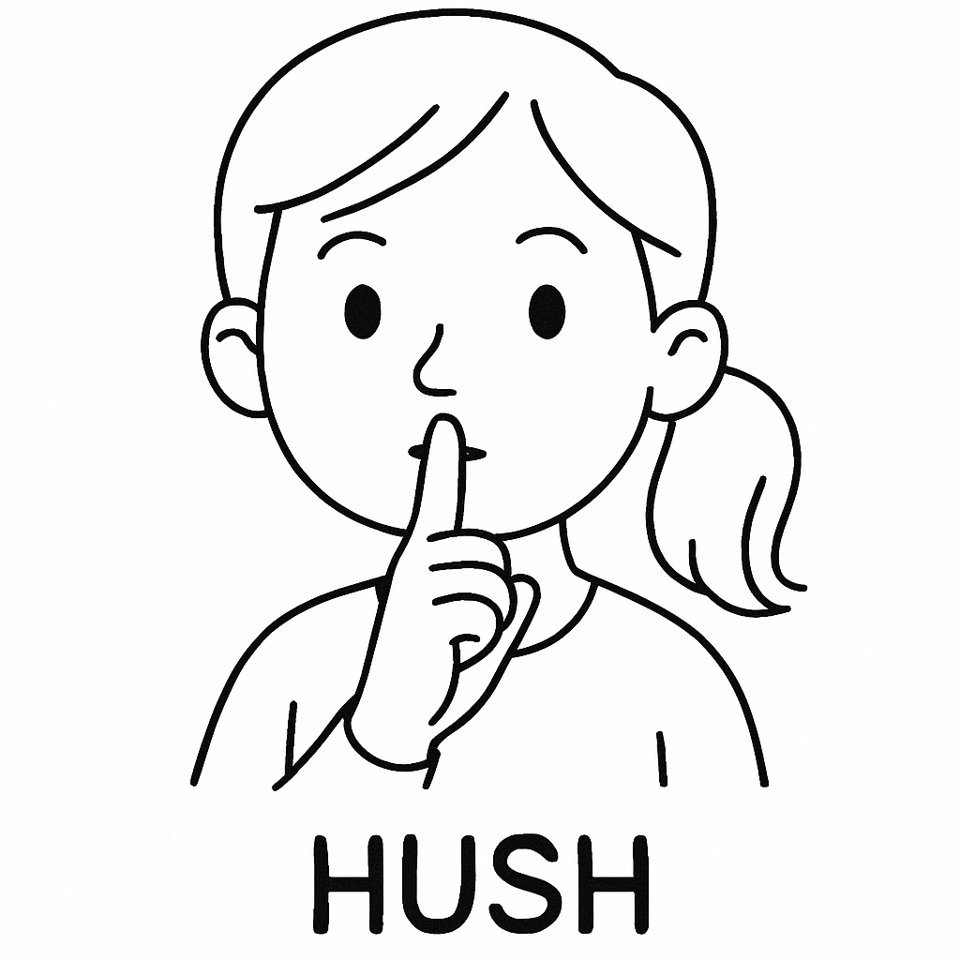 | hush
9 | 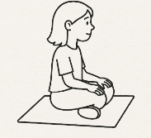 | sit
10 |  | hold
11 |  | best
12 | 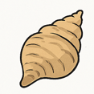 | shell

Online Game: https://wordwall.net/resource/93974951

Sasha’s /sh/ Sound Sort
🎯 Objective:
Sort the words with the /sh/ sound and the other words into their pages in Sasha’s pad.
📋 Instructions:
1. Look at the words in the box below.
2. Sort them into the correct side:
- Words with the /sh/ sound go in “sh words.”
- Words without /sh/ go in “other words.”
3. Draw 1 picture for a /sh/ word you like!
✂️ Word Bank:
shack, hold, ship, sun, shell, fish, hush, flag, shape, pen, Sasha, spot
📝 Sort the words:
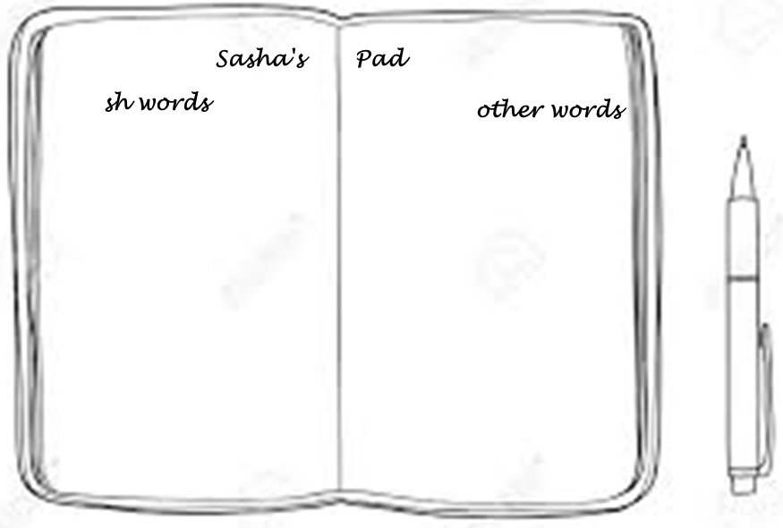

Bingo game:
Please press the link for an online bingo maker. Make your bingo according to the words and size you choose.

https://myfreebingocards.com/bingo-card-generator

Sasha’s /sh/ Sound Bingo
🎯 Objective:
Listen to the /sh/ words and mark them on your board. First to get a full row or column wins!
📋 Instructions:
1. Listen carefully as the teacher calls out a /sh/ word.
2. If the word is on your board, mark it.
3. First to complete a row, column, or diagonal shouts 'SH!'

