Sam, Pam and the Crab
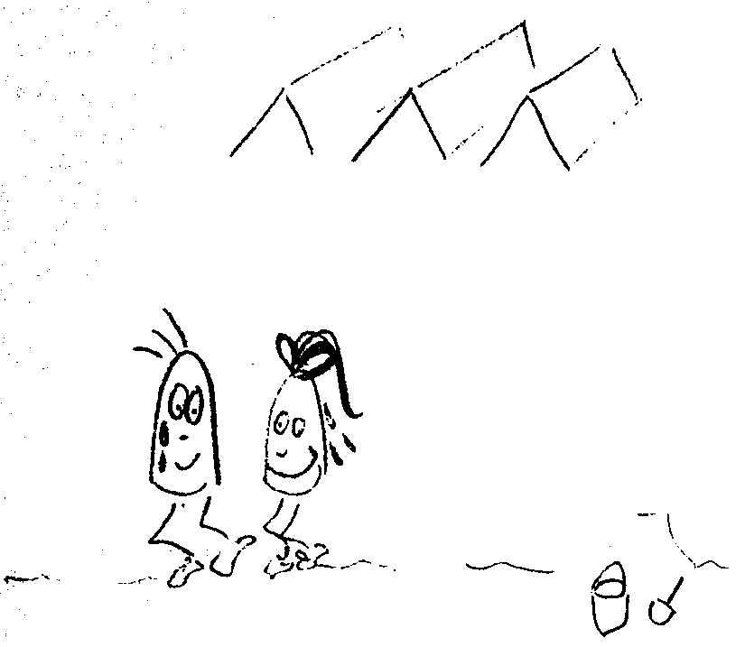  Sam and Pam ran in the sand in the camp. | 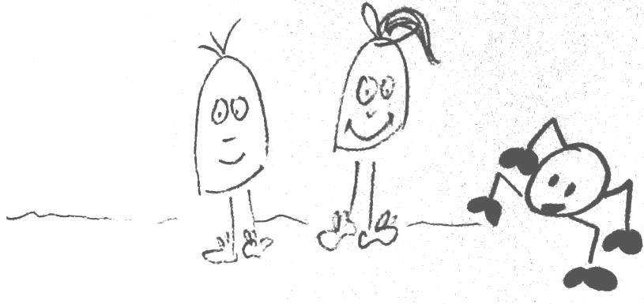  Sam and Pam met a crab.
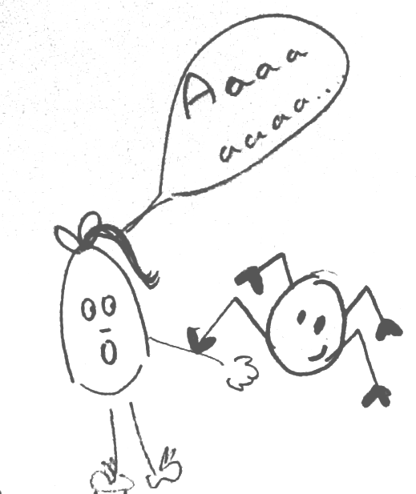  The crab bit Pam's skin:  "The crab bit me!" said Pam. | 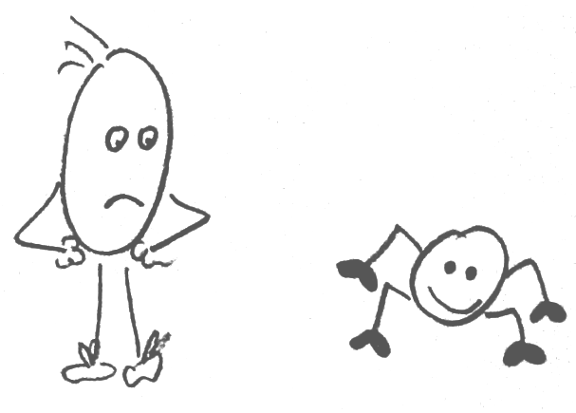  Sam is mad at the crab: " I am a mad man" said Sam.
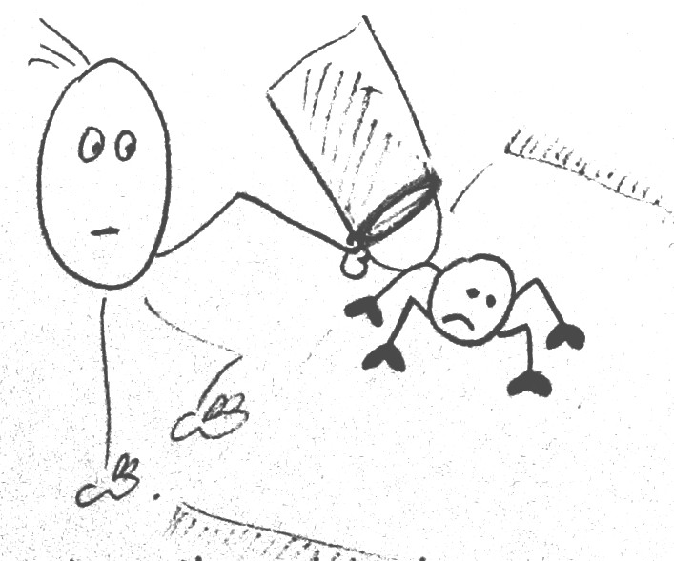  Sam traps the crab at the mat. | 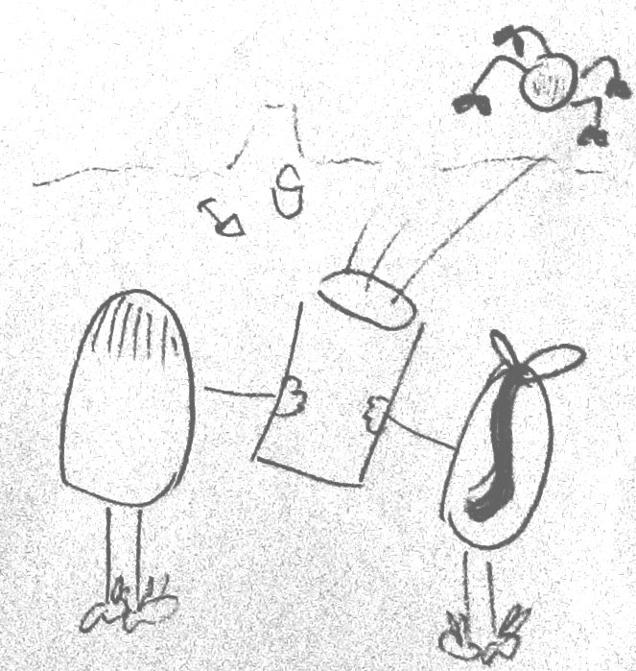  Sam and Pam cast the crab in the sand.

Word List
1 | 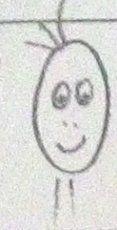 | Sam
2 | 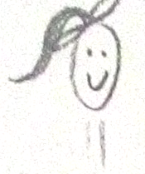 | Pam
3 | 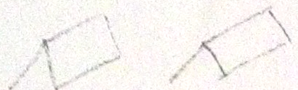 | camp
4 | 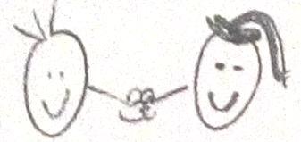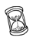 | met
5 | 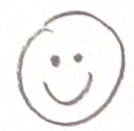 | me
6 | 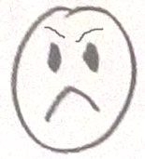 | mad
7 | 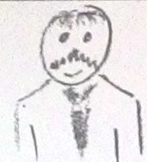 | man
8 | 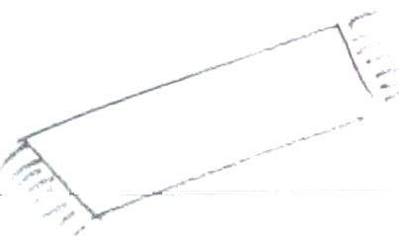 | mat
9 | 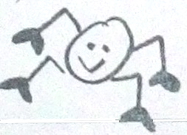 | crab
10 | 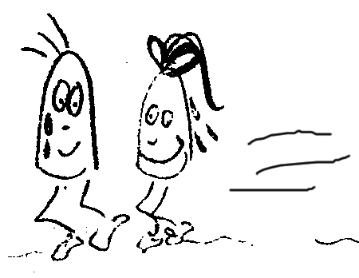 | ran
11 | 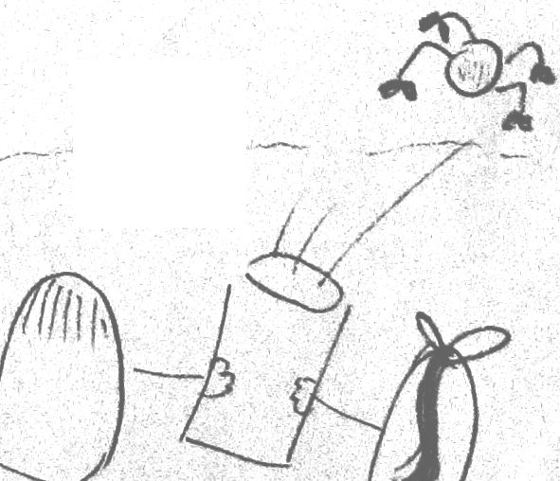 | cast
12 | 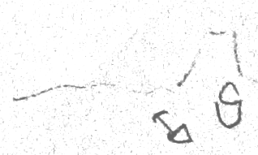 | sand

"Families" Game
Goal: To collect the four cards in the "family" with the same picture at the top of the card. (See key below for the family name represented by the picture.)
The student has to read the words to get the card, so he is very motivated.

How to play: Example: Do you have the picture "crab"?; other player answers "Yes/No" – If yes, "do you have "met"?" Yes/No

When the player has the four cards in the family with the same picture, he says "I have a set" and he has to make a sentence using the four words. He can add words and if it's difficult for him you can show him the picture without the sentence.

Sam  Pam  ran  camp | Sam  Pam  ran  camp | Sam  Pam  ran  camp
Sam  Pam  ran  camp | a  and  met  crab | a  and  met  crab
a  and  met  crab | a  and  met  crab | bit  skin  said  me
bit  skin  said  me | bit  skin  said  me | bit  skin  said  me
mad  at  am  man | mad  at  am  man | mad  at  am  man
mad  at  am  man | traps  mat  cast  sand | traps  mat  cast  sand
traps  mat  cast  sand | traps  mat  cast  sand

Key to picture (card family) names

camp mad crab
met mat

