A Firefly Isn’t a Pet
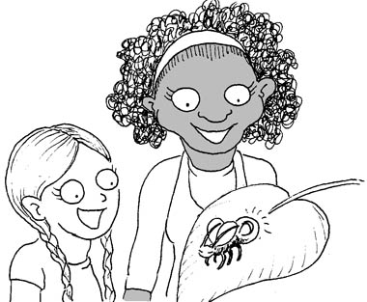  Little Ann and her friend, Franny, find a firefly. | 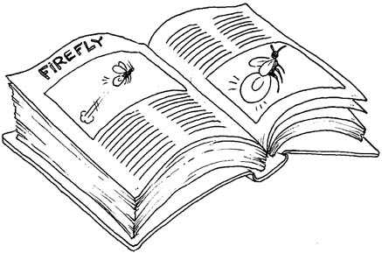  A firefly can fly fast.  It has a little fire in its backside.
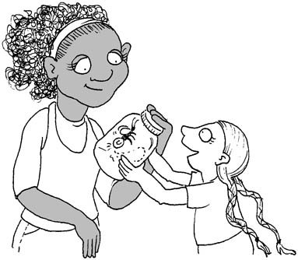  The friends talk. Ann tells Franny, “This is my small, tiny pet.” | 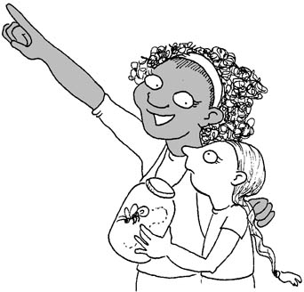  Franny smiles. She tells Ann,  “A firefly likes the sky! Let it fly!”
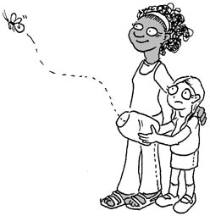  Ann and Franny let the firefly fly in the sky. | 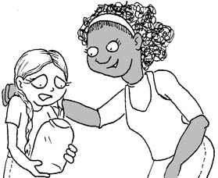  Ann felt a little sad. She didn’t cry. She said, “A firefly isn’t a pet.  It likes the sky.”
Word List
1 |  | Franny
2 | 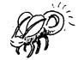 | firefly
3 |  | friends
4 | 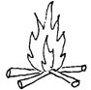 | fire
5 | 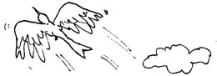 | fly
6 | 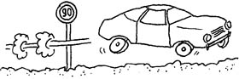 | fast
7 | 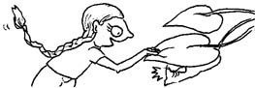 | find
8 | 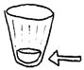 | little
9 | 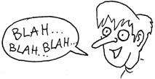 | talk
10 | 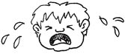 | cry
11 | 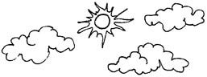 | sky
12 |  | tiny

F against P
Preparation: assemble the F/P die, glue the two boards and cards onto colored paper, cut up the cards. Setup: Lay the cards face up in a pool. Each player gets one board.
Play: Roll the die. If you get the letter that matches your board, you get to choose an appropriate letter card from the pool. Read the word and place on your board. The first one to get three in a row (or to fill his board) wins.

F f
 | 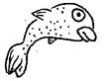 | 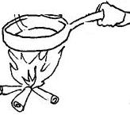

fast | find |  | fire |  | firefly | fly
fry | friends |  | fish |  | Franny
P p
 |  | 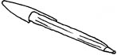 |  | 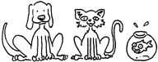
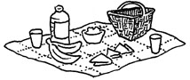 |  | 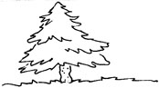 |  | 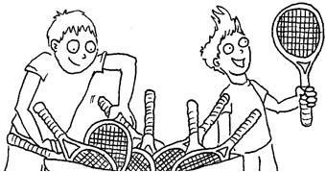
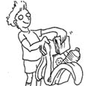 |  | 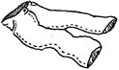 |  | 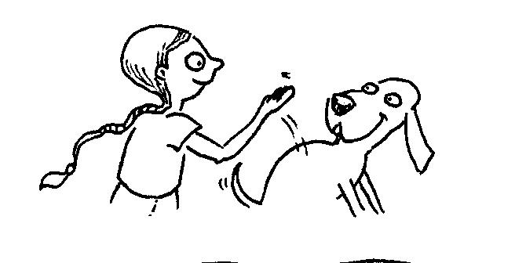

plants | pen | pets | picnic | pine
pick | pack | pants | pats

Assemble die: Cut out, fold on dotted lines, tuck in flaps and glue.
F f P
p

