Fruit Juice in the Building
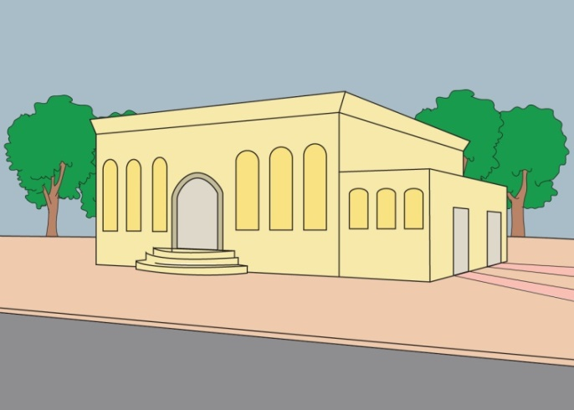  Uziel's bar mitzva party is being held in a building by the beit knesset. Friends of Uziel guide the guests to the building. | 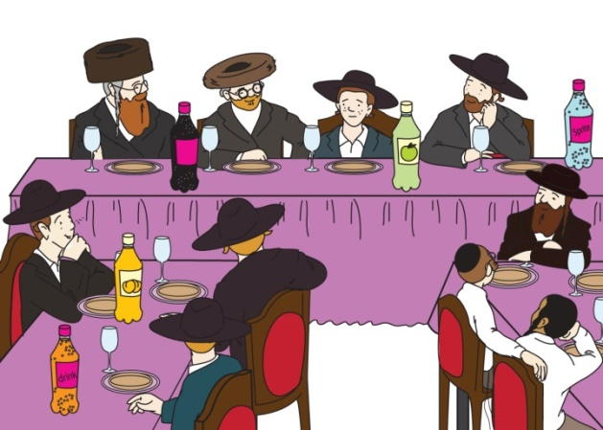  Uziel wears his new suit and hat. Inside the building, the guests have fruit juice to drink on the tables and wait for Uziel to start. The tension builds.
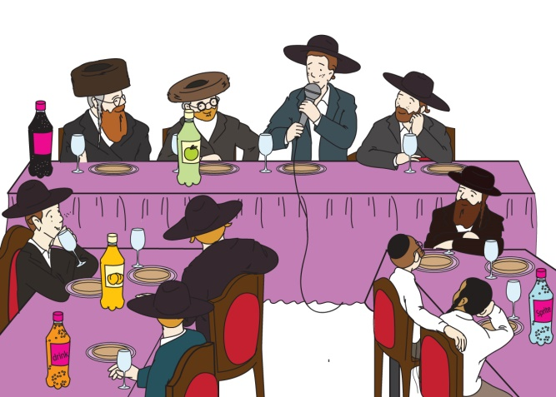  Uziel stands and starts to give his dvar Torah. Uziel built his bar mitzva drasha on the weekly portion. | 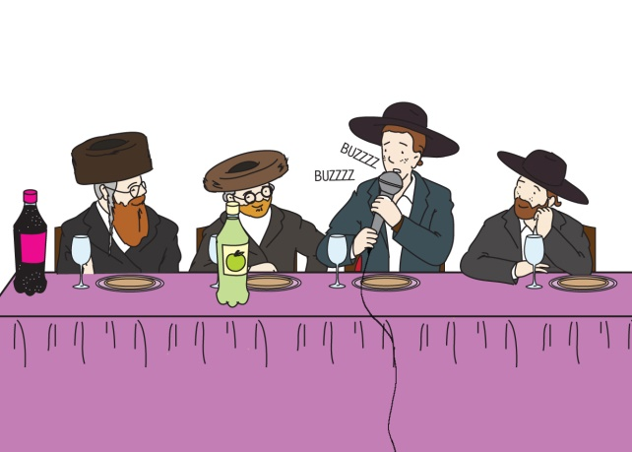  But the microphone is buzzing. It isn't suitable to go on with his dvar Torah until someone fixes the problem.
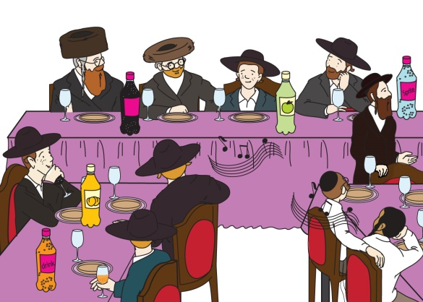  The rav calls the janitor who takes care of the building, and everyone sings along to a guitar. The guests sing and drink their fruit juice as they wait for the janitor to fix the buzzing microphone. | 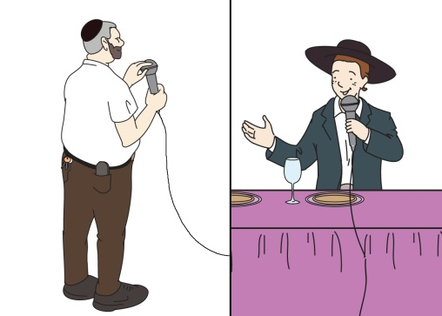  The janitor comes quickly and fixes the microphone. Then Uziel finishes his bar mitzva drasha. "Finally!" he says, "I can thank you all for coming to my bar mitzva party!"

Word List
1 |  | suit
2 |  | juice
3 | 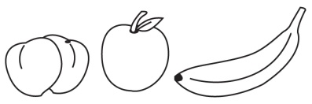 | fruit
4 |  | suitable
5 | 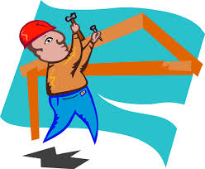 | build
6 | 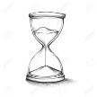 | built
7 |  | building
8 | 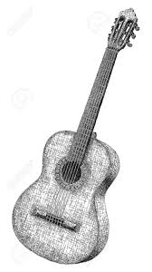 | guitar
9 |  | guide
10 |  | microphone
11 | 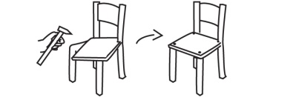 | fix
12 | 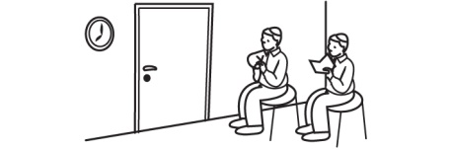 | wait

Match the Rhymes

This is a more sophisticated form of “concentration” because it includes a self-check and hints on words that the learner doesn’t know.

Preparation: Cut out the squares on the dotted lines only (don’t cut out the triangles).

To play: match the rhyming words, placing them together (the edges of their squares touching). Assemble the puzzle into a 3X3 square so that every word only touches a rhyming word. (There are lots of “right ways” to assemble the puzzle, since the words at the top and bottom of each column and both ends of each row also rhyme.)

guilty  sitar build  guilt | microphone  milled suit  guild | juicy  root guitar  fruit
quilt  plate building  janitor | filled  gilding juice  suitable | moot  moose wait  fix
parameter  torsion built  silty | rootable  gilt guide  acetone | mix  ride portion  Lucy

