**A Day at the Zoo**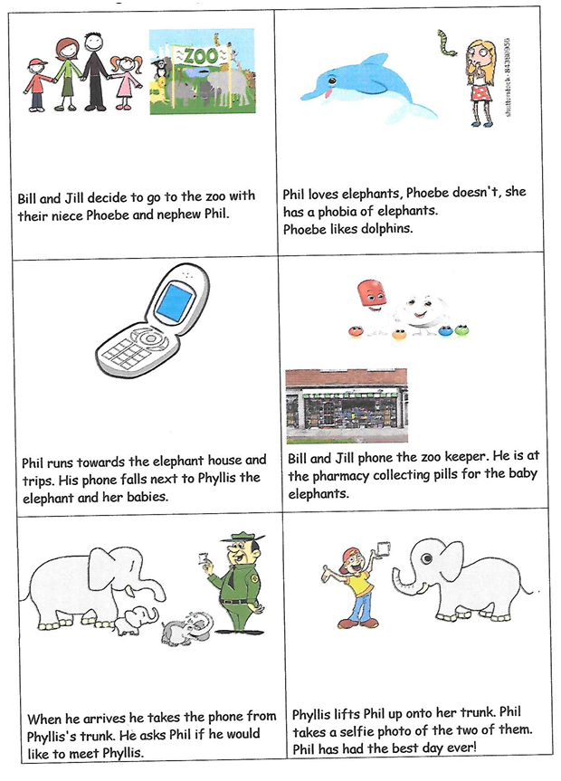

**Word List**

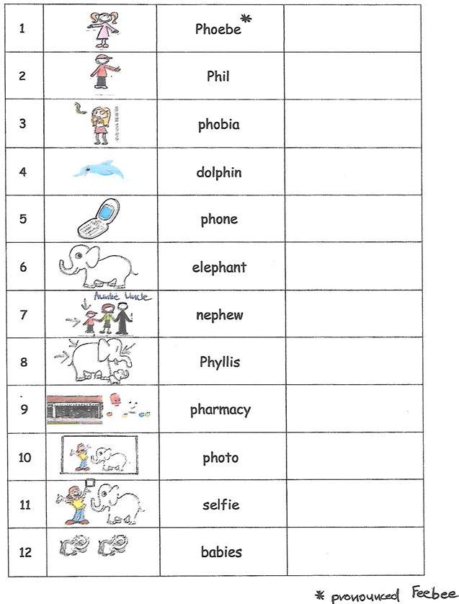

**Concentration or Matching Game**

**Cut apart the squares. Match each word to the picture it names.**

|  |  |
| --- | --- |
|  | dolphin |
|  | phobia |
|  | phone |
|  | Phyllis |
|  | Phil |
|  | Phoebe |
|  | photo |
|  | pharmacy |
|  | elephant |
|  | nephew |