Pale Blue Dot
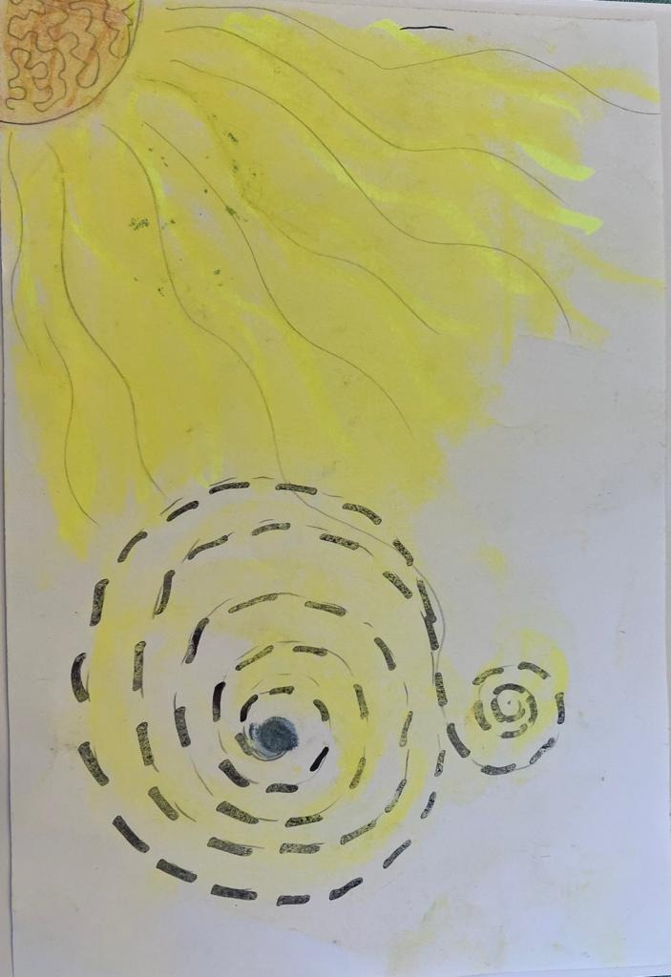 | Picture a pale blue dot  balanced in a sunbeam,  spiraling since birth.
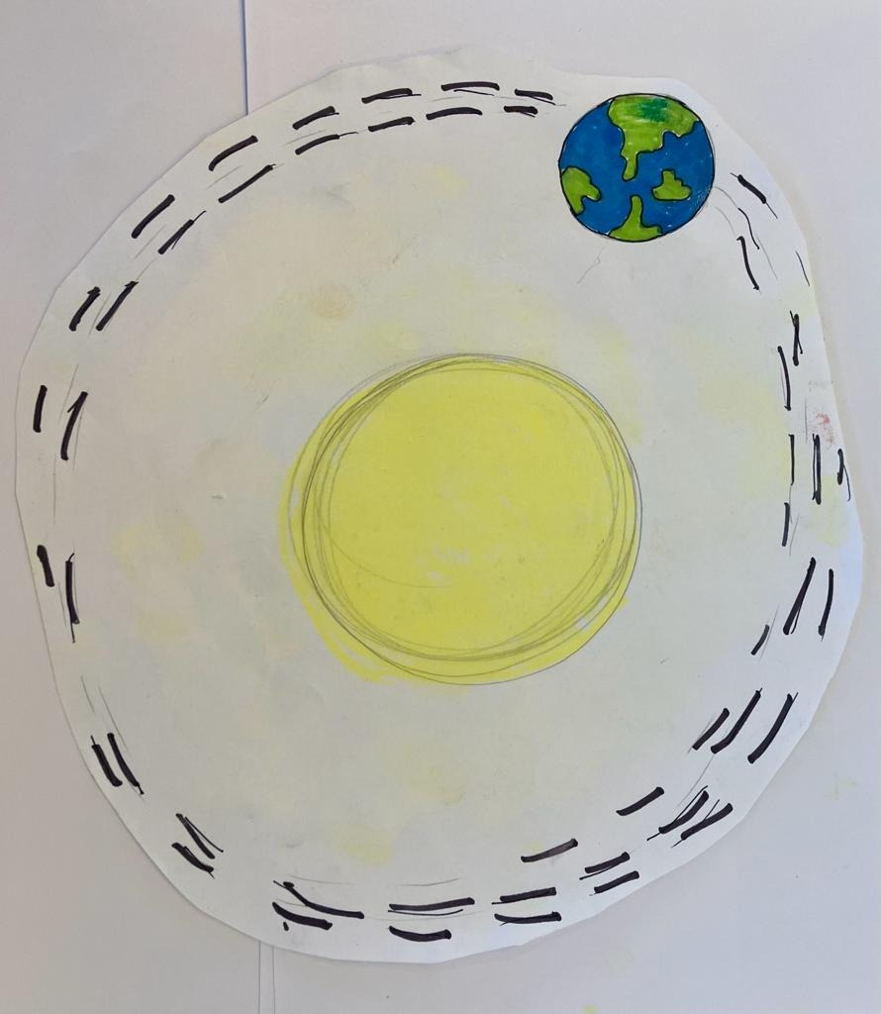 | Our own special planet  circling the sun,  for some known as Gaia,  and others as Mother Earth.
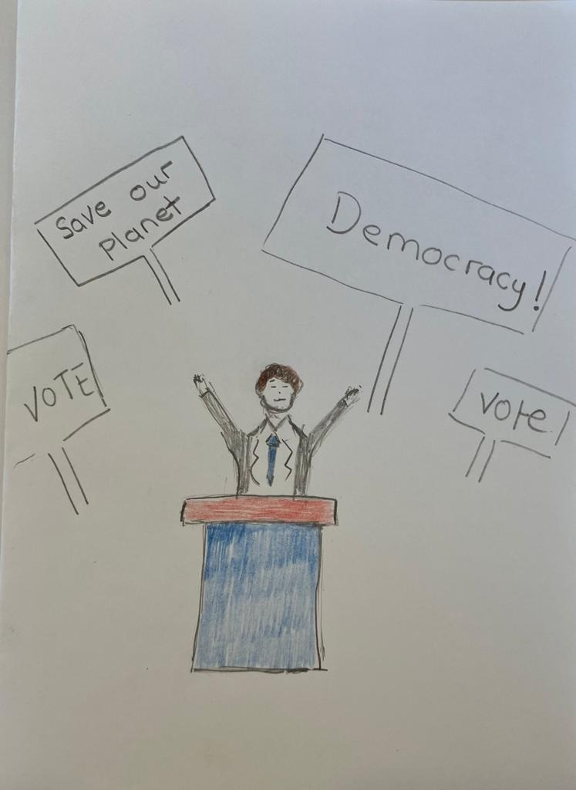 | Politicians build a future,  for us to call a home.
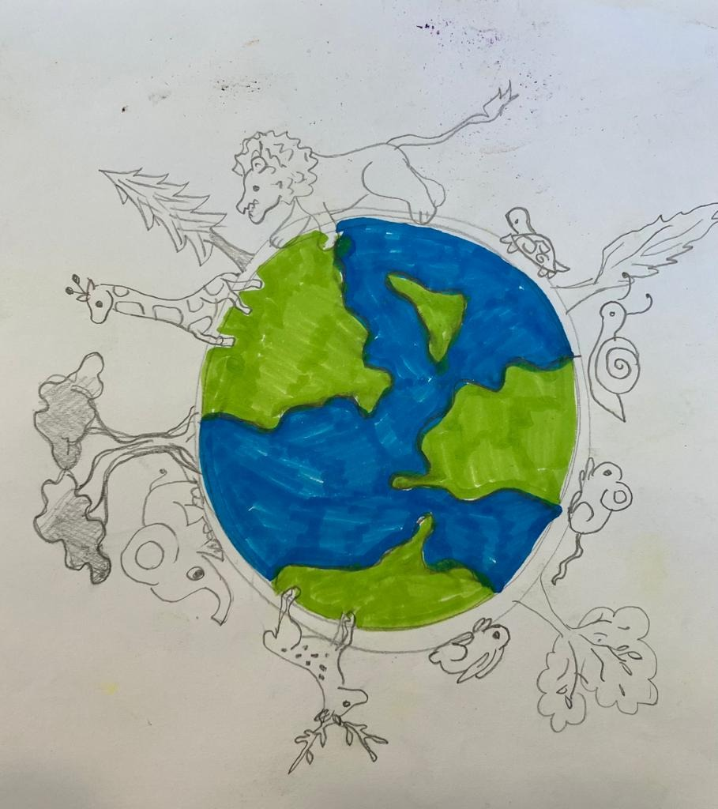 | Despite that, all the animals  simply want to live and roam.
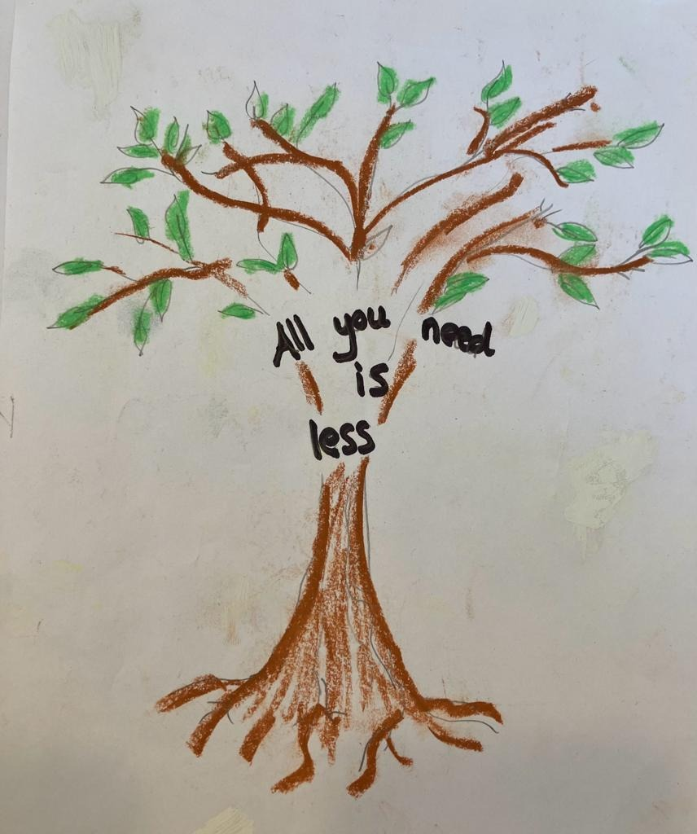 | For all that’s truly valuable  is really not financial.

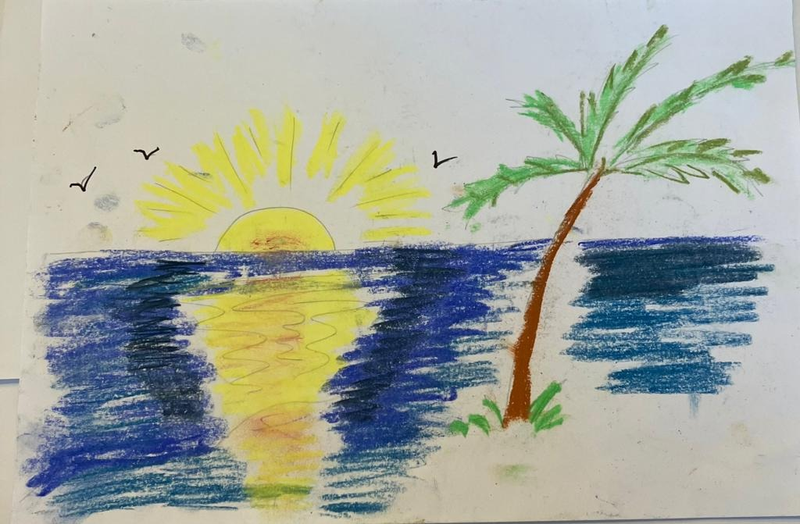 | Look at it calmly.  What’s fundamental  is not losing something natural.
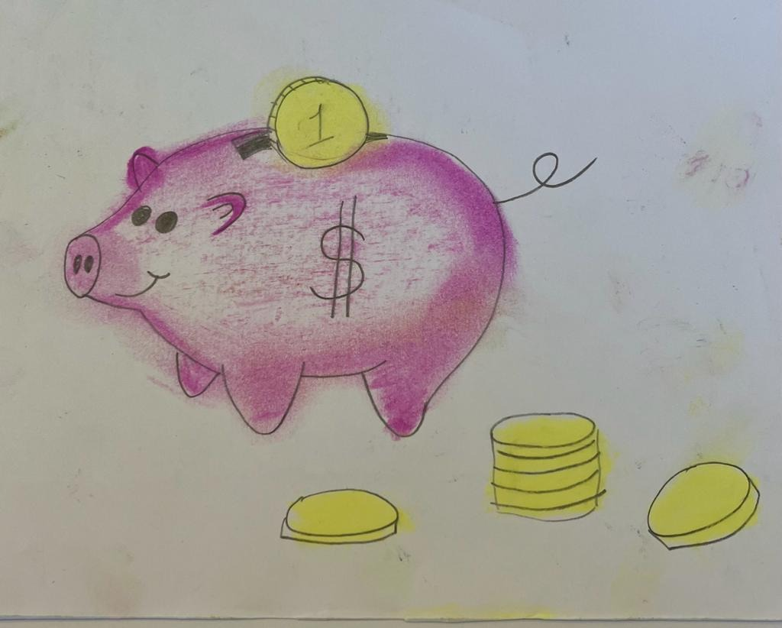 | So, let’s be smart and cautiously frugal,  remembering it is crucial.
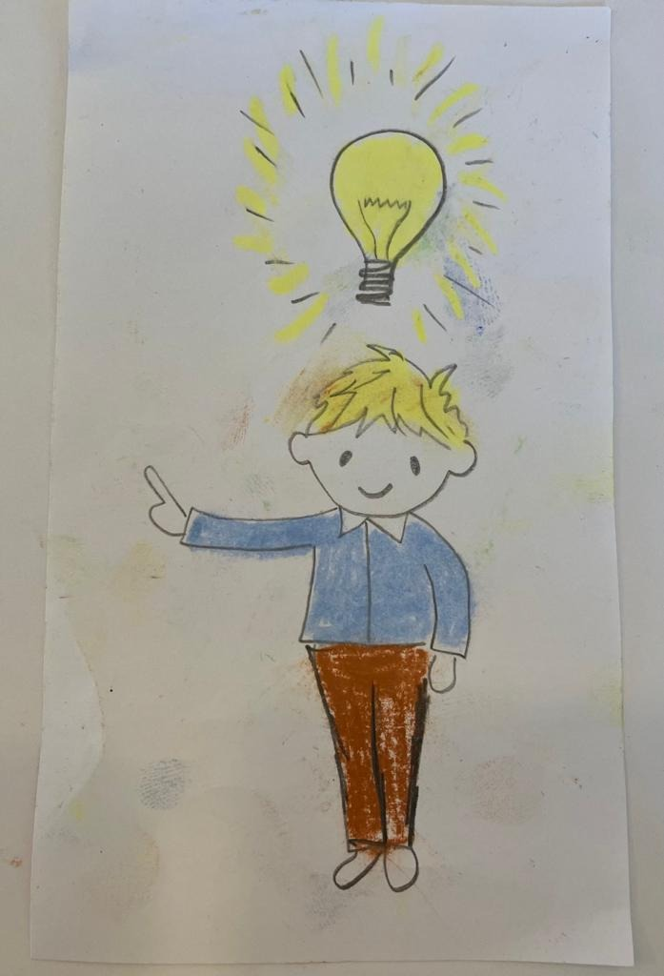 | Not to balk, but be committed,  logical and quick witted.
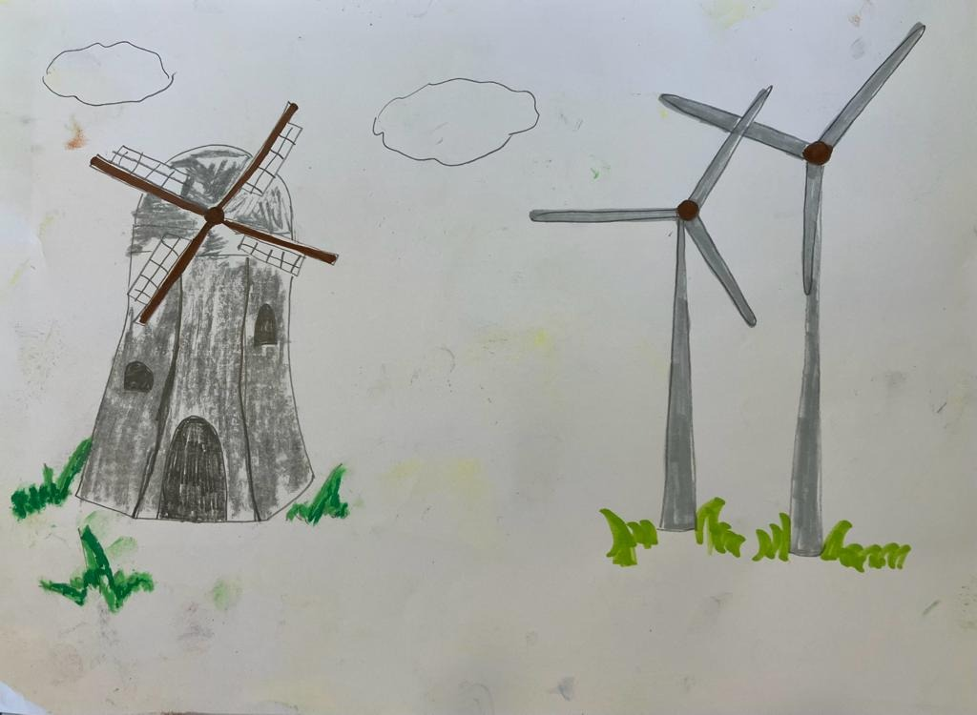 | We are allies, and so must alter,  ways in which to help the world.
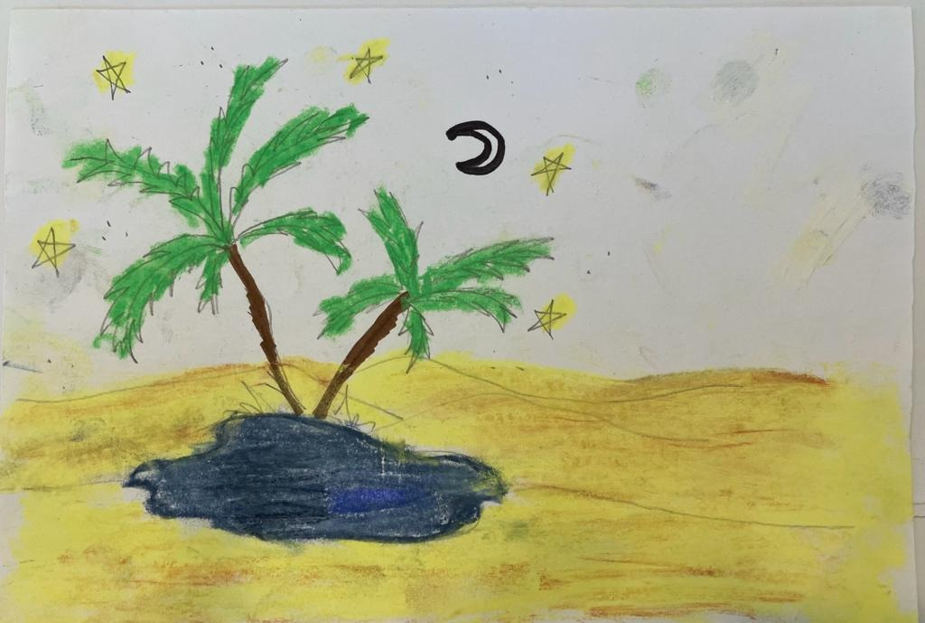 | Our celestial oasis,  from which none of us can be hurled.
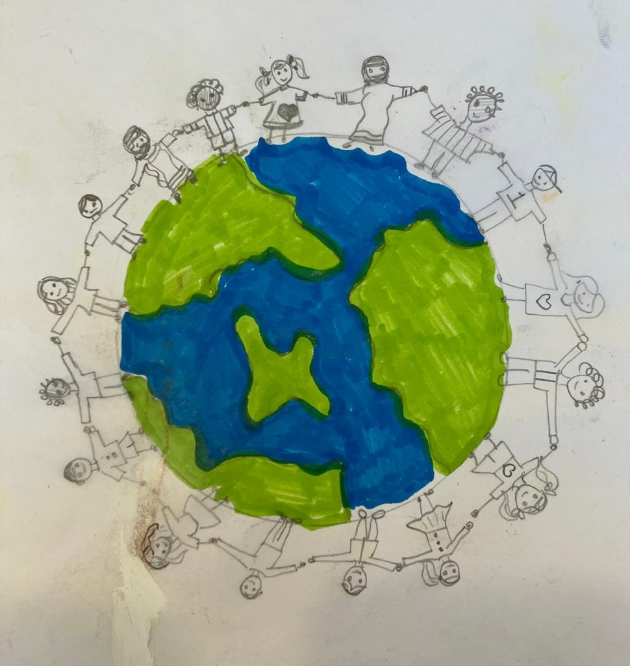 | This is our home;  we have no other.  Try genially living  as sister and brother.
Word List
1 | 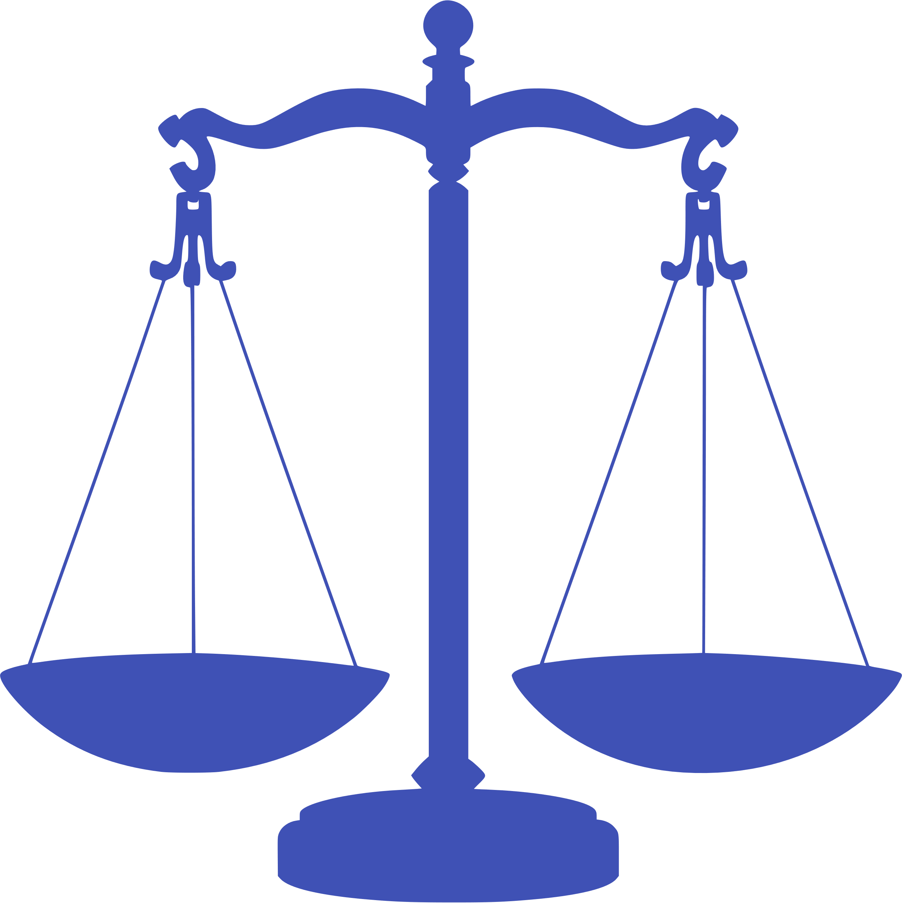 | balanced
2 | 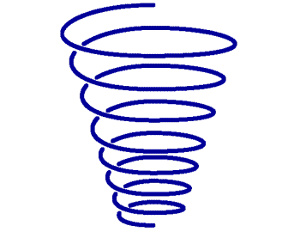  This Photo by Unknown Author is licensed under CC BY-NC | spiraling
3 | 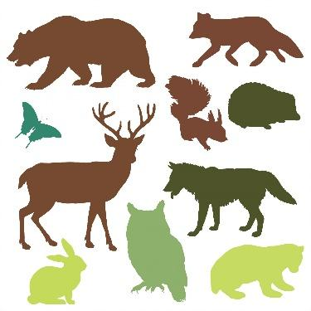 | animals
4 |  | financial
5 |  | calmly
6 |  | allies
7 |  | genially
8 |  | celestial
9 |  | picture
10 |  | politician
11 |  | build
12 | This Photo by Unknown Author is licensed under CC BY-SA | cautiously

Pale Blue Dot - Anagram Game
The goal of the game is sentence or text construction.
(see links to online games after text sheets, below)
Preparation Instructions:

- Stick text sheets 1 & 2 to coloured card.
- Cover with plastic laminate.
- Cut all words, or phrases, or whole sentences into separate units.

Play Instructions: below are 3 suggestions:

- Place face up, then take turns making sentences, of chosen length, either as a timed challenge or first to make 5.
- Place face down, then each player takes 7 words, taking turns to build phrases or sentences.
  - After each turn, if the player makes a sentence or phrase, they take 5 more words from the pile.
  - If the player passes on their turn, they take 2 words from the pile. First player to make 5 wins.
- Place face down, then take 7 words each. Then take turns in placing sentences, remembering to use a previous players word in a sentence, to cross over, such as in a crossword puzzle. Collect from the pile at random the same number of words used in the sentence placed. Score points for number of words used in a sentence. If no sentence is placed, the player takes 5 from the pile. Winner is first to a chosen score value OR first to finish all their words.

The following 2 pages contain the text to cut up, as you prefer (words, phrases, sentences) for the Anagram Game

Pale Blue Dot
Picture a pale blue dot balanced in a sunbeam,
spiralling since birth.

Our own special planet circling the sun,
for some known as Gaia, and others as Mother Earth.

Politicians build a future,
for us to call a home.

Despite that, all the animals,
simply want to live and roam.

For all that's truly valuable,
is really not financial.

Look at it calmly. What's fundamental,
is not losing what is natural.

So, let’s be smart and cautiously frugal,
remembering it is crucial.

Not to balk, but be committed,
logical and quick witted.

We are allies, and so must alter,
ways in which to help the world.

Our celestial oasis,
from which none of us can be hurled.

This is our home, we have no other,
try genially living as sister and brother.

PALE BLUE DOT: Online Games

Matching written words from the lesson to their written definitions:
https://wordwall.net/resource/56209637/hickey-lesson-99

Matching written words to the way they sound and pictures representing them:
https://wordwall.net/resource/56210251/hickey-lesson-99

Interact with and read the written text of the story:
https://wordwall.net/resource/56251795/hickey-lesson-99-pale-blue-dot

Reading comprehension quiz, for after you have done some research at the links on the next page:
https://www.liveworksheets.com/iv3427398zs

Word and vocabulary investigation resources:
Complete list of words that contain ‘al’:
https://wordfind.com/contains/al/

Complete list of words ending in ‘al’:
Words Ending In Al | Top Scrabble Words That End In Al (wordfind.com)

Enter a word, find rhymes, opposites, definitions, synonyms, etc.:
https://www.rhymezone.com/

Interesting and obscure words with their definitions:
https://www.merriam-webster.com/words-at-play/beautiful-useless-obscure-words

PALE BLUE DOT: Sources for Further Research
(on subject content)
Carl Sagan's Pale Blue Dot, YouTube video

How to Save Humankind (according to James Lovelock), YouTube video

https://en.wikipedia.org/wiki/Gaia

https://www.greenpeace.org/international/story/24978/gaia-ecology-earth-is-connected-rex-weyler/

https://en.wikipedia.org/wiki/Gaia_hypothesis

https://courses.seas.harvard.edu/climate/eli/Courses/EPS281r/Sources/Gaia/Gaia-hypothesis-wikipedia.pdf

https://aeon.co/essays/gaia-why-some-scientists-think-its-a-nonsensical-fantasy

