The old man was cold. | An old man sat on a chair.
The old man asked her to find his blanket. | A kind girl passed by.
The old man wasn't cold anymore, and the kind girl posted about the kind things that one can do. | The kind girl found the most beautiful blanket.
The Old Man and the Kind Girl

Word List
1 |  | old
2 | 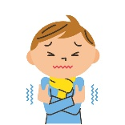 | cold
3 |  | kind
4 |  | find
5 | 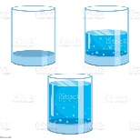 | most
6 | 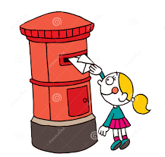 | post
7 |  | hold
8 |  | gold
9 | 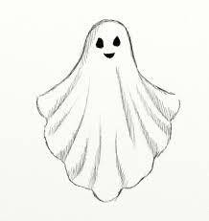 | ghost
10 | 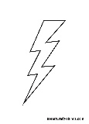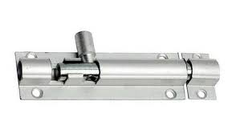 | bolt
11 | 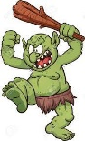 | troll
12 | 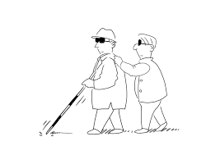 | blind

Memory Game:
Match the pictures to the words (same as in the online memory game):

 | blind
 | post | ghost
 | old
 | kind | find
 | gold
 | cold | hold
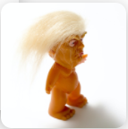 | troll
 | bolt | most

Online Random Wheel Game: (for half of the word list, the Wild Old Words in the story)
The game is a "Random Wheel" game. Each part of the wheel contains one of the Old Wild words from the list. The student needs to spin the wheel and read the word out loud. If he succeeded, then he can eliminate the word and spin the wheel again. If he didn't, he just spins the wheel again, moves to the next word, and tries again later.
Game link:
https://wordwall.net/resource/28228750
Online Memory Game: (For the whole word list)
In this online memory game, each participant clicks on two cards to turn them over and see what is on them. The goal is to find pairs that combine a word and a matching picture. If you found a pair, you may open two more cards. If you didn’t, the turn goes to the next player.
Game link:
https://interacty.me/projects/47e8f77fd35bddbb

