The Big Trip
David and Dana liked to travel a lot.  They traveled to England, India and Brazil... | One day they wanted to go to a different land.  They looked for a land with good food and pretty streets to stroll in.
They opened their atlas and  discovered a new land.  It was Italy! | The day after that they baked a cake for the trip and packed their things in their bags.  They kissed their mother goodbye and planned to be at 4 o'clock on the plane.
z  David and Dana missed their bus, so their father helped and they jumped into his car. They hoped to make it in time. | But when they arrived the door was locked. "Is it Saturday?" David asked. "Yes, it is" Dana smiled.  So, they walked back home.
Word List
1 |  | liked
2 |  | looked
3 |  | baked
4 |  | packed
5 |  | kissed
6 |  | missed
7 |  | helped
8 |  | jumped
9 |  | hoped
10 |  | locked
11 |  | asked
12 |  | walked

Word Search
Search for the words from the word bank!
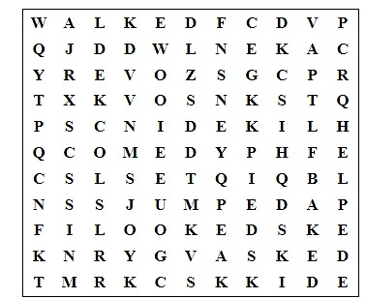

Word bank:
looked, missed, kissed,
liked, walked, baked, helped, asked, locked, packed, jumped.

