An Ice Dice Device
This is Dan.   | Dan makes dice from ice.  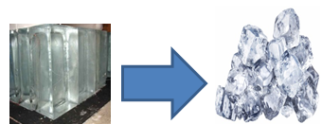
  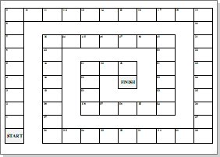  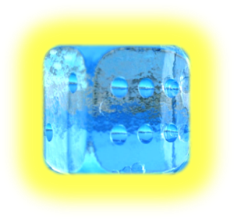  Dan plays with dice made of ice. Dan’s dice are nice. | This is Dan’s device. This device can slice ice into dice.  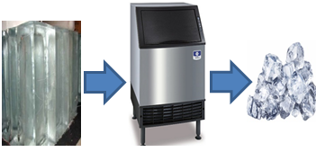
Here is another device. This device can slice twice the ice, as small as rice.  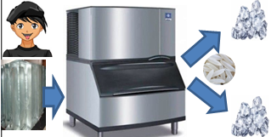 | But this device is twice the price!  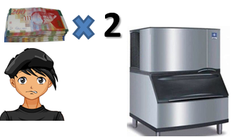
Dan’s dad gives him advice. He says that Dan's device will suffice even if it can’t cut twice the ice. He adds that Dan's money will not suffice for the price of this other device.  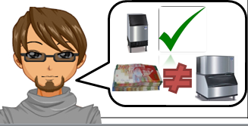 | So…Dan will keep making ice dice with his old device!  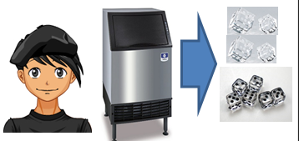
Word List
1 | 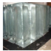 | ice
2 | 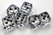 | dice
3 | 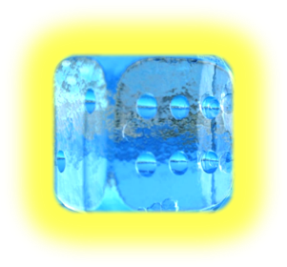 | nice
4 |  | twice
5 | 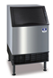 | device
6 | 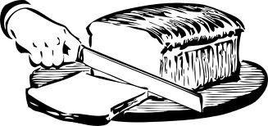 | slice
7 |  | suffice
8 |  | advice
9 |  | rice
10 | 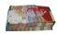 | price
11 |  | play
12 | 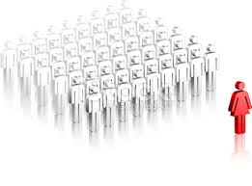 | other



