Plant and Animal Island
  Sara has an atlas. Sam has a map.  They talk. | 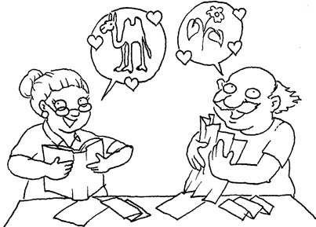  Sara likes animals.  Sam likes plants.
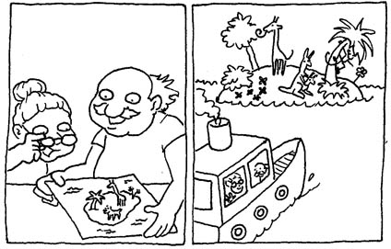  They pick an island that has plants and animals!  They plan an island trip. | 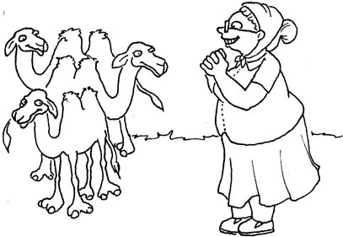  The island has little camels.  Sara smiles at them.
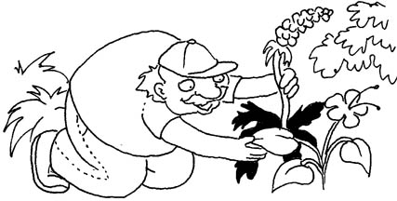  Sam likes the island’s red and black plants. | 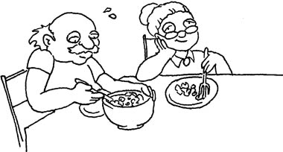  Sam and Sara are tired. They rest. They had a salad.  They like their island trip.

1 |  | atlas
2 | 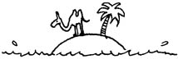 | island
3 | 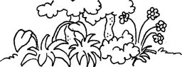 | plants
4 | 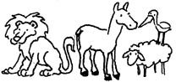 | animals
5 | 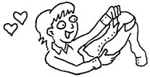 | like
6 |  | smile
7 |  | black
8 | 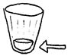 | little
9 | 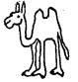 | camel
10 | 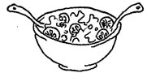 | salad
11 | 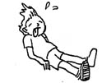 | tired
12 | 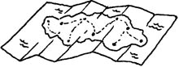 | map
Plant and Animal Island Lotto
Preparation: Glue two boards and cards onto card stock, color in reds, (laminate), cut out.
Play: Store the cards in a bag. Learner picks out a card and reads it out loud. Tutor and learner both check their boards to see if they have the word. Whoever has it on his board gets the card. The first player to get three in a row in any direction (or to fill his board, if you have time) wins.
Plant and Animal Island
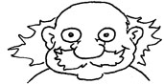
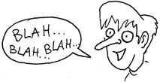
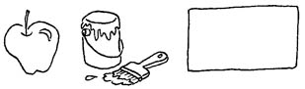
&

Plant and Animal Island

 | 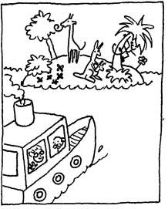 | 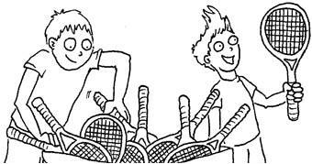
Game cards to cut out:

Sam | map | plants
island | talk | smile
like | red and black | tired

Sara | atlas | animals
plan | trip | pick
little | salad | camels

