Jim the Judge has Fudge
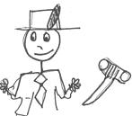  This is Jim the Judge. | 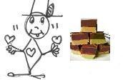  Jim loves fudge,
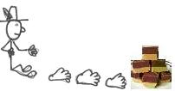  Jim has to trudge to get fudge. | 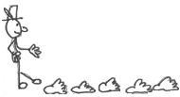  He has to trudge, trudge, trudge.
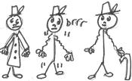  Jim has a jacket.  He is cold and he is old. | 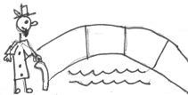  He has to trudge over the bridge over the river.
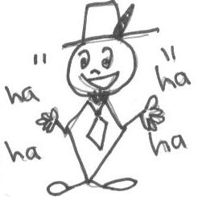  Jim is jolly, jolly, jolly! | 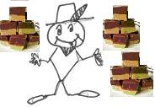  Jim has fudge, fudge, fudge!

Word List
1 | 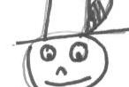 | Jim
2 | 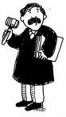 | judge
3 | 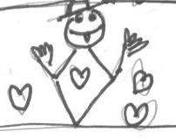 | loves
4 | 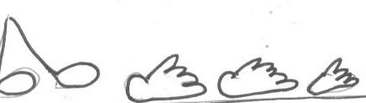 | trudge
5 | 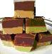 | fudge
6 | 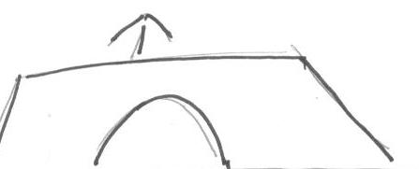 | over
7 | 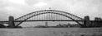 | bridge
8 | 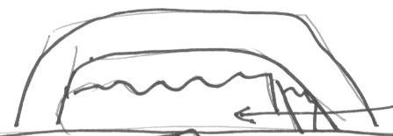 | river
9 | 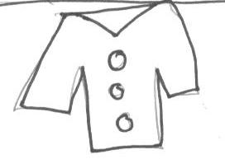 | jacket
10 | 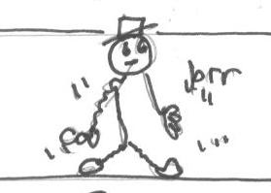 | cold
11 | 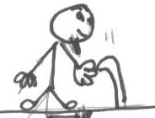 | old
12 | 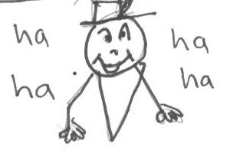 | jolly
Word search

Circle these words in the table, going across or down:

Jim  judge  loves  trudge  fudge  over | bridge  river  jacket  cold  old  jolly

c | k | h | f | u | d | g | e
o | j | i | m | s | h | l | m
l | u | n | y | k | g | k | j
d | d | l | o | v | e | s | n
h | g | h | l | o | g | t | j
o | e | r | i | v | e | r | a
l | n | u | h | e | j | u | c
d | n | k | m | r | m | d | k
g | g | b | r | i | d | g | e
j | l | k | k | l | n | e | t
u | g | j | o | l | l | y | m

Harder word search

Circle these words in the table, going in any direction:

Jim  judge  loves  trudge  fudge  over | bridge  river  jacket  cold  old  jolly

r | a | j | a | c | k | e | t
i | b | g | m | p | g | z | a
v | c | j | n | d | s | v | d
e | t | h | i | q | t | b | e
r | f | r | o | m | u | f | f
d | b | i | u | r | v | u | g
r | j | j | j | d | w | d | h
e | o | k | u | l | g | g | i
v | l | l | d | o | x | e | j
o | l | d | g | c | y | c | k
e | y | s | e | v | o | l | l

