Bobby's Problem
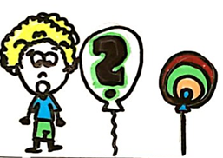  Bobby had a big problem.  He ate a lot of candy. | 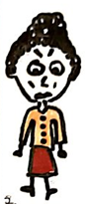  Bobby's mom, Sandy, is cross.
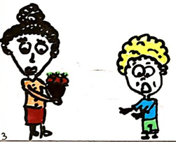  One time, Bobby's mom made him  a salad. | 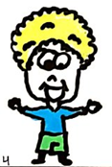  Bobby opens his lips and tastes  the salad. "I like it!" he said.
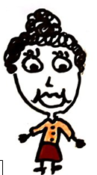  "I'm happy!" Mom said. "It's best to like salad. Less candy!" | 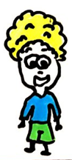  Bobby hops. He is happy. "I'll try salad, not candy,"  Bobby told his mom.

Word List
1 | 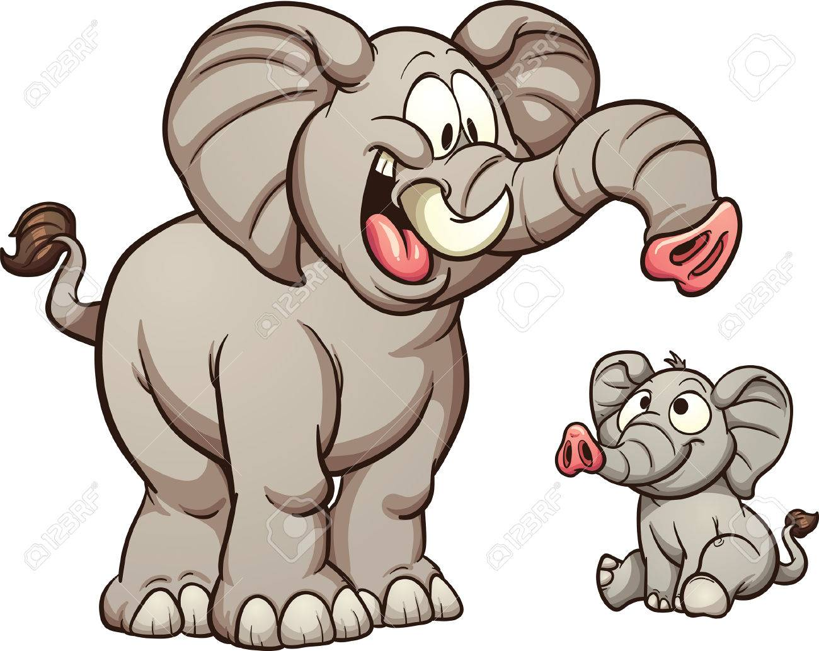 | less
2 | 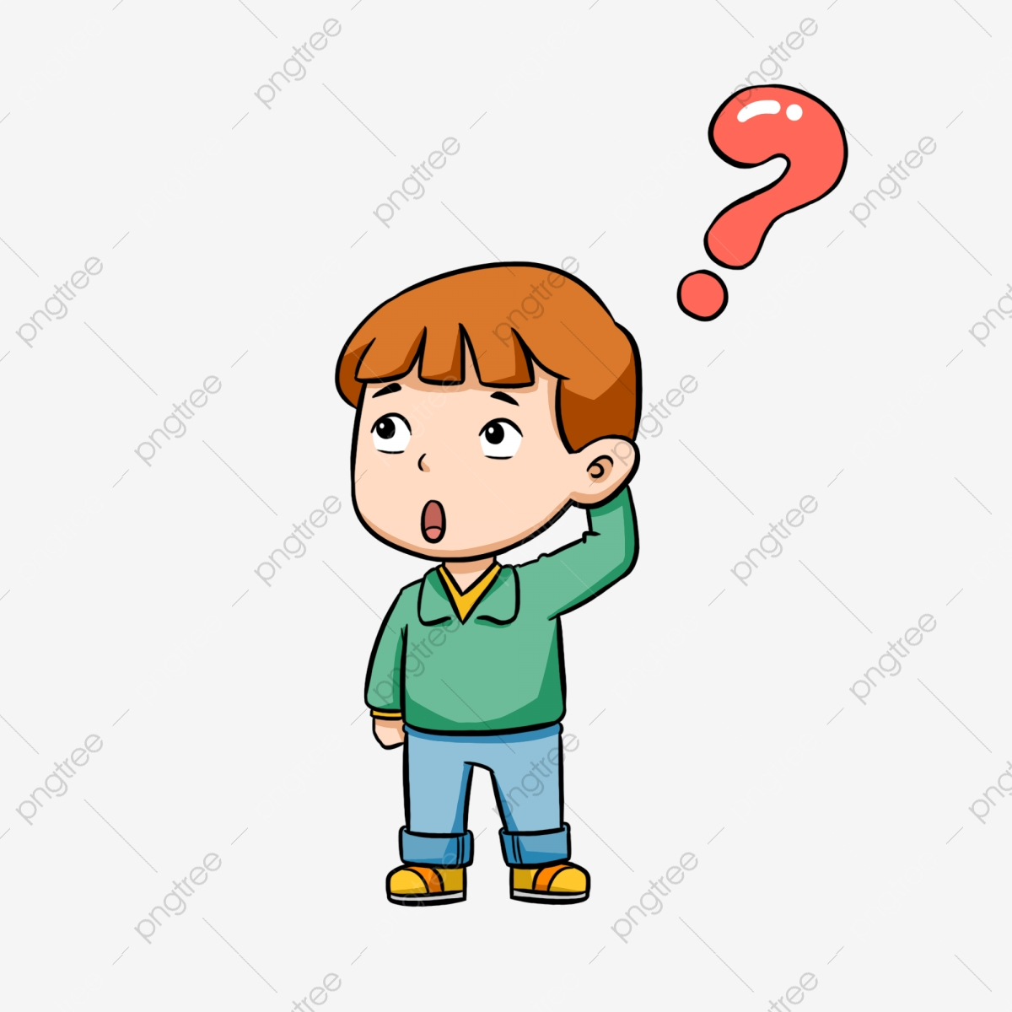 | problem
3 | 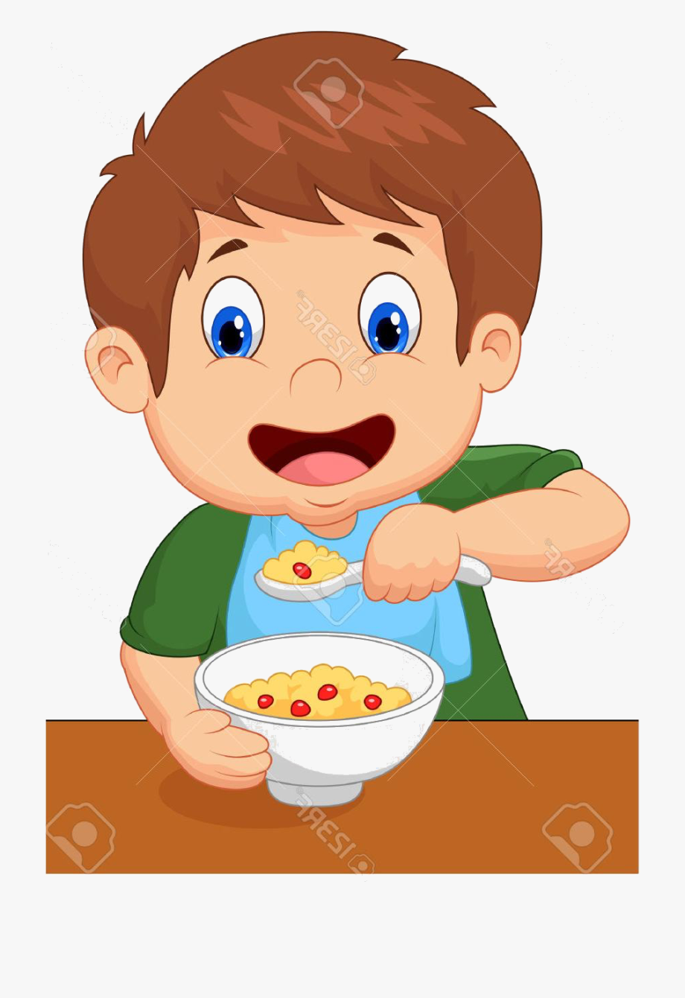 | ate
4 |  | candy
5 |  | mom
6 |  | cross
7 | 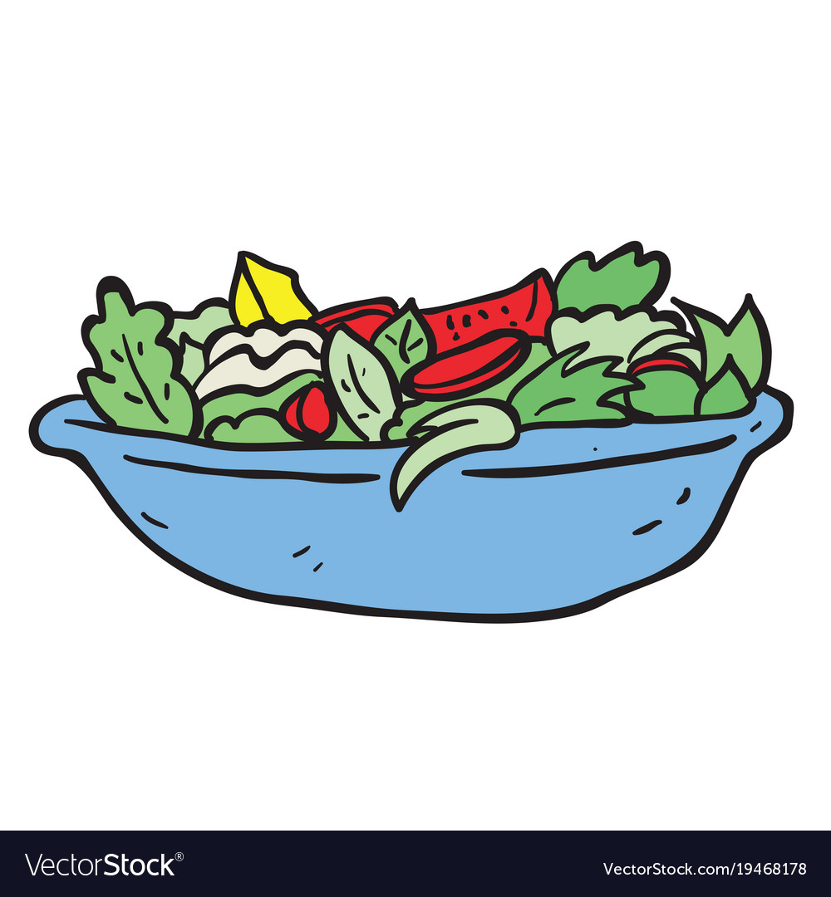 | salad
8 | 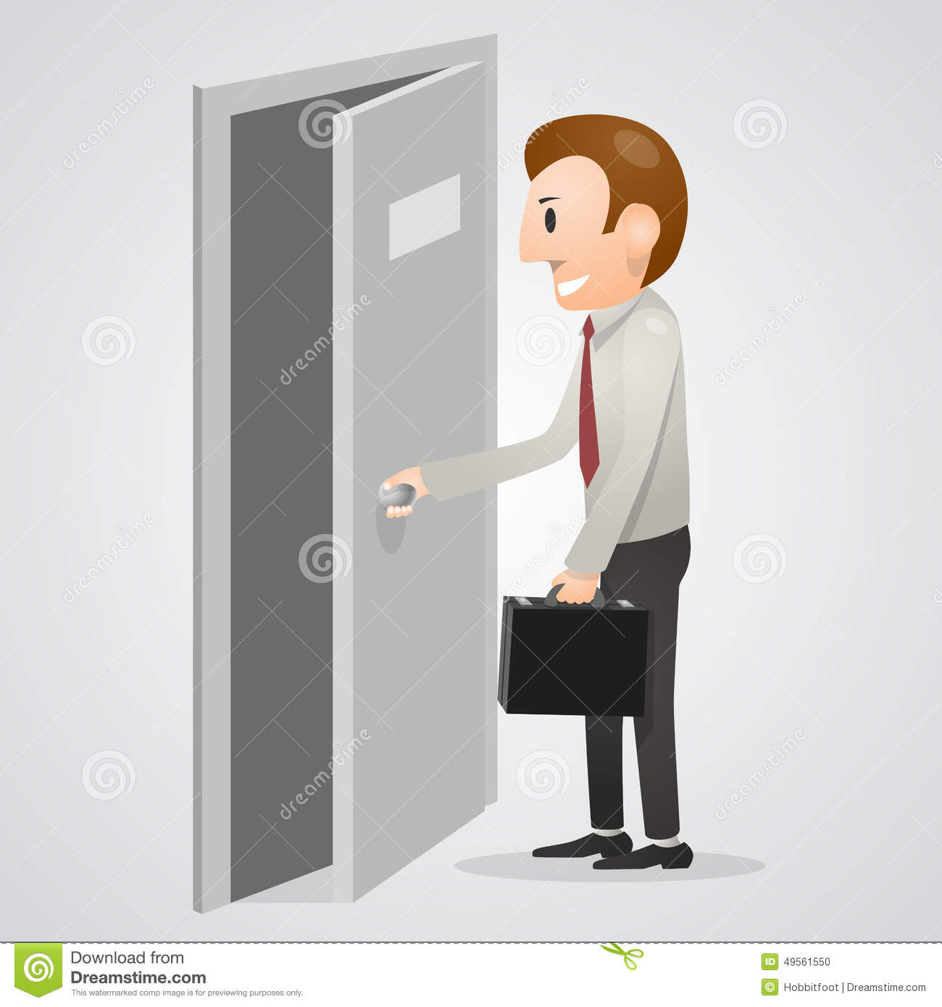 | open
9 |  | lips
10 |  | taste
11 |  | hop
12 |  | like

Matching game:
Cut out 9 squares on dotted lines only.
Match words at edges to form a 3x3 puzzle where every word matches.
There are many correct ways to assemble the puzzle

less  problem candy  ate | mom  candy salad  cross | open  salad problem  hop
ate  taste one  try | cross  one lips  time | hop  lips taste  like
try  stop to  less | time  to told  mom | like  told stop  open

